Project Proposal

On

**Online Re-Sale Store**



Module

**STW300CEM: Android Application Development**

Softwarica College of IT & E-Commerce

Mahakavi Marg, Kathmandu 44600, Nepal

**Submitted By**

**Kushal Kandel**

College ID: 160216

Batch: 19(C)

**Submitted To**

**Kiran Rana**

Module Leader

**Table of Contents**

Introduction 1

Project Introduction 1

Justification of the Project 1

Background of the Project 1

Problem Statement 1

Features of the Project 2

Aims and Objective of the project 3

Development Methodology 4

Description of the Methodology 4

Design Pattern 4

System Architecture (Three Tier Architecture) 5

Configuration Management 6

Prototyping 7

Conclusion 7

References 9

# Introduction

A android application with the aim of changing **“second-hand”** definition by providing used products having quality as good as new product but in very reasonable price.

## Project Introduction

The main focus of the project will be on how to enhance application feasibility & usability comparing to today’s application. It will be an e-commercial platform whose buyers and sellers will be from the same market itself. **Seller:** People who wants to sell used products & **Buyer**: People who are willing to buy those products. The products will be verified properly to check, if they will meet the quality or not before showcasing it into the market.

## Justification of the Project

### Background of the Project

In today’s market there are so many used products available in the market such as: electronic devices, clothes, playing instruments etc. which are not so bad comparing to their original ones. They are thrown away just because there is no enough space for those products in people’s closet nowadays. This application will be the closet for those products, the only difference is, it will also be able to sell the products.

### Problem Statement

The main problem that current market holds regarding used products is quality. There are so many shops & online stores for used products in the market but what they lack is quality in those products. The price people pay for the products value in those markets starts to fade down in very short gap. And online store are not as efficient and feasible as expected. Another problem that this project will be solving is it will be acting as a central hub for all types of products such as: electronic devices, furniture, sports item, transports etc. In short: **ANYTHING & EVERYTHING.**

## Features of the Project

The time people spend on their mobile devices is growing rapidly each and every year. Mobile phones are getting sophisticated, number of activities we can perform are always growing which means we can use them with great frequency. Some of the features of this project are:

**1) Easy Navigation with great usability:**

Mobile Application are found to be more advanced then they are needed. This app will have a easy navigation system for user and will be entirely intuitive about where and what to click in order to make a selection.

**2) Login & Sign-Up Feature for User:**

User will have an login and signup feature to gain full access to the application. After logging in they can get into their dashboard & get a look on the transactions they have performed.

**3) Quality in Supplied Products:**

Second Hand products are easily available in the markets & online store. So, what makes this application different from others? Quality in Products. Each products will be verified to make sure if they can meet the quality before showcasing them into the market.

**4) A Central-Hub for All:**

This will work as a central hub for all types of products like electronic items, books, furniture etc. If user need any item, they can just surf it here & will not be disappointed from the result.

**5) Online Payment:**

Nowadays cash payment method is getting fade comparing to past time. Online payments are making their way into the market. And this app will use that feature to make the application more & more user-friendly.

## Aims and Objective of the project

The main aim of the project will be to create an more scalable and easily usable android application which provide second-hand products in the market having quality as good as first-hand at a very reasonable price.

There are many objectives that needs to be completed in order to achieve the aim of this project and they are listed below:

1. Research on second hand markets & preference of users on the products available in those markets.
2. Developing an Interactive & Easily Accessible UI for the user.
3. Proper implementation of the designing phase.
4. Testing the application properly before showcasing it into the live market.
5. Developing an application that will work as a central app for all types of second-hand products.
6. Making application more scalable & usable.

# Development Methodology

It refers to a framework which is used to structure, plan and control the process of developing an system. It helps in improving product management and its design by dividing the work into distinct phases. There are different software development methodology but for this project I’m going to use the most common methodology of them all: Waterfall Development Methodology

## Description of the Methodology

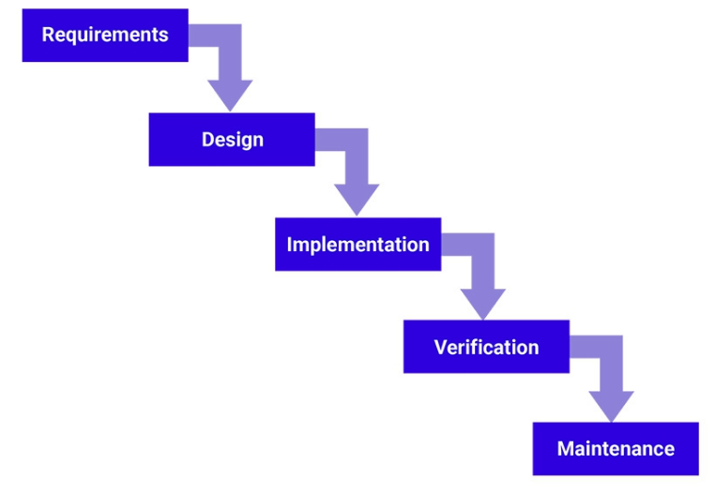Waterfall Method is considered to be the traditional software development approach. A linear model which consists of sequential phases and each phases should be completed 100% before moving on to the next phase. It’s method make this approach easy to understand and manage. As my project have clear objectives with stable requirements, I am going to use this method for development.

## Design Pattern

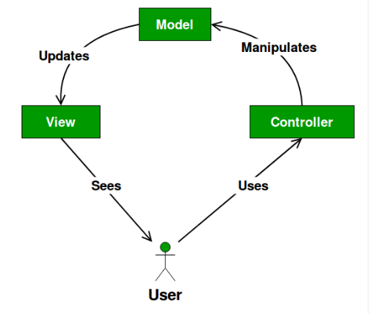Design Pattern refers to reusable solution for problems that occurs commonly while developing the software. For this project, I am going to follow MVC Design Pattern. It stands for **MODEL-VIEW-CONTROLLER**. This pattern separate the concerns of application into three part:

**MODEL:**   
It only contains data related to application only. It might also consists of some logic to update controller as per requirement.

**VIEW:**   
It showcase the model’s data to the user. It visualize the data to the user.

**CONTROLLER:**   
It separate model from view. It controls data flow into model object and updates view as data changes.

## System Architecture (Three Tier Architecture)

The process where concepts are developed, which will work as a backbone for the system in coming time is known as System Architecture. It describes the behavior and structure of the proposed system. The architecture that we are going to follow for the project is Three-Tier Architecture. A client-server architecture which consists of a presentation, application and a data tier. Data tier acts as a information storage, Application tier handles all the logic required and Presentation tier is a GUI for the application which communicate with other two tires. The main benefit of this architecture is it enhance scalability and performance of the system, which is the requirement for development this application. Given pictures shows the complete overview of the 3-Tier Architecture:

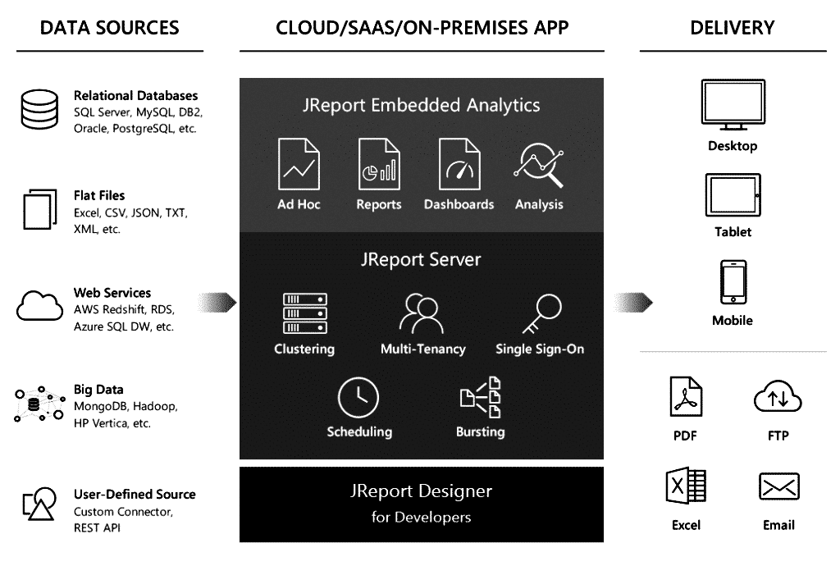

# Configuration Management

A system engineering process for ensuring consistency among physical and logical assets in an operation environment. For this project, GitHub will work as a storage for configuration files and the screenshot of the GitHub is shown below:

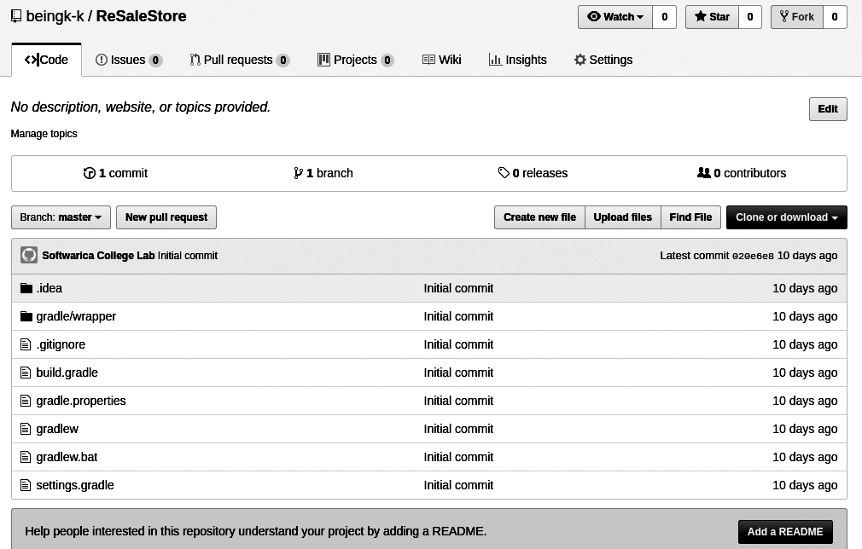

# Prototyping

Before developing any project, prototyping is the most to make sure how the application will look in coming time. So, the prototype for my project is shown below

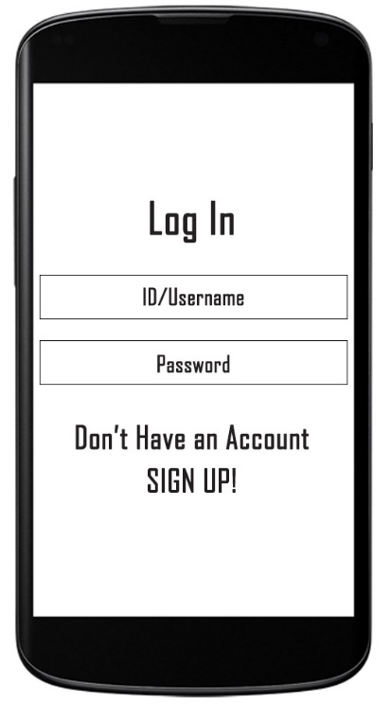**Landing Page Log In Page**

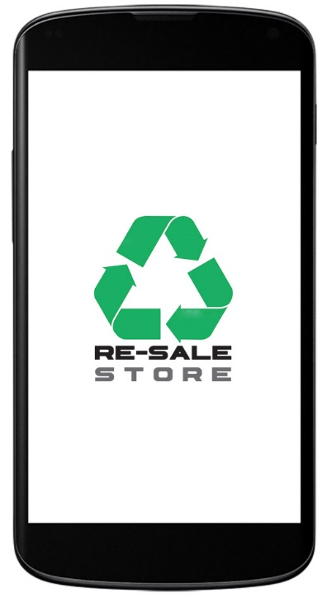

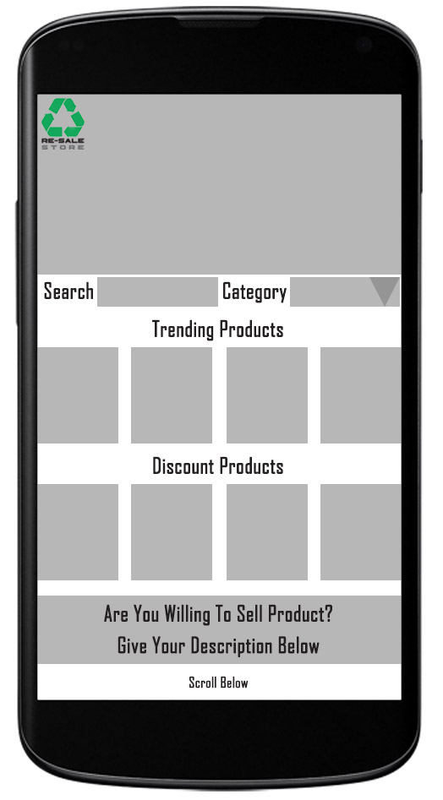**Home Page**

# Conclusion

This is a proposal for a Online-based Second Hand Store, which will sell products to the customer from the website itself. The application will be developed following Waterfall Development Model. For the development, Model-View-Controller pattern will be used along with Three-Tier architecture. GitHub will act as a storage for files which will be updated on regularly basis.

# References

*GeeksforGeeks. (2019). MVC Design Pattern - GeeksforGeeks. [online] Available at:*

*https://www.geeksforgeeks.org/mvc-design-pattern/ [Accessed 12 Apr. 2019].*

*SearchSoftwareQuality. (2019). What is 3-tier application architecture? –*

*Definition from WhatIs.com. [online] Available at:*

*https://searchsoftwarequality.techtarget.com/definition/3-tier-application [Accessed 12 Apr. 2019].*

*Itinfo.am. (2019). Software Development Methodologies. [online]*

*Available at: http://www.itinfo.am/eng/software-development-methodologies/ [Accessed 12 Apr. 2019].*