ObservaPedia
Operator Manual
A plain-English guide to running and updating the website
No coding experience required
Prepared as a handover document by the site's developer.
Covers: 1,000+ glossary terms · 27 categories · searchable site · user comments
Version 1.0

What's in this manual
Read sections 1–5 once to understand how everything fits together. After that, jump straight to the “Scenario” section that matches what you want to do.
1. Welcome — what this website is
2. What you need before you start
3. The big picture (how it all works)
4. The files explained — what each resource means
5. What a “term” looks like
6. A quick tour of the live website
7. Scenario A — Add a brand-new term
8. Scenario B — Edit an existing term
9. Scenario C — Delete a term
10. Scenario D — Add a new category
11. Scenario E — Change page wording (About, Contact…)
12. Scenario F — Turn on Google AdSense
13. The comments feature, explained
14. Preview your changes safely
15. Publishing your changes to the live site
16. The Golden Rules (read before every edit)
17. Troubleshooting — “I broke something!”
18. Quick-reference cheat sheet

1. Welcome — what this website is
ObservaPedia is a free online dictionary (a “glossary”) of technical terms used in observability, monitoring and IT operations. A visitor types a word — say “latency” — and the site instantly shows a clear definition. They can also browse an A–Z list, filter by category, and leave comments.
Here is the most important thing to understand:
💡 The website is just a folder of files on a computer.
There is no complicated database to log into and no programming to run. To change the site, you open a file, edit some text, save it, and the change appears. This manual shows you exactly which file to open for each kind of change.

Almost everything you'll ever do is one task:
adding or editing a glossary term. That's covered step-by-step in Scenario A and B.

2. What you need before you start
Three simple things:
- The website folder. It's called observapedia. Keep it somewhere safe and always know where it is.
- A text editor. This is a program for editing the files. Please install the free, friendly Visual Studio Code (code.visualstudio.com). In a pinch, TextEdit (Mac) or Notepad (Windows) works, but VS Code is much safer because it colour-codes the text and warns you about mistakes.
- A web browser. Chrome, Edge, Safari or Firefox — to look at your changes.
⚠️ Please don't use Microsoft Word or Google Docs to edit the website files.
They add invisible formatting that breaks the files. Always use a plain-text editor like VS Code.

3. The big picture (how it all works)
You only ever enter a term once. The website automatically uses it everywhere — the search box, the A–Z glossary, the category counts, and even the comments. You never update those by hand.
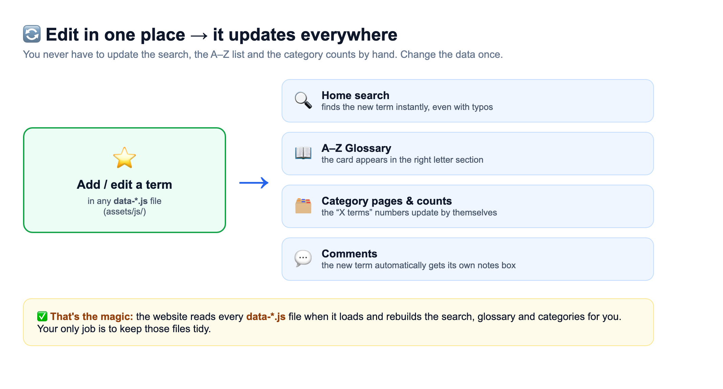
Figure 1 — Add or change a term in one place, and the whole site updates itself.

4. The files explained — what each resource means
When you open the observapedia folder you'll see the files below. The colours tell you how safe each one is to touch.
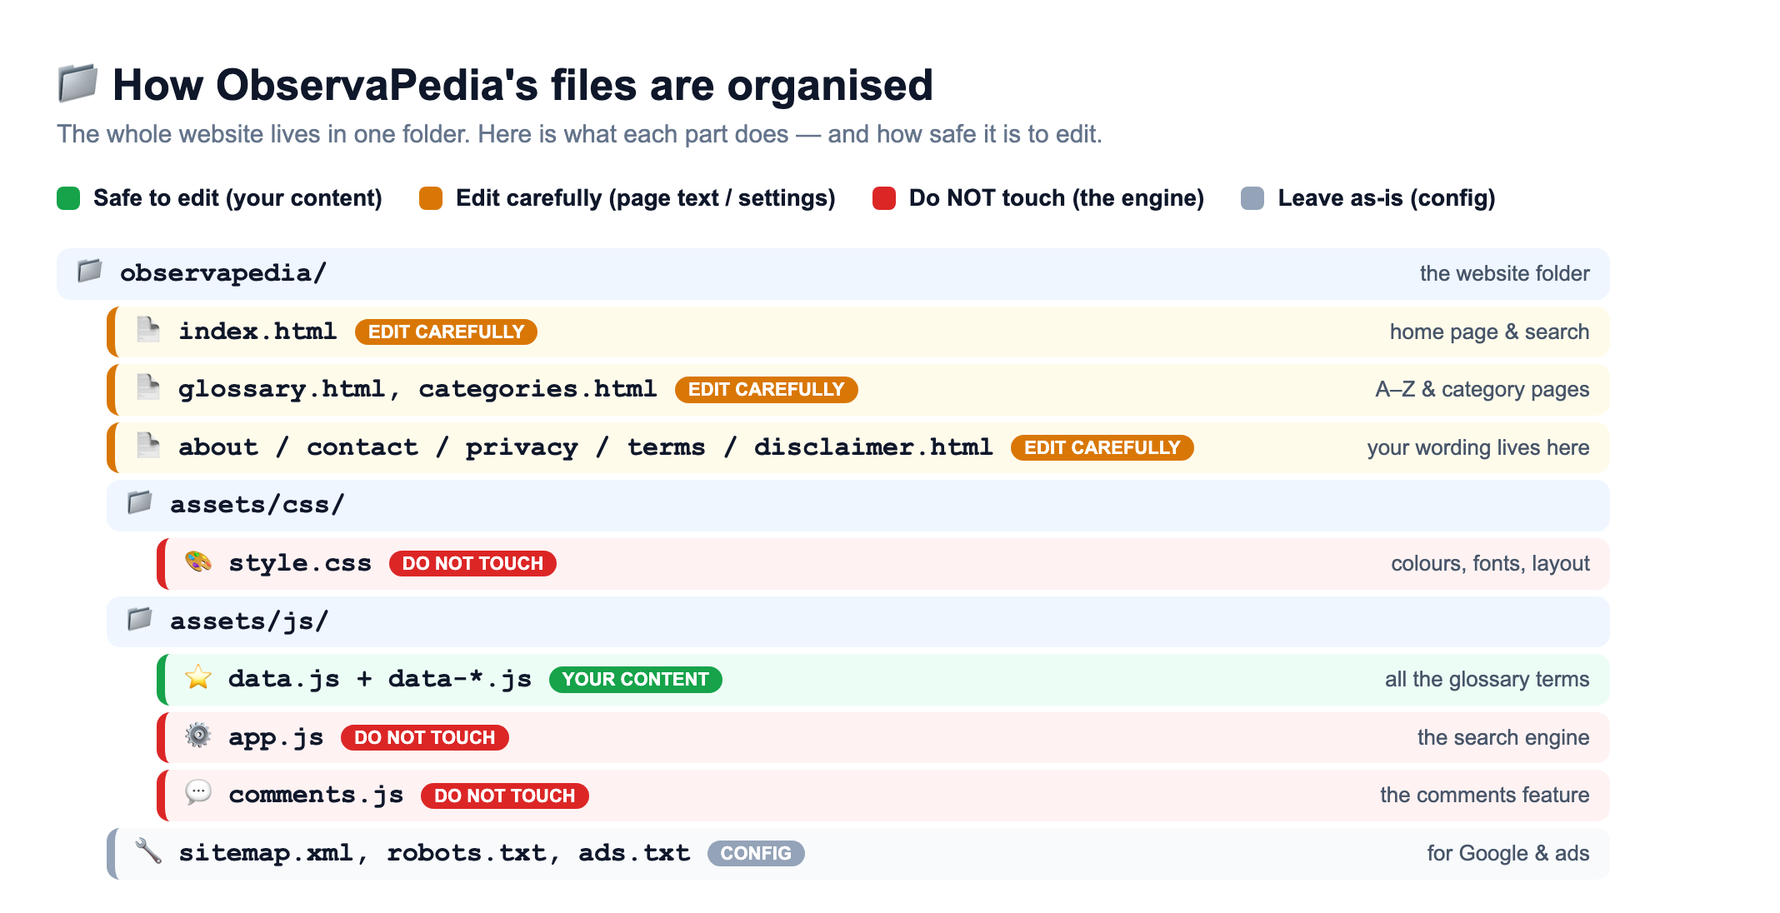
Figure 2 — The website folder, colour-coded by how safe it is to edit.
Here is the same information as a quick reference. “Resource” just means a file or folder that makes up the website.
Resource | What it is / does | When you edit it
data.js + data-*.js | All the glossary terms and their definitions, split into themed files (one for Kubernetes, one for security, etc.). | Often — your main job
index.html | The home page, including the headline text above the search box. | Rarely — only to change home-page wording
glossary.html / categories.html | The A–Z page and the categories page. | Rarely
about / contact / privacy / terms / disclaimer .html | The wording on those information pages. | Occasionally — to update your details
style.css | The colours, fonts and layout (how the site looks). | Don't — leave to a developer
app.js | The search engine and page logic. | Never touch
comments.js | The user-comments feature and where they're stored. | Never touch
sitemap.xml / robots.txt / ads.txt | Helper files for Google Search and Google AdSense. | Once, during setup (see Scenario F)

5. What a “term” looks like
Open any data-*.js file and you'll see a long list of little blocks. Each block is one glossary term. They look like this:
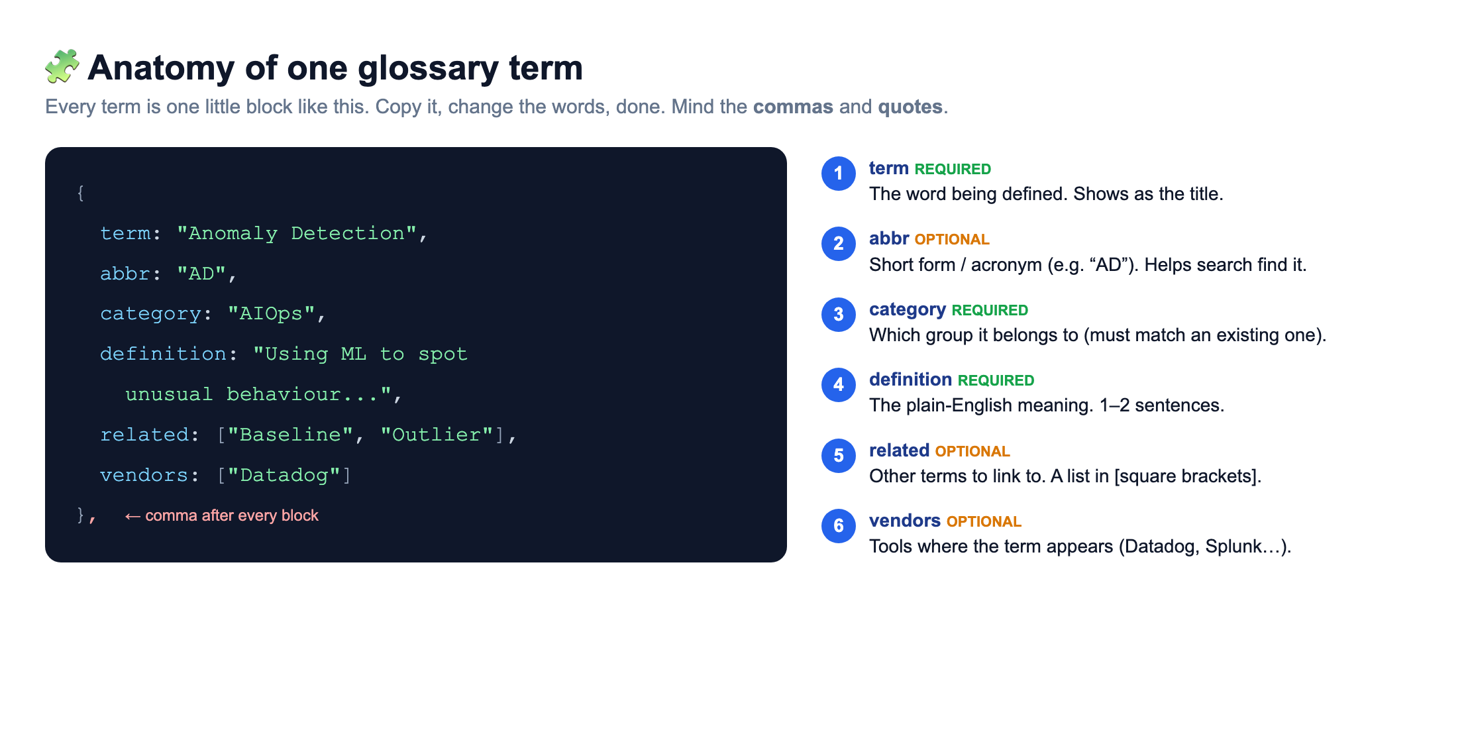
Figure 3 — One term is one block. Copy a block, change the words, and you've added a term.
The two parts marked REQUIRED must always be there. The OPTIONAL parts you can include or leave out. The most important habit to build:
✅ Every block ends with a comma, and every piece of text sits inside "double quotes".
If a comma or a quote is missing, the page can go blank. Section 16 (Golden Rules) and Section 17 (Troubleshooting) explain how to spot and fix this.

6. A quick tour of the live website

The home page
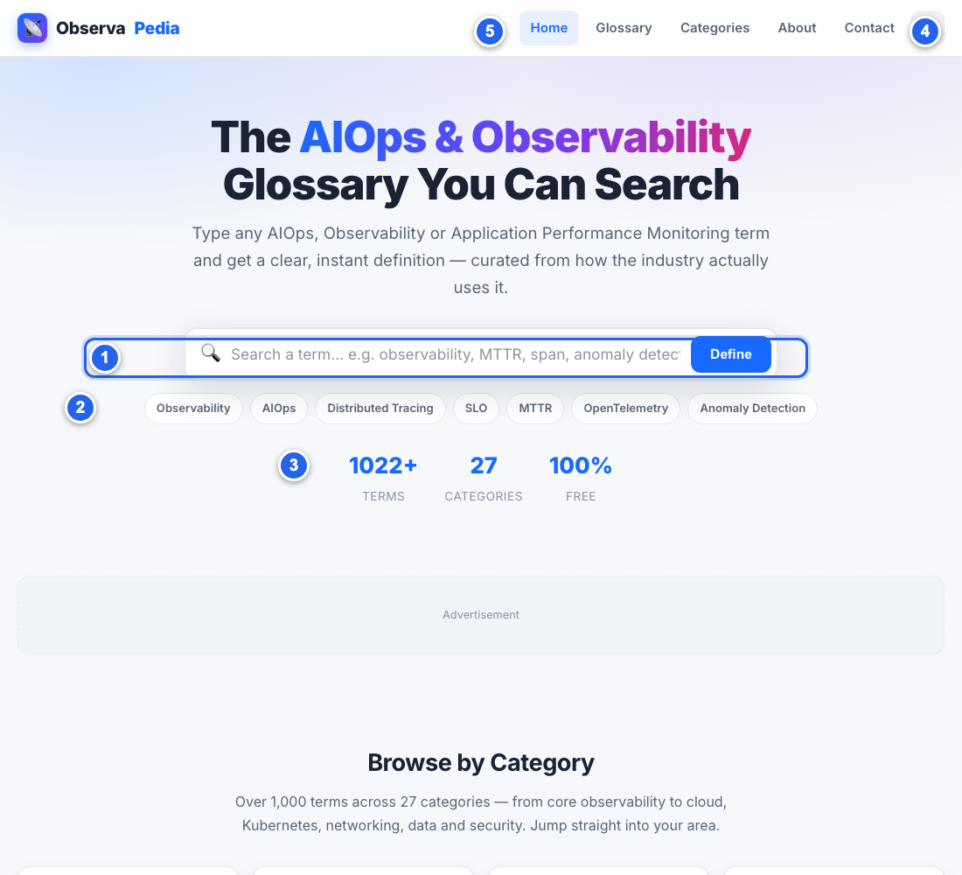

- 1 Search box — visitors type a term here and get an instant definition.
- 2 Example chips — one-click sample searches.
- 3 Live counters — total terms, categories, and “100% free”. These update automatically.
- 4 Light/Dark button — switches the colour theme.
- 5 Menu — links to the Glossary, Categories, About and Contact pages.

The A–Z glossary page
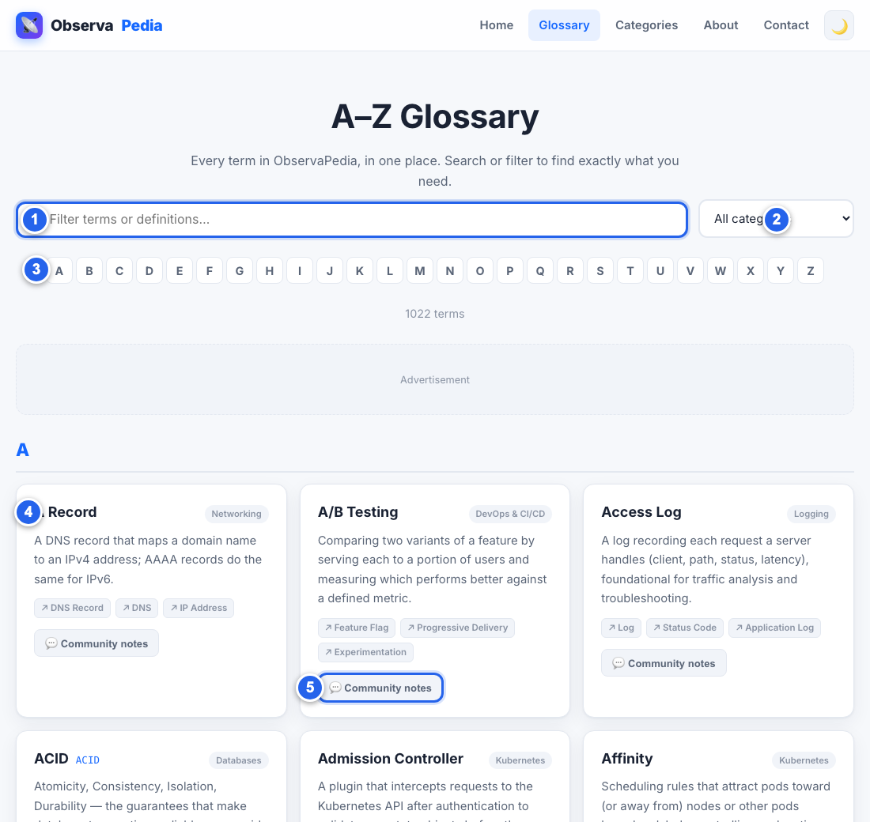

- 1 Filter box — narrows the list as you type.
- 2 Category filter — show only one category.
- 3 A–Z jump bar — jump to a letter.
- 4 A term card — one definition, with its category and related links.
- 5 “Community notes” — opens the comments box for that term (see Section 13).

7. Scenario A — Add a brand-new term
This is the task you'll do most. Take it slowly the first time.
- Pick the right file. In assets/js/, choose the data file that best fits your term — e.g. data-kubernetes.js for a Kubernetes term, or data.js for a general observability term. (If unsure, data.js is always fine.)
- Open it in VS Code.
- Find a good spot. Scroll to almost the bottom, to the last term block — the one just before the line that reads ]);.
- Copy this template and paste it on a new line right after the last block:
{
term: "Your New Term",
abbr: "ABC",
category: "AIOps",
definition: "A clear, one or two sentence explanation.",
related: ["Some Term", "Another Term"]
},

- Change the words between the quotes to your own. Keep the quotes and the comma. Delete the abbr or related lines if you don't need them.
- Save the file (Ctrl+S on Windows, Cmd+S on Mac).
- Check it. Open the website and search for your new term (see Section 14).
📌 Make sure the block BEFORE yours ends with a comma.
When you paste a new block after an existing one, the existing one must end with }, (curly brace + comma). The very last block in the file is the only one that may end without a comma. When in doubt, give every block a trailing comma — that's always safe here.

8. Scenario B — Edit an existing term
- Find the term. In VS Code press Ctrl+Shift+F (Cmd+Shift+F on Mac) to search across all files, and type the term's name. Click the result to jump to it.
- Edit the text between the quotes — usually the definition.
- Don't remove the quotes or the comma.
- Save, then refresh the website to check.
💡 Tip: fixing a typo in a definition is the safest possible edit.
As long as you only change words inside the "quotes" and leave the punctuation around them alone, you cannot break anything.

9. Scenario C — Delete a term
- Find the term's block (as in Scenario B).
- Select the whole block — from its opening { down to its closing }, including that comma — and delete it.
- Check the surroundings. Make sure the block now above the gap still ends in a comma, and the file still ends with ]);.
- Save and refresh.

10. Scenario D — Add a new category
Categories appear automatically. To create one, you simply use a new category name on a term. If you give a term a category that doesn't exist yet, the site creates it for you.
- Add or edit a term (Scenario A or B) and set its category to your new name, e.g. category: "FinOps",
- Save and refresh. The new category now appears in the Categories page and the glossary filter, with its count.
💡 To make a category look its best, it can be given a custom icon and description.
That part lives in app.js and is a developer task — but it's optional. Without it, the new category still works and simply shows a default book icon. Ask your developer if you want a custom icon.

11. Scenario E — Change page wording (About, Contact…)
The text on the information pages lives directly in the matching .html file:
To change… | Open this file
The About page text | about.html
The contact email / details | contact.html
The Privacy Policy | privacy.html
The Terms of Use | terms.html
The Disclaimer | disclaimer.html
The home-page headline | index.html

Inside these files, your readable words sit between tags that look like <p> … </p>. Change only the words between the tags — don't delete the tags themselves.
<p>Change THIS text only, not the tags around it.</p>

12. Scenario F — Turn on Google AdSense
The site is already built to be AdSense-friendly. Once Google approves your account and gives you a Publisher ID (it looks like ca-pub-1234567890123456), do this:
- Open each .html page (or ask a developer to do all at once).
- Find the placeholder near the top that mentions ca-pub-XXXX / AdSense.
- Replace ca-pub-XXXX with your real Publisher ID and un-comment the snippet (remove the <!-- and --> around it).
- Also paste your Publisher ID into ads.txt.
- Save and publish.
⚠️ This is the one setup task where a 30-minute call with a developer is worth it.
It only needs doing once. After that, ads appear automatically in the “Advertisement” spaces already built into the pages.

13. The comments feature, explained
Every term has a “Community Notes” box where visitors can leave a comment — handy for examples or clarifications.
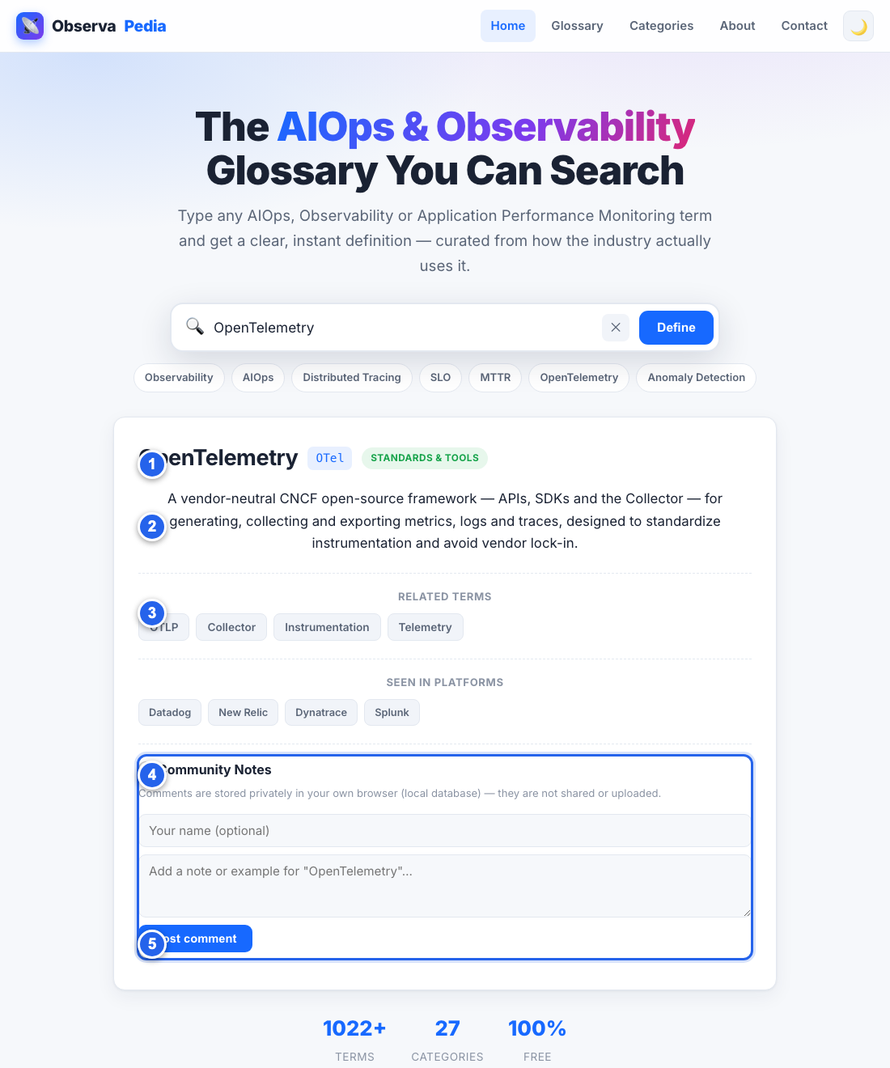
Figure 4 — A definition with its Community Notes box (4) and post button (5).
How it works, in plain terms:
- Comments are saved on the visitor's own computer (in their browser), using a small built-in database called IndexedDB.
- They are private. A comment one person writes is only visible to that person, on that device. Comments are never uploaded to a server and are not shared between visitors.
- Nothing for you to moderate. Because comments never leave the visitor's device, there is no inbox of comments to manage and nothing inappropriate can appear for other visitors.
💬 Want comments to be SHARED by everyone (a true community wall)?
That's a bigger change: it needs an online database (for example Firebase or Supabase) and a developer to connect comments.js to it. Tell your developer “make comments shared/global” and point them to the notes in comments.js and the project README.

14. Preview your changes safely
Always look at your change before publishing. Two easy ways:

The quick way
Double-click index.html — it opens in your browser. After editing a file, return to the browser and press Ctrl+R / Cmd+R to refresh and see the change.

The nicer way (a local preview server)
This mimics a real web address. Open the Terminal (Mac) or Command Prompt (Windows), then type:
cd path/to/observapedia
python3 -m http.server 8765

Then visit http://localhost:8765 in your browser. Press Ctrl+C in the Terminal to stop it when done.

15. Publishing your changes to the live site
Because the site is just a folder of files, “publishing” means copying the updated folder to wherever the site is hosted. The exact steps depend on your host, but it's usually one of these:
- A drag-and-drop host (Netlify, Vercel): drag the observapedia folder onto their upload page.
- GitHub Pages: upload/commit the changed files to your repository.
- Traditional web hosting (cPanel/FTP): upload the changed files into your public_html folder.
📝 Write down YOUR specific publishing steps here.
Ask whoever set up the hosting to fill in the exact 3–4 clicks for your setup, and keep them with this manual. Then publishing becomes routine.

16. The Golden Rules (read before every edit)
- Make a backup first. Before editing, copy the whole observapedia folder somewhere safe. If anything goes wrong, you can restore it in seconds.
- Only change words inside "double quotes". The quotes, commas, brackets and braces are the “scaffolding”. Change the words, keep the scaffolding.
- Every term block ends with a comma. Giving every block a trailing comma is always safe here. A missing comma is the #1 cause of problems.
- Use straight quotes, not curly ones. Type " not “ ”. This is why you must use a code editor (VS Code), not Word.
- Save, then refresh, then check. Never publish a change you haven't looked at in the browser first.
- When unsure, stop and ask. It's always cheaper to ask your developer one question than to fix a broken file later.

17. Troubleshooting — “I broke something!”
Don't panic. Almost every problem is a tiny punctuation slip and is easy to undo.
Symptom | Most likely cause | Fix
The whole page is blank / white | A missing comma, or a missing/curly quote, in a term block you just edited. | Undo your change (Ctrl+Z) and save. Then redo it carefully, checking commas and quotes.
My new term doesn't appear | The file wasn't saved, or the browser wasn't refreshed. | Save the file; hard-refresh the browser (Ctrl+Shift+R).
Search shows nothing at all | A broken term block is stopping the whole list from loading. | Look at the term you edited last — check its quotes/commas, or undo it.
Comments box won't open | Very old browser, or private-mode blocking storage. | Try a normal window in an up-to-date browser. Not a content issue.
Layout looks wrong / unstyled | The style.css file was moved or edited. | Restore style.css from your backup.

🛟 The ultimate safety net: your backup.
If a file is badly broken and you can't see why, just delete it and copy the good version back from the backup you made in Golden Rule #1. This is why the backup matters.

18. Quick-reference cheat sheet
I want to… | Do this
Add a term | Scenario A — copy the template into a data-*.js file, change the words, save.
Fix a definition | Scenario B — search the term in VS Code, edit text inside the quotes, save.
Remove a term | Scenario C — delete its whole { … }, block including the comma.
Add a category | Scenario D — just use a new category name on a term.
Edit About/Contact text | Scenario E — edit the matching .html file, words between the tags.
Switch on ads | Scenario F — paste your AdSense Publisher ID into the pages and ads.txt.
See my change | Section 14 — open index.html (or run the local server) and refresh.
Put changes live | Section 15 — copy the folder to your host.
Something broke | Section 17 — undo (Ctrl+Z), check commas/quotes, or restore your backup.

You've got this. Ninety percent of running ObservaPedia is just Scenario A and B — copy a block, change the words, save, refresh. Everything else is occasional.

