SYST 17796 TEAM PROJECT
Team Name: GROUP 3 _______________________________
  - Please negotiate, sign, scan and include as the first page in your Deliverable 1.

Team Contract
Please note that if cheating is discovered in a group assignment each member will be charged with a cheating offense regardless of their involvement in the offense. Each member will receive the appropriate sanction based on their individual academic integrity history.
Please ensure that you understand the importance of academic honesty. Each member of the group is responsible to ensure the academic integrity of all of the submitted work, not just their own part. Placing your name on a submission indicates that you take responsibility for its content.
Team Member Names (Please Print) | Signatures | Student ID
Project Leader: Arshdeep Kaur | Arshdeep kaur | 991777880
Jashan Sahota | Jashan sahota | 991726978
Komalpreet Kaur | Komalpreet kaur | 991777431
For further information, read Academic Integrity Policy here : https://caps.sheridancollege.ca/student-guide/academic-policies-and-procedures.aspx
By signing this contract, we acknowledge having read the Sheridan Academic Integrity Policy
Responsibilities of the Project Leader include:
- Assigning tasks to other team members, including self, in a fair and equitable manner.
- Ensuring work is completed with accuracy, completeness and timeliness.
- Planning for task completion to ensure timelines are met.
- Notifying the professor of any issues in a timely manner so that corrective measures can be taken.
- Any other duties as deemed necessary for project completion.

What we will do if . . .
Scenario | Accepted  initials | We agree to do the following  (Put an X corresponding to your choice in each box)
Team member does not regularly attend team meetings and/or does not respond to communications in a timely manner. |  | Project leader emails the student citing the concerns and cc’s the professor so they are aware of the situation at the very onset _X_ (Mandatory).  a) __ In addition to above, the leader/team will (add your own content here):
Team member does not deliver component on time due to severe illness or extreme personal problem. |  | a) Team absorbs workload temporarily __  b) Team seeks advice from professor __  c) Team shifts target date if possible __  d) __ Other (specify):
Team member has difficulty delivering component on time due to lack of understanding or ability. |  | a) Team reassigns component __  b) Team helps member __  c) Team member must ask professor for help __  d) __ Other (specify):
Team member does not deliver component on time due to lack of effort. |  | a) Team absorbs workload __  b) Team member(s) ask professor to request a Participation Form from all team members. This may result in individualized grades being awarded for a deliverable __  c) Both a. and b. above __  d) __ Other (specify):
Team cannot achieve consensus leaving one or more member(s) feeling that their voice(s) is/are not being heard in a decision which affects everyone. |  | a) Team agrees to abide by majority vote __  b) Team seeks advice from the professor __  c) __ Other (specify):
Team members do not share expectations for the quality of work on a particular deliverable. |  | a) Team members will draw on each other’s strengths to help bring the quality of the deliverable to a minimal acceptable level __  b) Team votes on each submission's quality __  c) Team member(s) ask professor to request a Participation Form from all team members, which may result in individualized grades being awarded for a deliverable __  d) __ Other (specify):
Team member behaves in an unprofessional manner, e.g. being rude, uncooperative and/or making one or more member(s) feel uncomfortable. |  | a) Team agrees to avoid use of all vocabulary inappropriate to a business/college setting __  b) Team attempts to resolve the issue by airing the problem at a team meeting __  c) Team requests a meeting with the professor to discuss further __  d) __ Other (specify):
There is a dominant team member who insists on making all decisions on the team's behalf leaving some team members feeling like subordinates rather than equal members |  | a) Team will actively solicit consensus on all decisions which affect project direction by asking for each member's decision and vote __  b) Team will express subordination feelings and attempt to resolve issue __  c) Team seeks advice from the professor __  d) __ Other (specify):
Team has a member who refuses to participate in decision making but complains to others that s/he wasn't consulted |  | a) Team forces decision sharing by routinely voting on all issues __  b) Team routinely checks with each other about perceived roles __  c) Team discusses the matter at team meeting __

SYST17796 - Deliverable 1: UNO Game Design Document

Table of Contents
- Introduction
- Game Overview
  - Rules Implemented
- Object-Oriented Design
  - Class Structure
- UML Diagram
- Key Features Implemented
  - Randomized Game Mechanics
  - Automatic Turn-Based System
  - GitHub Integration
- Testing & Validation
  - Sample Game Output
- Conclusion

1. Introduction
This document outlines the design and implementation of the UNO game, developed as part of the SYST17796 Software Development course. The game is an extension of the provided base project to create a simple card game based on an actual UNO game using OOP principles.

2. Game Overview

UNO is a multiplayer card game where players take turns playing cards that match the top card of the discard pile in either color or value. Special cards (e.g., Skip, Reverse, Draw Two) introduce additional game mechanics.

2.1 Rules Implemented
- Each player starts with 7 random UNO cards.
- Players must play a card matching the top of the discard pile (color or value).
- If a player has no valid card, they must draw a new card.
- Special cards (Skip, Reverse, Draw Two) affect gameplay.
- The first player to get rid of all cards wins.

3. Object-Oriented Design
The game follows OOP principles such as Encapsulation, Inheritance, and Polymorphism.

3.1 Class Structure
- Card (Abstract Class) → Base class for UnoCard
- UnoCard (Extends Card) → Represents a UNO card with color and value
- Game (Abstract Class) → Base class for UnoGame
- UnoGame (Extends Game) → Manages players and game flow
- Player (Abstract Class) → Base class for UnoPlayer
- UnoPlayer (Extends Player) → Represents each player and their hand of cards

4. UML Diagram
Below is the UML Class Diagram representing the UNO game’s design.

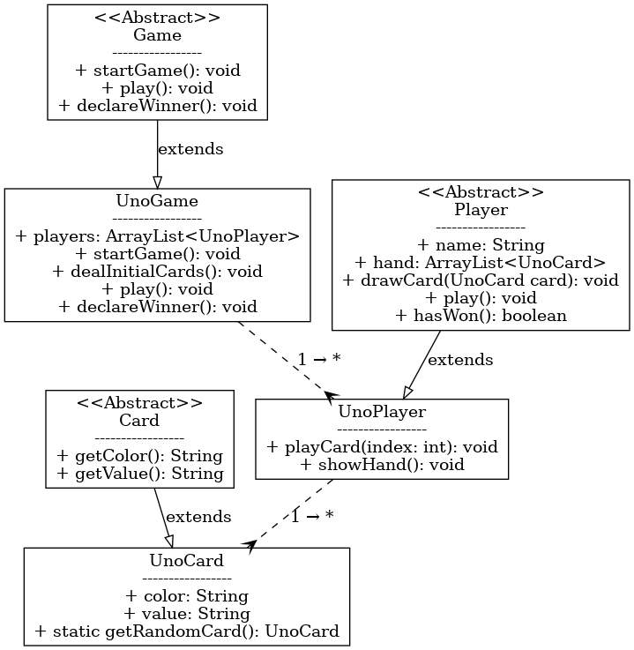

5. Key Features Implemented

Randomized Game Mechanics
- Players are shuffled at the start so no one always goes first.
- Each player is dealt random UNO cards.

Automatic Turn-Based System
- Players take turns until one runs out of cards.
- The winner is determined dynamically.

GitHub Integration
- Code is maintained on GitHub with version control.
- Repository link: https://github.com/beingkomal/SYST17796_UNO.git

6. Testing & Validation
The game was tested with multiple runs to ensure:
- The game logic follows UNO rules.
- Players receive random cards.
- The winner is randomly determined based on gameplay.

6.1 Sample Game Output
UNO Game Started!
Dealing random cards to players...
Alice drew a card: Blue 3
Bob drew a card: Yellow 9
Shuffled player order:
Bob
Alice
Bob played: Yellow 9
Alice played: Blue 3
Bob played: Red Skip
Alice played: Blue Reverse
Bob wins the game!

7. Conclusion
This project successfully builds upon the base system to create an interactive, turn-based UNO game. The gameplay follows the normal UNO rules while using OOP best practices. In the future, you may have support for multiplayer and, possibly, a GUI version as well.

