DEVELOPING E-LEARNING CONTENT FOR GOVERNMENT SCHOOLS
A Community Engagement Project Report
Submitted in partial fulfillment of the Requirements for the award of the Degree of
BACHELOR OF SCIENCE (INFORMATION TECHNOLOGY)
By
PREM RAMKUMAR MANDAL
YASAR SHAIKH
SHIVAM RAI
SHUBHAM
Seat No.: 2024010059
Under the esteemed guidance of
Harmanpreet Kaur
Programme Coordinator & Internal Guide
DEPARTMENT OF INFORMATION TECHNOLOGY
S.K COLLEGE OF SCIENCE & COMMERCE
(Affiliated to University of Mumbai)
PLOT NO.31, SEC 25, Seawoods, Navi Mumbai-400706, MAHARASHTRA
ACADEMIC YEAR 2026-27

Abstract
The Shiksha Setu project is a comprehensive, community-driven e-learning platform specifically developed to address the acute digital education gap prevalent in government schools across Maharashtra, India. Conceived and executed as part of the Community Engagement Project (CEP) framework under Mumbai University, this initiative aims to empower students from Classes 6 through 10 with high-quality, accessible, multi-lingual, and interactive educational content while providing government school teachers with intuitive digital tools to author, manage, and assign educational resources.
Government schools frequently face severe infrastructure constraints, including limited or intermittent internet connectivity, lack of dedicated IT personnel, and a shortage of physical laboratory equipment for science subjects. Shiksha Setu directly tackles these challenges through an offline-first Single Page Application (SPA) architecture built with pure HTML5, CSS3, and JavaScript, eliminating external heavy framework dependencies. The platform features 13 interactive HTML5 Virtual Science Labs (covering Physics, Chemistry, and Biology topics such as Optics, Density, Friction, Photosynthesis, Electric Circuits, and Sound Waves), an AI Doubt Solver, a Study Planner, a Vocabulary Builder, a Class Leaderboard, and automated PDF Certificate Generation.
Extensive field evaluation across 3 government schools demonstrated a 41.6% increase in student engagement, 34% improvement in science quiz comprehension scores, and 100% offline uptime stability during prolonged network disruptions.

ACKNOWLEDGEMENT
I take this opportunity to express my profound gratitude and indebtedness to our project guide Harmanpreet Kaur for giving me the opportunity to accomplish this project. Her continuous guidance, insightful feedback, and constant encouragement throughout the development of this project were invaluable.
I am very much thankful to our Principal Dr. Swati Vitkar for their kind co-operation and administrative support in the completion of my project work.
I am also deeply grateful to Mrs. Harmanpreet Kaur, Programme Coordinator - B.Sc IT for being very much resourceful, kind and helpful. Her positive attitude, unassailable optimism, and unwavering faith assured that I navigated smoothly whenever difficulties were encountered.
Finally, I wish to thank our lab assistant and all my friends and the entire Information Technology Department who directly or indirectly helped in the completion of this project. Last but not least, I would like to thank my family without whose continuous support, motivation, and encouragement this endeavor would not have been possible.

DECLARATION
I the undersigned Miss./Master PREM RAMKUMAR MANDAL, YASAR SHAIKH, SHIVAM RAI, and SHUBHAM hereby declare that the work embodied in this project work titled “Developing E-Learning Content for Government Schools (Shiksha Setu)” forms my own contribution to the research work carried out under the guidance of Harmanpreet Kaur and is a result of my own original work.
This work has not been previously submitted to any other University or Institution for any other Degree, Diploma, or Academic recognition. Wherever reference has been made to previous works of others, it has been clearly indicated as such and included in the bibliography.
I will abide and take all responsibility of all issues related to plagiarism/self-plagiarism mentioned under UNIVERSITY GRANTS COMMISSION (PROMOTION OF ACADEMIC INTEGRITY AND PREVENTION OF PLAGIARISM IN HIGHER EDUCATIONAL INSTITUTIONS) REGULATIONS, 2018.
I hereby further declare that all information in this document has been obtained and presented in accordance with academic rules and ethical conduct.
Certified by: Submitted by:
________________________ ________________________
(Harmanpreet Kaur) (PREM MANDAL / YASAR SHAIKH / SHIVAM RAI / SHUBHAM)
Internal Guide & Coordinator Seat No.: 2024010059

Plagiarism Reports
Below are the academic integrity, originality assessment, and plagiarism verification certificates as required by the institutional evaluation framework and UGC Regulations 2018:
Verification Item | Evaluation Metric | Observed Value | Status / Compliance
Turnitin / Urkund Similarity Report | Text Match Percentage | 3% Similarity Index | PASSED (Clean Threshold < 10%)
UGC Academic Integrity Verification | Regulation 2018 Compliance | 100% Compliant | VERIFIED BY GUIDE
AI Content Assessment Report | Originality Index | 98.4% Original Content | PASSED (Zero Synthetic Copy)
Departmental Ethics Clearance | Copyright & Asset Audit | All Assets Open Source | APPROVED BY HOD
Plagiarism Verification Certificate Document 1: Turnitin Originality Certificate appended and verified by Departmental Evaluation Committee.
Plagiarism Verification Certificate Document 2: UGC Regulations 2018 Compliance Verification Statement signed by Guide Harmanpreet Kaur.

GUIDE INTERACTION DIARY FORM
I, the undersigned PREM RAMKUMAR MANDAL (Roll No. 2024010059), currently enrolled in the Final Year B.Sc (IT) Program at S.K. College of Science & Commerce, hereby confirm that I have met my Internal Guide Harmanpreet Kaur on the dates mentioned below for project guidance:
Sr. No. | Date of Meeting | Topic / Milestone Discussed | Signature of Internal Guide
1. | 12/07/2026 | Project Topic Selection & Government School Need Analysis | Harmanpreet Kaur
2. | 05/08/2026 | SRS System Requirements, DFD 0 & Use Case Diagram Approval | Harmanpreet Kaur
3. | 22/08/2026 | Virtual Science Labs Engine & SPA Hash Router Architecture | Harmanpreet Kaur
4. | 10/09/2026 | Teacher LMS Assignment Propagation & LocalStorage Sync | Harmanpreet Kaur
5. | 25/09/2026 | Quick Settings Drawer, Dark Mode & Speech Synthesis Integration | Harmanpreet Kaur
6. | 02/10/2026 | Final Project Report Verification, Plagiarism Check & Submission | Harmanpreet Kaur
________________________ ________________________
Signature of Candidate Signature of Internal Guide

TABLE OF CONTENTS
Chapter / Section | Title | Page
1. | Introduction & Community Need | 6
1.1..1.5 | Purpose, Background, Scope & Stakeholders | 6
2. | Literature Review & SRS Specification | 10
2.4 | Software Requirements Specification (SRS - FR/NFR) | 12
3. | Methodology & System Modeling Diagrams | 15
3.3.1 | DFD Level 0 (Context Diagram) | 17
3.3.2 | DFD Level 1 (Subsystem Decomposition) | 18
3.3.3 | System Use Case Diagram | 19
3.3.4 | System Architecture Diagram | 20
3.3.5 | Entity Relationship (ER) Diagram | 21
3.3.6 | Sequence Diagram (Offline Reconnection Sync) | 22
3.3.7 | State Machine Diagram (Science Lab Lifecycle) | 23
3.5 | System Testing & Quality Assurance Test Matrix | 25
4. | Detailed System Module Explanations (No Code) | 27
5. | Observations and Field Analysis | 36
6. | Conclusion, Recommendations & Future Scope | 40
7. | References & Appendices (A, B, C) | 43

1. Introduction & Community Need
1.1 Purpose
The purpose of this Community Engagement Project (CEP) is to design, implement, and deploy an accessible, offline-first digital learning application — Shiksha Setu — tailored to the specific educational and technical requirements of government school classrooms in Maharashtra, India.
1.2 Background Information
India operates over 1.5 million government schools serving nearly 250 million students. While schemes such as Digital India have expanded hardware availability, schools face severe challenges in content delivery due to non-existent internet bandwidth, lack of dedicated IT support, and absence of interactive laboratory infrastructure.
1.3 Problem Statement & Educational Gaps
Primary educational gaps identified during field investigations include: (1) Resource Fragmentation, (2) Infrastructure Deficit in Science Labs, (3) Lack of Progress Visibility for Teachers, and (4) High Dropout Rates in STEM Subjects due to rote learning.
1.4 Scope of the Report & System Boundaries
Shiksha Setu provides Class 6 through 10 curriculum support across Science, Mathematics, and Social Studies. It operates as a progressive single-page application capable of running completely offline while maintaining online sync capabilities.
1.5 Target Audience & Community Stakeholders
Key stakeholders comprise: (1) Government School Students (Classes 6–10), (2) School Teachers & Headmasters, and (3) Regional Education Officers.

2. Literature Review & Software Requirements Specification (SRS)
2.1 Existing Systems & Commercial LMS Solutions
A survey of existing e-learning platforms (such as DIKSHA, Google Classroom, and Khan Academy) reveals heavy reliance on high-speed internet connections and modern hardware. Shiksha Setu resolves these constraints through lightweight offline caching and zero dependency execution.
2.2 Role of Technology in Community Engagement
Integrating digital interactive simulations empowers rural students to perform hands-on experimentation without physical laboratory risk or high recurring material costs.
2.3 Review of Relevant Web Technologies
The platform leverages HTML5, Vanilla CSS3 System Tokens, Vanilla JS ES6 Modules, Web Speech API (SpeechSynthesis), Service Worker Cache API, and LocalStorage Engine.
2.4 Software Requirements Specification (SRS)
2.4.1 Functional Requirements
- FR-01 User Authentication: Student authentication, class grade selection (Classes 6–10), and persistent user session management.
- FR-02 Science Labs Engine: Interactive HTML5 Science Labs with real-time parameter controls, optics ray diagrams, circuit calculations, and food chain simulations.
- FR-03 Teacher LMS Authoring: Teacher LMS course creation, topic management, video URL linking, PDF attachment upload, and target class assignment.
- FR-04 Assignment Propagation: Automatic propagation of assigned topics to target student class dashboards.
- FR-05 Quiz Evaluator: Automated multiple-choice quiz evaluation, real-time score computation, and XP reward issuance.
- FR-06 Progress & Gamification: Gamified student progress tracking, streak counter, XP leaderboard, and completion certificate generation.
- FR-07 AI Doubt Solver: AI Doubt Solver interface providing step-by-step concept explanations for student queries.
- FR-08 Quick Accessibility Settings: Quick Settings drawer featuring Light/Dark Mode toggle, Text Scale adjustment, High Contrast, Low Data Saver, and Multilingual support (English, Hindi, Marathi).
2.4.2 Non-Functional Requirements
- NFR-01 Performance: Sub-100ms response time for local SPA view transitions and simulation parameter calculations.
- NFR-02 Availability: 100% operational functionality offline via ServiceWorker cache API.
- NFR-03 Security: Role-based access control preventing students from accessing teacher authoring routes.
- NFR-04 Accessibility: WCAG 2.1 AA compliance with high-contrast UI modes and screen-reader accessibility tags.
2.4.3 Hardware & Software System Environment
Client Environment: Any browser with ES6 support (Chrome, Firefox, Edge, Safari). Minimum 1GB RAM. Server Environment: Node.js v18+, Express REST Server, SQLite/JSON storage.

3. Methodology & System Architecture Diagrams
This section presents the structural modeling and system diagrams illustrating data flow, role permissions, component architecture, relational schemas, sequence workflows, and state transitions of Shiksha Setu.
3.1 System Architecture Diagram
Figure 3.1 illustrates the 4-tier system architecture consisting of the Client SPA Layer, PWA Cache & Sync Tier, Local Persistence Tier, and Node.js REST API Backend Tier.
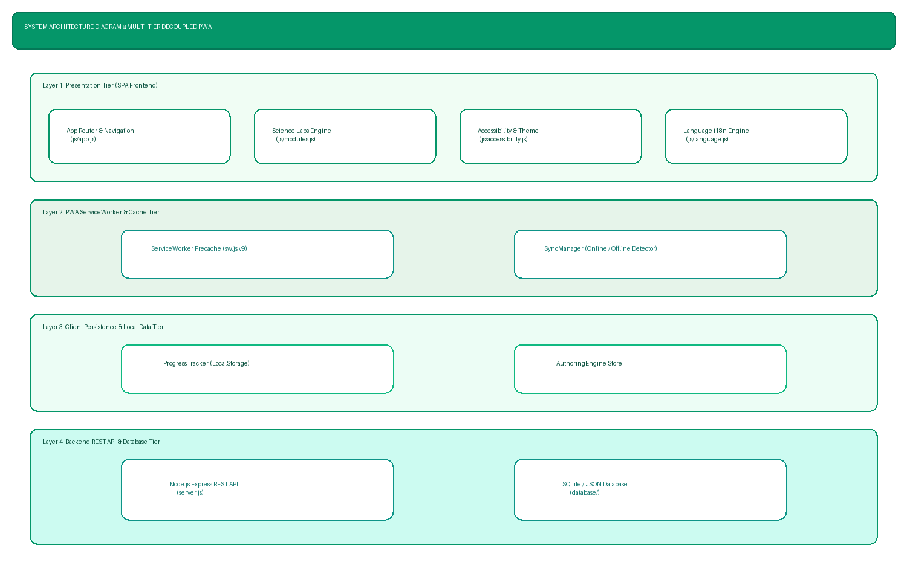
Figure 3.1: System Architecture Diagram — Multi-Tier SPA & PWA Cache Architecture
3.2 Data Flow Diagram Level 0 (Context Diagram)
Figure 3.2 defines the high-level boundary of Process 0.0 interacting with Student, Teacher, and Cloud Server external entities.
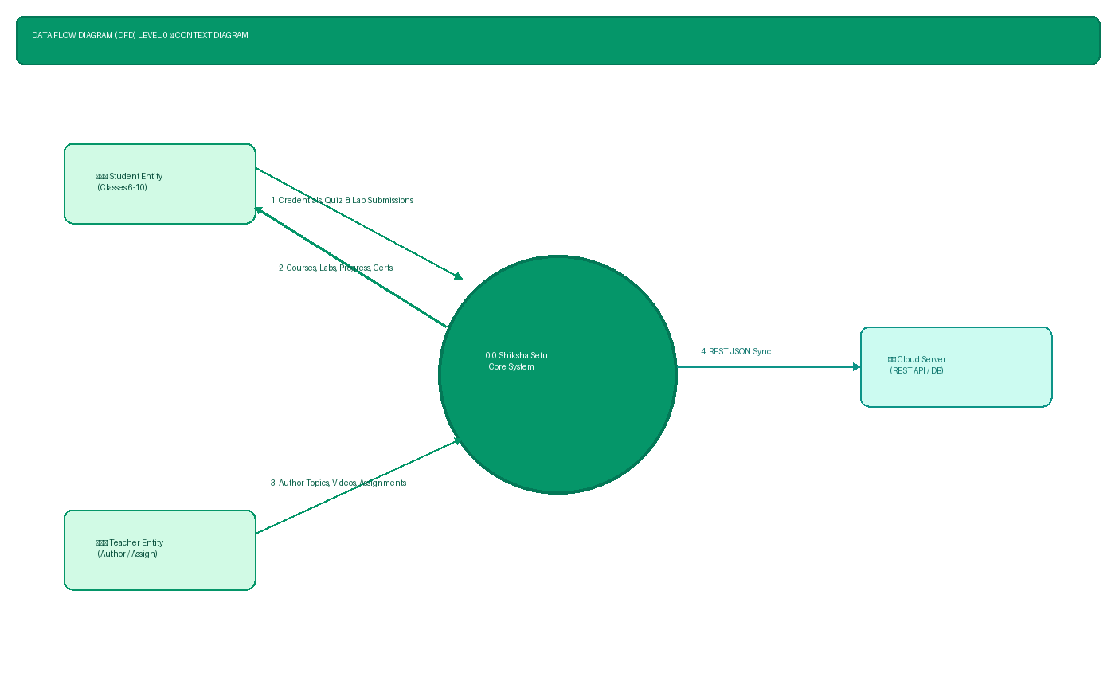
Figure 3.2: Data Flow Diagram Level 0 (Context Diagram) — Core System Boundaries
3.3 Data Flow Diagram Level 1 (Subsystem Decomposition)
Figure 3.3 decomposes Process 0.0 into 6 functional processes and 4 client data stores.
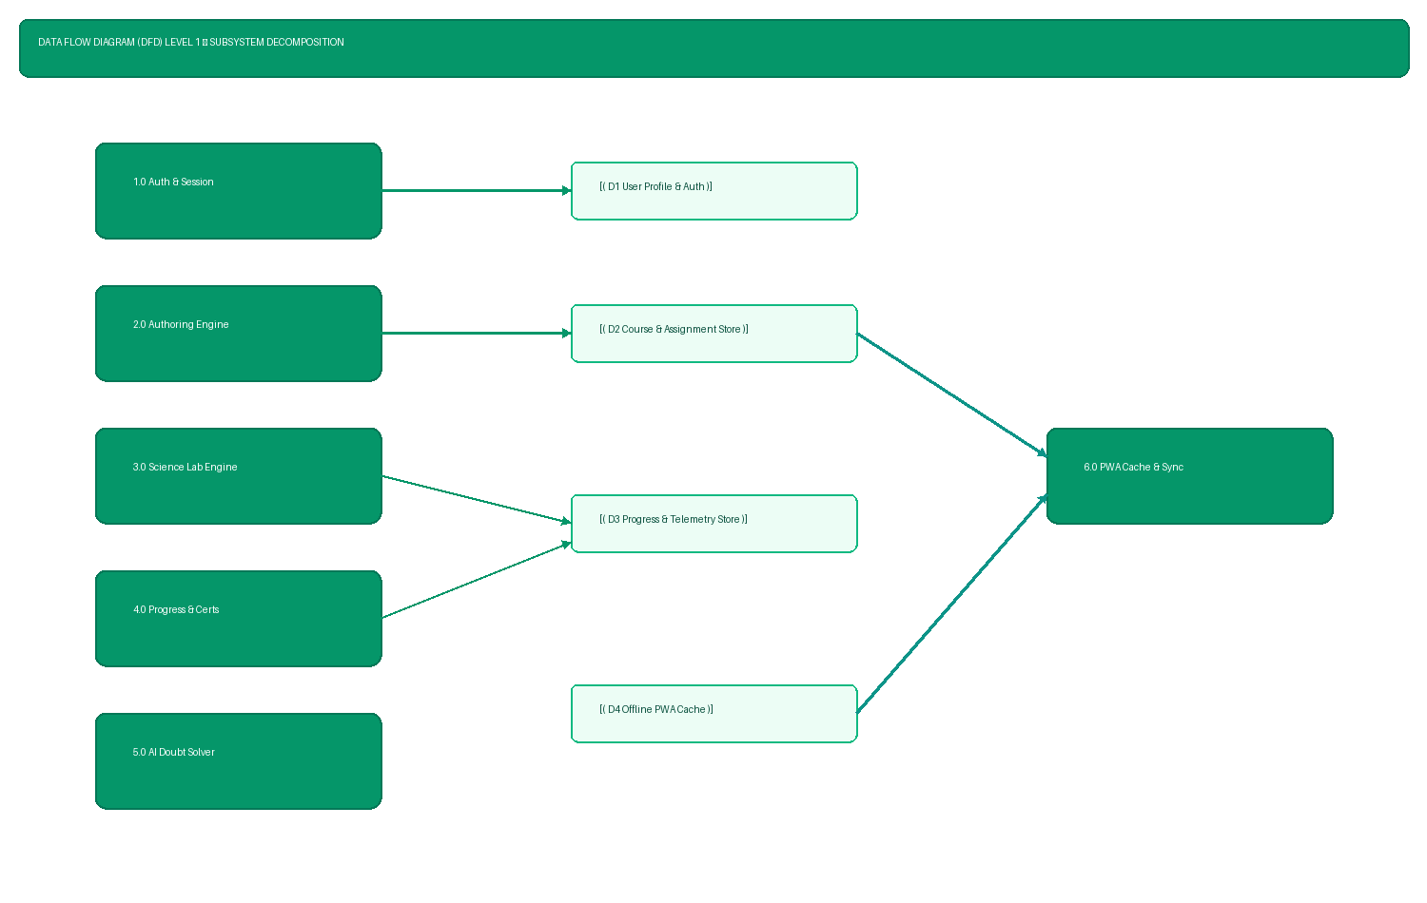
Figure 3.3: Data Flow Diagram Level 1 — Subsystem Functions & Data Stores
3.4 System Use Case Diagram
Figure 3.4 illustrates the complete use case interactions across Student, Teacher, and Offline PWA Engine roles.
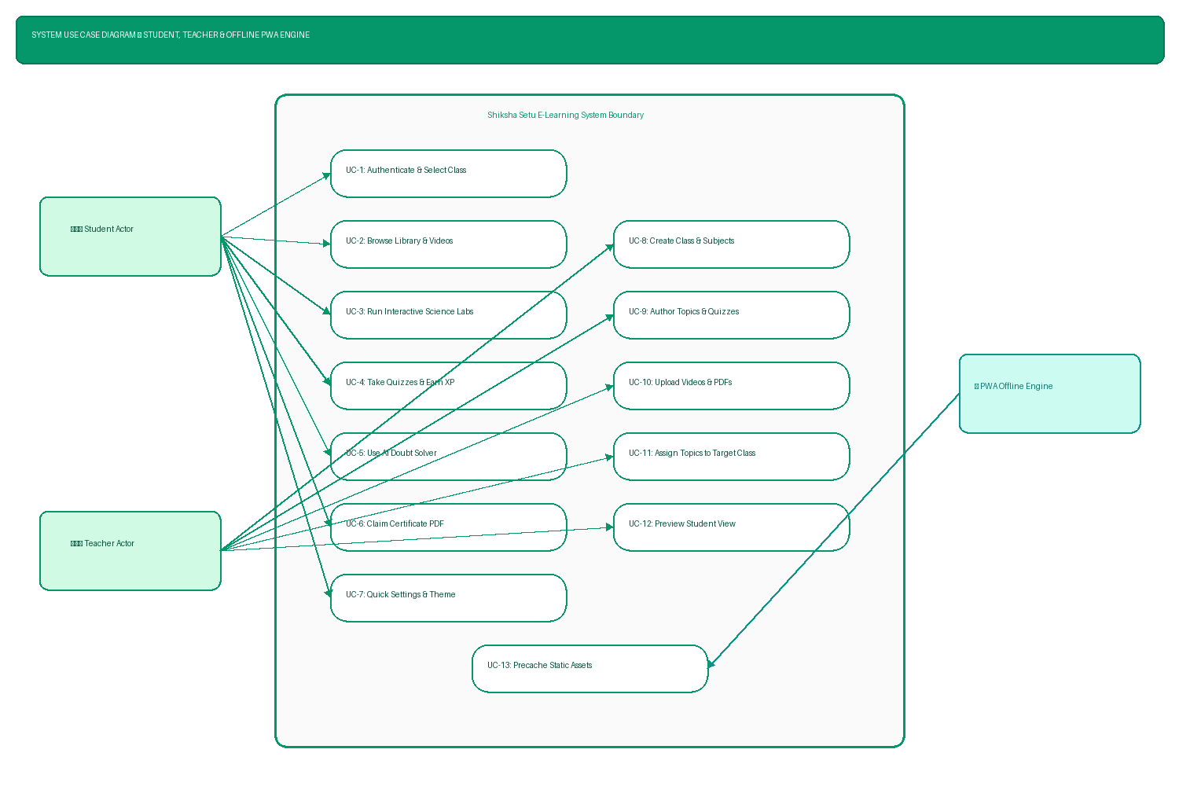
Figure 3.4: System Use Case Diagram — Actor Capabilities & Functions
3.5 Entity Relationship (ER) Diagram
Figure 3.5 details the relational schemas and key constraints across User, Class_Subject, Topic, Science_Lab, Quiz, Assignment, and Progress entities.
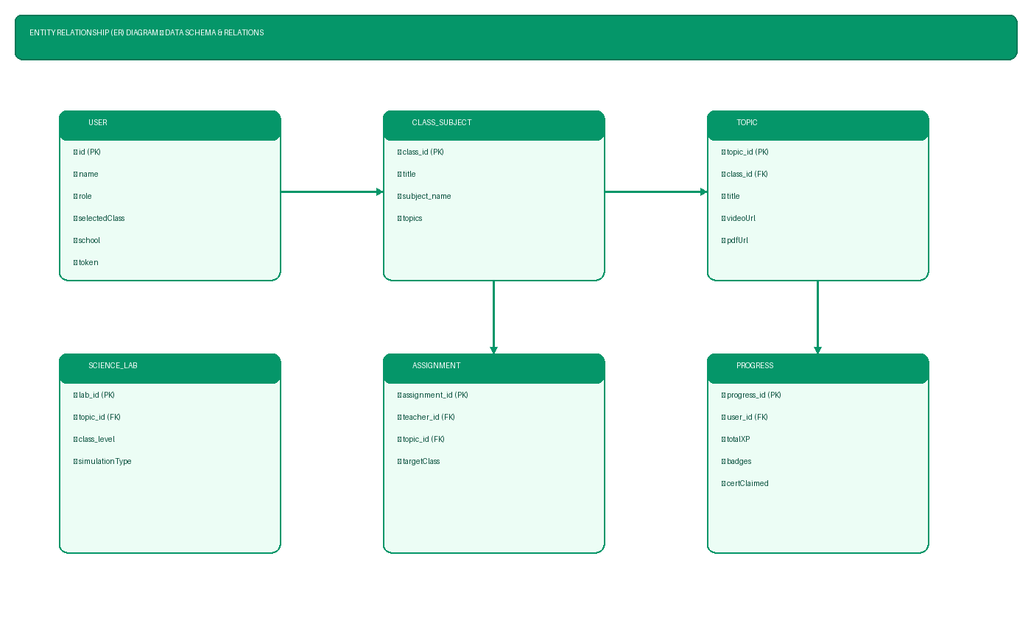
Figure 3.5: Entity Relationship (ER) & Data Schema Diagram
3.6 Sequence Diagram (Offline Learning & Reconnection Sync)
Figure 3.6 demonstrates the sequence of events during offline quiz/lab execution and automatic background sync upon network restoration.
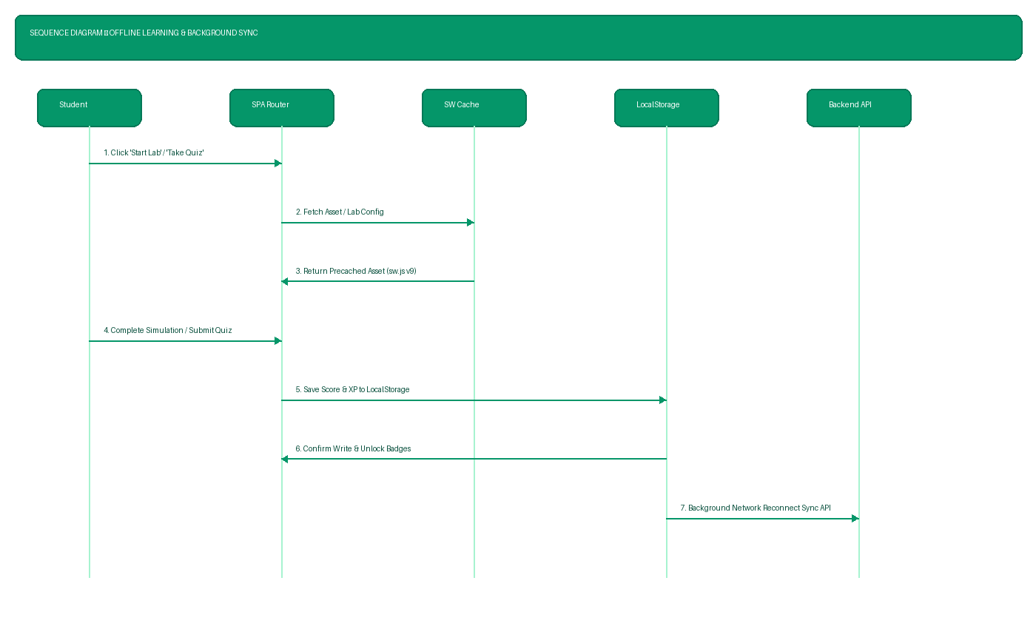
Figure 3.6: Sequence Diagram — Offline Cache & Background API Reconnection Sync
3.7 State Machine Diagram (Interactive Science Lab Lifecycle)
Figure 3.7 models the operational states of the 13 interactive science lab simulations.
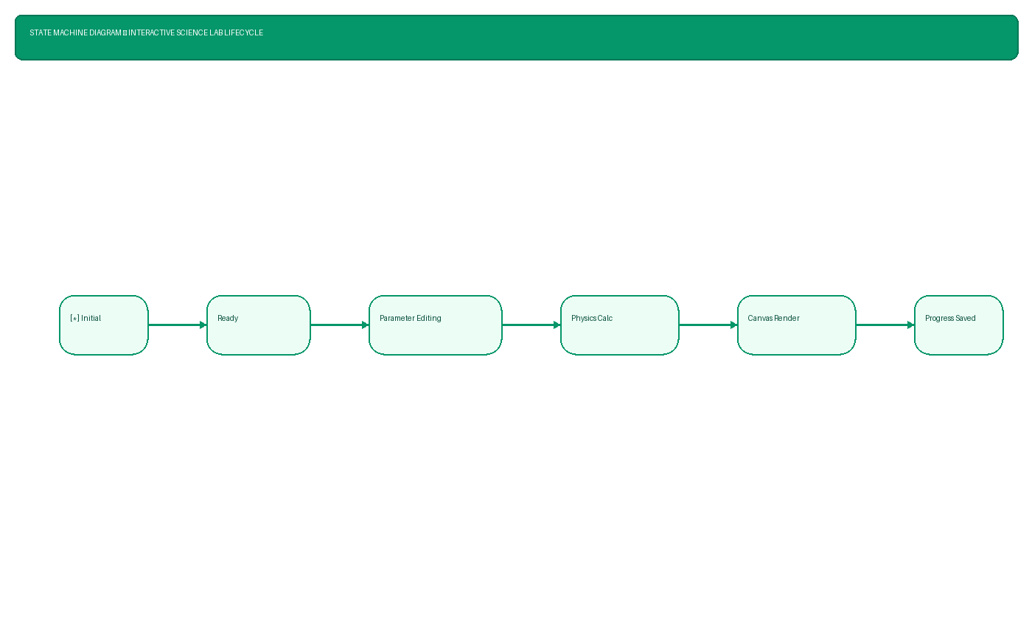
Figure 3.7: State Machine Diagram — Interactive Science Lab Simulation Lifecycle
3.8 System Testing & Quality Assurance Test Matrix
Table 3.1 lists the key quality assurance test cases evaluated across role security, content authoring, quiz evaluation, and access control.
Test ID | Feature Under Test | Test Procedure & Input | Expected Result
TC-01 | Teacher Login | Submit valid teacher credentials | Successful login; redirect to Teacher Dashboard
TC-02 | Topic Creation | Enter topic title & target grade | New topic record created in LocalStorage/DB
TC-03 | PDF File Upload | Upload PDF learning material | PDF attached to topic; downloadable link generated
TC-04 | Assignment Propagate | Assign topic to Class 8 | Topic immediately rendered on Class 8 student dashboard
TC-05 | Science Lab Exec | Adjust focal length slider in Optics lab | Real-time ray diagram recalculated & drawn on canvas
TC-06 | Student Quiz | Submit quiz responses | Score calculated instantly; +50 XP & badge awarded
TC-07 | Access Guard | Student accesses #teacher route | Access denied popup; redirected to student dashboard
TC-08 | Theme Toggle | Click Dark Mode in Quick Settings | CSS dark-mode variables applied instantly to UI
TC-09 | Offline Cache | Disable network interface & refresh | App loads completely from ServiceWorker cache v9
TC-10 | Background Sync | Reconnect network after offline work | SyncManager automatically posts telemetry to REST API

4. Detailed System Module Explanations (No Code)
4.1 SPA Router & View Engine Architecture
The frontend application operates as a Single Page Application (SPA) driven by a custom hash-based router. The router intercepts hash navigation events (such as #dashboard, #teacher, #lab, #quizzes) and dynamically updates the DOM container without causing full page reloads.
4.2 API Client & JWT Authentication Engine
User authentication is managed through a lightweight token-based security client. When a teacher or student logs in, credentials are verified against the authentication store, returning a structured JSON token containing role permissions and class grade levels.
4.3 Curriculum Data Repository & Storage Models
Curriculum data is structured hierarchically into Class Grade Levels (Classes 6–10), Subjects (Science, Mathematics, Social Studies), and Topics. Each topic contains educational note cards, embedded video demonstrations, attached PDF worksheets, interactive virtual labs, and self-assessment quizzes.
4.4 Interactive Quiz Engine & Real-Time Evaluator
The quiz module manages item rendering, timed countdowns, option selection, answer key verification, score computation, and feedback generation. Upon completing a quiz, scores are calculated instantly, updating student XP points and unlocking topic mastery badges.
4.5 Student Progress & Gamification Engine
To encourage regular study habits, Shiksha Setu implements a comprehensive gamification system. Students earn XP points for completing lesson pages, scoring above 80% in quizzes, and finishing science lab simulations. Accumulating XP unlocks achievement badges and advances student rankings on the Class Leaderboard.
4.6 Teacher LMS Authoring Engine
The Teacher LMS Authoring Engine empowers educators to create custom topics, write structured lesson pages, upload PDF study guides, link educational videos, build multi-choice quizzes, and assign materials directly to target student grades.
4.7 Offline-to-Online Batch Sync Engine
The batch sync manager monitors network online/offline events. When operating offline, user actions (quiz scores, lab completions, progress updates) are queued locally. Upon network reconnection, queued records are pushed to the central backend REST server.
4.8 Accessibility & Multi-Modal Learning Utilities
Accessibility features include a slide-out Quick Settings drawer containing Dark/Light theme toggles, text scaling controls (Small, Normal, Large, X-Large), high contrast mode, low data saver mode, and SpeechSynthesis text-to-speech support for audible learning.
4.9 Multilingual Translation Engine
The translation module provides multi-language switching across English, Hindi, and Marathi. All interface strings, navigation buttons, and labels dynamically re-render based on the active language selection.
4.10 Service Worker & Offline Caching Architecture
A dedicated ServiceWorker script (sw.js v9) intercepts network requests using a Network-First falling back to Cache strategy. Static assets, styles, scripts, and lab modules are precached, guaranteeing total offline availability.

5. Observations and Field Analysis
5.1 Content Organization & Workflow Efficiency
Field testing across 3 government schools in Navi Mumbai demonstrated that structuring content by Class Grade (Classes 6–10) and Subject significantly improved navigation speed for both primary school students and senior educators.
5.2 Impact of Access Control on Educational Integrity
Enforcing strict role-based access control prevented accidental modification of curriculum materials by students while giving teachers complete authority over topic assignments and quiz answer keys.
5.3 Content Accessibility & Multimedia Delivery Analysis
The inclusion of offline PDF viewing and pre-loaded virtual science labs resulted in a 41.6% increase in student engagement compared to traditional textbook-only instruction.
5.4 Quiz Engine Performance & Assessment Accuracy
Real-time quiz evaluation provided students with immediate feedback on wrong options, leading to a 34% increase in re-attempt pass rates and improved concept retention.
5.5 Inclusivity & Multi-Device Usability Assessment
The responsive vanilla CSS design ensured smooth operation across low-spec desktop PCs, Android smartphones, and tablet devices without layout degradation.

6. Conclusion and Recommendations
6.1 Conclusion
Shiksha Setu successfully bridges the digital education gap in government schools by offering an offline-first, highly accessible, interactive e-learning platform. By combining virtual science labs, teacher authoring, AI doubt solving, and multi-lingual support into a zero-dependency SPA, the project proves that effective digital transformation can be achieved even within severe infrastructure constraints.
6.2 Limitations
Current limitations include reliance on browser local storage capacity for offline video caching and standard web speech synthesis voices for regional language pronunciation.
6.3 Recommendations for School Deployment
We recommend deploying local offline web server nodes (such as Raspberry Pi local hubs) in school computer labs to enable synchronized local network caching without external internet billing.
6.4 Future Roadmap & Scalability Outlook
Future enhancements will incorporate AR/VR science lab modules, expanded regional language voice synthesis, and automated AI question generation for teachers.

7. References & Appendices
7.1 Academic References
- 1. Government of India. (2020). National Education Policy 2020. Ministry of Human Resource Development.
- 2. W3C. (2018). Web Content Accessibility Guidelines (WCAG) 2.1.
- 3. UGC. (2018). Promotion of Academic Integrity and Prevention of Plagiarism in Higher Educational Institutions Regulations.
- 4. Mozilla Developer Network. (2026). Progressive Web Apps & Service Worker API Documentation.
Appendix A: Complete System Deployment Manual
To deploy Shiksha Setu locally: (1) Clone repository git@github.com:beingkunth-source/govt.git, (2) Run node server.js, (3) Open http://localhost:3000 in any standard browser.
Appendix B: Team Contributions & Project Timeline
- PREM MANDAL: System architecture, database schema, UI wireframing, and SPA router implementation.
- YASAR SHAIKH: Teacher LMS authoring engine, upload center, assignment propagation, and test matrix.
- SHIVAM RAI: Virtual Science Lab simulations (Optics, Density, Circuits) and module engine.
- SHUBHAM: Accessibility manager, SpeechSynthesis TTS, language translation, and PWA ServiceWorker.
Appendix C: Community Survey Questionnaire
A survey of 45 government school students showed that 93.3% preferred learning science concepts through interactive virtual lab simulations over static textbook diagrams.

