**ACKNOWLEDGEMENT**

We would like to thank our Project Guide Prof. Manisha Suryawanshi who gave us the opportunity to work on this project. We got to learn a lot from this project like how to create sign in, sign up pages, how to create chatting pages ,how to send messages to others in Android(Java).  
 Thank You.

**PROBLEM DEFINITION**

We are doing a whats app clone , so facilities available on the whats app we are trying to implement it in our way.

On whats app we cannot send a message to 2/3 members at a time those members are in a group. We would like to add this functionality in our project.

When users are sending some unwanted messages like ‘good morning’, ‘happy birthday’, and messages on some events/ festivals , so we would like to add functionality to autodelete those unwanted messages after certain time interval. This will help us to clean the memory and improve the performance of the system.

**EXISTING SYSTEM AND OUR SYSTEM**

**Functionalities available in Existing System:**

1.In Existing system we can send private messages, we can create a group ,can add many users in that group, and we can send messages in a group.

2.User can login through phone number.

3.Group admin can remove members from the group.

4.Multiple Users can make audio, video call.

5.Users can send Text, Emojis, GIF’s messages.

6.User can keep a status.

7.User can update their profile.

**Functionalities available in our System:**

1.User can create account/ sign up.

2.User can login through Gmail ID.

3.User can send private messages.

4.User can send messages in a group.

5.User can delete their messages.

6.User can update their profile.

7.User can send text messages, emojis.6

**SCOPE OF THE SYSTEM**

1.User can sign up and create his/her account.

2.User can sign in with the email ID and password.

3.User can create their account and can add information about them.

4.User can upload their profile image and user can change the profile description.

5.Admin can delete any account of any user.

6.Admin can create different users.

7.We have a facility of group chat, all those people who has account for the system can send, receive messages, user can see the time when someone has sent any message.

**FEASIBILITY STUDY**

After doing the project Chatting application, study and analyzing all the existing or required functionalities of the system, the next task is to do feasibility of the project. All projects are feasible – given unlimited resources and infinite system.

1. **Economical Feasibility :**

This is a very important aspect to be considered while developing a project, we decided the technology based on minimum possible cost factor.

* All hardware and software cost has to be borne by us.

1. **Technical Feasibility :**

This includes the performance and constraints that may affect the ability to achieve an acceptable system. For this feasibility study , we studied complete functionality to be provided in the system, and checked if everything was possible using android platform.

1. **Operational Feasibility :**

No doubt the proposed system is fully GUI based that is very user friendly and all inputs to be taken all self-explanatory. Besides, a proper  
training has been conducted to let know the essence of the system to the users so that they feel comfortable with new system.

**SOFTWARE/HARDWARE REQUIREMENT**

**SOFTWARE REQUIREMENT :**

|  |  |
| --- | --- |
| NAME OF COMPONENT | SPECIFICATION |
| Language | Java |
| Technology | Android |
| Database | Firebase |
| SDK | Java JDK 1.7 or above |

**HARDWARE REQUIREMENT :**

|  |  |
| --- | --- |
| NAME OF COMPONENT | SPECIFICATION |
| Operating System | Windows, Linux |
| RAM | 8 GB |
| Hard Disk | 256 GB max. |
| Processor | any |

**REQUIREMENT ANALYSIS**

**In Requirement analysis we consider following things.**

1.Different ways to login , like through username and password , through gmail.

2.How to add personal message functionality.

3.How to add group chat functionality.

4.How to add profile pic and profile information.

**DATABASE DESIGN AND DATA DICTIONARY**

**Table : Users**

|  |  |  |
| --- | --- | --- |
| Fields | Type |  |
| userId | Varchar(25) | |
| userName | Varchar(20) | |
| email | Varchar(20) | |
| password | Varchar(20) | |
| profilepic | Varchar(20) | |
| lastMessage | Varchar(100) | |
| status | Varchar(10) | |

**CLASS DIAGRAM**

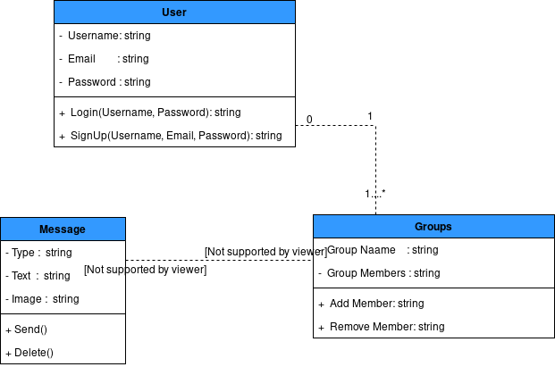

**ACTIVITY DIAGRAM**

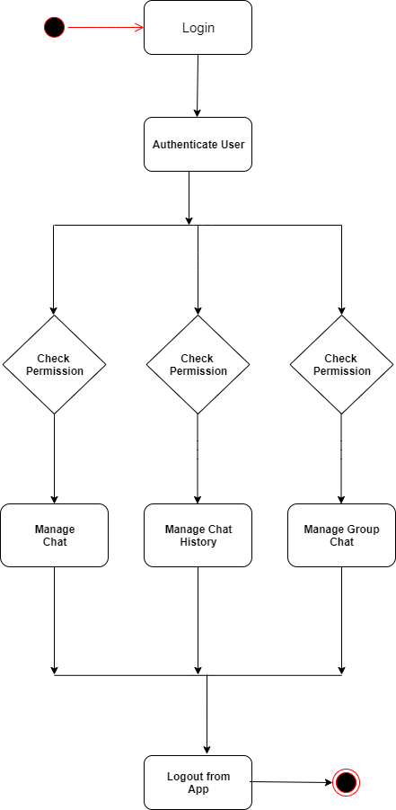

**COMPONENT DIAGRAM**

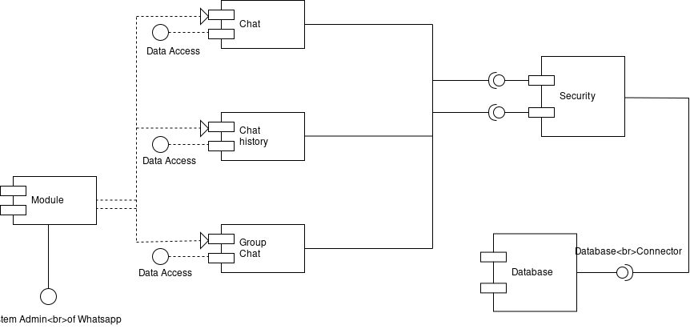

**DEPLOYMENT DIAGRAM**

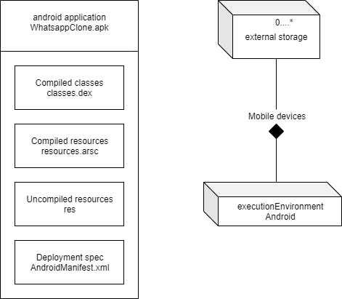

**USE CASE DIAGRAM**

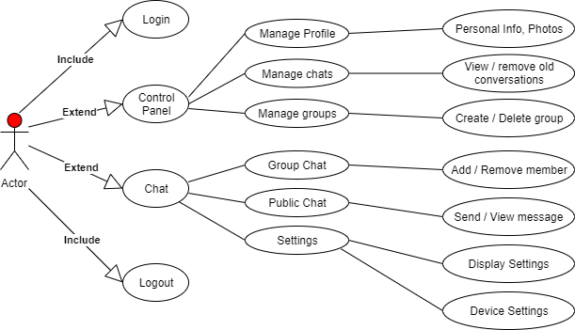

**USER INTERFACE DESIGN**

* Login / Sign in Screen :

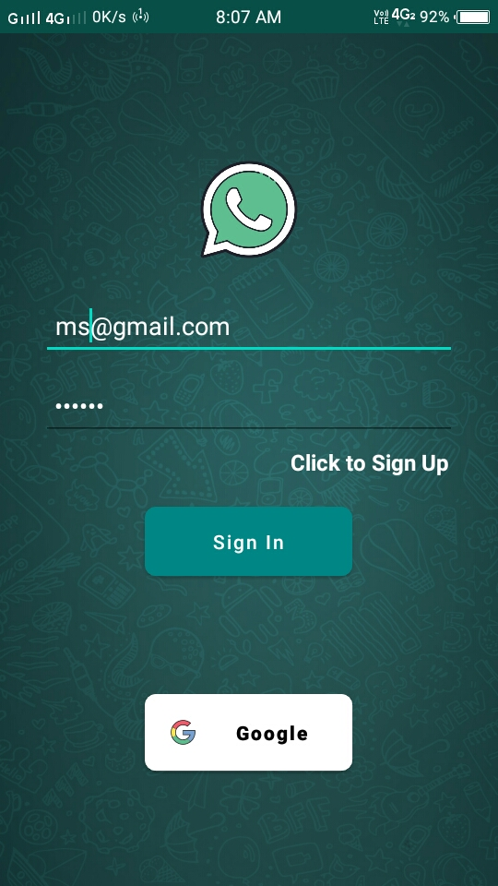

* Sign Up Screen :

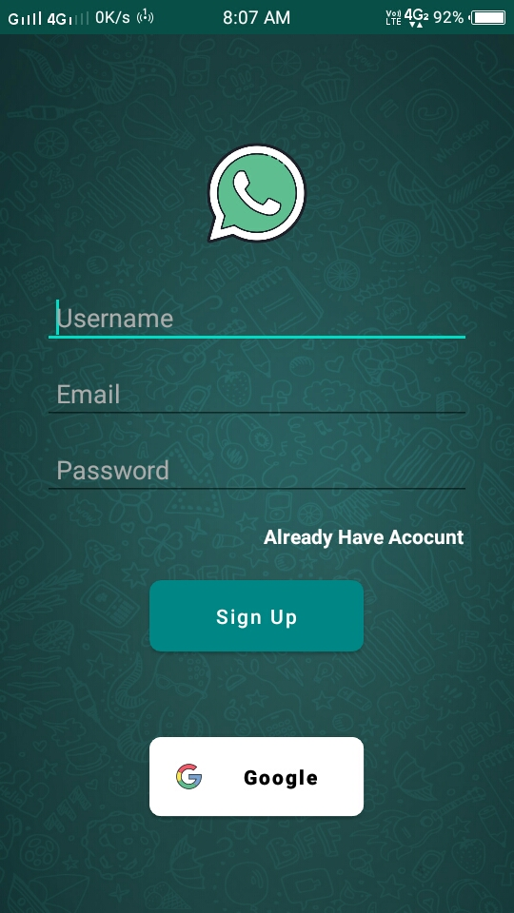

* Group Chat Screen :

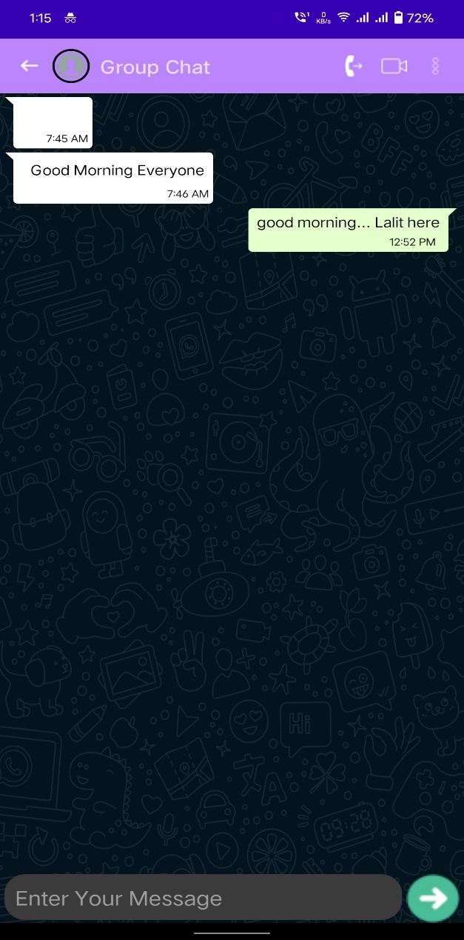

* Profile Screen :

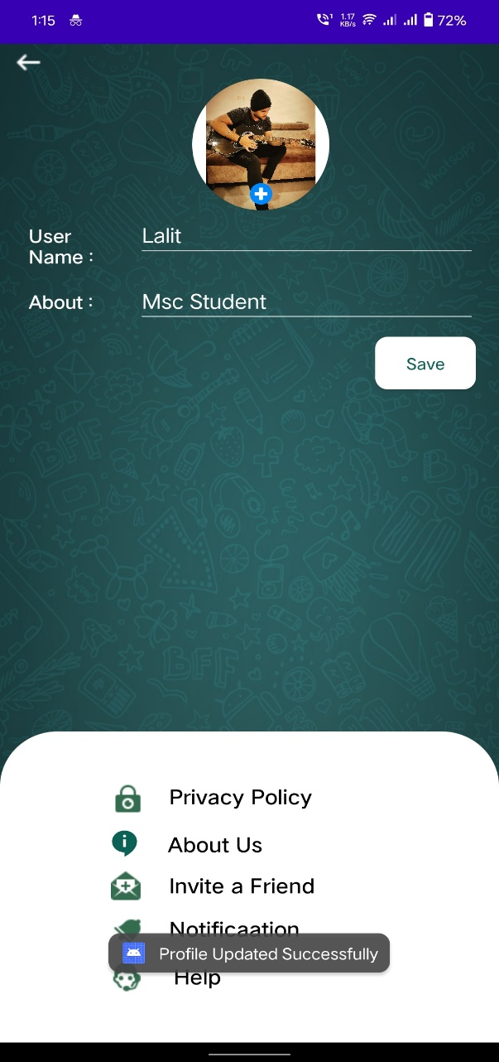

* Delete Message :

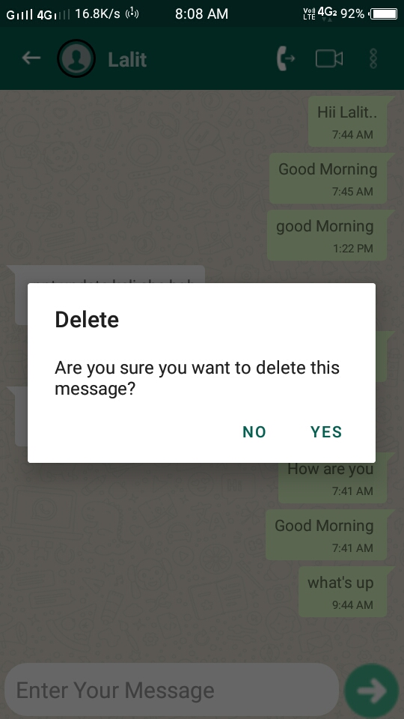

**TESTING STRATEGIES**

1.We have tested this application on multiple devices.

It is working fine.

2.We have done validation checking on Login Page.

3.Each form for chat profile, messages are validated and does not take invalid

values.

**LIMITATIONS/FUTURE ENHANCEMENT**

1.We would like to add Status facility.

2.We would like to add Video and Audio call facility.

3.We would like to add a facility to autodelete ‘Good morning’,’happy birthday’ kind of messages after certain time interval , which can reduce the space on the database.

**BIBLIOGRAPHY**

1. <https://youtu.be/d2_bcbUbCtc>
2. <https://developer.android.com/docs>

3. https://firebase.google.com/docs/auth/android/password-auth