Blue sheet Quick Start Guide
This document provides a quick start guide to using the online blue sheet module. Part I outlines the basics of using the Blue sheet module. Part II provides the basic steps required to successfully create, submit and track an electronically routed - online blue sheet. Part III provides the instructions to review, approve, or return a blue sheet submitted to you.

PART I – BLUE SHEET BASICS
- The Online Bluesheet can be accessed at the following URL: https://facultyprofile.txstate.edu/loginscreen.php
  - Enter your NetID and password (This is the same username and password that you use to login to your desktop/ or check your UTA email everyday) to login. If you have problems logging in please use the Forgot Password link for help.
- On successful login you should be directed to the Bluesheet Activity Page. The Bluesheet Activity page is organized into the following sections:
  - Bluesheets for Review – This section comprises of any bluesheets that are awaiting review and electronic approval from you
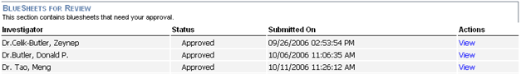
  - My Bluesheets – This section comprises of your saved or submitted bluesheets
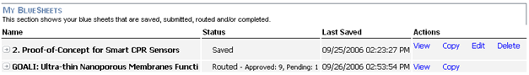
View – Print Preview of the Bluesheet, Copy – Duplicates and saves a working copy of a bluesheet, Edit – (if available) allows editing a bluesheet, Delete – (if available) deletes a bluesheet.
  - Create a New Bluesheet – See Part II for details
Tip: Clicking on the name of the investigator or the name of the bluesheet in the two sections below would give an expanded view of the status of the bluesheet.
- The following diagram illustrates the different stages of the lifecycle of a online blue sheet
Save
Submit to GCS
Routed by GCS
Wait for required approvals
Completed
Returned to PI
  - Save: In this stage the bluesheet is still editable by the Principal Investigator (PI)
  - Submit to GCS: In the stage the blue sheet gets routed the Office of Grant & Contract Services (GCS.
  - Routed by GCS: GCS in turn reviews the blue sheet and routes it to the PI’s Department Chair and College Dean and all of the co-investigators (CoPIs) and their Department Chairs and College Deans.
  - Wait for required approvals: All the required signatories can login anytime and approve or return a blue sheet during the routing process
  - Completed: The blue sheet has acquired all the signatures and can be now printed for filing
  - Returned to PI: A blue sheet can be returned back to the PI at any of the above stages as a result of which it goes back to the first stage and would go through the entire lifecycle again after the requested changes are made.
PART II – CREATE, SUBMIT & TRACK A BLUE SHEET
- Create a New Bluesheet – At the bottom of the Bluesheet activity page is a link to start a new bluesheet. Click on the link and enter a name for the Blue sheet (This name could be the same as the Title of the Proposal) and hit Go to start filling in information on the Blue sheet
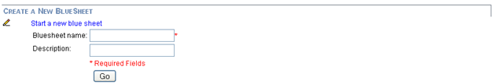
- Enter the information on the Blue Form section by section. Some of the features available while entering the information are outlined below
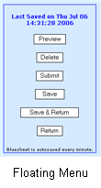
  - Auto-save – The Blue sheet auto-saves after 5 minutes the first time and every 1 minute from thereon.
  - Collapsible Help – Each section has a show hide help link located at the top right hand corner. The help outlines the requirements for the information to be filled out in that section of the Bluesheet.
  - Quick Access Floating Menu – This menu lists all the important functions available and the datetime for the last autosave.
    - Preview – Print Preview of the Bluesheet
    - Delete – Delete the Bluesheet and return to the activity page
    - Submit – Submit the Bluesheet to GCS for routing
    - Save – Save the bluesheet without leaving the screen
    - Save & Return – Save the bluesheet and return to the Activity page
    - Return – Return to the Activity page without saving the bluesheet
  - Add a CO-PI by searching by lastname, firstname in the Active Directory.
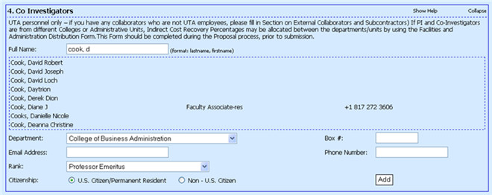Clicking on the CoPI would auto populate the lower half of the screen (shown above) and then by clicking on Add, the CoPI is added to the list. This step would be repeated for every CoPI that needs to be added to the blue sheet.
Note: A red flag next to the name entry for the CoPI indicates that the CoPI was not selected properly and hence the bluesheet would have to be routed manually to that CoPI.
  - Auto-calculation of Budget fields with capability to add custom categories on the fly.
- Proceed to the next step by submitting the Bluesheet (A submitted bluesheet is no longer editable).
- You can now track the progress of your bluesheet in the activity page.
PART III – REVIEWING A BLUE SHEET
- If there is bluesheet pending your review, you would have received an email in your UTA Exchange Email account. Please use the link provided in the email or https://facultyprofile.txstate.edu/loginscreen.php
- Click on the View link located next to the Bluesheet with status Pending. Use the Approve/Return to PI options located at the end of the Bluesheet to Approve the Bluesheet or Return the Bluesheet back to the PI.
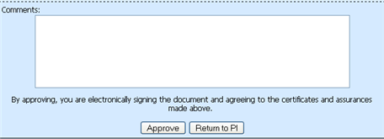

For any additional help please visit: contact your OSP Specialist at we10@txstate.edu (OSP Specialists by departments: http://www.txstate.edu/research/osp.html)

