reSearch Profiles Quick Start Guide
The reSearch Profile system (rSp) allows users to make changes to all their profiles very easily and effectively.

Step 1 Visit: http://www.uta.edu/expertise
Step 2 Locate the Faculty/Staff Login Box on the right hand corner of the screen.
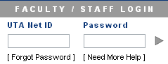
Login using your UTA NetID and password. This is the same username and password you use to login to any other campus computers and check your exchange email account. Use the “Need more Help” link if you require additional login help.
Step 3 If it is your first time logging in you will see an Account Information Screen.
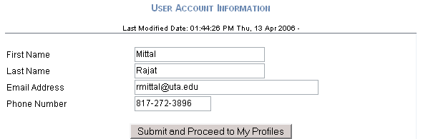

Verify the information and make changes if necessary before submitting.
Step 4 A Faculty profile has been created for you by taking existing information on your personal or departmental web-pages(s).
If your profile is not listed as shown above go to step 7
Step 5 You can now edit your profile by clicking on the Edit Icon. This will take you to the edit mode of your profile. Edit any details by clicking on the Edit Icon located next to or above the field you wish to edit. Use to save changes, to cancel, to delete or to add a new record. The Hide checkbox allows you to hide the information from public view.
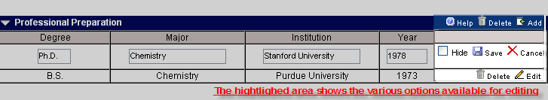
Step 6 To preview your profile or for advanced settings use the View and the Toolbox Tabs located at the top respectively. If your profile is not listed in the Browse or Search Pages then please check the Toolbox tab to check if the profile is activated.

Step 7 Use the Create profile section at the bottom of the My Profiles page (Use the menu on top, Home - > My Profiles, to go to this page) to create any additional profiles. If your faculty profile was not created, you will be able to use Create Faculty Profile Link to create your profile.

For any additional help please visit: http://www.uta.edu/ra/real/help or contact ERA Helpdesk at 817-272-1061 or email us at erahelpdesk@uta.edu.

