SYNOPSIS OF PROPOSAL

Title: Social Physique Anxiety, Eating Attitudes and Behaviors in College Female Athletes

The purpose of this study is to compare members of two separate Texas State University female sports teams on their psychosocial pressures, eating attitudes, and actual eating behaviors. Texas State University Track and Field and Softball athletes will be compared in regards to their attitudes about the thin ideal, their athletic stress, and their dietary nutrient intake. Outcomes of this study are expected to show whether there is a significant difference in social physique anxiety, eating attitudes and dietary nutrient intake for athletes from two sports teams with opposite views on emphasis of a thin ideal body image. Interpreted results and their implications will be considered for improved future understanding of psychosocial and behavioral aspects of disordered eating attitudes in collegiate athletes. This project is intended to fulfill the requirements for the Health Psychology Master’s Degree Thesis Project.

1. Identify the sources of the potential subjects, derived materials or data. Describe the characteristics of the subject population, such as their anticipated number, age, sex, ethnic background, and state of health. Identify the criteria for inclusion or exclusion. Explain the rationale for the use of special classes of subjects, such as fetuses, pregnant women, children, institutionalized mentally disabled, prisoners, or others, especially those whose ability to give voluntary informed consent may be in question.

Female track and field and softball athletes at Texas State University will be the subject population of this study. The expected number of participants will be 66 student athletes ages 18-25, ranging from freshman to seniors (this number does not take into account the dropout rate or potential participants who choose not to volunteer). The ethnic background of the athletes is mixed, with the majority being Caucasian and African American, and a smaller proportion being Latino/Hispanic and other ethnicities. The state of health is expected to be excellent since the population includes collegiate athletes. Inclusion criteria entail being a member of either the Texas State University track and field or softball team and being of female gender. Athletes will be screened for various health problems that might affect dietary nutrient intake differences. On the athlete information questionnaire, each participant will be asked to indicate whether she has any health conditions which might affect her diet.

The rationale for studying a special class of participants, female university athletes, is that extensive research on college female athletes shows they are a vulnerable population for making poor nutritional choices and forming disordered eating attitudes, due to performance demands and media influences for being thin and feminine. The reason for study of two different teams is that track and field belongs to the “thin ideal build” sport category and there is a great emphasis on physique and body shape. In comparison, in softball the same strong pressure for being thin and emphasizing body shape does not exist.

2. Describe the procedures for recruitment of subjects and the consent procedures to be followed. Include the circumstances under which consent will be solicited and obtained, who will seek it, the nature of information to be provided to prospective subjects, and the methods of documenting consent. (Include applicable consent form(s) for review purposes.) If written consent is not to be obtained, specifically point this out and explain why not.

Texas State University track and field and softball teams will be contacted through the head or assistant coach, and these coaches will grant permission to recruit athletes. An informational and recruitment meeting will be set up during which the researcher will meet with the team and explain the study to the athletes with the purpose of recruiting volunteers. The obtained volunteer participants then will be given a consent form (see attached form) which they will read and sign in the presence of the researcher and they will have an opportunity to ask any questions about the study. Also, for participants that volunteered, height and weight will be measured at the time of recruitment into the study. This information will be collected for future use in computing energy intake requirements. Completed consent documents will be stored at Texas State University in a locked office in the Psychology Department for 2 weeks of data collection and then will be destroyed. No individual other than the researcher and her supervisor will have access to these documents.

3. Describe the project’s methodology in detail. If applicable, detail the data collection procedures, the testing instruments, the intervention(s), etc. If using a survey, questionnaire, or interview, please provide a copy of the items or questions.

Each athlete who participates will have her height and weight measured by the researcher when she is given the questionnaire packet. Each athlete will be given an individual survey packet with a random number (1-66) for coding purposes in order to ensure the anonymity of the data. Informed consent will be the only paper that doesn’t include the experiment ID number. In order to differentiate between the two teams, packets for the track and field team will have “1” in front of each individual packet number, and packets for the softball team will have “2” in front of each individual number. Each participant will be asked to voluntarily provide their preferred email address in the consent form for the purpose of the one-time mass reminder email. There will be no connection between the informed consent and the experiment ID number. Therefore, included surveys will be anonymous. Each athlete will have 2 weeks to complete her personal packet consisting of general athlete information, Social Physique Anxiety Scale (SPAS), and EAT Eating Attitudes Test (EAT) (See attached surveys). Also, each athlete will be asked to record a three-day dietary and physical activity history using the attached forms (See attached).

Handouts/manuals with dietary intake description instructions will also be distributed as part of the individual survey packet so that athletes will be able to refer to those sources if they need help keeping a dietary intake record.

4. Describe any potential risks — physical, psychological, social, legal or other — and assess their likelihood and seriousness. Describe alternative methods, if any, that were considered and why they will not be used.

Potential psychological risks of this study might include mild discomfort associated with the sensitive subject of social physique anxiety and eating attitudes and behaviors. Although these are serious concerns, in the anonymous process of completing the survey we feel their occurrence is not highly likely. It is not possible to assess the constructs of interest in any other way than through survey methods. There might be a minor discomfort due to measuring person’s weight.

5. Describe the procedures for protecting against or minimizing any potential risks and include an assessment of their likely effectiveness. Include a discussion of confidentiality safeguards, where relevant, and arrangements for providing medical treatment if needed.

In order to minimize the potential risks all the surveys will be anonymous. Each participant will be given a packet with an ID number (1-66) on each questionnaire by which the results can be grouped for analysis in case the contents of the packet get disorganized. The two teams will have common identification numbers on their packets (“1” for track and field and “2” for softball). Email addresses will be used only once for the mass email reminder and then immediately destroyed after that. There will be no connection between informed consent forms with email address indicated and the experiment ID for each participant. Participants will be assured they can terminate their participation at any time if they are uncomfortable answering the survey questions. On the consent form, phone numbers to at least three support resources will be provided for counseling or emergency assistance. Participants will also be told they can consult the investigator for additional resources if they feel discomfort about the survey items. Participants will also be allowed to skip any items that are uncomfortable answering and proceed with the rest of the survey if desired. Confidentiality will be kept as much as possible. No information about individual results of the surveys will be given to the coaches. Coaches will be notified about deficits in nutrient intake or psychological tendencies and issues regarding the team in general. During the weight in, volunteers will be weighed with their back to the scale to minimize the discomfort of being measured. The data collected will be safely kept in a locked file cabinet in the Psychology Department for the time of data collection and then immediately destroyed. No outside individuals except for the primary investigator- Yana Kruglikova and her supervisor Dr. Kelly Haskard will have access to the data.

6. Describe and assess the potential benefits to be gained by the subjects, as well as the benefits that may occur to society in general as a result of the planned work.

There are several benefits to the participants. First, female student athletes will be provided with specific information about their dietary nutrient and energy intake which can potentially lead them to adopt new healthier and more optimal dietary habits, thereby enhancing performance. Also, participants’ awareness of their attitudes toward their body in relation to their sport may he heightened and they may come to personal realizations of areas in which they need change or further support. Identified general team deficits and issues may potentially be addressed in further lectures, workshops, and interventions in order to improve the knowledge and health of the team members. Benefits of this study to society in general will include greater insight into the psycho-social aspects influencing certain college sports and knowledge of sensitive and problematic areas within female college sports so that future efforts can be directed towards minimizing psychological and physical harm resulting from specific athletic pressures.

7. Discuss the risks in relation to the anticipated benefits to the subjects and to society.

The benefits of this research outweigh the risks because the problems of unhealthy eating attitudes and poor dietary intake in athletes pose special risk not only for the athletes damaging their bodies to fit a certain ideal image but also for the image and reputation of a sport and its specific demands. Participants volunteering to share and identify their personal issues and stressors will help in the long run to identify the faulty stigmas within each sport and also help point out the flaws of sports perceptions within our society. This study will provide valuable information about eating behaviors and attitudes both for the participants and society as a whole.

8. Clearly describe any compensation to be offered/provided to the participants. If extra credit is provided as an incentive, include the percentage of extra credit in relation to the total points offered in the class. Also, if extra credit is provided, describe alternatives to participation in your research for earning extra credit.

No extra credit will be provided due to the sensitivity of the subject. However, each volunteer will be provided with the detailed information about their personal diet (analysis done with the help of the nutritional software). This information will help athletes discuss and better plan their optimal diet for their optimal performance in sport. In addition, identified general team deficits in dietary nutrient intake may potentially be addressed in further lectures or workshops in order to improve the knowledge and health of the team members.

9. Identify the specific sites/agencies to be used as well as approval status. Include copies of approval letters from agencies to be used (required for final approval). If they are not available at the time of IRB review, approval will be contingent upon their receipt.

Permission of the coaching staff of both teams will be obtained prior to the experiment (See attached letters of support).

10. If you are a student, indicate the relationship of the proposal to your program of work and identify your supervising/sponsor faculty member.

This project is intended to fulfill the requirements for the Master’s Degree thesis in Health Psychology.

11. In the case of student projects, pilot studies, thesis, or dissertations, evidence of approval of Supervising Professor or Faculty Sponsor should be included. Thesis and dissertation proposals must be approved by the student’s committee before proceeding to the IRB for review.

See attached Thesis Committee Selection Form

12. Has the project had prior review by another IRB? If yes, attach copy of approval/ disapproval and related correspondence.

This project has not been reviewed by another IRB.

13. Identify all individuals who will have access, during or after completion, to the unpublished results of this study.

No outside individuals except for the primary investigator- Yana Kruglikova, her supervisor Dr. Haskard, and thesis committee members Dr. Czyzewska and Dr. Friedman will have access to the unpublished results of this study.

In addition to this synopsis, you are required to submit all relevant documentation for review. This may include, but is not necessarily limited to: 1) recruiting documents (e.g., flyers, letter, e-mails, brochures, etc.), 2) a consent form, 3) an assent form, 4) letters of approval from relevant organization(s), 5) surveys/instruments/questionnaires, esp. those created by the researcher, 6) a list of questions that the researcher may ask (e.g., focus groups questions, questions for qualitative studies, etc.), and 7) all documents in translated versions.

Consent and Information Form

Title of Study: Social Physique Anxiety, Eating Attitudes and Behaviors in Female College Athletes

Purposes of the study. You are invited to participate in a research study being conducted by Yana Kruglikova (yk1014@txstate.edu) to fulfill the requirements for a master's thesis in Health Psychology at Texas State University. The purpose of this study is to learn more about social physique anxiety (a subtype of social anxiety involving self-consciousness about one’s body, and is believed to be a type of negative emotional response to concern about being judged by others), eating attitudes and dietary habits of female college track and field and softball athletes.

Procedures.

If you agree to participate in this study, the following will occur:

1.You agree to provide your email address in order to be contacted as a reminder to turn in the packet of questionnaires. The email will not be used in any other way except to send a mass reminder to the group to return questionnaire packets. The email will be sent two weeks after the questionnaires are distributed and will be in blinded form so others will not see your email address. The primary investigator, Yana Kruglikova, is the only person who will have access to this information. A reminder email will only be sent once. Then, all the information with each participant’s email address will be destroyed. 2. You will complete an individual survey packet which will take approximately 35 minutes to complete. The packet will consist of general information about you, the Social Physique Anxiety Scale (SPAS) and the Eating Attitudes Test (EAT). You are not obligated to answer all of the questions if you choose not to. SPAS consists of 12 questions which take about 10-15 minutes to complete. EAT includes 40 questions which take about 10-15 minutes to complete.

3. You will be asked to record your dietary intake and physical activity for three days.

4. Your height and weight will be measured at the beginning of the study.

Risks and Discomforts of Participation in this Study. Potential psychological risks of this study might include mild discomfort associated with answering questions about the sensitive subjects of social physique anxiety and eating attitudes. It is not possible to assess these constructs of interest in any other way. You do not have to continue completing the surveys if you feel discomfort at any point. You may also skip any questions you feel uncomfortable answering without any penalty and continue with the survey if you wish to do so. If you feel that you need further help or counseling on issues related to your eating attitudes and social physique anxiety, you can find help by contacting the Texas State University Counseling Center at 24-hr Crisis Hotline 1-877-466-0660 (Toll Free) or for emergency after business hours contact 512-245-2890. Also, the Hays County Crisis Hotline can be contacted at 512-396-3939.

Benefits. This study may directly benefit your knowledge of your dietary nutrient intake. The information given back to you may be used for planning and enhancing your optimal athletic performance. The information about the overall deficits and nutrient intake issues for your specific team may be focused on in lectures and intervention programs.

Costs/Incentives. Participation in this study will not cost you any money. Detailed analysis of dietary intake including nutrient content, energy intake, and daily recommended norms will be provided for each participating athlete at the end of the study. Dietary intake will be analyzed with the help of Food Processor SQL program (Version 10.3, 2008, ESHA Research) in collaboration with the Nutrition and Foods Program at Texas State.

Questions/Contact Persons. For more information about this research contact Yana Kruglikova at (319)230-8084 or yk1014@txstate.edu, or her supervisor, Dr. Kelly Haskard, at (512) 245-8710 or kh36@txstate.edu. For information regarding your rights as a research participant you may contact the co-chairs of the Institutional Review Board Dr. Eric Schmidt (512-245-3979-es17@txstate.edu) and/or Dr. Lisa Lloyd (512-245-8358-LL12@txstate.edu), or the OSP Administrator, Ms. Becky Northcut, at 512-245-2102. Summary of the findings will be provided to participants upon completion of the study if requested from Yana Kruglikova.

Confidentiality. All information about you obtained as a result of your participation in this research will be kept confidential. The only form of identification asked will be each participant’s preferred email address in order to send a one-time mass email reminder at the end of the 2 week period given to complete the questionnaire packet. The data with each individual’s email address will be safely kept in a locked file cabinet in the Psychology Department for the time of data collection and will be immediately destroyed after the email reminder has been sent to all the participants. During the survey completion, each participant will be assigned an experiment ID by which the data will be categorized and the results can be matched for analysis. All the surveys inside the packet will have experiment ID written on them in case some forms get misplaced. There will be no documents linking a participant's email address and experiment ID number so the data analysis will be anonymous. No outside individuals except for the primary investigator, Yana Kruglikova and her supervisor Dr. Kelly Haskard, will have access to the data.

Voluntary Participation. Your participation in this study is completely voluntary. You do not have to participate, and you may withdraw your consent to participate in this study at any time without prejudice or jeopardy to your standing with the University or Athletic Department.

Statement of Consent. I have read the above information. I willingly consent to participate in this research. I willingly agree to share my preferred email address for the purpose of a one-time mass email reminder. I understand that confidentiality of my information will be maintained. I can terminate my participation at any time. Upon signing this form, I will receive a copy for my personal records.

Your preferred email address_________________________________

___________________________ ______________
Signature of Participant Date

___________________________ ______________
Signature of Investigator Date

ATHLETE INFORMATION FORM

EXPERIMENT ID NUMBER _____________
SPORT TEAM_________________________EVENT________________________
CURRENTLY IN SEASON_______ CURRENTLY OFF SEASON_______
COLLEGE RANK:
FRESHMAN ___ SOPHOMORE____ JUNIOR_____ SENIOR ____ OTHER ____
AGE______
ETHNIC BACKGROUND:
CAUCASIAN______ AFRICAN AMERICAN_____ASIAN AMERICAN____
HISPANIC/LATINO_____ NATIVE AMERICAN_____ OTHER____________________
DO YOU HAVE ANY HEALTH PROBLEMS/CONDITIONS REQUIRING SPECIAL TREATMENT OR DIET?
NO_____YES_____
IF YES, PLEASE DESCRIBE____________________________________________
IF YES, DO YOU TAKE ANY MEDICATION FOR YOUR HEALTH CONDITION?
NO_____ YES_____
IF YES, WHAT KIND? __________________________________________________

Food Diary/ DAY________________ DATE__________________________
MEAL(Foods list) | AMOUNT EATEN | HOW PREPARED | WHERE EATEN (work, home, etc.) | MOOD WHILE EATING
Breakfast
Snack
Lunch
Snack
Dinner
Amount of physical exercise (min, hours) _________________________________________
Type of physical exercise ______________________________________________________
Food supplements Can/Day: ____________________ Name: ________________________
Vitamin/Mineral Supplement: ___________________________________________________
Elsevier items and derived items © 2008, 2004 by Saunders, an imprint of Elsevier Inc.

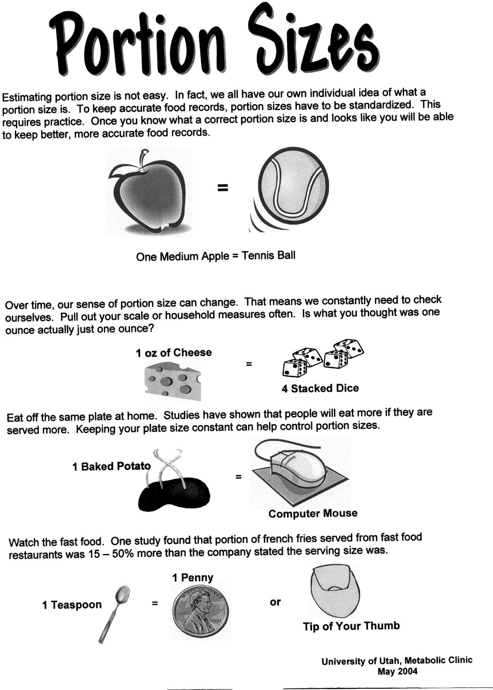

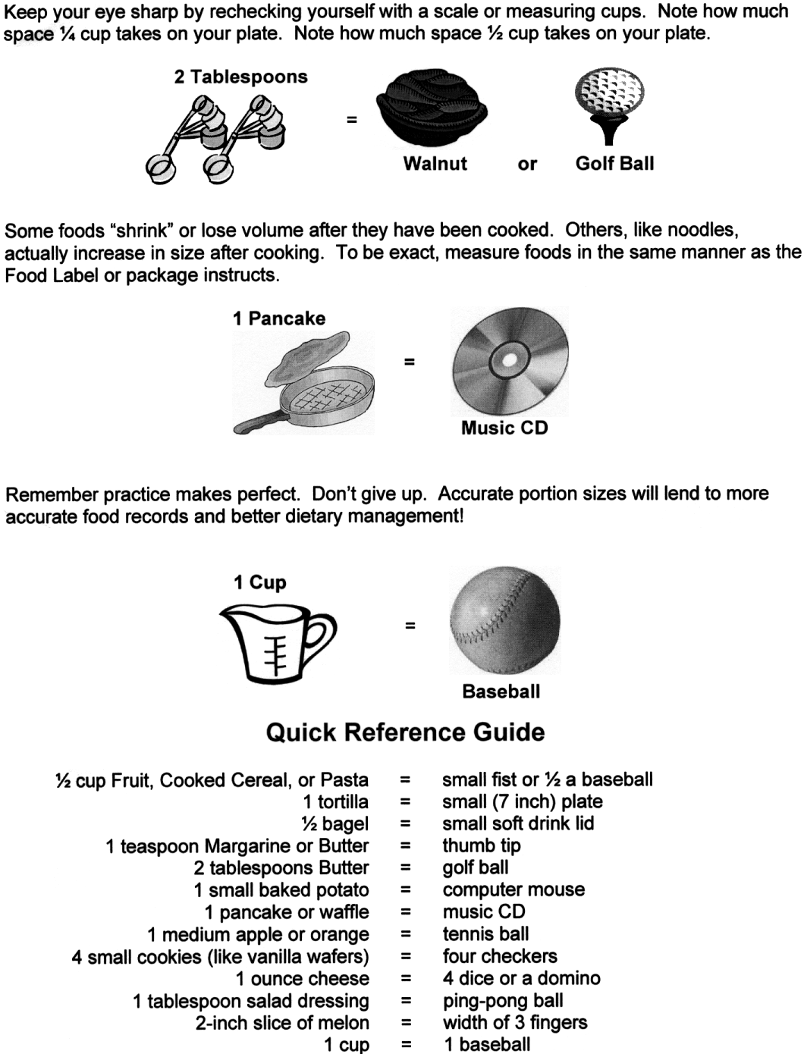

Eating Attitudes Test
(Garner & Garfinkel, 1979)
Please place an (X) under the column which applies best to each of the numbered statements. All of the results will be strictly confidential. Most of the questions directly relate to food or eating, although other types of questions have been included. Please answer each question carefully. Thank you.
Always | Very  Often | Often | Some  times | Rarely | Never
( ) | ( ) | ( ) | ( ) | ( ) | ( ) | - I like eating with other people.
( ) | ( ) | ( ) | ( ) | ( ) | ( ) | - I prepare foods for others but do not eat what I cook.
( ) | ( ) | ( ) | ( ) | ( ) | ( ) | - I become anxious prior to eating.
( ) | ( ) | ( ) | ( ) | ( ) | ( ) | - I am terrified about being overweight.
( ) | ( ) | ( ) | ( ) | ( ) | ( ) | - I avoid eating when I am hungry.
( ) | ( ) | ( ) | ( ) | ( ) | ( ) | - I find myself preoccupied with food.
( ) | ( ) | ( ) | ( ) | ( ) | ( ) | - I have gone on eating binges where I feel that I may not be able to stop.
( ) | ( ) | ( ) | ( ) | ( ) | ( ) | - I cut my food into small pieces.
( ) | ( ) | ( ) | ( ) | ( ) | ( ) | - I am aware of the calorie content of foods that I eat.
( ) | ( ) | ( ) | ( ) | ( ) | ( ) | - I particularly avoid foods with high carbohydrate content (e.g. bread, potatoes, rice, etc.)
( ) | ( ) | ( ) | ( ) | ( ) | ( ) | - I feel bloated after meals.
( ) | ( ) | ( ) | ( ) | ( ) | ( ) | - I feel that others would prefer if I ate more.
( ) | ( ) | ( ) | ( ) | ( ) | ( ) | - I vomit after I have eaten.
( ) | ( ) | ( ) | ( ) | ( ) | ( ) | - I feel extremely guilty after eating.
( ) | ( ) | ( ) | ( ) | ( ) | ( ) | - I am preoccupied with a desire to be thinner.
( ) | ( ) | ( ) | ( ) | ( ) | ( ) | - I exercise strenuously to burn off calories.
( ) | ( ) | ( ) | ( ) | ( ) | ( ) | - I weigh myself several times a day.
( ) | ( ) | ( ) | ( ) | ( ) | ( ) | - I like my clothes to fit tightly.
( ) | ( ) | ( ) | ( ) | ( ) | ( ) | - I enjoy eating meat.
( ) | ( ) | ( ) | ( ) | ( ) | ( ) | - I wake up early in the morning.
( ) | ( ) | ( ) | ( ) | ( ) | ( ) | - I eat the same foods day after day.
( ) | ( ) | ( ) | ( ) | ( ) | ( ) | - I think about burning up calories when I exercise.
( ) | ( ) | ( ) | ( ) | ( ) | ( ) | - I have regular menstrual periods.
( ) | ( ) | ( ) | ( ) | ( ) | ( ) | - Other people think I am too thin.
( ) | ( ) | ( ) | ( ) | ( ) | ( ) | - I am preoccupied with the thought of having fat on my body.
( ) | ( ) | ( ) | ( ) | ( ) | ( ) | - I take longer than others to eat my meals.
( ) | ( ) | ( ) | ( ) | ( ) | ( ) | - I enjoy eating at restaurants.
( ) | ( ) | ( ) | ( ) | ( ) | ( ) | - I take laxatives.
( ) | ( ) | ( ) | ( ) | ( ) | ( ) | - I avoid foods with sugar in them.
( ) | ( ) | ( ) | ( ) | ( ) | ( ) | - I eat diet foods.
( ) | ( ) | ( ) | ( ) | ( ) | ( ) | - I feel that food controls my life.
( ) | ( ) | ( ) | ( ) | ( ) | ( ) | - I display self control around food.
( ) | ( ) | ( ) | ( ) | ( ) | ( ) | - I feel that others pressure me to eat.
( ) | ( ) | ( ) | ( ) | ( ) | ( ) | - I give too much time and thought to food.
( ) | ( ) | ( ) | ( ) | ( ) | ( ) | - I suffer from constipation.
( ) | ( ) | ( ) | ( ) | ( ) | ( ) | - I feel uncomfortable after eating sweets.
( ) | ( ) | ( ) | ( ) | ( ) | ( ) | - I engage in dieting behavior.
( ) | ( ) | ( ) | ( ) | ( ) | ( ) | - I like my stomach to be empty.
( ) | ( ) | ( ) | ( ) | ( ) | ( ) | - I enjoy trying new rich foods.
( ) | ( ) | ( ) | ( ) | ( ) | ( ) | - I have the impulse to vomit after meals.

Social Physique Anxiety Scale
(Hart, Leary, & Rejeski, 1989)
For each item, please indicate the degree to which the statement is characteristic or true of you on a 5-point scale
- I am comfortable with the appearance of my physique/figure

( ) Not at all ( ) Slightly ( ) Moderately ( ) Very ( ) Extremely

- I would never worry about wearing clothes that might make me look too thin or overweight

( ) Not at all ( ) Slightly ( ) Moderately ( ) Very ( ) Extremely

- I wish I wasn’t so uptight about my physique/figure

( ) Not at all ( ) Slightly ( ) Moderately ( ) Very ( ) Extremely

- There are times when I am bothered by thoughts that other people are evaluating my weight or muscular development negatively

( ) Not at all ( ) Slightly ( ) Moderately ( ) Very ( ) Extremely

- When I look in the mirror I feel good about my physique/figure

( ) Not at all ( ) Slightly ( ) Moderately ( ) Very ( ) Extremely

- Unattractive features of my physique make me nervous in certain social settings

( ) Not at all ( ) Slightly ( ) Moderately ( ) Very ( ) Extremely

- In the presence of others, I feel apprehensive about my physique/figure

( ) Not at all ( ) Slightly ( ) Moderately ( ) Very ( ) Extremely

- I am comfortable with how fit my body appears to others

( ) Not at all ( ) Slightly ( ) Moderately ( ) Very ( ) Extremely

- It would make me uncomfortable to know others were evaluating my physique/figure

( ) Not at all ( ) Slightly ( ) Moderately ( ) Very ( ) Extremely

- When it comes to displaying my physique/figure to others, I am a shy person

( ) Not at all ( ) Slightly ( ) Moderately ( ) Very ( ) Extremely

- I usually feel relaxed when it is obvious that others are looking at my physique/figure

( ) Not at all ( ) Slightly ( ) Moderately ( ) Very ( ) Extremely

- When in a bathing suit, I often feel nervous about the shape of my body

( ) Not at all ( ) Slightly ( ) Moderately ( ) Very ( ) Extremely

