
School of Social Work

601 University Drive
San Marcos, Texas 78666-4616
office: 512.245.2592
Fax: 512.245.8097
www.socialwork.txstate.edu

January 29, 2009

Texas State University
IRB Committee
601 University Drive
San Marcos, TX 78666

Dear Committee Members,

I am fully aware of and am participating in the research proposed by MSW student Erin Henry entitled A Study of Older Adult Women with ADHD. She proposed this project to me as a directed study. The course is SOWK 5360.251 for the Spring semester of 2009. I am assisting her with the consent form and process, the interview questions, literature review, interpreting results, and writing up the results.

Please feel free to contact me if you have any questions.

Sincerely,

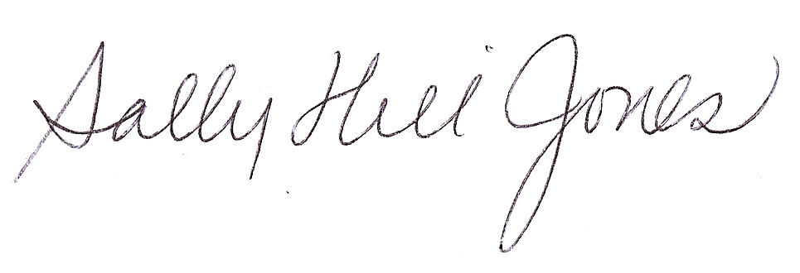
Sally Hill Jones, PhD, LCSW
Assistant Professor, School of Social Work
Texas State University
601 University Drive
San Marcos, TX 78666
512-245-1712
Sh29@txstate.edu

Texas State University – San Marcos, founded 1899, is a member of the Texas State University System.

