Title of Study
The Effects of Ankle Taping on Dynamic Postural Control after Acute Ankle Sprains

- Identify the sources of the potential subjects, derived materials or data. Describe the characteristics of the subject population, such as their anticipated number, age, sex, ethnic background, and state of health. Identify the criteria for inclusion or exclusion. Explain the rationale for the use of special classes of subjects, such as fetuses, pregnant women, children, institutionalized mentally disabled, prisoners, or others, especially those whose ability to give voluntary informed consent may be in question.

Participants will be 30 physically active adult volunteers between the ages of 18-35. These volunteers will be Texas State University-San Marcos collegiate athletes, intramural athletes, personal fitness and wellness (PFW) students, or students who visit the Texas State University Student Health Center for treatment of an ankle injury.

Inclusion criteria:
Participants will be: physically active as defined by the American Heart Association (AHA) guidelines (30 min moderate 5X/wk; 20 min vigorous 3X/wk,) between the ages of 18-35, have a grade I or II ankle sprain, and evaluated and tested within 120 hours.

Participants will have had no other lower extremity injury on affected side within the past 6 months; no history of lower extremity surgery on affected side; no self reported concussions; visual/vestibular problems; inner ear infections; or upper respiratory infections. Participants must have a history of 1 or less ankle sprains on injured side (not including the current ankle injury) and no self reported chronic ankle instability (CAI) which is defined as having feelings of instability/ “giving way,” inflammation during or after activity.

Exclusion criteria:
Potential participants will be excluded if they meet any of the 6 exclusion criteria: 1) unable to obtain 20 degrees of ankle range of motion while performing a stabilized one-leg squat as measured by an accu-angle inclinometer attached to the lower leg just below the knee, 2) have a positive ligament laxity test with the anterior drawer or talar tilt test indicating a full rupture of the ligament(s), 3) have a positive test for shooting pain with the bump or compression tests, 4) unable to walk 10 steps with pain <5/12 on a Graphic Pain Rating Scale, 5) unable to go up/down 3 stairs with pain <5/12 on a Graphic Pain Rating Scale, 6) or perform a single leg squat with pain <5/12 on a Graphic Pain Rating Scale. These exclusion criteria will be measured to ensure that the participant’s symptoms are mild enough to not cause additional discomfort during the balance testing.

- Describe the procedures for recruitment of subjects and the consent procedures to be followed. Include the circumstances under which consent will be solicited and obtained, who will seek it, the nature of information to be provided to prospective subjects, and the methods of documenting consent. (Include applicable consent form(s) for review.) If written consent is not to be obtained, this should be clearly stated and justified.

Subject recruitment will take place on the Texas State University-San Marcos campus. Participants will be intercollegiate athletes, intramural athletes, recreation sports athletes, PFW students, or students who visit the Texas State University Student Health Center for treatment of an ankle injury. Recruitment will be completed by the principal investigator via pre-approved flyers and announcements (see attached,) and word of mouth. The investigator will speak with the PFW classes per the permission of the instructor within the first 5 minutes of a class time. The investigator will read the material from the approved flyer during this time and will ensure that students are aware that participation is not required and will not affect their PFW class grade. In addition, no coercion tactics will be used by the instructor or the investigator to recruit participants in the study at all other sites. All potential participants interested in the study will be required to contact the principal investigator to set up a time to meet at the EndZone Athletic Training Room to complete the IRB approved consent form. The potential participants will be given time to read through all of the material, ask questions if needed, and consent to participation in the study. Two copies of the consent form will be signed. One will be given to the participant, while the other copy will be kept on file in a locked cabinet in the Athletic Training Research Laboratory for a seven year period.

- Describe the project’s methodology in detail. If applicable, detail the data collection procedures, the testing instruments, the intervention(s), etc. If using a survey, questionnaire, or interview, please provide a copy of the items or questions.

After consent has been obtained participants will be given an ID number to ensure confidentiality. Participants will complete a self-report demographic form and testing to ensure that each participant meets all of the inclusion criteria. The self-reported demographic survey will consist of questions regarding history of injury and other general health questions. Participants must also self report no neurological symptoms, no visual/vestibular problems, no upper respiratory infections, no ear infections, no present illnesses, etc. After ensuring inclusion criteria, exclusion testing will be completed through the use of the following tests: anterior drawer, talar tilt, bump, and compression tests and functional tests. The tests will be completed by a Certified Athletic Trainer that has 20 years of experience to ensure accuracy and to ensure unbiased results. The participant will next complete a Graphic Pain Rating Scale then perform the functional tests (walk 10 steps, go up/down 3 stairs, and perform a single leg squat) to ensure that their symptoms are mild enough (<5/12 on Graphic Pain Rating Scale) to not cause additional discomfort during the balance testing. After exclusion criteria have been ruled out the researcher will move forward with data collection by having the participants learn, practice, and complete the Star Excursion Balance Test and Balance Error Scoring System Test on the injured and uninjured leg under two conditions (tape and no tape). The ankle will be taped according to standard protocol to help prevent inversion of the ankle. Participants will also complete the Graphic Pain Rating Scale and Graphic Confidence Scales while performing the balance tasks under both conditions.

Below is a description of all the tests used in this research project. Each are standardized tests commonly used in Athletic Training with established validity and reliability measures.:

Leg Length
Leg length will be measured in centimeters with the participant on their back. Measurement will be taken from two bony landmarks, the anterior superior iliac spine & the medial malleolus, of the affected side. This measurement will allow for standardization of each participant’s reach distance on the Star Excursion Balance Test.

Anterior Drawer Test
The anterior drawer is a test of ligament laxity and will have the examiner stabilize the lower leg with the ankle in neutral and apply pressure to the back part of the ankle to pull the talus forward. Complete laxity or rupture found with this test will prove a positive test and be means for disqualification as a participant.
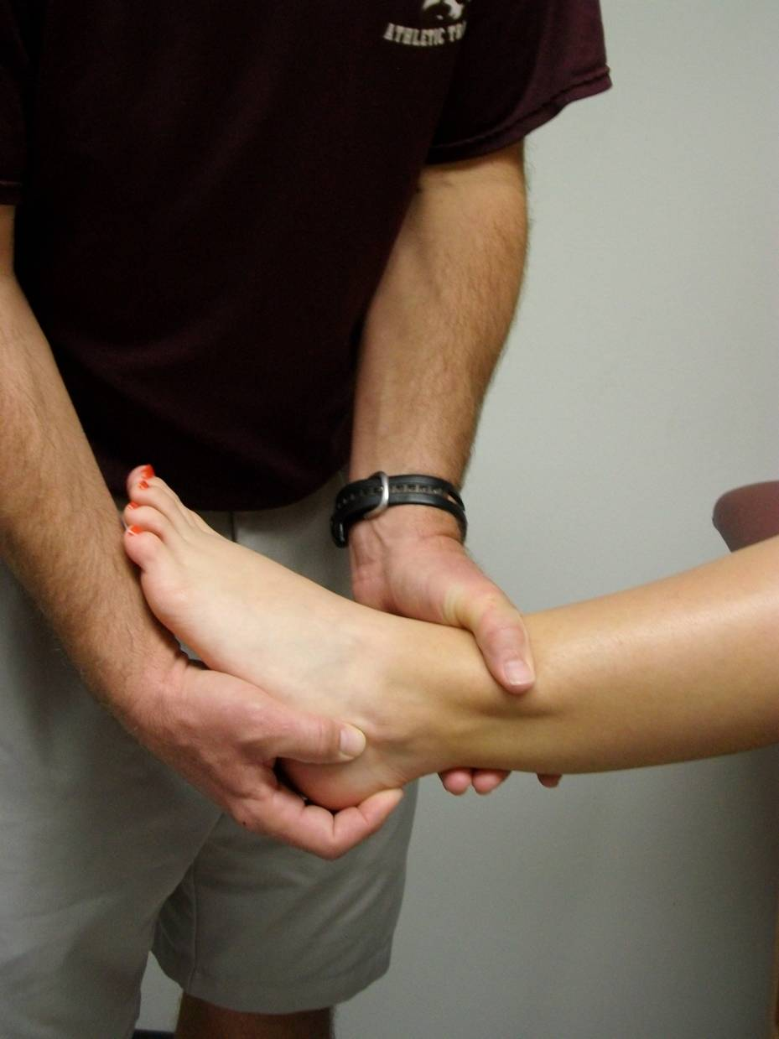

Talar Tilt Test
The talar tilt is a test of ligament laxity and will also be performed with the ankle in neutral and the rearfoot turned inward. Complete laxity or rupture found with this test will prove a positive test and be means for disqualification as a participant.
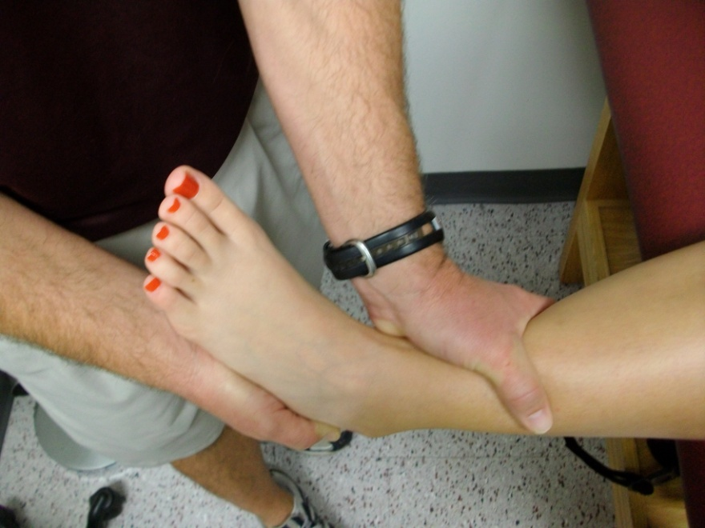

Bump Test
The bump is a test for bone fracture and will be performed with the examiner stabilizing the lower leg with the ankle in neutral. The examiner will then hit the bottom of the patient’s heel with the heel of their hand. Shooting pain during the bump test will be means for disqualification.

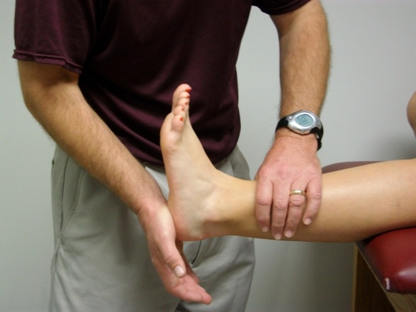

Compression Test
The compression is a test for bone fracture will have the examiner stabilizing the lower leg while compressing the tibia and fibula together. Shooting pain during the compression test will be means for disqualification.
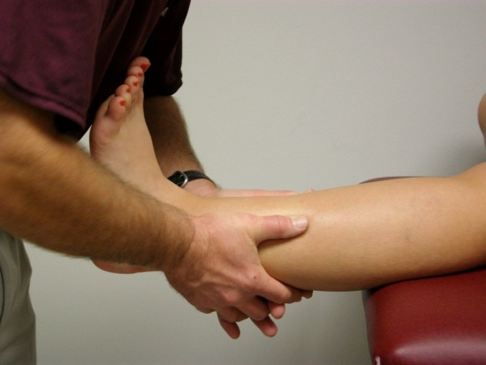

Graphic Pain Rating Scale (GPRS)
The GPRS is a visual analog scale with a twelve centimeter line and seven descriptors evenly spaced within the scale ranging from no pain to unbearable pain. The participant will be asked to draw a mark on the line closest to the number and description of pain they are experiencing at that moment. The participant will complete the GPRS on seven occasions per leg tested: 1) three times upon completing the functional exclusion tasks, 2) once after completing the SEBT with the tape condition and once after complete the SEBT without tape, and 3) once after completing the BESS with the tape condition and once after complete the BESS without tape (see attached).

Graphic Confidence Rating Scale
The Graphic Confidence Rating Scale is scored the same as the GPRS and is also a visual analog scale where the participant will draw a mark on the line closes to the number and descriptor of confidence they feel. This will allow for secondary information of confidence to be evaluated and the participant’s perception of confidence during the task to be quantified. This will only be completed four times per leg tested:1) once after completing the SEBT with the tape condition and once after complete the SEBT without tape, and 2) once after completing the BESS with the tape condition and once after complete the BESS without tape (see attached).

Functional Testing
Walking 10 steps
Participants will be asked to walk 10 steps and then complete the GPRS. They will be included in the study if they mark a score of 5 or less on the GPRS. This is a test for functionality of the patient and helps to ensure their safety and comfort throughout the study.

Walking up and down stairs
Participants will be asked to walk up and down 3 stairs and then complete the GPRS. They will be included in the study if they mark a score of 5 or less on the GPRS. This is a test for functionality of the patient and helps to ensure their safety and comfort throughout the study.

Single leg lunge
Participants will be asked to complete a single leg squat with a bubble inclinometer attached to their lower leg. This will be the test for dorsiflexion (pulling the foot up) range of motion as well as functionality of the participant. They will be included in the study if they mark a score of 5 or less on the GPRS. Additionally, a participant will be excluded if they are unable to reach 20 degrees of range of motion. This is a test helps to ensure participant safety and comfort throughout the study.

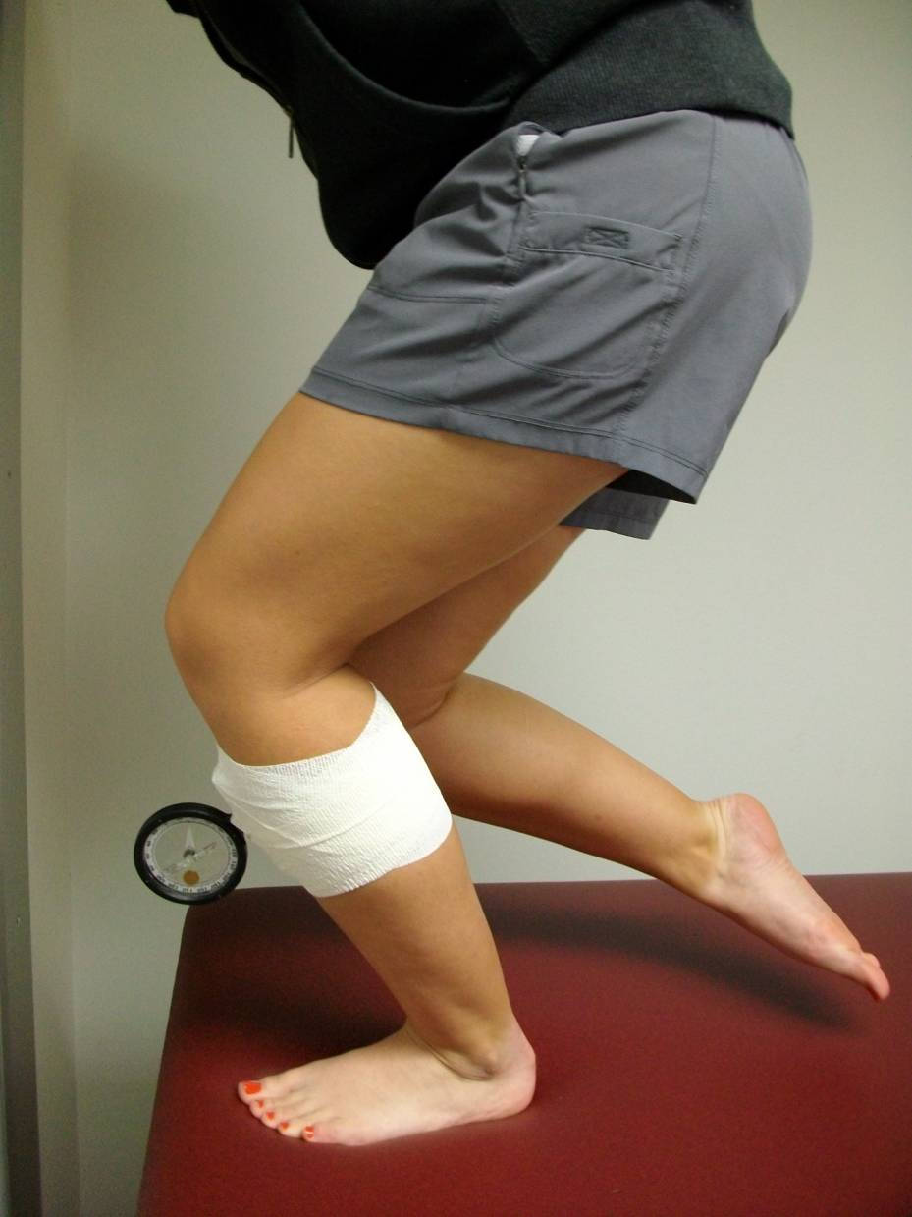

Star Excursion Balance Test
The Star Excursion Balance Test (SEBT) is a dynamic balance test in which the participant stands on one leg (the affected limb) while reaching with the opposite leg in three different directions. The reach distance measurement is taken in centimeters and averaged over three reaches in each direction. Furthermore, the reach distance is normalized to leg length.

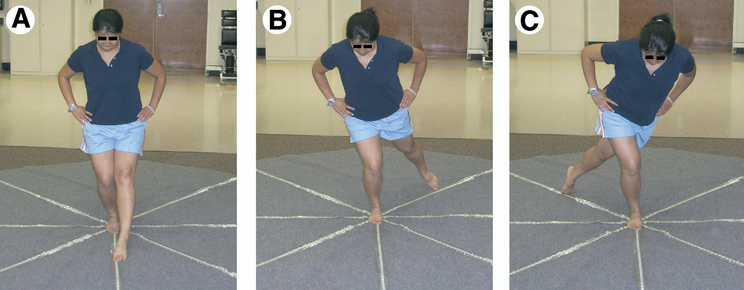

Balance Error Scoring System (BESS)
This field examination consists of six total conditions. Three of these conditions include changes in foot position (double leg, single leg, and tandem stance) on a stable and unstable surface (firm ground or foam Airex pad) for each stance. All of these conditions are completed with the eyes closed and the patient’s hands on hips. If the patients make a mistake, they will need to correct themselves as quickly as possible. Points for mistakes will be tallied for all six conditions to create individual test condition scores and a cumulative BESS score. One point will be alloted for each of the following six errors the participant may commit: 1.) lifting their hands off of their hips, 2.) opening their eyes, 3.) stepping, stumbling, or falling, 4.) remaining out of the appropriate position for more than 5 seconds, 5.) moving their hip into 30 degrees or more of hip forward or sideways, or 6.) lifting their forefoot or heel off of the respective surfaces.

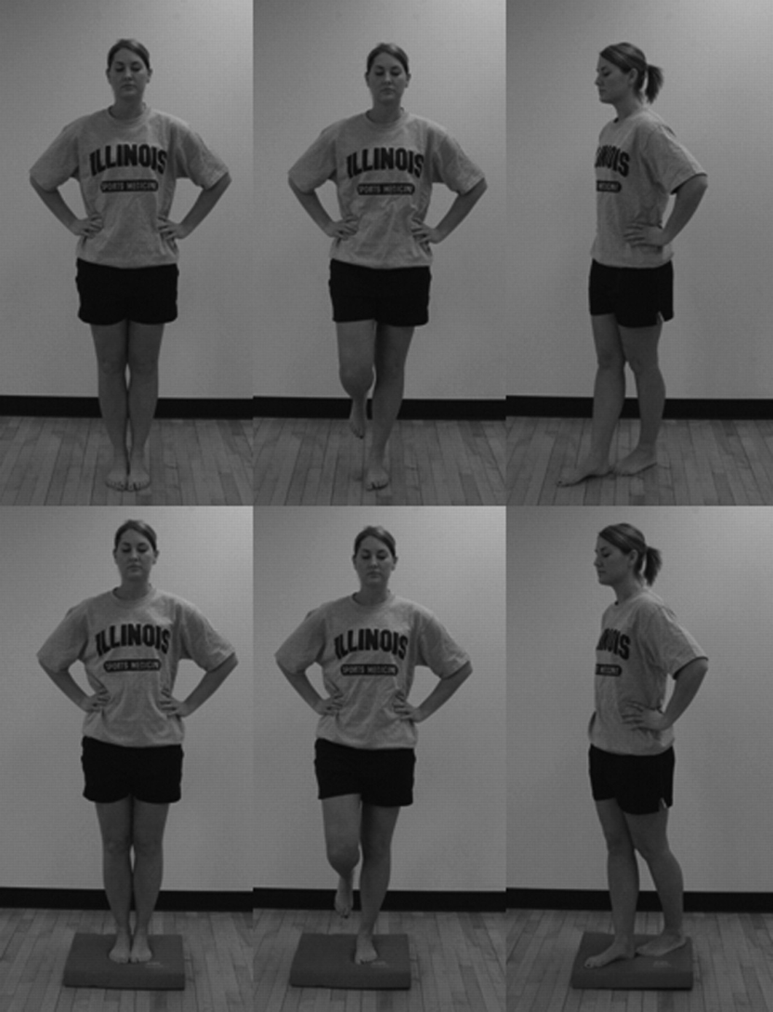
sph.sagepub.com

- Describe any potential risks — physical, psychological, social, legal or other — and state their likelihood and seriousness. Describe alternative methods, if any, that were considered and why they will not be used.

Potential risks are minimal but may include muscle or joint soreness upon completion of the SEBT and BESS. Although unlikely, the participants may experience minor scapes, bruises, or swelling if they fall during either test. The likelihood of this event occurring in young, physically active adults is low. Additionally, the participant may feel some minor pain while completing the balance tasks. To reduce potential risks or the patient discomfort, patients will have the ability to opt out of the study at any time if they feel the need. To further decrease this risk, the SEBT and BESS will be completed in a controlled environment with minimal noise and distractions. The SEBT and BESS have been validated in many other studies and therefore, no alternative test will be considered. The use of specific exclusion criteria have been created to avoid adding any discomfort to the participants while participating in the study

- Describe the procedures for protecting against or minimizing any potential risks and include an assessment of the likely effectiveness of those procedures. Include a discussion of confidentiality safeguards, where relevant, and arrangements for providing mental health or medical treatment, if needed.

The exclusion criteria for this study will help to minimize the potential risks in this study. Participants that are physically active, free of vestibular problems, or concussions, and have no upper respiratory infections are unlikely to fall during the SEBT and BESS. In addition, participants who pass the screening process, but are unable to perform the task safely or comfortably will be able to withdraw from the study or may be withdrawn by the investigator. Participant comfort and ability to perform the tasks is more important in this study than the completion of the tests. All steps have been taken in the creation of the exclusion criteria to minimize the potential for pain and further injury in participants.

Participant confidentiality will be ensured by having all consent and screening forms kept in a locked cabinet in the Athletic Training Research Laboratory. Data collected will be identified by participant ID rather than participant names and kept in a password-protected file on the data collection computer that is housed in the Athletic Training Research Laboratory. Following data analysis, the information will be removed from the computer and placed with the previously collected information.

Medical treatment will be limited to first aid and ice. Participants will also be instructed on the RICES (rest, ice, compression, elevation and stabilization) principle and given contact information for the Texas State University Student Health Center in the case that further medical attention is needed.

- Describe and assess the potential benefits to be gained by the subjects, as well as the benefits that may accrue to society in general as a result of the proposed study.

Potential participants, even those who do not meet the criteria, will all be given an at-home rehabilitation program consisting of strengthening and balance exercises as well as a piece of Theraband. Theraband will be used in the rehabilitation program to aid in strengthening the muscles of the ankle.

The benefits to society will be mostly to clinicians in athletic training and related fields. From this study, a better understanding of how tape affects performance, pain and confidence in patients with acute ankle sprains will be obtained. This information will directly impact the treatment protocols that athletic trainers follow after an acute ankle sprain.

- Clearly describe any compensation to be offered/provided to the participants. If extra credit is provided as an incentive, include the percentage of extra credit in relation to the total points offered in the class. Also, if extra credit is provided, describe alternatives to participation in your research for earning extra credit.

Compensation for participation in the study will include an at home rehabilitation program and a piece of Theraband for use in the rehabilitation program.

- Discuss the risks in relation to the anticipated benefits to the subjects and society.

The risks are minimal to participants in this study. The SEBT and BESS are controlled and less likely to lead to further injury when compared to continuing normal activity in a dynamic environment which houses risks of uneven surfaces or other unexpected stimulus. The potential benefits are twofold: 1) identifying the effect of ankle taping on acute ankle sprains may lead to a change in procedure or continuation of the preventative and rehabilitative ankle taping and 2) providing participants with a rehabilitation program will aid in the healing and recovery process after the ankle sprain.

- Identify the specific sites/agencies to be used as well as approval status. Include copies of approval letters from agencies to be used (note: these are required for final approval). If they are not available at the time of IRB review, approval of the proposal will be contingent upon their receipt.

All data collection will take place in the EndZone Athletic Training Room. No agencies or sites outside of Texas State University will be used for subject recruitment and data collection.

- If you are a student, indicate the relationship of the proposal to your program of work and identify your supervising/sponsor faculty member.

Dr. Luzita Vela is an Assistant Professor in the Athletic Training Education Program at Texas State University, where I am a current Graduate Student with a major in Athletic Training.

- In the case of student projects, pilot studies, theses, or dissertations, evidence of approval of Supervising Professor or Faculty Sponsor should be included. Thesis and dissertation proposals must be approved by the student’s committee before proceeding to the IRB for review.

Please see attached approval form.

- If the proposed study has been approved by another IRB, attach a copy of the letter verifying approval/disapproval and any related correspondence. If the proposed study has not been reviewed/approved by another IRB, please state this explicitly.

The proposed study has not been reviewed or approved by another IRB.

- Identify all individuals who will have access, during or after completion, to the results of this study, whether they be published or unpublished.

All interested individuals or groups may contact the principal investigators for results of the study. No persons, except the principal investigators, will have access to the raw data or personal indentifying information.

In addition to this synopsis, you are required to submit all relevant documentation for review. This may include, but is not necessarily limited to: 1) recruiting documents (e.g., flyers, letter, e-mails, brochures, etc.), 2) a consent form, 3) an assent form, 4) letters of approval from relevant organization(s), 5) surveys/instruments/questionnaires, esp. those created by the researcher, 6) a list of questions that the researcher may ask (e.g., focus groups questions, questions for qualitative studies, etc.), and 7) all documents in translated versions.

