EndZone Athletic Training Room
Do you have a Sprained ANKLE???
We are looking for physically active persons between the ages of 18-35 who have sprained their ankle in the past 5 days to participate in a balance study. Your participation will take no longer than 60 minutes at the EndZone Athletic Training Room and you will be given an at home rehabilitation program for your time. Please contact Megan Haynes for more details.
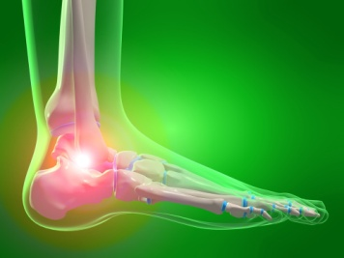

Contact Person: Megan Haynes
Email: mh1220@txstate.edu Phone: 361-532-9897

Megan Haynes
Mh1220@txstate.edu
361-532-9897
Megan Haynes
Mh1220@txstate.edu
361-532-9897
Megan Haynes
Mh1220@txstate.edu
361-532-9897
Megan Haynes
Mh1220@txstate.edu
361-532-9897
Megan Haynes
Mh1220@txstate.edu
361-532-9897
Megan Haynes
Mh1220@txstate.edu
361-532-9897
Megan Haynes
Mh1220@txstate.edu
361-532-9897
Megan Haynes
Mh1220@txstate.edu
361-532-9897
Megan Haynes
Mh1220@txstate.edu
361-532-9897

