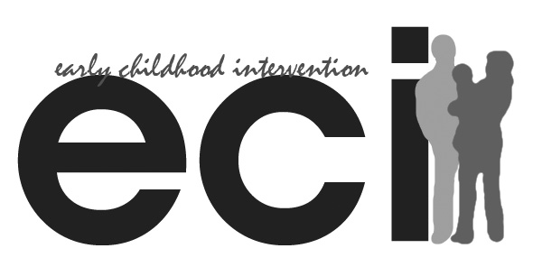
1-800-628-5115
Phone: (512) 334-4464
Fax: (512) 334-4465
www.abcaus.org

An Affiliate of Texas Early Childhood Intervention
Any Baby Can Child & Family Resource Center
Early Childhood Intervention Program

November 13, 2010

To Whom It May Concern:

Early Childhood Intervention Program at Any Baby Can is a program for families with children, birth
1121 E 7th St
Austin, TX 78702
Address goes here

to three, with disabilities and developmental delays. ECI supports families to help their children reach

their potential through developmental services. ECI goes to families and focuses on working with the

child and family in their natural environment, such as at home, grandma's, or a child care center.

Essentially, it's where children live, learn and play.

We received a request from Megan Amidon on November 2, 2010 for a qualitative case-study. She
1121 E 7th St
Austin, TX 78702
Address goes here

has an interest in Early Intervention and Family Centered practice. We are supportive of her proposed

research study “A Case Study of the Inclusion of Siblings in Early Intervention Activities”. We are

very excited to give her the opportunity to work with our unique population. If you have any

request or question, please don’t hesitate to contact us.

Sincerely,

Cynthia Quinones
Supervisor
Any Baby Can/ ECI Program
1121 E 7th St Austin, TX 78702
(512) 334-4437
cynthiaq@abcaus.org

