March 15, 2010

Re: Brian Fremaux, IRB #: 2010W3172

Dear Becky,

This letter is to certify that Brian Fremaux is currently an independent studies student under my supervision who is planning to conduct a study entitled "Electroencephalography and the processing of verbs". He is conducting this research under my supervision and with my full approval. Please do not hesitate to contact me if you have any questions about Brian or his proposed research.

Sincerely,

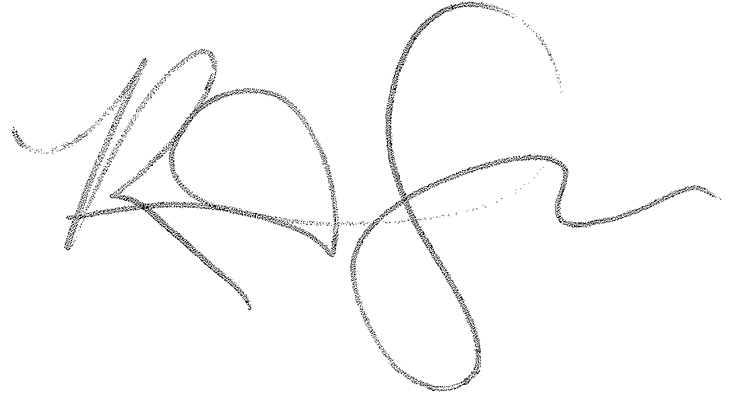

Reiko Graham
Assistant Professor, Psychology
Phone: (512) 245-6806
Email: rg30@txstate.edu

