INSTRUCTIONS

- Answer questions by circling your choice, e.g.
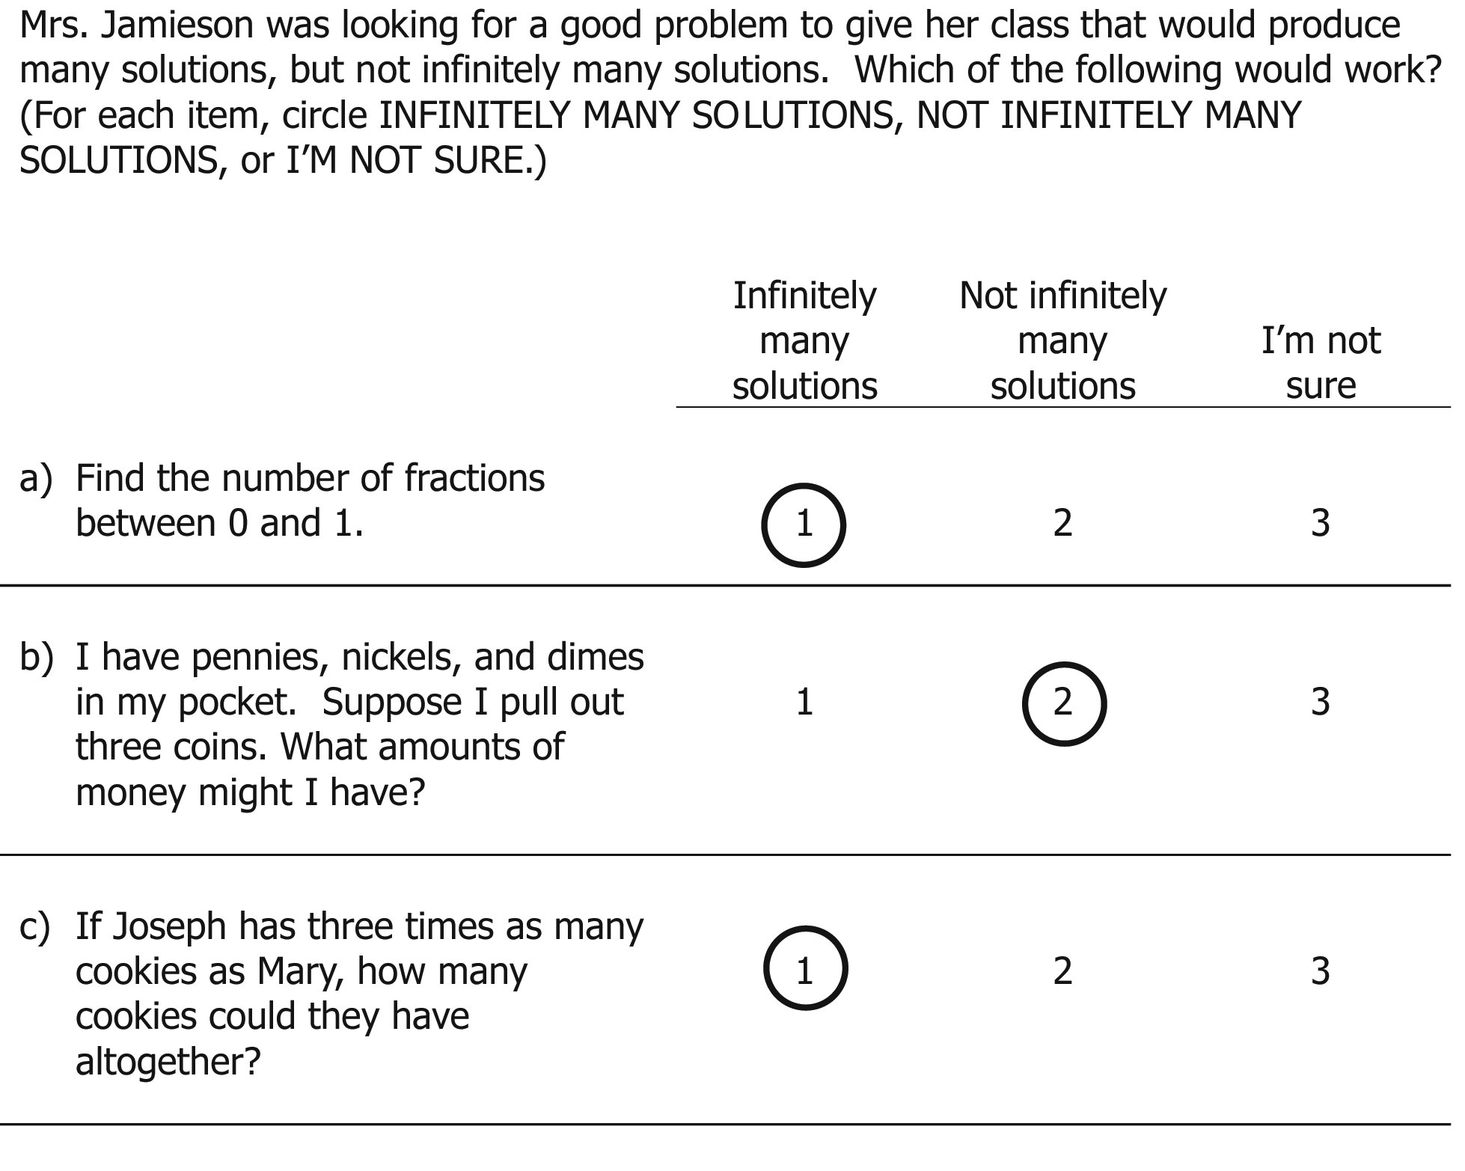

- In completing this questionnaire, you should not spend more than 1-2 minutes on any question. Imagine you are responding to real classroom situations, and select the answer that most closely matches what you would do, say, or answer at that moment.

1. Five students disagree about solutions to the equation
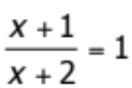.

Which student statement is correct? (Circle ONE answer.)

- It can't have any solutions, because x + 1 can’t be equal to x + 2, so the ratio can't be equal to 1.

- There are no solutions because x + 2 cannot be in the denominator of a fraction, since x + 2 = 0 when x = -2.

- If you cancel the x’s, the equation says =1 which is impossible, so there’s no solution.

- It might have solutions, because x could be fraction or a negative number.

- If you multiply through by x + 2 you get a linear equation, so it must have a solution.

2. Mr. Jones used the following problem to develop his students’ ability to write formulas to describe patterns:

A row of squares can be made from toothpicks as follows:



Write a formula to represent the number of toothpicks for any number of squares. Use t for the number of toothpicks and s for the number of squares.

Which of the following formulas represents the number of toothpicks (t) for a given number of squares (s)? (Circle ONE answer.)

- t = 4s

- t = 3s + 4

- t = 4s – (s – 2)

- t = 2s + (s + 1)

3. Ms. Covey wants to use story problems during a unit on linear functions. She looks through some supplemental materials for teaching algebra, but becomes concerned that not all problems she sees represent linear functions.

Of the following stories, which does NOT represent linear behavior in the context of the story? (Circle ONE answer.)

- The first day Nathan gets one penny. Each day after that, he gets twice as many pennies as he did the day before. How many pennies does he get on the n^{th} day?

- It takes Kara 2 pints of paint to cover 30 square yards of a wall. How many pints does Kara need to cover n square yards?

- The cost of a taxicab ride is $1.00 plus 20 cents for each fifth of a mile. What is the fare for traveling n miles?

- Shelly has $100.00. Each day she spends $1.25. How much money does she have on the n^{th} day?

- All of these stories represent linear behavior.

4. While working on different ways to represent linear functions, Ms. Hamid’s class got into a debate. Students put the following on the board.

I    The first house figure has five toothpicks. The second has nine. Write a formula to show the number of toothpicks in the n^{th} figure. | II  “Leah had one baseball card, and her brother gives her four cards every day. Show how many baseball cards she’d have on the n^{th} day.”
III  4n+1 | IV  n+4

Ms. Hamid’s students made different claims about which of the four represent the same linear function, where n = 1, 2, 3, …. Of the following statements, which best characterizes the relationships among these representations? (Circle ONE answer.)

- Each of these represents a different linear function.

- Only I and IV represent the same function.

- Only II and III represent the same function.

- Only II and IV represent the same function.

- Only I, II, and III represent the same function.

5. Ms. Diaz went to a workshop about using area models for multiplication to help students visualize algebra problems. She was given three types of blocks:

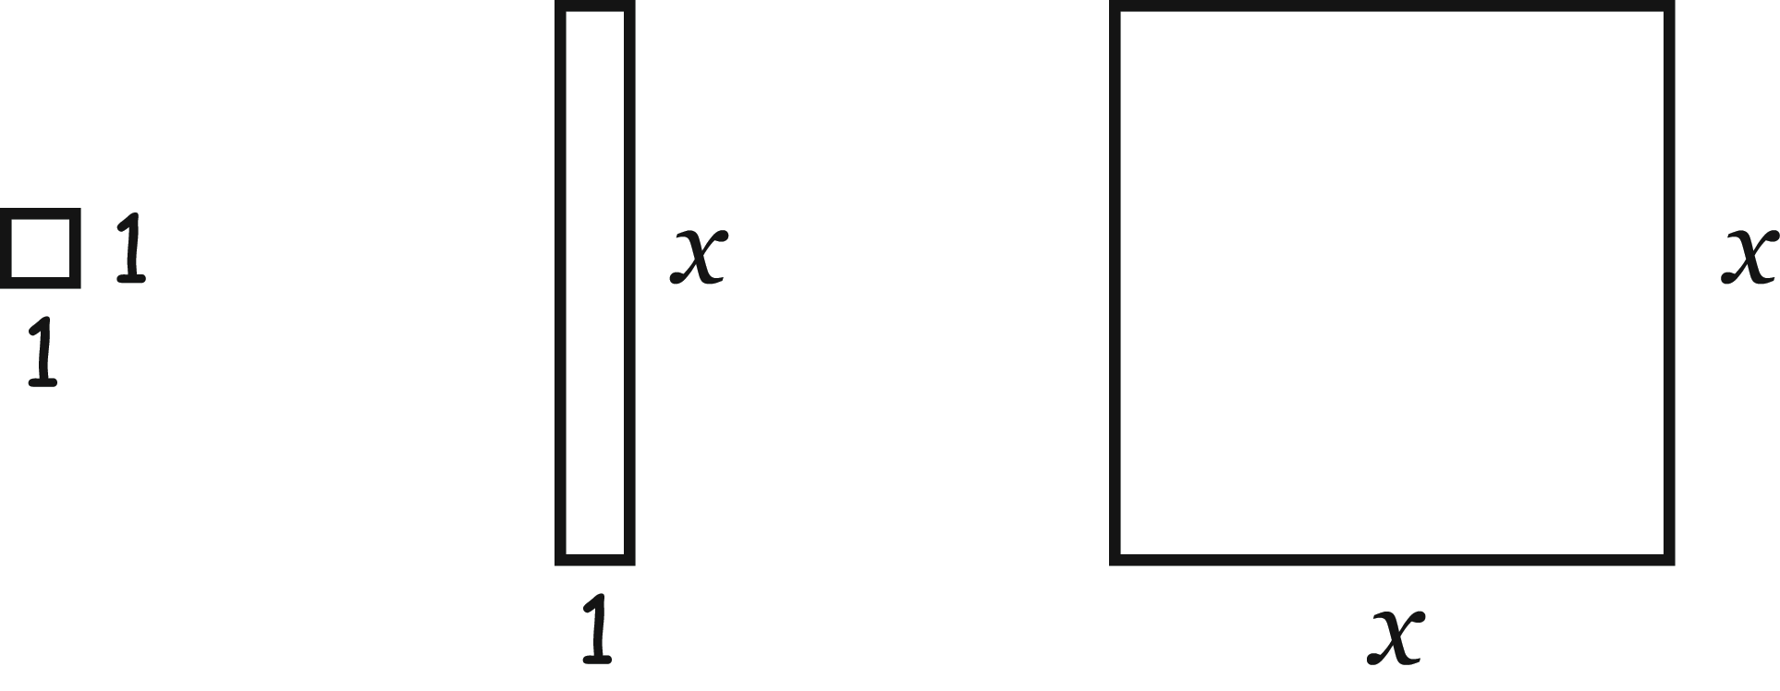

Which of the following correctly represents an area model for x(x + 5)? (For each item below, circle YES, NO, or I’M NOT SURE.)

 | Yes | No | I’m Not  Sure
-  | 1 | 2 | 3
-  | 1 | 2 | 3
-  | 1 | 2 | 3
-  | 1 | 2 | 3

6. Mr. McWhorter wants his students to be able to read and interpret algebraic expressions in different ways. In the expression 2x + 3, for instance, his students might say that x is multiplied by two before having three added, or they might say that you start with three and then add two times x. He asks his students to interpret the following expression in different ways:

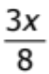

His students arrive at several different interpretations of this expression. For each statement, decide whether or not it correctly interprets 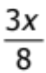. (For each item below, circle CORRECTLY INTERPRETS , INCORRECTLY INTERPRETS , or I’M NOT SURE.)

 | Correctly interprets | Incorrectly interprets | I’m not sure
- I think this means three eighths times some unknown, x. | 1 | 2 | 3
- It means some number divided by 8, then that result is multiplied by 3. | 1 | 2 | 3
- I think this is  times 3x. | 1 | 2 | 3
- This is the same as x + x +x. | 1 | 2 | 3

7. Mr. Watson is working with his students on sequences. He finds the initial terms for the following three sequences in some supplemental materials to his textbook:

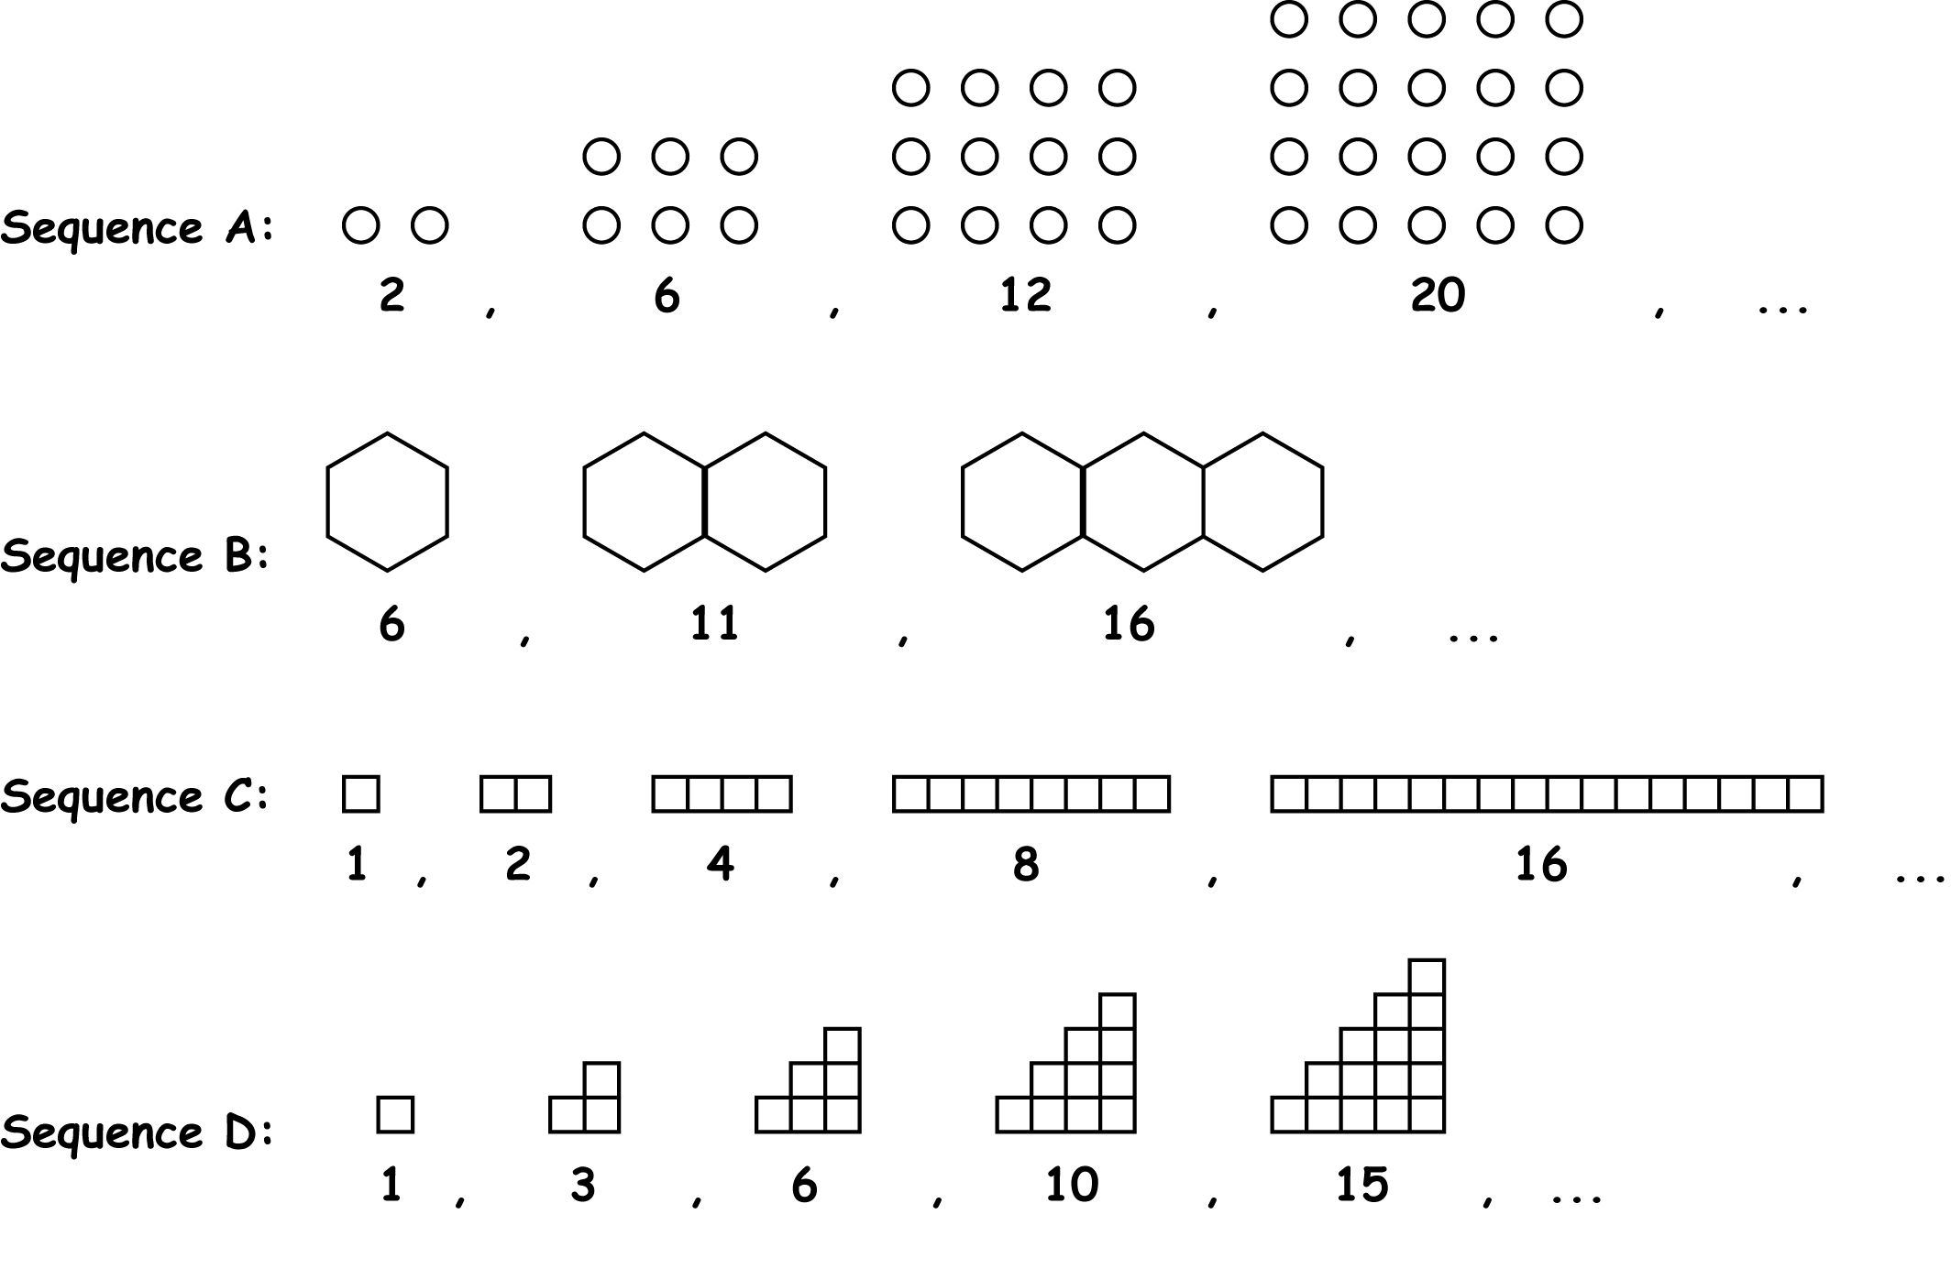

Mr. Watson decides to use these examples for lessons on linear, quadratic, and exponential functions. For which type of function would each serve as an illustration? (For each item below, circle LINEAR, QUADRATIC, EXPONENTIAL, or I’M NOT SURE.)
 | Type of growth
 | Linear | Quadratic | Exponential | I’m not sure
- Sequence A | 1 | 2 | 3 | 4
- Sequence B | 1 | 2 | 3 | 4
- Sequence C | 1 | 2 | 3 | 4
- Sequence D | 1 | 2 | 3 | 4

8. Ms. Morris’s class was studying real number equations and inequalities. She was trying to assess whether or not her students could identify when equations or inequalities have no solutions, one solution, or multiple solutions.

Which kind of solution set does each of the following equations or inequalities have? (For each item below, circle NO SOLUTION, EXACTLY ONE SOLUTION, MORE THAN ONE SOLUTION, or I’M NOT SURE.)

 | No solution | Exactly one solution | More than one solution | I’m not sure
- 2x < 8 and -3x < -15 | 1 | 2 | 3 | 4
- 3 < x < 5 | 1 | 2 | 3 | 4
- 3x + 7 = x + 2(x + 3) + 1 | 1 | 2 | 3 | 4
- 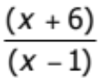 = 1 | 1 | 2 | 3 | 4
- -|x| = -4 | 1 | 2 | 3 | 4
f) x² = 16 | 1 | 2 | 3 | 4

9. During a unit on functions, Ms. Lopez asks her students to write journal entries on exponential growth. Which of the following journal entries illustrate exponential growth? (For each item below, circle EXPONENTIAL, NOT EXPONENTIAL or I’M NOT SURE.)

 | Exponential | Not exponential | I’m not  sure
- An example of exponential growth would be if you got a 1% raise each year. | 1 | 2 | 3
- An example of exponential growth would be if a car increases in speed by 10 miles per hour every second. | 1 | 2 | 3
- Exponential growth is when the y-axis increases faster than the x-axis. For example, if each time the x-coordinate goes up by 2, the y-coordinate goes up by 3. | 1 | 2 | 3
- Exponential growth is when the change in one thing is faster than the change in another—like if I earn 1 dollar the first day, 2 dollars the second day, 3 dollars the third day, 4 dollars the fourth day, and so on, and the total amount of money would be exponential. | 1 | 2 | 3

10. Sharon was trying to solve the equation 2x² = 6x. First, she divided both sides by 2.

x² = 3x

Then she divided both sides by x:

x = 3

Gustavo said, “You can’t divide both sides by x.” Sharon responded, “If you can divide both sides by 2, why can’t you divide by x ?” They asked their teacher, Mr. Padilla, to explain. Which of the following explanations is correct? (Circle ONE answer.)

- Because x is a variable, it can vary – you may not be canceling the same amount from both sides.
- You can cancel x because it represents a real number.

- You can only divide by whole numbers when solving equations.

- It is better to take the square root of both sides after dividing by 2, that way you won’t have to worry about dividing by x.

- You cannot divide by zero, so you would have to consider the case of x = 0 separately.

11. Mrs. Moore was teaching the distributive property and wanted to use a model to help her students understand why a(b + c) = ab + ac. She decided to start by modeling the example 3(2+4) = 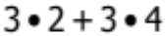

Which of the following models best represents 3(2+4) = ? (Circle ONE answer.)

a)

b)

c)

d)

e)

12. Ms. Peña noticed that different textbooks define functions in different ways. She wants a definition that is both mathematically accurate and comprehensible to her middle school students. Which of the following definitions would best meet her criteria? (Circle ONE answer.)

- A graph that passes the vertical line test.
- A one-to-one mapping of a set of numbers (or elements) X onto a set of numbers (or elements) Y.
- A mapping of each number (or element) in a set to exactly one number (or element) in another set.
- A relationship between two quantities that is usually shown by a graph, a table of number pairs, or an equation.
- A set of ordered pairs such that each element of the domain appears as the first element of a unique ordered pair.

13. Mr. Rivera has noticed that although his students can solve systems of linear equations using several different methods (elimination, substitution, and by guess and check/inspection), many of his students tend to stick with one method on all systems that they solve, even when there might be a more strategic or efficient method for a particular problem. To address this issue, Mr. Rivera gave his students a matching problem. Assuming each method matches only one problem, draw lines connecting each problem to its most strategic solution method.
a) 2x + y = 4  2x + y = 3 |  |  |  | Elimination/linear combination
b) y = 2x + 1  3x + 2y = 9 |  |  |  | Guess and check/inspection
c) 2x + 5y = 5  7x – 5y = 12 |  |  |  | Substitution

14. Mrs. Charalambous asked her students to describe a situation that could be modeled by the following velocity graph:
Time
Velocity

Students proposed different scenarios. Which of the following best fits this graph? (Circle ONE answer.)

a) A ball rolling up a hill.
b) A ball rolling down a hill.

c) A ball dropping from the top of a building.

d) A ball thrown downward from the top of a building.

e) All of these situations fit the graph equally well.

15. During a unit on patterns, sequences, and functions, a student, Mayra, asked how sequences are related to functions. Several students offered ideas about whether sequences are functions. Which of the following demonstrates the best understanding of the relationship between sequences and functions? (Circle ONE answer.)

a) Sequences are not functions, because a sequence is only a list. Functions require both an x and a y.

b) Some sequences are functions, while others are not. Simple sequences can easily be modeled as functions (e.g., 4, 7, 10, 13… corresponds to a linear function), while more complex sequences (e.g., 8, 1, 1, 8, 1, 1, 8, 1, 1, 8, 1, …, or the Fibonacci sequence) cannot.

c) Sequences can be interpreted as functions, because the domain can be thought of as the counting numbers.

d) Sequences and functions are just different names for the same thing. Every sequence is a function, and every function is a sequence (e.g., ordered by the real line).

e) Sequences are linear functions because each term is one more than the previous term.

16. Which of the following situations could be used as an example for teaching about linear functions? (Circle ONE answer.)

  - The cost of printing n copies of a 5-page test, where each page costs 4¢ to print.
  - The cost of printing n brochures if there is a set-up cost of $20 and each brochure costs $1.50 to print.
  - The total number of pennies you have if each day the number of pennies you are given is two more than the number you were given the previous day.

a) Situations i and ii only

b) Situations i and iii only

c) Situations ii and iii only

d) Situations i, ii, and iii

Section 2: Your background and teaching

1. Please indicate the total number of years you have taught mathematics: ____

2. Please indicate the grade(s) to which you presently teach mathematics. (Check ALL that apply):

__ Grades K-3 | __ Grade 7
__ Grade 4 | __ Grade 8
__ Grade 5 | __ Grade 9
__ Grade 6 | __ Grade 10 or higher
___ I do not presently teach mathematics

3. Please indicate grades in which you have ever taught mathematics. (Check ALL that apply).

__ Grades K-3 | __ Grade 7
__ Grade 4 | __ Grade 8
__ Grade 5 | __ Grade 9
__ Grade 6 | __ Grade 10 or higher
___ I have never taught mathematics

4. Do you teach in a self-contained classroom (i.e., you are responsible for all subjects?)

__ Yes (skip to question #6)
__ No

5. If you teach in a mathematics department, please indicate the courses you currently teach: (Check ALL that apply.)

__ Remedial mathematics (e.g. consumer mathematics)
__ Special education mathematics
__ General mathematics
__ Integrated mathematics program (e.g. Connected mathematics)
__ Pre-algebra
__ Algebra
__ Geometry
__ AP Statistics
__ Other mathematics course ____________________________________

6. How much total time have you spent on in-service education about statistics (or the teaching of statistics) and about mathematics in the past year? Include attendance at professional meetings, workshops, and conferences, but do not include formal courses for which you have received college credit. (CIRCLE ONE RESPONSE )

Approximate hours of in-service
education in the past year:
- None | 1
- Less than 6 hours | 2
- 6-15 hours | 3
- 16-35 hours | 4
- More than 35 hours | 5

7. About how many undergraduate or graduate level classes have you taken at a college or university in the following areas? (Circle ONE response for each item.)

 | No classes | One class | Two classes | Three or more classes
Mathematics | 1 | 2 | 3 | 4
- Methods of teaching Mathematics | 1 | 2 | 3 | 4

8. How often do the students in your statistics class do the following? (Circle ONE response for each item.)

 | Never | Less than once a month | 1-3 times per month | 1-2 times per week | 3-4 times per week | Every day
- Listen to me present the definition of a term or the steps of a procedure. | 1 | 2 | 3 | 4 | 5 | 6
- Perform tasks requiring methods or ideas already introduced to them. | 1 | 2 | 3 | 4 | 5 | 6
- Assess a problem and choose a method to use from those already introduced to them. | 1 | 2 | 3 | 4 | 5 | 6
- Explain an answer or a solution method for a particular problem. | 1 | 2 | 3 | 4 | 5 | 6
- Analyze similarities and differences among representations, solutions, or methods. | 1 | 2 | 3 | 4 | 5 | 6
- Prove that a solution is valid or that a method works for all similar cases | 1 | 2 | 3 | 4 | 5 | 6

9. For what grade levels did you receive your credential, or expect to receive your credential if in progress? (Check ALL that apply.)

__ Grades K-3 | __ Grade 8
__ Grade 4 | __ Grade 9
__ Grade 5 | __ Grade 10
__ Grade 6 | __ Grade 11
__ Grade 7 | __ Grade 12

10. For what subject matters did you receive your credential, or expect to receive your credential (if in progress)? (Check ALL that apply.)

__ All subjects (generalist)
__ Mathematics
__ Science
__ Other subject matter-specific credential: ___________________________

11. Please indicate your credential status: (Check ONE answer)

__ Emergency
__ Waiver
__ Intern
__ Preliminary
__ Completed (full/clear)
12. Are you:

__ Hispanic, regardless of race
__ Black, not of Hispanic origin
__ White, not of Hispanic origin
__ Asian or Pacific Islander
__ American Indian or Alaskan Native
__ Biracial/multiracial
__ Other ________________

13. Is English your first (native) language? Yes ___ No ___

14. Are you: Female ___ Male ___

THANK YOU FOR COMPLETING THIS QUESTIONNAIRE!

If you have any comments about the questions, please write them in the space below.

Copyright © 2008 The Regents of the University of Michigan. For information, questions, or permission requests please contact Merrie Blunk, Learning Mathematics for Teaching, 734-615-7632. Not for reproduction or use without written consent of LMT. Measures development supported by NSF grants REC-9979873, REC- 0207649, EHR-0233456 & EHR 0335411, and by a subcontract to CPRE on Department of Education (DOE), Office of Educational Research and Improvement (OERI) award #R308A960003.

