**What:** Proposal to utilize the **GOAL Program - Challenge Course** in SOWK 5327: Groups and SOWK 4425: Practice III

**Purpose:** Each of these courses has a practical group work component (lab) to help students experience what it is like being in a group so they are prepared for this aspect of their social work field education. Participation in the GOAL Program would allow students to experience an adventure-based group modality and then reflect on how to apply this type of intervention within a therapeutic setting and with special populations. Group members will discuss ethical issues around adventure-based practice, along with potential risks and benefits of this approach. Students will be given supplemental readings from peer-reviewed journals about the utilization of this type of modality.

**When:** November 15/16, 2008 or November 22/23, 2008

**Where:** University Camp – Challenge Course

**Costs:** Students must each pay $7 and carpool out to University Camp; the rests of the costs are supported by the School of Social Work

The G.O.A.L. PROGRAM stands for Group Oriented Achievement 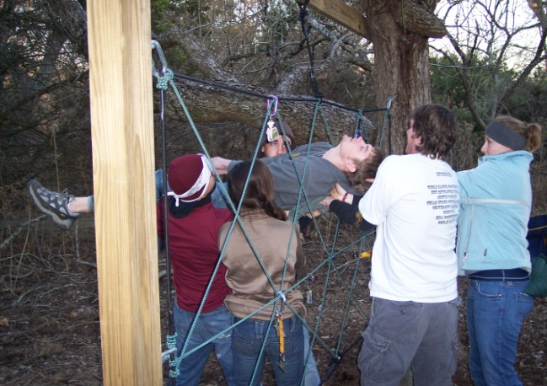and Learning.   
This program is tailored to focus on the achievement and learning of individual groups and their members. The G.O.A.L. Program is based on Experiential Education principles and philosophy using initiatives and activities that are socially, mentally, physically, and environmentally challenging.  Activities are designed to strengthen group cohesiveness, group processing, interpersonal relationships, or individual members' self-awareness and confidence level.  Within the G.O.A.L. program our staff will specially tailor a program to fit your group needs.

(Retrieved from: <http://www.campusrecreation.txstate.edu/programs/outdoor/g-o-a-l-program.html> on 9/9/08).

They offer...

* Low Elements
* Portable Low Elements (at a site you select or at the camp)
* High Elements (following completion of low elements session)

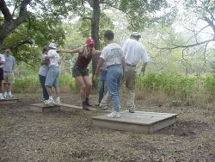**Low Elements*-** Low Elements focus on the group as a whole by presenting problem-solving scenarios that require teamwork, trust, leadership, and communication skills. The group finds success through working together and depending upon the member's strengths.

Portable Low Elements- Can't get your group to University Camp?  We can bring the Portable Low Elements to you!  The G.O.A.L. Program staff can bring similar group challenges and problem-solving scenarios offered at the Challenge Course with the convenience of having them at your chosen location.

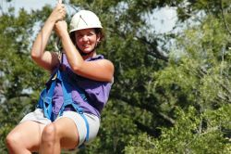**High Elements*-** High Elements focus on individual achievements by providing the opportunity to push oneself both physically and mentally through controlled risk-taking situations.  The group is also challenged to provide support and encouragement in order to create the type of environment that will assist individuals in accomplishing their goals.  For group development, groups must participate in Low Elements prior to or on the same day as the Highs.

**\*The students in SOWK 5327 and SOWK 4425 would participate in a full day of both low and high elements.  However, it has been made clear that this is a VOLUNTARY activity, and that their course grade will in no way be jeopardized by their non-participation. Students who do participate will be given 10 extra credit points towards their semester grade. An alternative assignment for extra credit will also be given. All students who choose to participate will need to complete the forms below, and the School of Social Work will not be liable for this experience.**

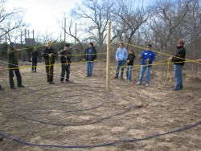

* Application Form [(pdf)](http://www.campusrecreation.txstate.edu/programs/outdoor/g-o-a-l-program/contentParagraph/00/content_files/file/GOAL%20Application%20Form.pdf) ([doc](http://www.campusrecreation.txstate.edu/programs/outdoor/g-o-a-l-program/contentParagraph/00/content_files/file4/application.doc))
* Release and Indemnity Agreement Form [(pdf)](http://www.campusrecreation.txstate.edu/programs/outdoor/g-o-a-l-program/contentParagraph/00/content_files/file2/Release%20and%20Indemnity%20Agreement.pdf) [(doc)](http://www.campusrecreation.txstate.edu/programs/outdoor/g-o-a-l-program/contentParagraph/00/content_files/file6/Release%20and%20Indemnity%20Agreement.doc)
* Health Form [(pdf)](http://www.campusrecreation.txstate.edu/programs/outdoor/g-o-a-l-program/contentParagraph/00/content_files/file7/Health%20Form%20-%20GOAL%20program.pdf) [(doc)](http://www.campusrecreation.txstate.edu/programs/outdoor/g-o-a-l-program/contentParagraph/00/content_files/file15/Health%20Form%20-%20GOAL%20program.doc)