Texas School Safety Center

***Letter of Agreement***

**Project Title: The Impact of ClubGEN on Personal and Professional Skills**

**Principal Investigator: Maggie Watson**

**Associate Investigator(s): Rebekah Sills Lamm**

**Name of Organization or Institution Providing Support: GENaustin**

**Name and Title of Individual Authorizing Support: Rachel Ladov**

**Assistance Requested:** *Access to evaluation results concerning the ClubGEN afterschool program. GENaustin understands that the TX School Safety Center will lead a focus group with the leaders of clubGEN. GENaustin agrees to provide evaluation results as support data.*

**Estimated Duration of Study:** *October 2009-October 2010*

11/23/09

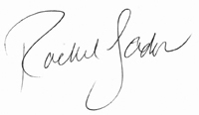

______________________________________________ ________________________

Signature of Approving Authority Date

*To the approving authority: if you have comments or specific instructions for the Principal Investigator, please note them below:*