IRB SYNOPSIS OR PROPOSAL

The Association of the Presence of Insomnia and Level of Excessive Daytime Sleepiness in a Veteran Population on a College Campus

1. The source of the potential subjects is students that are enrolled in the spring 2010 semester with a veteran status at Texas State University – San Marcos. Subjects will not be excluded because of ethnicity or gender or state of health. They will have previously served in the United States Armed Forces and be adults aged eighteen years and older. The population will be approximately 1200 and I hope to have a participation number of 300 or higher.
2. With granted permission from the office of Veterans Affairs at Texas State University – San Marcos, an email will be sent out to the enrolled veterans by the office of Veterans Affairs on my behalf. The information contained in the email will describe the study along with an invitation to participate and consent form. Also included will be a link to the survey that participants will be asked to complete. A written consent form will not be obtained however, before the link, a sentence in all caps and bold will inform the participant that by clicking on the link below they will be giving consent to participate in this survey and agree that they understand the consent form and its contents.
3. Once IRB approval has been granted an email will be sent out to all veterans enrolled at Texas State in the spring semester. Those that choose to participate will click on a link and complete a survey that consists of a collaboration of seven demographic questions and two short valid and reliable adopted instruments. The surveys will be collected and be secured through a paid online survey agency (SurveyMonkey). Data from the questionnaire will be taken from their secure location, and transferred to an excel spreadsheet. Special care will be taken to ensure accurate transfer, and minimization of error. Excel will allow the cleaning and organization of data prior to analysis. Data will be transferred to SPSS for analysis and statistical testing.
4. There are no potential risks.
5. No names or means of identification will be collected to protect the privacy of the participants. No mental health and medical treatment will be needed for providing responses to the survey.
6. There will be no benefits for the participants; however by participating in this study they can help researchers gain a better understanding of the demographics, presence of insomnia, level of excessive daytime sleepiness and associations with this specific population. Results and further investigation can potentially lead to implementation of various strategies in hopes to improve the sleep status of veteran college students.
7. There will be no compensation offered or provided to the participants of this study.
8. The risks are low and the potential benefits are high. There is currently no literature that investigates the presence of insomnia and level of excessive daytime sleepiness and its associations specifically on veteran college student populatio. This study would be a baseline and possible foundation to future research. The potential benefits outweigh the potential risk by far.
9. The Office of Veterans Affairs will be the agency that will be assisting me in this study. I have been granted approval to contact the enrolled veterans.
10. The proposed research directly relates to all courses in the academic module of my MSIS Occupational Education degree. My academic module focuses on sleep and includes eighteen hours of polysomnography studies. Dr. Albert S. Dietz is my supervising faculty.
11. Dr. Dietz has approved this study and a copy of the contract will be provided.
12. The proposed study has not been reviewed/approved by another IRB.
13. Individuals that will have access to the results during this study include Dr. Albert Dietz, supervising faculty, Dr. Lynda Harkins, independent evaluator, and myself. After completion of this study, it will be accessible to the public.

Demographic Questions that will be asked:

1. Gender:

Male

Female

1. Age:

18-29

30-39

40-49

50-59

60+ years of age.

1. Ethnicity:

White

Hispanic

African-American

Asian

American Indian

Other

1. What is the number of years that you have attended college before and after military service?

1-2

3-4

5-6

7+ years

1. Have you had previous combat experience?

Combat Experience

No combat experience

1. What is the length of time since your last deployment or discharge?

less than 1 year

1-5 years

6-10 years

11-20 years

21+ years.

1. Based on your past medical history, have you ever been diagnosed with Post Traumatic Stress Disorder (PTSD) since you’ve been in the United States Armed Forces?

Diagnosis of PTSD

No diagnosis of PTSD

Instruments

**Epworth Sleepiness Scale**

Your age (Yrs): _______________ Your sex (Male = M, Female = F): ________

How likely are you to doze off or fall asleep in the following situations, in contrast to feeling just

tired?

This refers to your usual way of life in recent times.

Even if you haven’t done some of these things recently try to work out how they would have affected

you.

Use the following scale to choose the **most appropriate number** for each situation:

0 = would **never** doze

1 = **slight chance** of dozing

2 = **moderate chance** of dozing

3 = **high chance** of dozing

***It is important that you answer each question as best you can.***

**Situation Chance of Dozing (0-3)**

Sitting and reading __________________________________________________________________________

Watching TV _________________________________________________________________________________

Sitting, inactive in a public place (e.g. a theatre or a meeting) _____________________________

As a passenger in a car for an hour without a break _____________________________________

Lying down to rest in the afternoon when circumstances permit ___________________________

Sitting and talking to someone_____________________________________________________________

Sitting quietly after a lunch without alcohol___ ___________________________________________

In a car, while stopped for a few minutes in the traffic ___________________________________

***THANK YOU FOR YOUR COOPERATION***

© **M.W. Johns 1990-97**

**PITTSBURGH INSOMNIA RATING SCALE**

*The following questions ask about your sleep* ***in the past 7 days and nights****. Please circle the one* ***best*** *answer for each question.*

**A. In the past week, how much were you Not at all Slightly Moderately Severely**

**bothered by: bothered bothered bothered bothered**

|  |  |  |  |  |
| --- | --- | --- | --- | --- |
| 1. One or more awakenings after getting into sleep | 0 | 1 | 2 | 3 |
| 2. Not getting enough sleep | 0 | 1 | 2 | 3 |
| 3. Sleep that doesn’t fully refresh you | 0 | 1 | 2 | 3 |
| 4. Poor alertness during the daytime | 0 | 1 | 2 | 3 |
| 5. Difficulty keeping your thoughts focused | 0 | 1 | 2 | 3 |
| 6. Others noticing you appeared tired or fatigued | 0 | 1 | 2 | 3 |
| 7. Too many difficulties to overcome | 0 | 1 | 2 | 3 |
| 8. Bad mood(s) because you had poor sleep | 0 | 1 | 2 | 3 |
| 9. Lack of energy because of poor sleep | 0 | 1 | 2 | 3 |
| 10. Poor sleep that interferes with your relationships | 0 | 1 | 2 | 3 |
| 11. Being unable to sleep | 0 | 1 | 2 | 3 |
| 12. Being able to do only enough to get by | 0 | 1 | 2 | 3 |

**B. Please circle the best answer for each question about the past week:**

13. From the time you tried to go to sleep, how long did it take to fall asleep on **most** nights?

1. Less than ½ hour
2. Between ½ to 1 hour
3. Between 1 to 3 hours
4. More than 3 hours or I didn’t sleep

14. If you woke up during the night, how long did it take to fall back to sleep on **most** nights?

1. Less than ½ hour or I didn’t wake up
2. Between ½ to 1 hour
3. Between 1 to 3 hours
4. More than 3 hours or I didn’t fall back to sleep

15. Not counting times when you were awake in bed, how many hours of **actual** sleep did you get during the **worst** night?

1. More than 7 hours
2. Between 4 to 7 hours
3. Between 2 to 4 hours
4. Less than 2 hours or I didn’t sleep

16. On how many days did you have trouble coping **because of poor sleep**?

1. None or 1 day
2. On 2 or 3 days
3. On 4 or 5 days
4. On 6 or all days

**C. Over the past week, how would you rate: Excellent Good Fair Poor**

|  |  |  |  |  |
| --- | --- | --- | --- | --- |
| 17. Your sleep quality, compared to most people | 0 | 1 | 2 | 3 |
| 18. Your satisfaction with your sleep | 0 | 1 | 2 | 3 |
| 19. The regularity of your sleep | 0 | 1 | 2 | 3 |
| 20. The soundness of your sleep | 0 | 1 | 2 | 3 |

Agency Approval

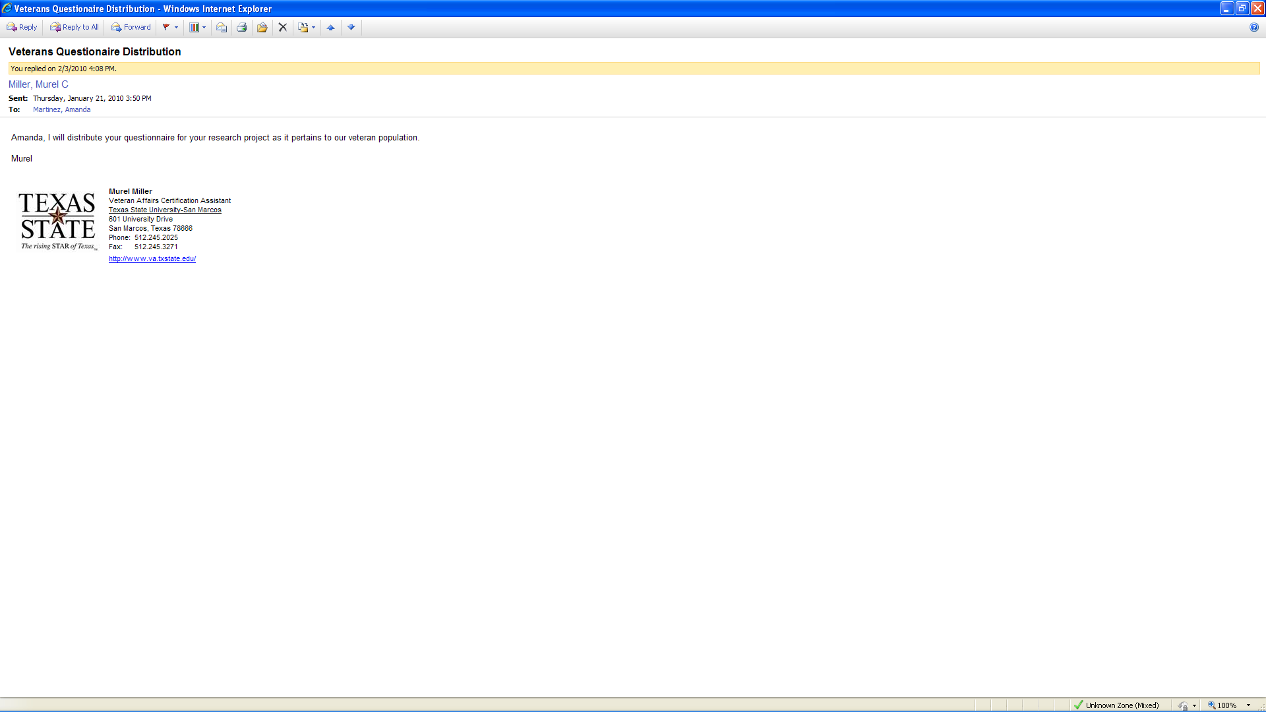

|  |  |
| --- | --- |
| |  | | --- | | **CITI Collaborative Institutional Training Initiative** | |
| |  |  | | --- | --- | | **Human Research Curriculum Completion Report** | | | **Printed on 12/4/2009** | | |  | | | **Learner:** Amanda Martinez (username: am1316) | | | **Institution:** Texas State University - San Marcos | | | **Contact Information** | Email: am1316@txstate.edu |  |  |  |  |  |  |  |  |  |  |  |  |  |  |  |  |  |  |  |  |  |  |  |  |  |  |  |  |  |  |  |  |  |  |  |  |  |  |  |  |  |  |  |  |  |  |  |  |  |  | | --- | --- | --- | --- | --- | --- | --- | --- | --- | --- | --- | --- | --- | --- | --- | --- | --- | --- | --- | --- | --- | --- | --- | --- | --- | --- | --- | --- | --- | --- | --- | --- | --- | --- | --- | --- | --- | --- | --- | --- | --- | --- | --- | --- | --- | --- | --- | --- | --- | |  | **Social and Behavioral Research:**   **Stage 1. Basic Course Passed on 12/04/09** (Ref # 3815795)   |  |  | | --- | --- | | **Required Modules** | **Date Completed** | | Introduction | 12/04/09 | no quiz | | History and Ethical Principles – SBR | 12/04/09 | 4/4 (100%) | | Defining Research with Human Subjects - SBR | 12/04/09 | 5/5 (100%) | | The Regulations and The Social and Behavioral Sciences - SBR | 12/04/09 | 5/5 (100%) | | Assessing Risk in Social and Behavioral Sciences - SBR | 12/04/09 | 5/5 (100%) | | Informed Consent – SBR | 12/04/09 | 4/4 (100%) | | Privacy and Confidentiality – SBR | 12/04/09 | 3/3 (100%) | | Research with Prisoners – SBR | 12/04/09 | 4/4 (100%) | | Research with Children – SBR | 12/04/09 | 4/4 (100%) | | Research in Public Elementary and Secondary Schools - SBR | 12/04/09 | 4/4 (100%) | | International Research – SBR | 12/04/09 | 3/3 (100%) | | Internet Research – SBR | 12/04/09 | 5/5 (100%) | | Workers as Research Subjects-A Vulnerable Population | 12/04/09 | 4/4 (100%) | | Conflicts of Interest in Research Involving Human Subjects | 12/04/09 | 0/2 (0%) | | Texas State University - San Marcos | 02/06/07 | no quiz |   **For this Completion Report to be valid, the learner listed above must be affiliated with a CITI participating institution. Falsified information and unauthorized use of the CITI course site is unethical, and may be considered scientific misconduct by your institution.**  Paul Braunschweiger Ph.D. Professor, University of Miami Director Office of Research Education CITI Course Coordinator | |

Recruiting Document that will be sent via e-mail

Dear potential participant,  
   
You have been selected as a participant to take this survey for a graduate research project that will study **The Association of the Presence of Insomnia and Level of Excessive Daytime Sleepiness in a Veteran Population on a College Campus** .  
   
**IRB Approval # ________________________**

**Consent Form**

My name is Amanda Martinez and I am a graduate student at Texas State University working toward a master’s degree in Interdisciplinary Studies, Department of Occupational Education, College of Applied Arts.  This study will provide data to determine the presence of insomnia and the level of excessive daytime sleepiness on college students with a veteran status as well as provide demographics. The survey will consist of approximately 35 questions and should take no more than 15 minutes to complete.   
  
All collected data will be kept confidential and no identifying information will be collected or reported from this survey. No summary of data will be compiled and released to participants. Your participation is voluntary and your decision to participate will not affect your future relations with Texas State University. If you decide to participate, you are free to discontinue participation at any time during the assessment. Any questions, concerns or comments regarding this study should be directed to the supervising instructor, **Dr. A. Steven Dietz at 512-245-2115.**  
To take the survey now, click on the link below  
**BY CLICKING ON THE LINK BELOW, YOU ARE GIVING CONSENT TO PARTICIPATE IN THIS SURVEY AND AGREE THAT YOU UNDERSTAND THE CONSENT FORM AND ITS CONTENTS.**   
  
[https://](https://synergy.txstate.edu/owa/redir.aspx?C=52eb52ec9d5e479fa4366115bc585e14&URL=https%3a%2f%2ftracs.txstate.edu%2fportal%2flogin)   
  
 Thank you,

Amanda Martinez, BSRC, RRT-SDS