1. **Introduction:** There is an annual estimate of 1.5 million persons who experience traumatic brain injury. Approximately 80% are classified as mild (mTBI). In addition, the current conflict in Iraq and Afghanistan has increased the incidence of mTBI as associated with the increase in blast related injuries. Emerging studies suggest that oculomotor dysfunction may be related to several other common symptoms post mTBI as part of a “symptom cluster” including headache, fatigue, complaints of dizziness and imbalance, difficulties with hearing, difficulties with memory and concentration, post traumatic stress disorders, sleep disorder and volatile emotional states (Hoge 2008). Symptoms relating to oculomotor dysfunction can also lead to post traumatic vertigo and can be debilitating for return to previous functional levels such as work. However, a review by Ponsford (2004) found that oculomotor rehabilitation successfully helped decrease several related symptoms to allow return back to a higher ADL function after treatment twice a week for 8 weeks (Kapoor 2004). The complex presentation of oculomotor dysfunction within the “symptom cluster” continues to challenge rehabilitation specialists to improve diagnostic and treatment strategies to better care for persons after mTBI (Marzo 2004). Recent work mentioned suggests that there are tremendous benefits, however there continues to be a paucity of work investigating standardized assessment of oculomotor function during recovery of persons after mTBI.
2. **Preliminary Oculomotor Studies at Texas State:** Previous work by our research team suggests that oculomotor function can be measured with high accuracy using 2-dimensional measurements with the Tobii x120 eye-tracker (Stockholm, Sweden) which uses a sampling rate of 120Hz, accuracy of ± 0.5°, spatial resolution ±0.2°, and drift ±0.3°. We have thus been able to demonstrate fine motor control in the oculomotor system as influenced by gender, substance abuse and age. For example, results indicate that saccade latencies vary around mean values of 219 (+/- 31)ms with longer delays associated with ETOH abuse. In addition, aspects of oculomotor dysmetria indicating overshoot or undershoot have varied with a mean magnitude of overshoot of 1.3º (+/- 0.8º) and undershoot of 1.5º (+/- 0.9) (unpublished results).

Dynamic visual acuity for horizontal (DVA-h) and vertical (DVA-v) head movements was also found to be with significant deficits in persons after mTBI compared to age-matched healthy participants. Impaired mean DVA-h error values were 2.09 (± 1.22) compared to 1.50 (± 1.18) lines in the healthy group while mean DVA-v values were 1.80 (± 1.03) compared to 1.73 (± 0.90) lines respectively. Thus, our work agrees with other well-known labs (Leigh & Zee 2006) indicating that deficits in oculomotor response occur even with mild neurological disorders. However, we have yet to explore how all documented components of oculomotor dysfunction in persons with mTBI might respond simultaneously over time during phases of recovery or customized rehabilitation similar to those suggested by Kapoor et al (2004).

1. **Research Design and Methods:**
2. **Objectives:** This one-year project proposes a test-retest study design to develop a computerized assessment of oculomotor dysfunction in persons with mTBI.

* **Aim 1:** Compare oculomotor function in persons with and without mTBI in response to a recently developed computerized assessment battery.
* **Aim 2:** Compare oculomotor function in persons with and without mTBI in response to repeated exposure to the assessment battery.

1. **Methods:** Twenty (20) participants aged 18 – 40 years of age will be recruited from the Student Health Center and Physical Therapy Clinic at Texas State and the University Medical Center Brackenridge Hospital, Austin, Texas. Ten (10) persons with diagnosed mTBI and ten (10) persons without a history of mTBI will be recruited as a control group. All participants will provide informed written consent according to Texas State policies for human subject protection. Inclusion criteria will include binocular vision with visual acuity at least 20/100, eye tracker “literate” or trackable pupils, at least 4 weeks post a head injury classified as 13-15 on the Glasgow Coma Scale or a Grade 1-2 concussion, no spine abnormalities, and a Mini-Mental State Exam score of at least 25.

**2a. Assessment of Quality of Life:** All participants will complete a simple medical history form and then be screened by a physical therapist to ensure appropriate inclusion in the project. Then each participant will complete two standardized quality of life questionnaires, the Neurobehavioral Symptom Index (NSI: 22-item) and the Dizziness Handicap Index (DHI: 25-item). Both clinical questionnaires have demonstrated high sensitivity and specificity as a self-report of how symptoms might affect participation in activities of daily living following mTBI (Cicerone 1995, Jacobson 1990).

**2b. Computerized Assessment of Oculomotor Function:** Dynamic visual acuity (DVA) will be assessed using the standardized NeuroCom InVision® protocol (NeuroCom International, Inc.). This computerized clinical test quantifies a patient’s ability to maintain visual acuity and stable gaze while actively moving the head. The test includes two protocols to test both Dynamic Visual Acuity (DVA) and Gaze Stability (GS). The DVA measurement quantifies the impact of the vestibular ocular reflex (VOR) system impairment for a patient’s ability to perceive objects accurately while moving the head at a given velocity on a given movement axis (i.e. vertical, horizontal or diagonal). The GS measurement quantifies the range of head movement velocities on a given axis over which a patient is able to maintain an acceptable level of visual acuity. Activities of daily living require gaze stability at head velocities up to 120 degrees per second (Leigh & Zee 2006).

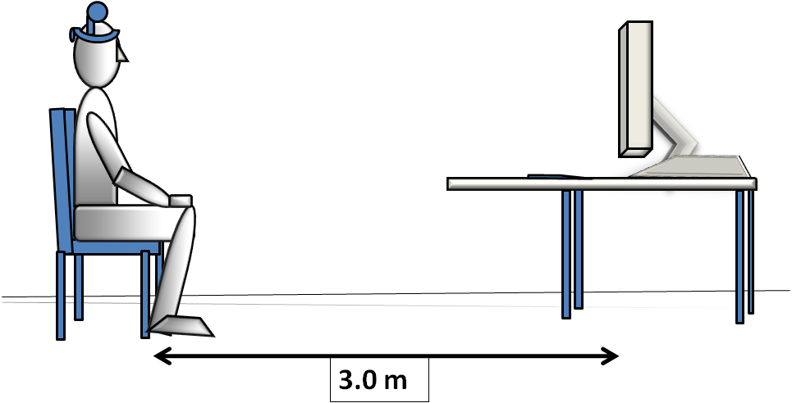

**Figure 1:** Participants sit in a comfortable chair 3.0 meters from the computer screen while wearing a light weight headband with sensor of the InVison® system. Participates will identify the orientation of an optyotype “E” while moving the head to compare static and dynamic visual acuity.

Participants, wearing a lightweight headband and sensor, will be asked to sit in a comfortable chair 10 feet in front of a computer screen. (Figure 1) The participant will assess the orientation of the visual optotype “E,” which will be manipulated in size to record differences in visual acuity during static and dynamic head positions. A head sensor will record the participant’s head position and movement velocity in three axes during testing. Test scores will be used to quantify aspects of oculomotor function.

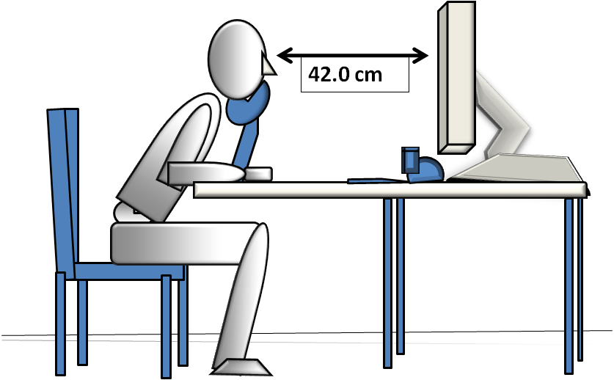

**70cm**

Figure 2: Assessments of Smooth Pursuit and Saccadic Oculomotor movements. Participants will sit comfortably with the head resting on a chin rest while viewing targets on a computer screen while 2.-dimensional eye movements are recorded by the Tobii x120 ® computerized eye-tracking system.

In addition, aspects of smooth pursuit (SP) and saccadic (SC) oculomotor function will be assessed using the Tobii x120® computerized eye-tracking system which uses infrared light to track papillary 2-dimensional movements at a sampling rate of 120Hz.

Each participant will be asked to sit in front of a 19 inch monitor with the chin resting comfortably on a chin rest and look at a special stimulus designed to invoke saccades and smooth pursuit eye movements. (Figures 2 & 3) The eye movement data will be recorded and then processed offline by MATLAB® analysis software to validate proposed oculomotor function metrics. All participants will participate in three test sessions (baseline-T1, 1 week-T2, and 2-weeks-T3).

Figure 3:

Example of simple eye movement patterns for the computerized Smooth Pursuit and Saccadic Oculomotor Assessment. Patterns increase in complexity by using varied target positions and numbers.



1. **DATA MANAGEMENT AND ANALYSIS**

A repeated-measures ANOVA statistical approach will be used to compare group versus time interactions. Independent variables will be Group and Time while dependent variables will be questionnaire scores and oculomotor measurement scores. A reliability analysis will use the Spearman-Brown Coefficient of Reliability calculated with a hypothesized mean of zero. SPSS (vs.17.0) will be used for database management and data analysis. A power analysis (Power & Precision vs. 3.0) was conducted for a sample size of 20 subjects (10 per group) using criterion for significance 80% power and an alpha 0.05, for a 2-tailed test. The interaction between the within and between group factors will achieve 76 – 82%*. A Geisser-Greenhouse Corrected F Tests is assumed to be used.* Therefore, effect sizes will be assumed as medium according to Cohen’s guidelines.

**Budget and Specific Roles of Investigators:**

* Dr. Gobert (30% effort) will coordinate participant assessment protocols and conduct student training along with the study design & development, data collection & interpretation, analysis, & reports.
* Dr. Komogortsev (30% effort) coordinate all eye-tracking monitoring and computer programming methodology and conduct student trainging along with contributions to study, design & development, data collection / analysis, and reports.
* Two graduate student assistants (50% effort) will receive specialized training to assist in participant recruitment, development of the eye-tracker programming for the stimulus presentation, raw eye position processing and data reduction, eye movement metric assessment algorithms and data validation, assessment protocols and data analysis.

CONCLUSION

The primary goal of this one-year study will be to develop a reliable assessment battery for oculomotor function in persons with mTBI and to explore responses to repeated exposure of our computerized protocols. Therefore, our project proposes a systematic assessment of oculomotor function to characterize and detect specific components over time. Results will also be used as the basis for subsequent, therapeutic oculomotor training for persons with mTBI. Therefore, this proposed project describes a unique approach to augment and support rehabilitation strategies for persons with mTBI.

**References:**

1. Bryant, D. Disentangling Mild Traumatic Brain Injury and Stress Reactions, NEJM, (2008),Vol(5)358:525-527.
2. Cicerone KD. Neurobehavior Symptom Inventory, J Head Tr Rehabilitation. 1995: 10 (3): 1-17.
3. Hoge CW., et al, Mild Traumatic Brain Injury in U.S. Soldiers Returning from Iraq, NEJM,(2008),Vol(5) 358:453-463.
4. Jacobson et al. The development of the Dizziness Handicap Inventory. *Arch OtolaryngolHead Neck Surg*1990:Vol. 116 No. 4, April 1990
5. Kapoor et al. “Oculomotor rehabilitation in acquired brain injury: A case series”, Archives of Physical Medicine and Rehabilitation, Vol 85, (10), October 2004, Pages 1667-1678
6. Leigh, R. J. and D. S. Zee (2006). The Neurology of Eye Movements, Oxford University Press.
7. Marzo, S et al. (2004). Diagnosis and management of post traumatic vertigo. Laryngoscope, 114(10)(October), 1720-1723.
8. Ponsford JL et al. (2008). Gender differences in outcome in patients with hypotension and severe traumatic brain injury. Injury, Int. J. Care Injured, 39, 67—76.