*IoT-Enabled Medicine Dispenser for Pills and Liquid Medication*

Nabeel Hassan

*Computer Science, Sharda University*

Greater Noida, India

[sk.hassan2013@gmail.com](mailto:sk.hassan2013@gmail.com)

Aditya Gaur

*Computer Science, Sharda University*

Greater Noida, India

[adityagaur9457@gmail.com](mailto:adityagaur9457@gmail.com)

Yash Jadaun

*Computer Science, Sharda University*

Greater Noida, India

[yashthakur8283@gmail.com](mailto:yashthakur8283@gmail.com)

Akash Bhasney

*Computer Science, Sharda University*

Greater Noida, India

[akash.bhasney@sharda.ac.in](mailto:akash.bhasney@sharda.ac.in)

***Abstract*—This study presents a technology for developing an IoT-Based Drug Dispenser to enhance adherence to drugs by the elderly. With the option to automatically dispense pills and liquid medications and a user-friendly interface for caregivers, the system ensures medications are accepted on time and enables simplified compliance monitoring. The system integrates an Arduino UNO that acts as a slave and controls various hardware components, with a Raspberry Pi 4B acting as the master. The Raspberry Pi hosts a web application that schedules drug delivery and communication, while the Arduino manages all sensors and actuators involved in delivery. Use of an intuitive, web-based application enables caretakers to prescribe medications remotely, obtain notifications, and supervise drug usage. With the deployment of the described medication dispensing system based on IoT technology, an impressive increase in medication adherence is seen in elderly patients. The impact was that adherence improved notably through real-time monitoring due to scheduling alerts and remote management features resulting in reduced missed doses. By and large, the elderly population’s problem of not taking their medicine was addressed using the IoT-enabled medication dispenser, leading to better patient results as well as quality of life improvements.**

***Keywords— internet of things, raspberry pi, python, arduino uno, c++, solenoid valve, servo motor, buck converter, smtp protocols, twilio api.***

1. INTRODUCTION

In the era of the Internet of Things (IoT), we see many new developments in healthcare technology relying on smart devices coming into being, with the goal of providing better and more efficient patient care. [1]. One prominent example includes a high-tech IoT-based medicine dispenser that addresses the specific needs of elderly people. [2]. This sophisticated technique revolutionises conventional medicine dispensation procedures by incorporating hi-tech hardware and software platforms that guarantee prompt and precise drug administration, which is crucial in elderly healthcare [3]. The study investigates the clash between medication non-adherence issues and the potential of IoT in elderly care. It points out that non-adherence problems are not only multifaceted but also directly connected to IoT’s power to monitor the physical condition and quality of life of elderly individuals remotely [4]. It underlines the importance of interventions that would be both original, psychosocially oriented, and integrated methods that would use individual behavior dynamics as well as technological developments in order to improve elder care and ensure medication adherence. [5].

The solution presented here is a dependable, user-friendly medicine dispenser for both pill and liquid forms of medications and an intuitive web-based application for caregivers. The idea behind this approach is to ease medication management as well as create a platform that can facilitate direct interaction between patients and their respective carers.

The ultimate aim of this study is to mitigate the risks associated with missed or incorrect dosages of medication, which can lead to severe health complications or even fatalities among the elderly. By leveraging IoT technology, this dispenser system seeks to provide a solution that ensures adherence to prescribed medication regimens, reduces the potential for human error, and improves the quality of life for geriatric patients. In doing so, it sets a new standard for personalised, technology-driven patient care.

The following sections of this study deal with the detailed design. In Section II current approaches to the drug dispensing system is discussed. Proposed methodology can be found in Section III, discussing System architecture and algorithm used. In Section IV Experimental result analysis is provided and the conclusion and future scope provided in Section V.

1. LITERATURE SURVEY

To address non-adherence, the current strategy explores smart medication adherence devices and emphasizes their diverse qualities. The study highlights how connection and automation are critical to these device’s ability to manage medications and track adherence in real-time. This study supports clinical decision-making by evaluating multiple smart devices and highlights the need for individualized approachesto improve medication adherence in home settings at the comfort of elderly citizens [6]. Kanna et al. [7] Proposed a smart pill box system that ensures medication adherence and improves patient outcomes through timely notifications and detection functionality. Mahmud et al. [8] proposed an IoT-based smart medicine box to help seniors when face-to-face meetings are not taking place. The system uses sensors and a server to ensure that medications are taken on time and that patients and doctors communicate effectively. Kader et al. [9] proposed an automated medication box to remind elderly and hospitalized patients to take their medications as prescribed. The system includes 21 airtight containers for medication storage, including a weekly medication schedule followed by three daily reminders. Guerrero-Ulloa et al. [10] proposed an automated smart drug dispensing system enhanced by a smartphone application. Alexander, Elizabeth, and Ranjana et al. [11] proposed the creation of an automated medication reminder and health monitoring system for the elderly. The design includes a smart medication box that alerts users to take their medications on time through visual and audible signals. Boudrali and Boudour et al. [12] proposed an IoT-based medication management system. It combines a smart pill dispenser with a mobile app. The device has a locking mechanism to manage prescribed dosage and alert users through mobile notifications and dispenser alerts. Jabeena and Kumar et al. [13] proposed a smart medication dispenser with a method that leverages IoT technology to ensure timely medication administration without human intervention by combining features such as LED indicators and buzzer audible alarms with a GSM module to send notifications to caregivers. Gupta et al. [14] proposed a smart medical box that can monitor basic health parameters such as heart rate, oxygen saturation, and temperature and can also distribute medicines at predefined intervals. Mohanapriya et al. [15] proposed a Raspberry Pi-driven health monitoring system with a focus on vital signs and continuous ECG monitoring.

By assessing the shortcomings of the current approach, this study highlights the need to introduce cutting-edge technological solutions to transform IoT-based smart medication dispensers and promote medication adherence among elderly patients.

1. PROPOSED METHODOLOGY

The proposed approach combines cutting-edge technologies with adaptive controls to address issues of prescription adherence and overuse of preventive medications, thereby promoting a healthy balance between seniors and caregivers.

1. *Overview of the system*

The study presented stands at the confluence of cutting-edge technologies and embodies sophisticated integration that combines the physical precision of hardware with the seamless flexibility of software. At its core, this IoT-enabled medication dispenser is a testament to the potential of modern technology designed to meet the nuanced needs of geriatric patient care. The general overview of the system used presents RaspberryPi as the brain of the system in serial connection with Arduino Uno in master-slave style. The LDR sensor is used to detect the presence or absence of pills in the dispenser, the LM393 sensor is used to detect the insertion of a pill into the container. Servo motors are used for tablet dispensing by adjusting the angle of rotation that determines the amount of medication dispensed. The 24V solenoid valve is used for dispensing liquid medication. The button is used for manual entry by selecting medication or confirming delivery.

The 16 x 2 LCD display provides visual feedback and system status information. The buzzer provides audible warnings or notifications. The LM2596 DC/DC step-down converter is used for power management, which is used to regulate voltage levels by typically converting a higher voltage to a lower voltage to power the system components. The design overview of the proposed solution is shown in Fig. 1.

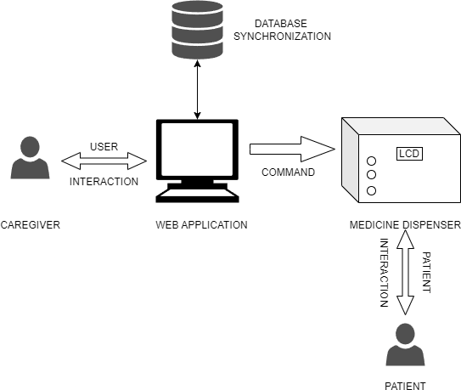

Fig. 1. Design Overview

1. *Hardware specification*
   1. ***Raspberry Pi****:* The Raspberry Pi is a single circuit board computer the size of a visiting card that can run multiple operating systems [16]. It acts as the primary controller in our study, controlling how the drug dispenser operates.
   2. ***Arduino Uno****:* Arduino Uno is a microcontroller board, having both digital and analogue input/output pins [17]. In our study, the Arduino Uno acts as the main controller’s slave by integrating with sensors.
   3. ***Photoelectric Sensor****:* This module detects changes in the light intensity [18]. The sensor in our study is LM393, which is positioned atop the prescription bottle. This allows for precise inventory monitoring and prompt medication distribution.
   4. ***Servo motors****:* Servo motors are rotary actuators with precise acceleration, velocity, and angular position control [18]. Servo motors are employed in our idea to dispense medicine.
   5. ***LM2596 DC-DC Buck Converter****:* This is an effective circuit that integrates a voltage regulator to step down higher voltage levels to lower voltage levels. The input voltage, which is usually 12 volts, is changed by the converter to a lower, more stable voltage level, like 5 volts.
2. *Software Specifications*
   1. ***Arduino Sketch(c/c++)****:* For configuring the microcontroller (such as the Arduino Uno or Nano) to manage hardware parts including sensors, servo motors, and UI elements.
   2. ***Arduino IDE****:* Integrated Development Environment created especially for Arduino software development.
   3. ***Mysql****:* An open-source RDBMS system that is popularly accepted to store user login credentials, medication schedules, and medication histories.
   4. ***Python****:* Our study relies heavily on Python, a high-level programming language that is both legible and flexible. Backend development, web interface development using Flask or Django, automated activities, and data analysis using pandas libraries are among its applications.
   5. ***Twilio Api****:* A cloud-based platform for communication, Twilio API enables configurable SMS, voice, and messaging features. In order to improve medication adherence and management, our study uses the Twilio API to send WhatsApp notifications to patients, reminding them to take their medications on time.
   6. ***SMTP Protocol****:* An internet-based communication protocol for sending email messages is called SMTP (Simple Mail Transfer Protocol). SMTP is utilized in our study to notify caretakers via email when a medication is forgotten.
   7. ***Raspbian OS****:* A Debian-based operating system made particularly for Raspberry Pi single circuit board computers is called Raspbian.
   8. ***HTTP/HTTPS Protocol****:* A client and a server can exchange data using the communication protocols HTTP and HTTPS.
3. *System Architecture*

A methodological strategy for developing and commissioning the proposed Internet of Things enabled pill and liquid medication dispenser. This section provides detailed guidance for understanding and reproducing the research approach used to achieve the study objectives.

The system architecture is such that Raspberry Pi model 4B with 2GB RAM, mounted on a single circuit board, serves as the main control unit. It is responsible for monitoring sensor functions like LM393 and LDR, as well as the actions of actuators including servo motors and a solenoid valve through an Arduino UNO microcontroller used in this system.

In the hardware setup, we have incorporated a 24V solenoid valve for fluid medication or syrup dispensing. Similarly, for solid pills or tablets, we have placed SG90 micro servo motors at the bottom of the pill container to ensure precise motion control required for efficient dispensing. Such a system can be described as ‘smart’ because it has a complicated architecture with multiple sensors and indicators, creating two-way feedback between the patient and a caregiver, thus enhancing the usability of the system at once.The perfect mixing of pills and liquids, along with timely administration, is accomplished through careful integration, which aims to cater to various needs of the aged. The caregivers create prescription plans, monitor adherence levels, and get notified through a web-based application that enables remote control. The system architecture of such a study is quite complex. This can be seen from Fig. 2 presented below, which describes this element in detail.

1. ***Functional Integration of diverse hardware components****:* A serial connection uses an Arduino UNO and a Raspberry Pi, each playing a different role in how the system works. The Arduino UNO provides power and facilitates the functional integration of hardware components, while the Raspberry Pi runs a web application for medication scheduling. Solid tablets are stored in two containers, each with an LM393 photoelectric sensor module at the opening to detect when a pill is inserted. To measure pill inventory, a global variable called “medicineCount” is updated based on sensor data.

The presence of pills is detected using LDR sensors at the bottom of the containers. The readings are compared to a threshold to use LED indicators to show the condition of the container. Tablet dispensing is done via servo motors whose angles can be adjusted for effective delivery. Output is started by pressing buttons, which also turn on servo motors and an audible buzzer. Arduino controls a 24V solenoid valve that dispenses liquid medication. By controlling the voltage, an LM2596 DC/DC step-down converter regulates power and ensures the stable operation of electrical components. This integrated hardware architecture ensures both accurate drug management and user-friendly functionality.

1. ***User-friendly web application****:* The web application provides an easy-to-use interface for medication administration. When logging in, users will receive a screen asking them to authenticate. After they are verified, they can see tabs that show all of their prescriptions for the coming days, as well as a “History” tab that records the times they have taken their medications in the past. By clicking on the “plus” icon, users can add more pills or alarms. This will display relevant information and alarm setting options.

If users don’t respond to alarm triggers, a buzzer will sound for one minute through a powerful, tiered notification system, escalating to WhatsApp notifications after five minutes. If there is still no response, the medication status is recorded in the database as “missed” and caregivers are notified via email. The above functionality is shown here in Fig. 3. With the help of this web service, caregivers can remotely manage medication schedules and change dosages as needed. Additionally, consumers receive notifications when their prescriptions need to be refilled, ensuring pill boxes are refilled on time.

1. *Algorithm*
   1. ***For Application****:* Use these instructions to set up medication reminder timers using an HTML page that communicates with a Raspberry Pi server. First, there are two timer sections on the HTML page, each with a home button and an input form where users can select the time. The setTimer function is triggered when a timer is set. It extracts the selected time and starts a JavaScript interval to compare the current time with the set time. Once completed, the interval is deleted and the HTML paragraph element is changed accordingly. The Raspberry Pi server receives an HTTP request from the activateTimer function telling it that the timer has been set up. A Python application on the Raspberry Pi serves as an HTTP server and listens for requests. It uses the RequestHandler class to process requests, extract the timer ID, and activate the corresponding GPIO pin for a specified period of time. Also required are modules for email and WhatsApp notifications, RPi.GPIO for GPIO control, and http.server for basic HTTP server functions button and an input form where users can select the time. The setTimer function is triggered when a timer is set. It extracts the selected time and starts a JavaScript interval to compare the current time with the set time. Once completed, the interval is deleted and the HTML paragraph element is changed accordingly.

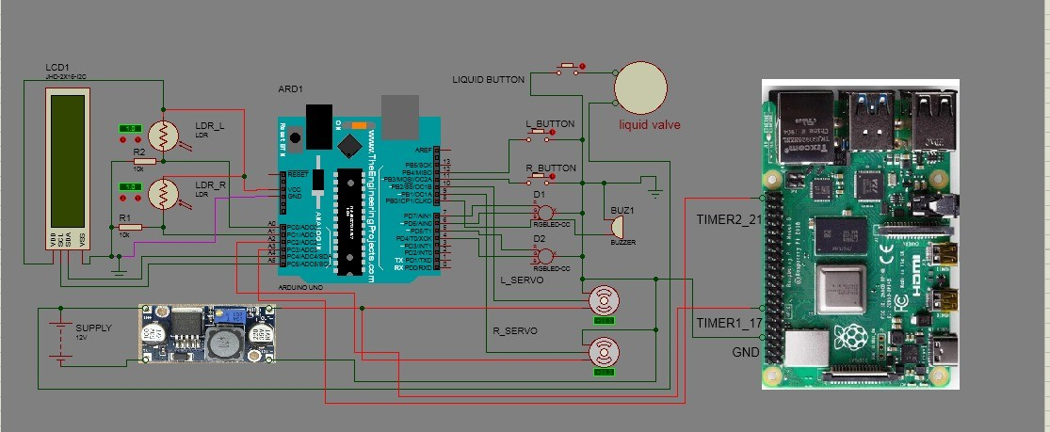

Fig. 2. Architecture

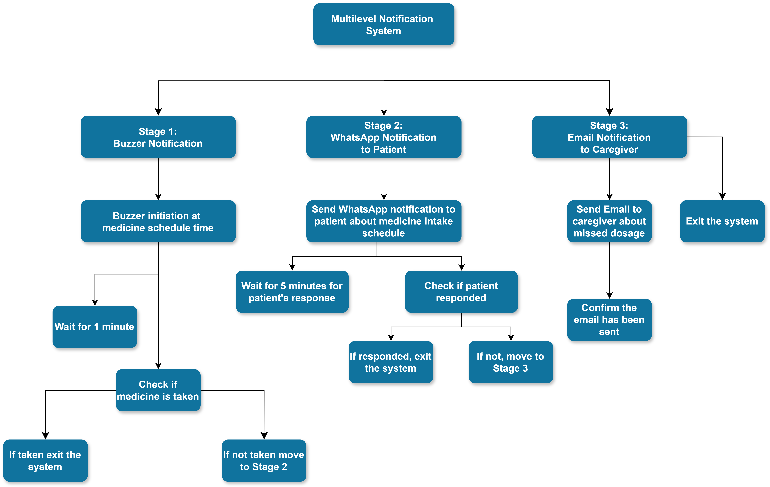

Fig. 3. Illustration of multilevel notification system

The Raspberry Pi server receives an HTTP request from the activateTimer function telling it that the timer has been set up. A Python application on the Raspberry Pi serves as an HTTP server and listens for requests. It uses the RequestHandler class to process requests, extract the timer ID, and activate the corresponding GPIO pin for a specified period of time. Also required are modules for email and WhatsApp notifications, RPi.GPIO for GPIO control, and http.server for basic HTTP server functions.

The SMTP protocol was used for emails and the Twilio API was used for WhatsApp messages. Functions for GPIO activation, email notification and WhatsApp messaging are developed and GPIO pins are configured accordingly. The RequestHandler class is used to process incoming requests, enable GPIO pins, and manage WhatsApp notifications. This approach makes it easier to set up medication reminder clocks connected to a Raspberry Pi server.

* 1. ***For database****:* Here in Fig. 4. the ER diagram is shown. To initialize the medication dispensing system database, it is necessary to connect to the MySQL database and create the necessary tables for users, medication schedules and protocols. Using CRUD procedures, medication plans can be created, accessed, modified and deleted. Logging and adherence tracking features record medication dispensing events and track missing medications. While alerts and notifications ensure rapid delivery of adherence data to caregivers for efficient medication management, user management features take care of user registration and login validation.

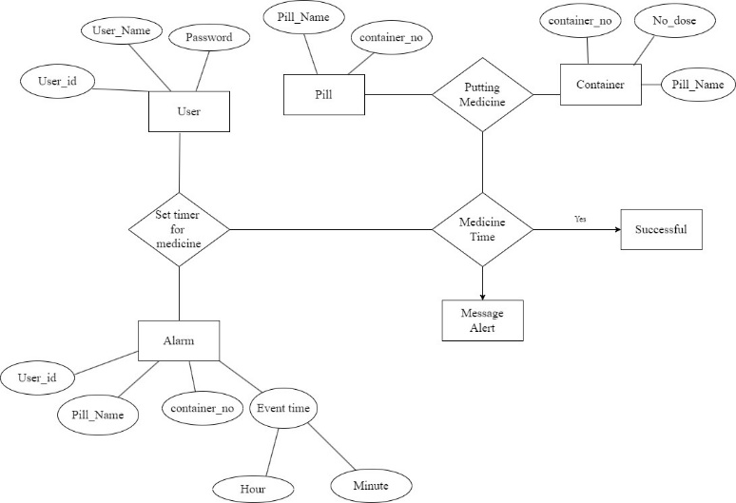

Fig. 4. ER Diagram

1. RESULTS AND DISCUSSION

The medication dispensing system shown in Fig. 5. was created by further integrating all components and encasing them in a rectangular box structure. The box is designed to be easy to handle and maneuver by both the patient and caregiver for remote access. In addition, the developed web application interface for appointment scheduling and remote access to medication is shown in Fig. 6. For elder notification, the buzzer is activated first, followed by a WhatsApp message if the buzzer is ignored for the patient, and an email to the caretaker if both the buzzer and WhatsApp message are ignored.

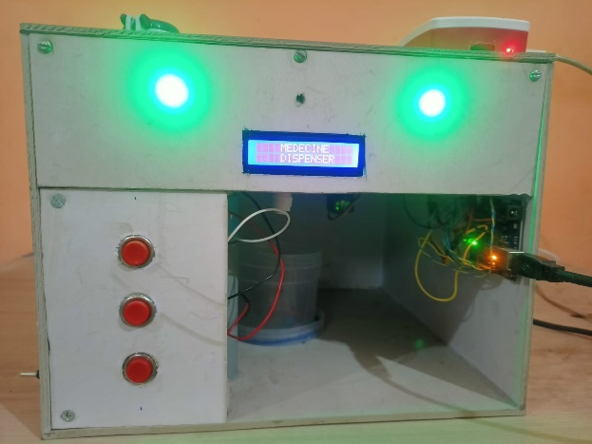

Fig. 5. Medicine Dispenser

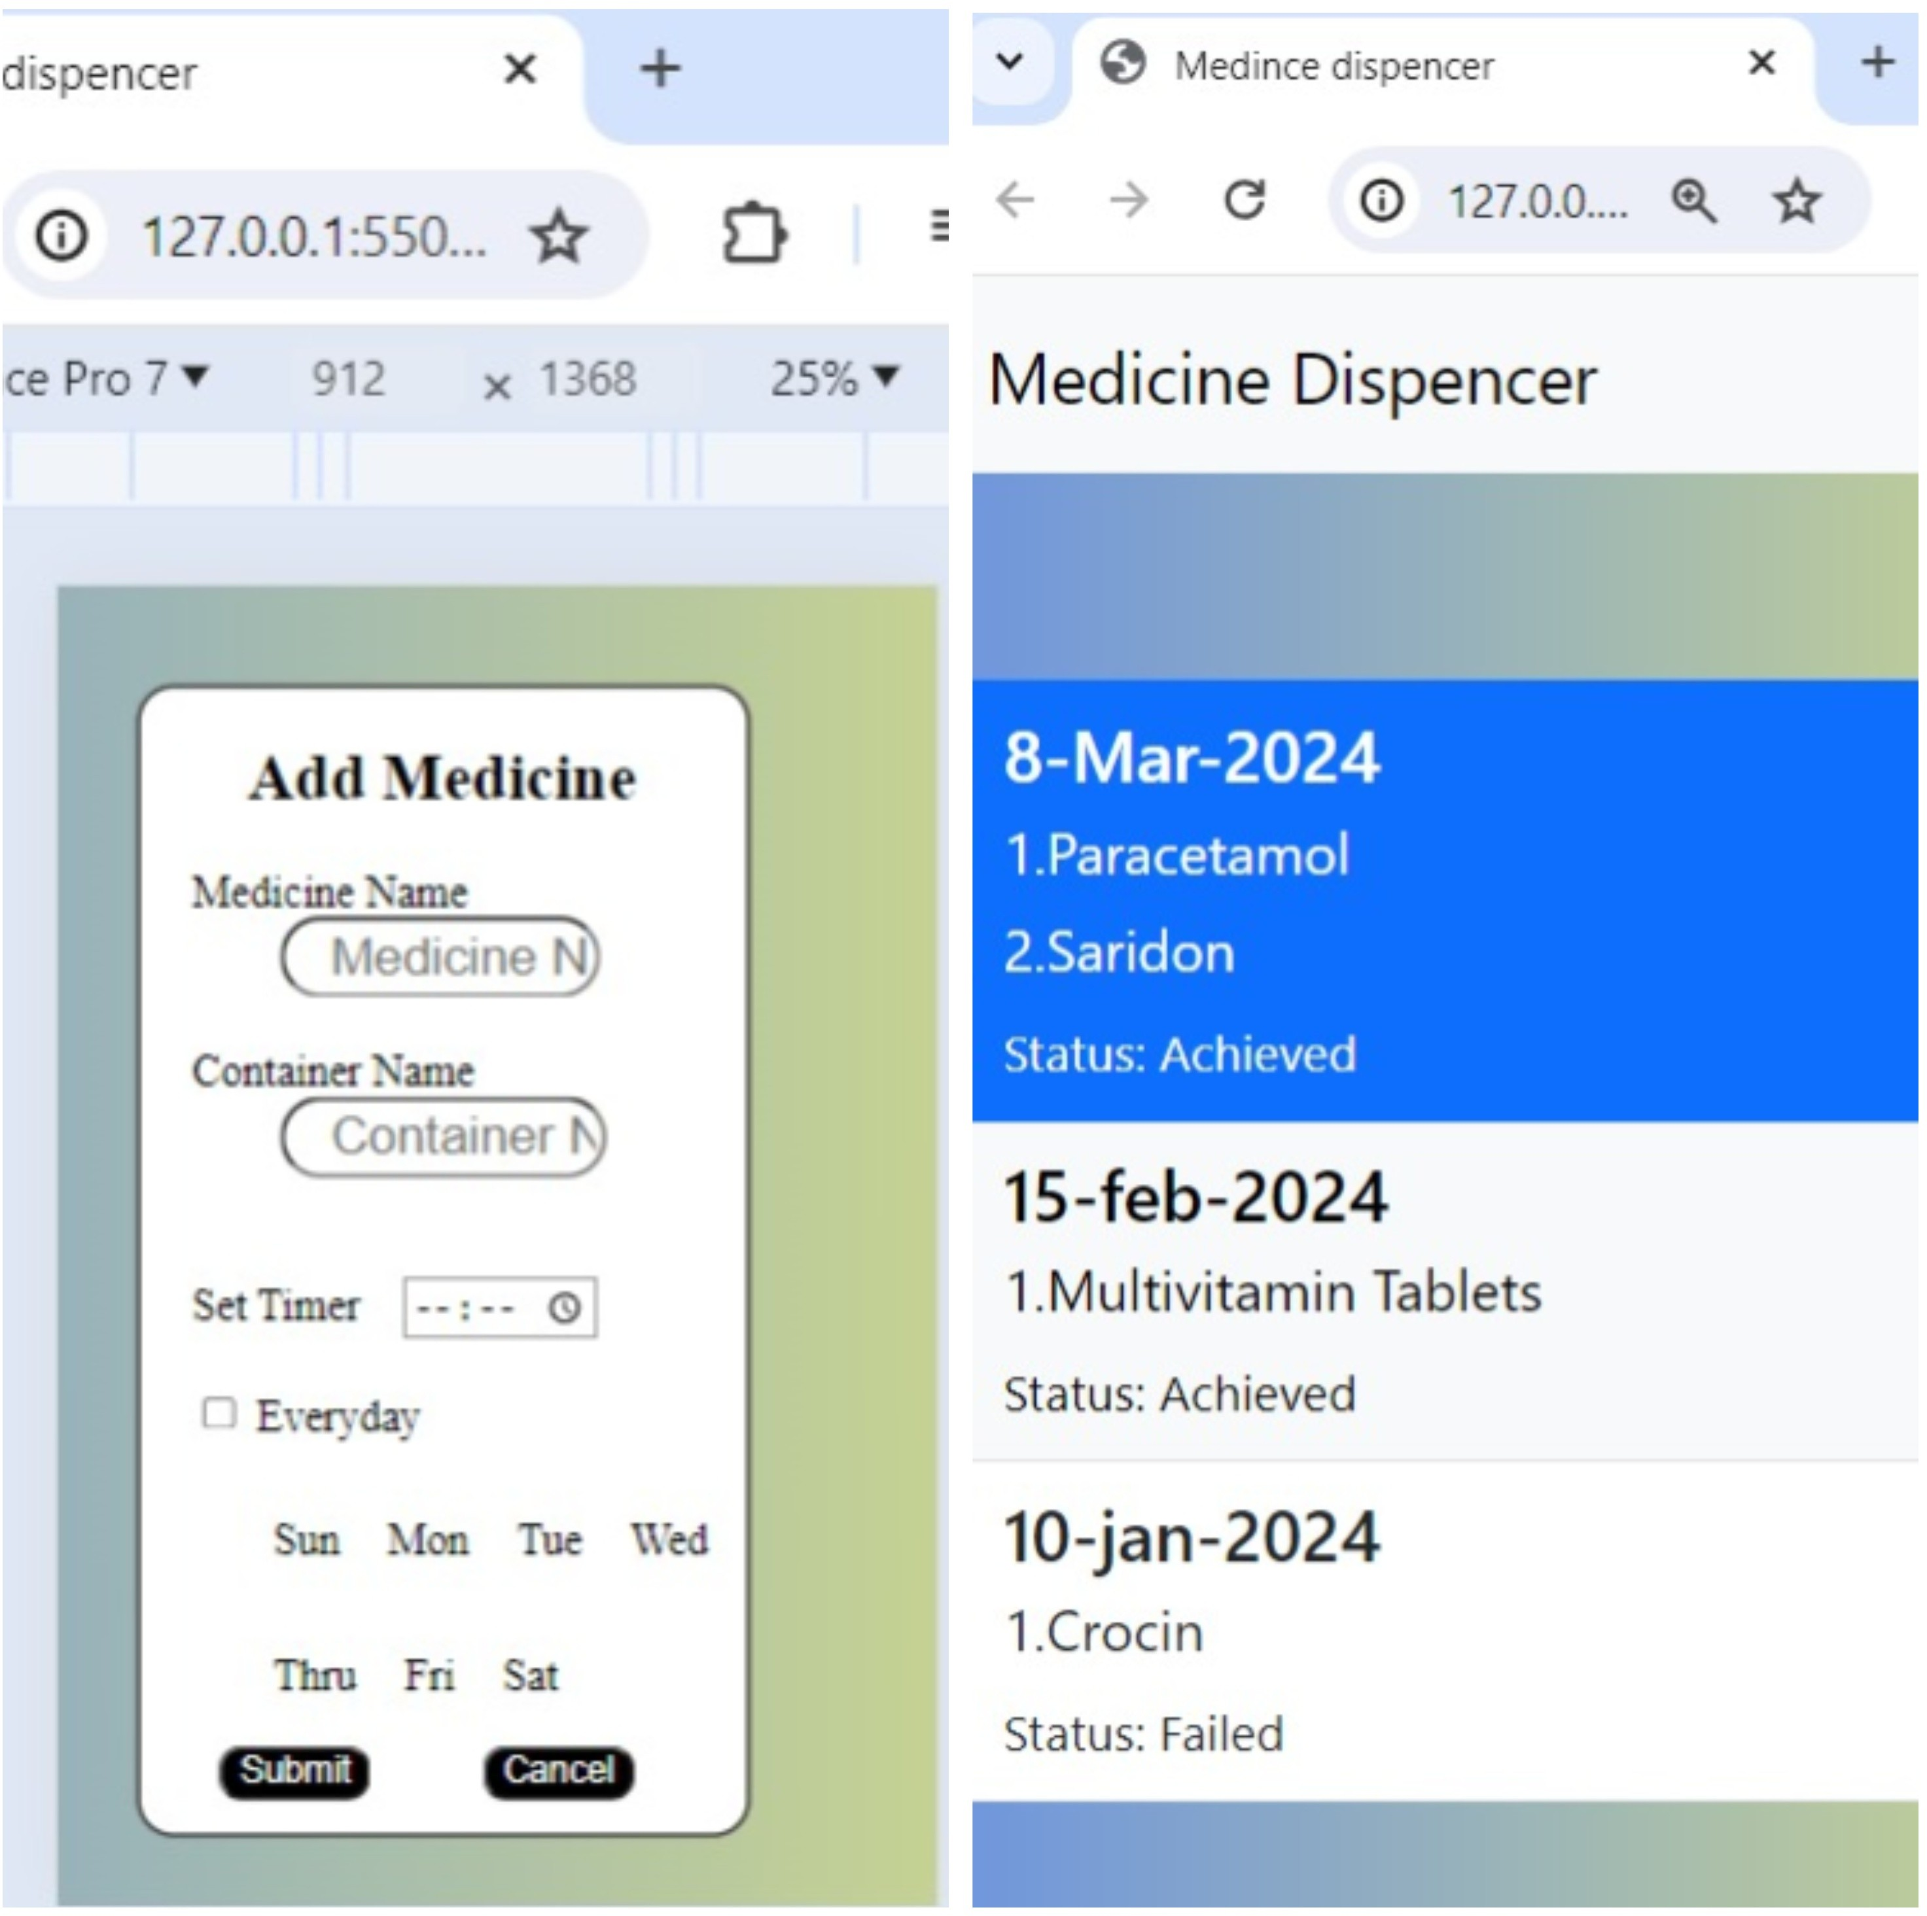

Fig. 6. Add and history page

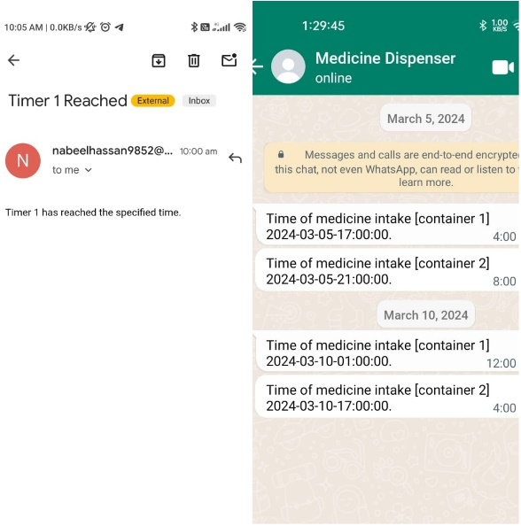

Fig. 7. Whatsapp and e-mail message

Here in Fig. 7., a WhatsApp message is sent to the elderly patient and an email is sent to the caretaker. The extensive testing protocols and validation studies have demonstrated the device’s reliability and strong performance in everyday home environments and highlighted its potential for widespread implementation in various healthcare areas. The device is well positioned to support sustainable health practices and mitigate the effects of medication overuse as it provides real-time monitoring of medication adherence and enables proactive dispensing of pills and liquid medications.

1. CONCLUSION AND FUTURE SCOPE

The development and functional validation of the proposed Internet of Things-based medication dispenser for senior citizens. The proposed solution addresses important medication adherence issues and represents a significant advance in individualized healthcare for the elderly. To prevent improper or insufficient medication, the system enables the prompt and accurate delivery of doses. This includes not only the user-friendly web interface provided for caretakers but also hardware components like Arduino UNO or Raspberry Pi 4B. As a result, this system has greatly enhanced medication compliance by reducing failure rates due to missed or wrong prescriptions. Real-time notifications and remote control have now made it possible for caregivers to ensure that their patients take medications on time, improving patient health status systematically. Through their creatively designed system, patients are empowered to assume greater responsibility in daily healthcare routines while facilitating medication management for care providers.

A better follow-up could involve AI techniques to identify patient adherence patterns and then customize reminders that help foster compliance. By connecting with healthcare data repositories, the device can even assist in providing individualized medication regimens using past records and real-time health updates. Moreover, examining smaller energy-consuming or smaller devices should enhance the usefulness of the technology for more people. Because of its adaptability to all types of medications and disease programs, the system holds great promise in personalized healthcare applications on a much wider scale.

REFERENCES

1. M. T. Ghozali, “Implementation of the IoT-based technology on patient medication adherence: A comprehensive bibliometric and systematic review,” J. Inf. Commun. Technol., vol. 22, no. 4, pp. 503-544, 2023. doi: 10.32890/jict2023.22.4.1.
2. P. S. Pandey, S. K. Raghuwanshi, and G. S. Tomar, “The real time hardware of smart medicine dispenser to reduce the adverse drugs reactions,” in International Conference on advances in computing and communication engineering (ICACCE). IEEE, 2018, pp. 413–418. doi: 10.1109/ICACCE.2018.8441709.
3. I., Gómez-Sebastià, J. Moreno, S. Á. Lvarez-Napagao, D. Garcia-Gasulla, C. Barrué, and U. Cortés, “Situated agents and humans in social interaction for elderly healthcare: From Coaalas to AVICENA,” J. Med. Syst., vol. 40, pp. 1, 2016.
4. S. J. F. Stewart, Z. Moon, and R. Horne, “Medication nonadherence: Health impact, prevalence, correlates and interventions,” Psychol. Health, vol. 38, no. 6, pp. 726–765, 2023. doi: 10.1080/08870446.2022.2144923.
5. D. Sahu, B. Pradhan, A. Khasnobish, S. Verma, D. Kim, and K. Pal, “The internet of things in geriatric healthcare,” J. Healthc. Eng., vol. 2021, 6611366, 2021. doi: 10.1155/2021/6611366.
6. S. Faisal, J. Ivo, and T. Patel, “A review of features and characteristics of smart medication adherence products,” Can. Pharm. J. (Ott), vol. 154, no. 5, no. 5, pp. 312–323, 2021. doi: 10.1177/17151635211034198.
7. R. K. Kanna, R. Vasuki, and N. Kripa, “Modern smart medicine dispenser kit based on emergency alert system,” Nat. Sci. Ed. Journal of Xiaˆ C™ an Shiyou University, pp. 123–137.
8. O. Al-Mahmud, K. Khan, R. Roy, and F. M. Mashuque Alamgir, “Internet of things (IoT) based smart health care medical box for elderly people,” in International Conference for Emerging Technology (INCET). IEEE, 2020, pp. 1–6. doi: 10.1109/INCET49848.2020.9153994.
9. M. A. Kader, M. N. Uddin, A. M. Arfi, N. Islam, and Md. Anisuzzaman, “Design implementation of an automated reminder medicine box for old people and hospital,” in International conference on innovations in science, engineering and technology (ICISET). IEEE, 2018, pp. 390–394.
10. R. O. D. R. Carlos, “IoT-based medicine dispenser to control and supervise medication intake,” in Intelligent Environments 2020: Workshop Proceedings of the 16th International Conference on Intelligent Environments, vol. 28. IOS Press, 2020, p. 39.
11. P. Ranjana and E. Alexander, “health alert and medicine reminder using internet of things,” in IEEE International Conference on Computational Intelligence and Computing Research (ICCIC). IEEE, 2018, pp. 1-4. Doi: 10.1109/ICCIC.2018.8782349.
12. B. Roumaissa and B. Rachid, “An IoT-based pill management system for elderly,” Informatica, vol. 46, no. 4, 2022. Doi: 10.31449/inf.v46i4.4195.
13. A. Jabeena and S. Kumar, “Smart medicine dispenser,” in International Conference on Smart Systems and Inventive Technology (ICSSIT). IEEE, 2018, pp. 410-414. doi: 10.1109/ICSSIT.2018.8748601.
14. M. S. D. Gupta, V. Patchava, V. Menezes, “Healthcare based iot using raspberry pi,” in International Conference on Green Computing and Internet of Things (ICGCIoT). IEEE, 2015, pp. 796-799. Doi: 10.1109/ICGCIoT.2015.7380571.
15. D. MohanaPriya, D.V, S. M, S.Y. C, “A real time support system to impart medicine using smart dispenser,” in International Conference on Systems, Computation, Automation and Networking (ICSCAN). IEEE, 2020, pp. 1-10. doi: 10.1109/ICSCAN49426.2020.9262424.
16. P. Dayananda and A. G. Upadhya, “Development of smart pill expert systems based on IoT,” J. Inst. Eng. (India) B, pp. 1-11, 2024. doi: 10.1007/s40031-023-00956-2.
17. S. Jayapradha, P. M. Durai, and R. Vinvent, “An IOT based Human healthcare system using Arduino Uno board,” in International Conference on Intelligent Computing, Instrumentation and Control. Technologies (ICICICT). IEEE, 2017, pp. 880-885. doi: 10.1109/ICICICT1.2017.8342681.
18. Z. Nasir, A. Asif, M. Nawaz, and M. Ali, “Design of a smart medical box for automatic pill dispensing and health monitoring,” Eng. Proc., vol. 32, no. 1, p. 7, 2023. doi: 10.3390/engproc2023032007.