# Heavy Metal Pollution Index (HMPI)

## 1. What is HMPI?

The Heavy Metal Pollution Index (HMPI) is a method used to evaluate the overall quality of water with respect to heavy metal contamination. It provides a single value that reflects the combined effect of multiple heavy metals on water quality. Instead of analyzing each metal individually, HMPI gives a composite score, making it easier to assess pollution trends and compare sites.  
  
For example, consider a river receiving effluents from an industrial area. It may contain lead (Pb), cadmium (Cd), arsenic (As), and chromium (Cr). Analyzing each concentration separately can be difficult for decision-making, but HMPI combines them into a single index value that reflects whether the water is safe or unsafe for human consumption and aquatic life.

## 2. Main and Different Formulas

There are multiple formulas for calculating HMPI, each with its own context of use.  
  
a) Weighted Arithmetic Mean Formula (Most Common):  
 HMPI = Σ(Wi * Qi) / ΣWi  
 - Qi = Quality rating of the ith parameter  
 - Wi = Unit weight of the ith parameter  
  
b) Modified Background Level Formula:  
 HMPI = Σ(Wi * Qi*) / ΣWi  
 - Here, Qi* considers background or baseline concentrations in the region.  
 - Useful when natural levels of metals are already higher than average.  
  
c) Hazard Quotient (HQ)-Based Formula:  
 HMPI = Σ (Ci / Si)  
 - Ci = Measured concentration  
 - Si = Standard permissible concentration  
 - Used when the goal is to directly compare exposure to regulatory limits.

## 3. Significance of Different Formulas

The significance of using different formulas depends on the environmental and geographical context:  
  
- Weighted Arithmetic Mean Formula: Best for general water quality assessment. For example, a city monitoring its river water quality on a monthly basis would rely on this formula.  
  
- Modified Background Level Formula: Important in locations where metals naturally occur at higher levels. For instance, groundwater in a mining region may naturally contain high iron (Fe). Without modification, the HMPI might wrongly classify this water as highly polluted, even though the values are natural.  
  
- HQ-Based Formula: Useful for quick risk assessments. For example, if cadmium in drinking water is 0.02 mg/L and the standard is 0.01 mg/L, HQ = 2, directly showing twice the safe limit.

## 4. What do you mean by Background Levels?

Background levels refer to the naturally existing concentrations of heavy metals in soil, rocks, or water before any human interference. These levels differ by location and geology.  
  
For example:  
- Location A (mineral-rich region): Groundwater may naturally contain high manganese (Mn) and iron (Fe).  
- Location B (sedimentary plain): Water may have very low natural metal content.  
  
If the same level of iron (say 0.5 mg/L) is found in both places, it might be considered 'normal' in Location A but 'pollution' in Location B.

## 5. Why Do Background Levels and Modified Formulas Matter?

Background levels and modified formulas matter because they ensure that water quality assessments are accurate and not misleading.  
  
If background levels are ignored:  
- A natural high concentration of iron in Location A might incorrectly suggest pollution, leading to unnecessary alarms.  
- Conversely, in Location B, even a small increase in heavy metals could indicate a real pollution source that needs immediate attention.  
  
By considering background levels, researchers and policymakers can distinguish between natural presence and anthropogenic (human-made) contamination.  
  
For example:  
- Location A: Arsenic is naturally present at 0.01 mg/L (close to the standard limit). If human activities add another 0.01 mg/L, the modified HMPI formula will show the 'extra' pollution beyond natural levels.  
- Location B: Arsenic background is almost zero. Even 0.005 mg/L from industry will raise concern, and HMPI will reflect this.

# Real-Life Case Studies on Heavy Metal Pollution

## Case Study 1: Arsenic in West Bengal Groundwater (India)

One of the most well-documented heavy metal pollution crises is the arsenic contamination in the groundwater of West Bengal, India. Millions of people were exposed to high levels of arsenic due to natural geological processes and excessive groundwater extraction. The Hazardous Metal Pollution Index (HMPI) was used to quantify the extent of pollution.  
  
Example:  
- Background level of arsenic in groundwater: < 0.01 mg/L (safe limit).  
- Observed concentration in some areas: 0.2–0.5 mg/L.  
- HMPI values indicated 'high' to 'critical' pollution, requiring urgent mitigation.

This case highlights why background levels are crucial: without knowing the natural baseline, it would be impossible to judge how much of the contamination was anthropogenic versus natural. Modified HMPI formulas were applied here to reflect the cumulative exposure risks.

## Case Study 2: Lead Contamination in Flint (USA)

In Flint, Michigan (USA), a water supply switch in 2014 caused lead from aging pipes to leach into the drinking water. This led to widespread lead poisoning, particularly affecting children.  
  
Example:  
- Background level of lead in safe water: effectively 0 mg/L (no safe limit for lead).  
- Observed concentration in some homes: > 0.1 mg/L (over 100 times the guideline).  
- HMPI values spiked dramatically, classifying the water as extremely hazardous.

This case showed the importance of modified formulas that account for toxicity weighting. Lead is far more toxic at low concentrations than many other metals, so assigning it a higher weight in the HMPI calculation ensured the index truly reflected the risk.

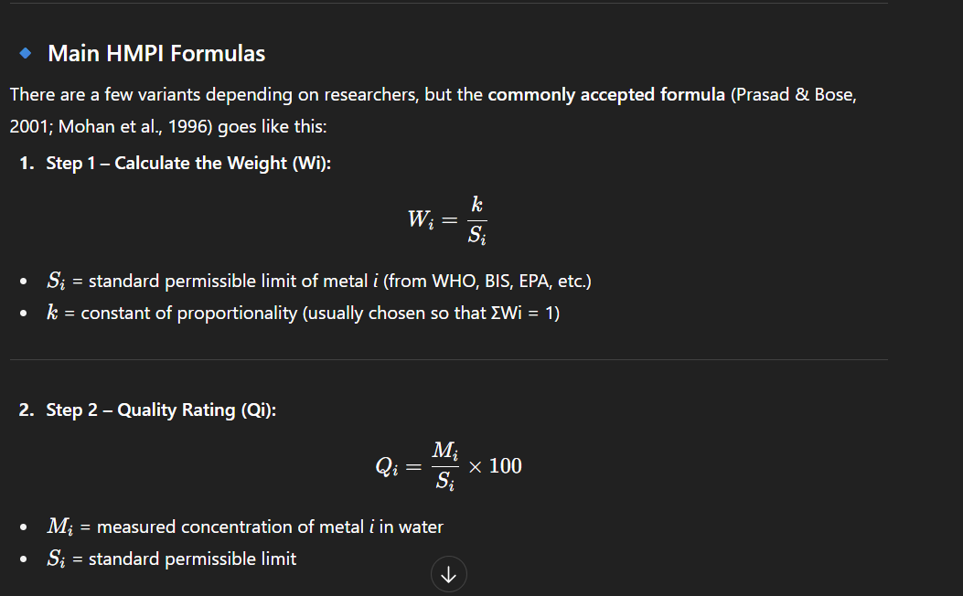

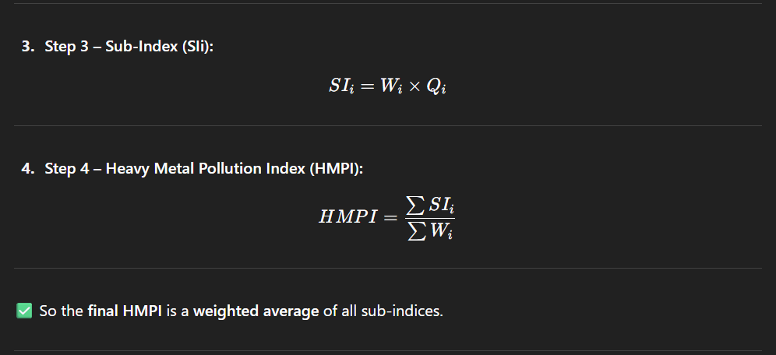

Chat link:- https://chatgpt.com/share/68b1e2da-6a5c-8006-b8f2-f177332aa93e

