A data pipeline is created which reads json data from a local path and dynamically flattens any nested json data. The flattened data is stored as a dynamic table in local path.

The flattened json data can also be queried upon like any other database table after creating temp view over it. Or it can be directly transformed using spark dataframe or sparkSql API functions

Below are the screenshots of output:

Input Json:

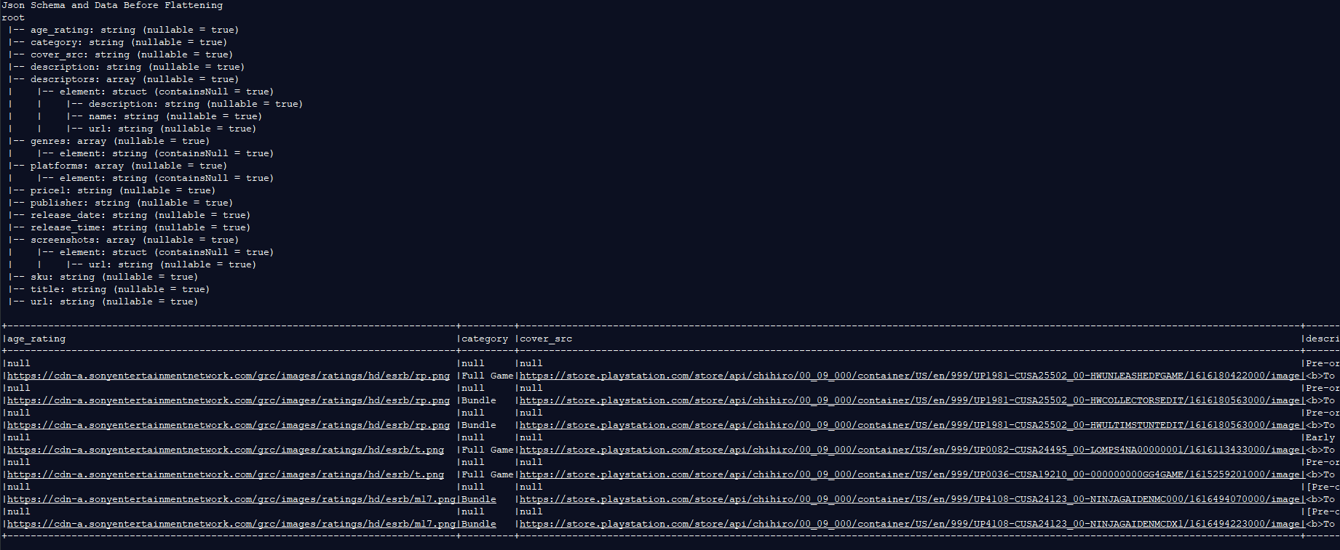

Flattened Json:

