## This document helps to run and test the akka project on standalone Ubuntu server.

* **We require below steps to be done:**

1. Needed code change to build the JAR successfully **(detailed about the code change is mentioned in the different section).**
2. Update build.sbt as provided **(detailed about the code change is mentioned in the different section).**
3. Go to sbt shell in the intelliJ and run below command:

assembly

This will create JAR (vedavaapi-swagger-akka-http-assembly-0.1-SNAPSHOT.jar) under <project dir>/target\scala-2.12.

1. Copy this JAR to unix box .
2. If it is new unix box first execute the below command:

sudo apt install lttoolbox

1. After successfully completion of step 5 , run the below command to execute the application :

chmod 777 vedavaapi-swagger-akka-http-assembly-0.1-SNAPSHOT.jar

JAVA -jar vedavaapi-swagger-akka-http-assembly-0.1-SNAPSHOT.jar

* **Below files has been added/Modified (please refer the source project shared with you)**

1. dbUtil-> JsonHelper file (ADDED)
2. AnalyserService.scala (MODIFIED)
3. GeneratorService.scala (MODIFIED)
4. ArchiveItemPodcastService.scala (MODIFIED)
5. See the build.sbt (MODIFED)

* **For Testing of apis ,please use Swagger and Postman with below url:**

# http://52.34.26.71:9090/swagger/index.html

* As shown in the screen shot, you will get all the rest request in this browser.

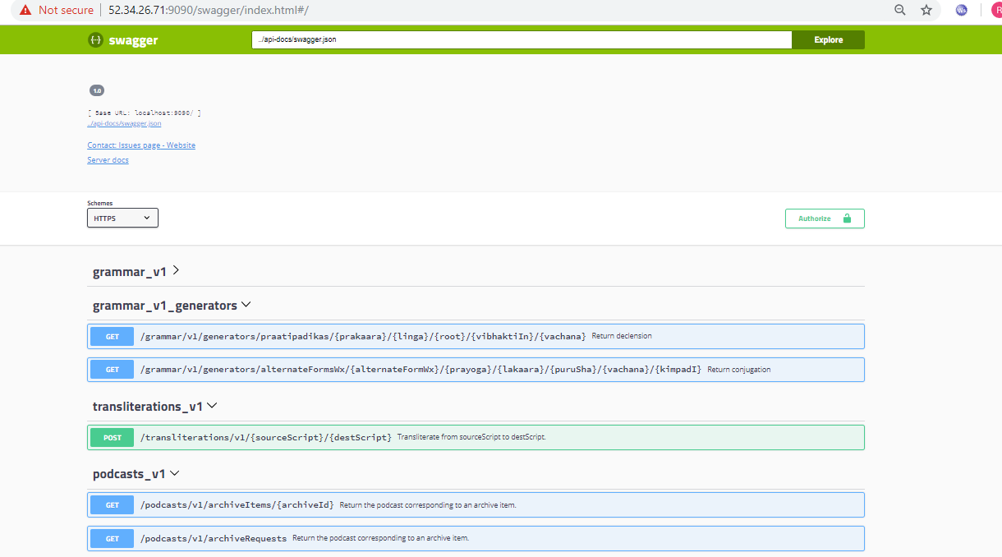

* Just use that url in the postman and execute the request as shown below:

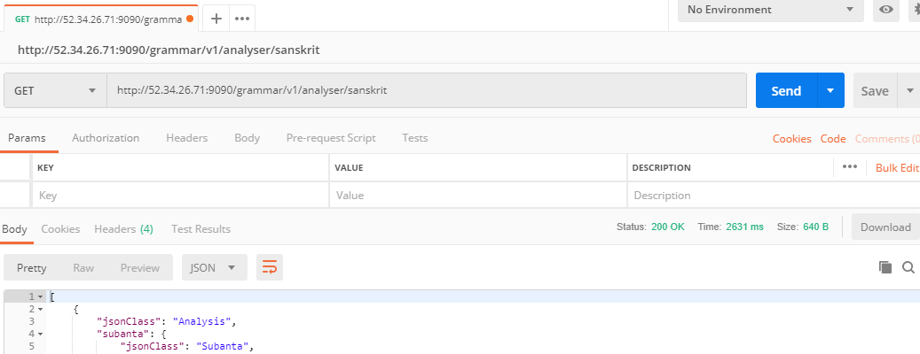

If you get proper response , you are all set for production.