### **TF-IDF (Term Frequency - Inverse Document Frequency) Vectorizer:**

TF-IDF is a technique used to transform text data into a numerical format (vector form), similar to how the **CountVectorizer** works, but with a key difference. It aims to reflect how important a word is to a document in a collection of documents (corpus), considering both its frequency within a document and how common it is across all documents.

#### **How does TF-IDF work?**

1. **Term Frequency (TF):** This measures how often a word appears in a document. The idea is that words that appear more frequently in a document should be given more importance.  
    TF(t,d)=Number of times term t appears in document dTotal number of terms in document d\text{TF}(t, d) = \frac{\text{Number of times term t appears in document d}}{\text{Total number of terms in document d}}
2. **Inverse Document Frequency (IDF):** This measures how important a word is across all documents. Words that appear in many documents (i.e., common words like "the," "is," etc.) are not very informative and are down-weighted. Words that appear in fewer documents are considered more informative and get higher weight.  
    IDF(t)=log⁡(Total number of documentsNumber of documents containing term t)\text{IDF}(t) = \log\left(\frac{\text{Total number of documents}}{\text{Number of documents containing term t}}\right)
3. **TF-IDF Calculation:** TF-IDF(t,d)=TF(t,d)×IDF(t)\text{TF-IDF}(t, d) = \text{TF}(t, d) \times \text{IDF}(t)

#### **How is TF-IDF different from CountVectorizer?**

* **CountVectorizer** simply counts how many times each word appears in a document and creates a frequency count of terms in the entire corpus. It doesn't consider how often words appear across other documents in the corpus, which can sometimes lead to overly frequent, but not very informative words, dominating the model.
* **TF-IDF**, on the other hand, adjusts for the fact that some words appear very frequently in many documents but carry less meaning (like "the," "is," etc.). It assigns higher weights to words that are frequent in a specific document but rare across the entire corpus, making it more focused on the more **informative words**.

### **Example:**

#### **Given Documents:**

* **Doc 1**: "I love programming"
* **Doc 2**: "I love coding"
* **Doc 3**: "I hate bugs"

#### **CountVectorizer Output:**

The **CountVectorizer** would simply count the occurrences of each word in the corpus. Here is how it would work for the above documents:

|  |  |  |  |
| --- | --- | --- | --- |
| **Word** | **Doc 1** | **Doc 2** | **Doc 3** |
| I | 1 | 1 | 1 |
| love | 1 | 1 | 0 |
| programming | 1 | 0 | 0 |
| coding | 0 | 1 | 0 |
| hate | 0 | 0 | 1 |
| bugs | 0 | 0 | 1 |

#### **TF-IDF Output:**

Now, applying **TF-IDF**, we calculate both **TF** and **IDF** for each word:

* **TF** is the same as the count for each word divided by the total number of words in the document.
* **IDF** adjusts the weight for each word based on how rare or common it is across all documents.

For example, the term **"love"** will have a higher TF-IDF score in Doc 1 and Doc 2 since it’s more important in those documents compared to Doc 3, where it appears less often. On the other hand, common words like **"I"** will have a lower TF-IDF score since they appear in all documents.

|  |  |  |  |
| --- | --- | --- | --- |
| **Word** | **Doc 1** | **Doc 2** | **Doc 3** |
| I | 0.0 | 0.0 | 0.0 |
| love | 0.5 | 0.5 | 0.0 |
| programming | 0.7 | 0.0 | 0.0 |
| coding | 0.0 | 0.7 | 0.0 |
| hate | 0.0 | 0.0 | 0.7 |
| bugs | 0.0 | 0.0 | 0.7 |

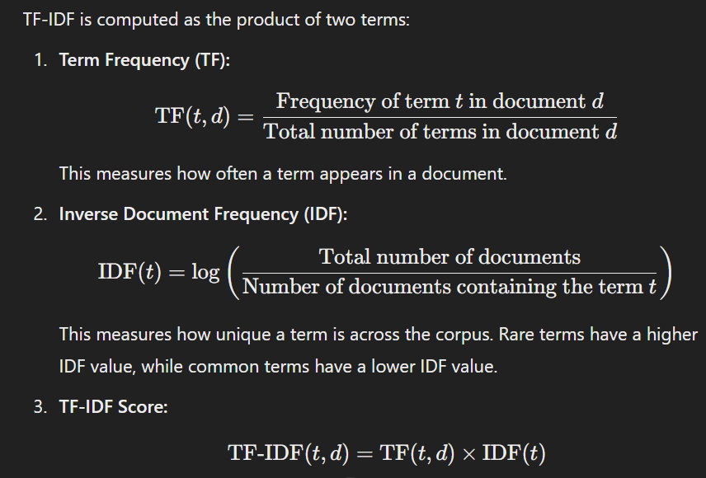

### **When to Use TF-IDF vs. CountVectorizer:**

* **Use TF-IDF when:**
  + You want to emphasize words that are more **informative** and reduce the impact of common words that don’t add much value (e.g., "is," "the," "and").
  + Your corpus contains a lot of common words that appear in many documents but aren’t useful for classification or clustering.
* **Use CountVectorizer when:**
  + You’re interested in **absolute frequencies** of terms and when the occurrence of a word itself (without considering its rarity across the corpus) is more important for your task.
  + You have a small corpus where all words are more or less equally informative, or the problem you're solving doesn't need to down-weight common words.

### **Which One is Better?**

* **TF-IDF** generally performs better in tasks like **text classification**, **information retrieval**, and **search engines** where distinguishing between important and unimportant words is crucial. It also helps to prevent overemphasis on common terms that appear in almost every document, like stopwords (e.g., "the," "a").
* **CountVectorizer** can be useful for **basic word frequency analysis** or for models where word frequency alone is an important feature (e.g., some types of **topic modeling**).

In most cases, **TF-IDF** is preferred because it produces more meaningful features for machine learning models by distinguishing between important and less informative words.

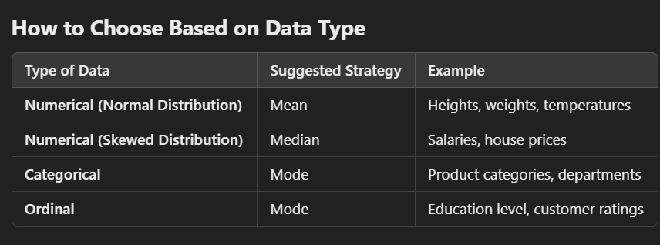

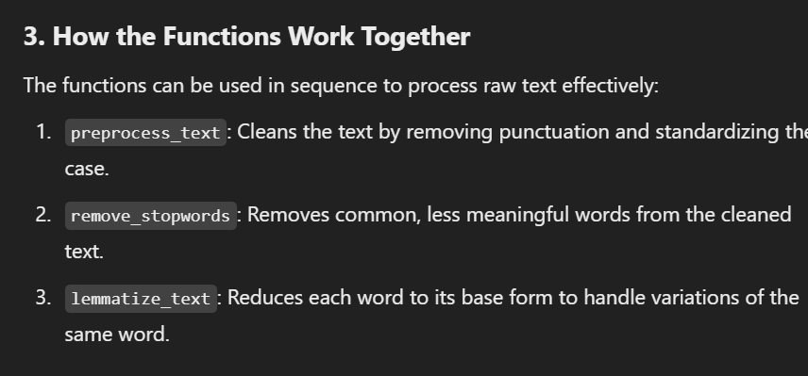

• **punkt**: A pre-trained tokenizer in NLTK used to split text into sentences or words.

Handling missing data

1. Replace with constant value – using simple imputer
2. Replace with mean mode or median – using simple imputer
3. Dropna(pandas) with true so that document will be drop out

In **Random Forest**, overfitting can occur when the model becomes too complex (e.g., when individual trees are too deep or the number of trees is too high). However, there are several techniques to **control overfitting** and improve the model's generalization ability:

### **1. Limiting the Depth of Trees (Pruning)**

* **Pruning** refers to the process of limiting how deep each decision tree in the forest can grow. A tree that is too deep can model very specific patterns in the training data, which might not generalize well to unseen data.
* By setting a **maximum depth** for the trees, we can prevent them from becoming too specific to the training data, thus reducing overfitting.
  + In scikit-learn, you can set the parameter max_depth when initializing the Random Forest model.

### **2. Limiting the Number of Features to Consider for Splits (Max Features)**

* Random Forest selects a random subset of features for each decision tree at each split. By controlling the number of features (max_features), you reduce the chance of overfitting.
* The fewer features available for splitting, the simpler the trees will be, and this can help reduce overfitting.
  + In scikit-learn, you can set the parameter max_features to a specific number or fraction (e.g., sqrt for the square root of the total number of features, or log2).

### **3. Minimum Samples per Leaf or Split**

* The **minimum samples per leaf** (min_samples_leaf) or **minimum samples per split** (min_samples_split) parameters control how many data points a node needs before it can make a split.
  + If these values are set too low, the trees can become overly complex and overfit.
  + Increasing these values ensures that each split involves a sufficiently large sample, reducing the likelihood of fitting noise or minor fluctuations in the data.
  + You can adjust these parameters in scikit-learn with min_samples_split and min_samples_leaf.

### **4. Bootstrapping and Bagging**

* Random Forest uses a technique called **bootstrapping** (sampling with replacement) to train each decision tree. This means that each tree is trained on a random subset of the data.
* **Bagging** (Bootstrap Aggregating) is a technique that helps reduce overfitting by averaging the predictions of multiple trees, thus smoothing out predictions and making the model more robust to noise in the training data.
* The randomness introduced by bootstrapping ensures that individual trees are less likely to overfit the data, as they are trained on slightly different subsets of the data.

### **5. Increasing the Number of Trees**

* While **increasing the number of trees** (n_estimators) in a Random Forest can improve performance, it does not necessarily cause overfitting. A higher number of trees increases the model's ability to generalize by reducing variance.
* However, there is a point of diminishing returns, where adding more trees provides little to no improvement in performance.
* It is crucial to find a balance by experimenting with the number of trees to avoid excessive computation time while still improving generalization.

### **6. Using Cross-Validation**

* **Cross-validation** helps to assess the model's generalization ability and check for overfitting. It involves splitting the dataset into multiple subsets and training the model on different combinations of these subsets.
* Random Forest can be cross-validated to evaluate its performance on unseen data, helping to identify whether the model is overfitting or underfitting.
* In scikit-learn, you can use cross_val_score to perform cross-validation.

### **7. Setting a Random Seed for Reproducibility**

* By setting a **random seed** (random_state), you ensure that the randomness in the model (e.g., in the bootstrap sampling) is reproducible. This can help in consistently measuring how changes to the model affect overfitting.

### **8. Feature Engineering and Regularization**

* You can also apply **feature selection** or **regularization** to reduce overfitting. Reducing the number of irrelevant or redundant features in the dataset can prevent the model from overfitting the noise in the data.
* Techniques like **L1 regularization (Lasso)** or **L2 regularization (Ridge)** can be applied when training other models like linear regression, but in Random Forest, this would typically be handled through feature selection or reducing tree depth.

### **Summary of Techniques to Control Overfitting:**

|  |  |
| --- | --- |
| **Technique** | **Effect on Overfitting** |
| Limiting tree depth (Pruning) | Prevents trees from becoming too complex and overfitting |
| Limiting features per split (max_features) | Reduces the complexity of trees by limiting the number of features by pruning |
| Minimum samples per split/leaf (min_samples_split, min_samples_leaf) | Ensures trees are not too specific to small data subsets |
| Bootstrapping and Bagging | Reduces variance and improves generalization by averaging predictions |
| Increasing number of trees (n_estimators) | Reduces variance by adding more trees, but too many can be computationally expensive |
| Cross-validation | Helps identify overfitting by evaluating model performance on different subsets |
| Random seed (random_state) | Ensures reproducibility and helps assess stability of the model |
| Feature engineering and selection | Reduces irrelevant features and noise, preventing overfitting |

By tuning these hyperparameters and employing these techniques, you can effectively **control overfitting** in Random Forest and improve the model's ability to generalize to new, unseen data.

U can mention number of decision tree as parameter to predict

**Why random over naive**

**Random Forest** is preferred over **Naive Bayes** for a few simple reasons:

1. **Doesn't assume features are independent**:  
   * Naive Bayes assumes that all the features (like words in text) are independent, which isn't true in real-world data. For example, words in a sentence depend on each other.
   * Random Forest doesn’t make this assumption, so it works better when features are related.
2. **Handles complex data better**:  
   * Naive Bayes works well for simple problems but struggles with more complex data where features interact in non-obvious ways.
   * Random Forest can handle **complex patterns** and relationships between features, making it more flexible.
3. **Works well with different types of data**:  
   * Naive Bayes works best with text or categorical data, but Random Forest can handle a wide range of data types (like numbers, categories, or mixed data) and even large datasets.
4. **Robust to noise**:  
   * Random Forest can deal with noisy or irrelevant data better than Naive Bayes. It reduces the risk of overfitting by averaging the predictions of many trees.
5. **Higher accuracy**:  
   * In general, Random Forest tends to provide **more accurate predictions** because it combines the results of multiple decision trees.

So, in simple terms, **Random Forest** is better because it can handle more complex data, doesn’t assume features are independent, and is more accurate in a wider range of problems than **Naive Bayes**.

**Improvements needed**

Your code for sentiment analysis using **Random Forest** is well-structured, but there are several areas for potential improvement or fine-tuning. Here's a breakdown of the strengths and areas where improvements can be made:

### **Strengths:**

1. **Text Preprocessing:**
   * You've applied essential text preprocessing steps like converting to lowercase, removing non-alphanumeric characters, and lemmatization, which are crucial for cleaning the text data.
2. **Imputation:**
   * You're handling missing values by imputing them with a constant value ("Unknown"), which is appropriate for categorical features.
3. **Model Selection:**
   * You've implemented **Random Forest**, which is a solid choice for this type of problem as it can handle complex relationships and typically performs better than Naive Bayes on many types of text data.
4. **Word Clouds:**
   * Visualizing the sentiment categories using word clouds is an excellent approach for understanding the most frequent terms in each sentiment class.

### **Areas for Improvement:**

1. **Improving Data Preprocessing:**
   * **Removing URLs/mentions/hashtags**: Tweets often contain URLs, user mentions (@username), or hashtags (#hashtag). You can remove or process them to avoid unnecessary noise in the model.
   * **Handling negations**: A common improvement in sentiment analysis is handling negations (e.g., "not good" should be treated differently than "good").
   * **Advanced tokenization**: You are using the NLTK tokenizer, but using **spaCy** for tokenization and preprocessing might offer better handling for punctuation and entities.
2. **Feature Engineering:**
   * You are using **CountVectorizer**, but it can be enhanced by adjusting parameters like **ngram_range** to consider sequences of words (bigrams or trigrams). This can help capture more context and improve model performance.
   * Instead of using a simple CountVectorizer, you could explore **TF-IDF Vectorization**, which assigns more importance to rare words that may be more significant.
3. **Hyperparameter Tuning:**
   * You are using **default hyperparameters** for **Random Forest**. Hyperparameter tuning using techniques like **GridSearchCV** or **RandomizedSearchCV** could optimize the performance of the model (e.g., tuning n_estimators, max_depth, min_samples_split, etc.).
   * For Random Forest, you could also experiment with increasing the number of trees (n_estimators) to see if it improves accuracy.
4. **Class Imbalance:**
   * If your data is imbalanced (e.g., more "Neutral" or "Positive" tweets), it can affect the model's performance. You could consider **class weights** or use **SMOTE** (Synthetic Minority Over-sampling Technique) to balance the dataset.
5. **Cross-Validation:**
   * Using **cross-validation** (cross_val_score or StratifiedKFold) can give you a better sense of the model's performance across different subsets of the data, reducing the risk of overfitting.
6. **Accuracy and Evaluation:**
   * You’re calculating the accuracy and using confusion matrices, which is great. But make sure to check other metrics like **precision**, **recall**, and **F1-score**, especially if the dataset is imbalanced. Accuracy alone may not be sufficient in such cases.
   * You might want to adjust your model to handle **multiclass classification** if TYPE contains more than two sentiment categories.
7. **Handling Overfitting:**
   * Random Forests can overfit, especially if the number of trees is very high. You should monitor the performance on the test set and ensure the model doesn't overfit.
8. **Using Other Models:**
   * **Logistic Regression** or **Gradient Boosting Machines (GBM)** can also be tested as they are commonly used in text classification tasks and can sometimes outperform Random Forests for certain types of data.

### **Predicted Score:**

Based on the current code and its potential optimizations, the model should likely have a performance around **85-92% accuracy** (as you mentioned). The Random Forest model, with some adjustments, should be competitive in terms of accuracy, especially after hyperparameter tuning.

However, keep in mind that with **better feature engineering, hyperparameter tuning, and handling of class imbalance**, you may be able to push this accuracy higher and potentially improve the performance across various evaluation metrics.

### **Future Improvements:**

1. **Hyperparameter optimization** (using GridSearchCV/RandomizedSearchCV).
2. **TF-IDF** or **word embeddings** like **Word2Vec** or **GloVe** for better vectorization.
3. **Use deep learning models** (like **LSTM** or **BERT**) for better text representation and sentiment prediction.
4. **Ensemble learning** to combine predictions from multiple models and increase robustness.

Here's a short summary of the key points for the **scope** of your sentiment analysis project:

1. **Improving Model Performance**:  
   * Tune hyperparameters, use TF-IDF, n-grams, or advanced models (like LSTM or BERT).
2. **Handling Imbalanced Data**:  
   * Use techniques like SMOTE or class weights to balance the dataset.
3. **Real-Time Sentiment Analysis**:  
   * Deploy the model for real-time analysis via web or mobile apps, integrating with APIs like Twitter.
4. **Multilingual Support**:  
   * Expand to handle multiple languages for wider application.
5. **Topic Modeling**:  
   * Use techniques like LDA or NMF to uncover topics in the data, beyond just sentiment.
6. **Business Integration**:  
   * Integrate sentiment analysis into dashboards for market research, brand monitoring, or customer feedback.
7. **Extended Applications**:  
   * Apply in customer support, social media monitoring, and political sentiment tracking.
8. **Model Interpretability**:  
   * Use tools like SHAP or LIME to explain predictions and improve transparency.
9. **Cross-Platform Applications**:  
   * Implement the model in mobile apps, chatbots, or other platforms for broader reach.
10. **Industry Collaboration**:

* Expand use cases to healthcare, finance, and other sectors for further impact.

In short, your project has significant potential for improvement, expansion into real-time applications, and integration across various industries.

Difficulties

What u learn form project