Investigating HubSpot Blog Titles:

Quantifying Dan Lyons’ Frustrations

David Beinhart

76-388 Topics in Digital Humanities: Coding For Humanities

Professor Ishizaki

December 14th, 2016

Table of Contents
Introduction: 3
Procedure: 3
Results & Discussion: 5
Conclusion: 10
References: 11
Further Research: 11

Introduction:

This investigation was inspired by Dan Lyons’ 2016 book, Disrupted: My Misadventures at a Startup Unicorn. In the book Lyons describes his time working for HubSpot, a Boston based software company that focuses on inbound marketing (blogging for businesses).

In the “tell all book” Lyons rips his former employer, with a litany of grievances ranging from his co-worker’s behavior, to the wall of candy used to incentivize their work. Above all, he cannot stand the content that they are creating to populate the company’s blog. The following is an investigation to discover if the visceral language Lyons uses to describe the HubSpot blog has any merit, that is to say if Dan Lyons did in fact write articles that were different than his colleagues.

Lyons describes the culture clash between what he had come to expect as the former editor of Newsweek and working for HubSpot saying, “reporters are trained to hate corporate jargon and to eliminate it, not to engage in it. We’re expected to be cynical and skeptical, not to be cheerleaders.” However, he soon realizes, “the (HubSpot’s) blog team sits at the top of a funnel, drawing in new visitors, generating new leads, and starting people off on their “buyer’s journey”—the lovable, nurturing trip down the funnel that we hope will end with them becoming paying customers.”

To further this investigation, I will also be analyzing titles from Buzzfeed posts. In his book, Lyons mentions the “Buzzfeed” style of articles that his colleagues create. In particular, he has a disdain for the type of substance-less list articles that are common of the style.

Procedure:

Using Beautiful Soup 4, I scraped data from HubSpot’s blog and saved it as a CSV file. I was able to pull the Title, Date and Author for blog posts across all 64 of their categories. I set my initial program so that it would start at https://blog.hubspot.com/topics which provides a listing of all blog topics.

From there I created a list of all the topics and further links of each category up to page 30 which is what I had observed to be the highest page any category went up to. I then looped through the URL of each category, generating a list of every link under that category.

For the purposes of this project it was appropriate to use this structure, pulling every title once and saving it all to a CSV file, however, if I was interested in continuing to observe trends in their titles, I would consider creating a program that could scrap the website at a fixed interval either daily or weekly, and save the results to a JSON file.

Table 1 Provides a summary of these results:

HubSpot Corpus:
Number of Posts: | 11,277
Number of Categories: | 64
Number of Duplicates: | 3,080 (27%)
Number of Unique Articles: | 8,144
Table 1

I used a very similar procedure to scrape posts from BuzzFeed. I limited this investigation to the 16 most recent pages across 22 categories. For BuzzFeed, I only pulled the titles and the category for which the article was posted under. Whereas my results from HubSpot went as far back as 2006, the BuzzFeed articles were from 2014-Present.

Table 2 Provide a summary of the BuzzFeed results:

BuzzFeed Corpus:
7,485 Recent Articles Across 22 Categories: | Audio: 191 | Parents: 376 | Science: 336 | Style: 402
7,485 Recent Articles Across 22 Categories: | Geeky: 361 | Politics: 420 | Tech: 365 | Food: 389
7,485 Recent Articles Across 22 Categories: | Health: 282 | Puzzles: 155 | Travel: 408 | Books: 240
7,485 Recent Articles Across 22 Categories: | LGBT: 354 | Reader: 311 | Weddings: 404 | Business: 398
Animals : 398 | Music: 311 | Rewind: 305 | Sports: 419 | Celebrity: 271
Table 2 *

* There were 9,074 articles originally scraped, but 1,589 or 17% were duplicates posted to more than one category. For this corpus, I simply deleted all duplicates leaving the 7,485 articles used for this investigation *

Processing this data required me to read each file. For the HubSpot articles, I removed the pagination from each category. While it was useful to know that a title was from the 5th page of the Inbound marketing category for example, allowing me to quickly check https://blog.hubspot.com/marketing/topic/Inbound-Marketing/page/5 to confirm that everything was copied correctly, for the purposes of my analysis I did not need to make any distinction between various pages of a category and thus needed to remove the pagination from each category.

In reading the HubSpot CSV file I also made sure to separate articles that had been written by Dan Lyons from the rest. After reading each file, I was able to calculate the average number of words per title and average length of words per title for articles written by Dan Lyons, the rest of the HubSpot staff and BuzzFeed articles.

Further testing these three groups of articles, I created four regular expression patterns to compare usage of common styles for titles. I was most interested in finding articles that contained or started with numbers. Therefore, I chose these first regular expressions to be used as an approximation of list articles. Due to BuzzFeed’s infamous usage of “listicles” I was expecting these categories to occur more frequently in BuzzFeed titles.

I was also intrigued to find the number of articles that contained the phrase “How To.” I was expecting HubSpot to use this pattern with a very high frequency because providing simple, actionable advice fits why companies use inbound marketing (bring potential customers to a site by providing useful information). Finally, after reading through many of the HubSpot titles and noticing a trend, I wanted to see exactly how many titles used bracketed subtitles, [ ].

In testing for these four different patterns, I tried to maintain as much information about the results as possible. I made sure to return not only the number of articles that met a given criterion, but also the percent of articles that were matches, the top authors creating that type of content, the top categories they were occurring both as a raw number and a percentage of articles created, and the complete data for each match (title, author, date, category ect that was originally collected). This gave me greater flexibility in how I processed the data during my analysis and creates opportunities for further analysis in the future.

Results & Discussion:

Comparing articles written by Dan Lyons to the rest of the HubSpot blog team, it is clear that he consistently implements list, “how to” and bracket subtitled articles at a lower rate than the rest of the company’s writers.

Table 3 Provides A Summary Comparison between Dan Lyons and the rest of HubSpot:

Dan Lyons: | HubSpot Corpus | All Other Authors:
84 | Number of Articles | 8144
5.19 | Average Length of Words Per Title | 4.54
9.68 | Average Number of Words Per Title | 10.00
24% | Contains a Number | 50%
6% | Starts with a Number | 32%
4% | Contains “How To” | 16%
5% | Contains a bracketed subtitle | 21%
Table 3

“How To” and bracketed subtitled titles occurred at a rate similar to what I had expected. However, looking specifically at titles by all other authors, I was surprised to see how many contained a number, (50%) and started with a number (32%).

It is important to note that both Contains a Number and Starts with a Number are imperfect measures of list articles. For example, the following are among the 20 articles that contain numbers written by Dan Lyons:

“NY Times Does a 6-Month Study Concludes It Needs To Move Faster”,
“Billion-Dollar Babies: Are All These Little Companies Really Worth $1 Billion?”
and “What You Need to Know This Morning: June 4th 2013”, the last of which, “What You Need to Know…”, was a style of title first written by Dan and later implemented by other writers, a possible sign of Lyons’ influence (albeit weak) on the rest of the HubSpot team.

This is not to say that Dan did not have his fair share of listicles, after all he did write, “9 Insider Tips for Native Advertising that Actually Works” as well as “9 Tips From The Greatest Viral Content Genius on the Planet.”

Continuing my analysis, I expected BuzzFeed to have a greater frequency of these types of articles, more titles that either contained or started with a number. I was surprised however to see the following:

Buzzfeed Corpus
Number of Articles | 7,485
Average Length of Words Per Title: | 4.89
Number of Words Per Title: | 10.61
Contains a Number: | 34%
Starts with a Number: | 23%
Contains “How To”: | 1%
Contains a bracketed subtitle | 0%**
Table 4

Given these approximations for list articles, it appears that HubSpot titles occurring (50%) of the time, are close to 32% more “Buzzfeedy” than BuzzFeed occurring (34%) of the time!

**I was surprised to see that bracketed subtitles did not occur at all in BuzzFeed titles until I realized that unlike HubSpot, BuzzFeed subtitles are presented as a separate line of text on their website. Image 1 is from BuzzFeed and shows the this subtitle structure.


Image 1

Whereas image 2 demonstrates how HubSpot used bracketed subtitles as tags within their main titles to represent a particular type of content.

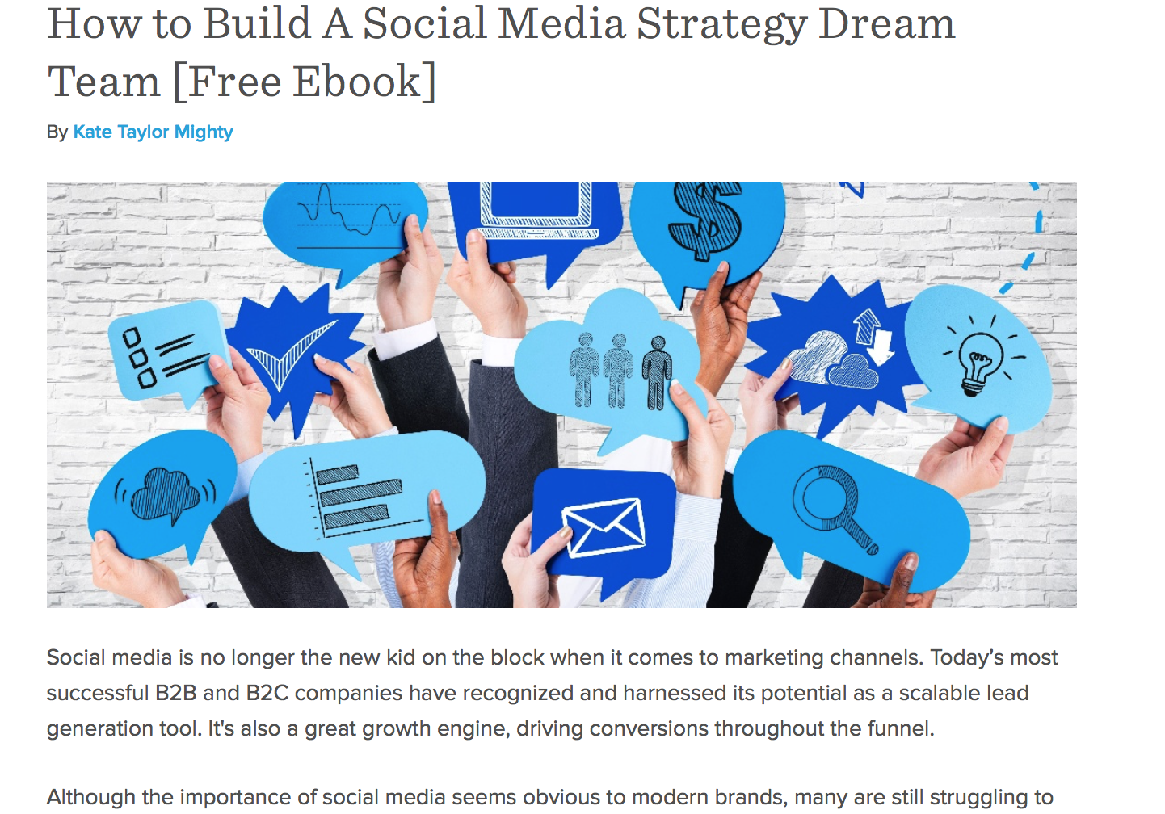
Image 2

Overall, the bracketed subtitles is an aspect of my research that needs to be reworked for BuzzFeed and further explored within HubSpot.

However, focusing on list articles, the following table provides a closer look at what BuzzFeed categories had the most titles containing numbers:

BuzzFeed Categories that Contain a Number
Lowest: | Highest:
Politics: 9% | Style: 63%
World: 11% | Travel: 57%
Reader: 12% | Parents: 55%
Table 5

There is a stark polarity separating the most frequent categories and the least frequent categories in Table 5.

The results in table 6 show the occurrences by percent of each BuzzFeed category that start with a number:

BuzzFeed Categories that Start with a Number:
Lowest: | Highest:
Business: 1% | Style: 55%
Politics: 1% | Travel: 50%
Puzzles: 2% | Parents: 44%
Table 6

Again, there is a steep difference between the BuzzFeed categories that implement titles that start with a number and those that do not. Table 6 shows that while Politics, Business and Puzzles are largely free from this type of pattern, Style, Travel and Parents use it heavily.

Compared to BuzzFeed, the results for HubSpot in tables 7 and 8 respectively show that both the floor for the lowest categories and ceiling for most occurring category are much higher.

HubSpot Categories that Contain a Number:
Lowest: | Highest:
Podcast: 22% (9%) | Sales-Closing: 81%  (67%)
Media: 24%  (11%) | Sales-Emails: 78%  (57%)
Inside-Sales: 28%  (12%) | Sales-Pitch: 75%  (55%)
Table 7

HubSpot Categories That Start with a Number:
Lowest: | Highest:
Podcast: 9%  (1%) | Sales-Presentations: 62% (55%)
Media: 11%  (1%) | Sales-Pitch: 62%  (50%)
PPC: 12%  (2%) | Sales-Calls: 62%  (44%)
Table 8

Again, the floor for the least occurring categories is much higher for HubSpot than BuzzFeed as well as the ceiling for the most occurring categories. It is interesting that this list can almost perfectly be split along the sub categories of Marketing and Sales. While Marketing categories such as Inbound Marketing was the most frequently occurring category overall, the Marketing categories tend to be the lower percent in terms of fitting these list article patterns, whereas the Sales subsection seems to rely on these patterns much more frequently.

Conclusion:

This research supports my initial hypothesis that Dan Lyons did employ a different writing style during his tenure at HubSpot. His titles do not conform to many of the stylistic conventions I identified within the other HubSpot titles.

His claim that the HubSpot blog was only used to sell their software is supported by the consistent approach to articles across categories and the high rate at which articles were posted across categories. These tactics seem to indicate that HubSpot identified a style of writing articles that they believe best generates leads for their sales team and tried to disperse this material across as many “categories” as possible to create an increased impression of activity/thought leadership.

As a journalist accustomed to writing in a particular manner the shockingly high percentage at which list style articles were being generated must have been frustrating. Likewise, there does not seem to be a category in which he could take professional refuge and write the type of articles he would want to. Whereas BuzzFeed has categories such as Business or Politics that do not employ these types of title patterns, the HubSpot categories consistently implement them at a higher percentage across all categories.

References:

Disrupted: My Misadventure in the Startup Bubble by Dan Lyons

Further Research:

Looking for trends over time, I produced the following graphs:

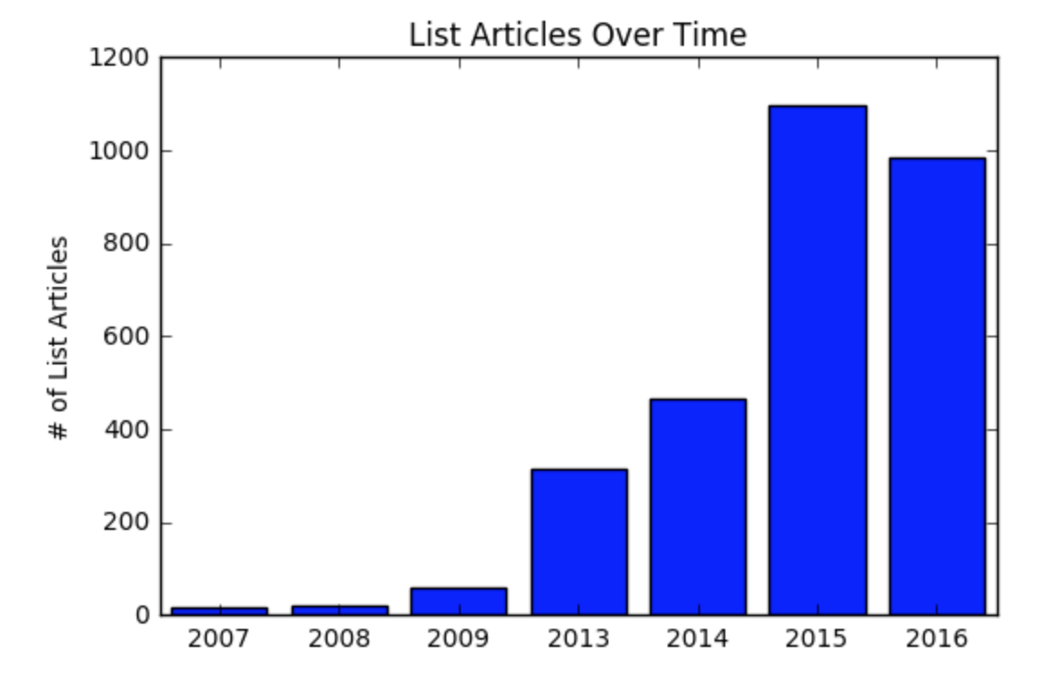
Graph 1

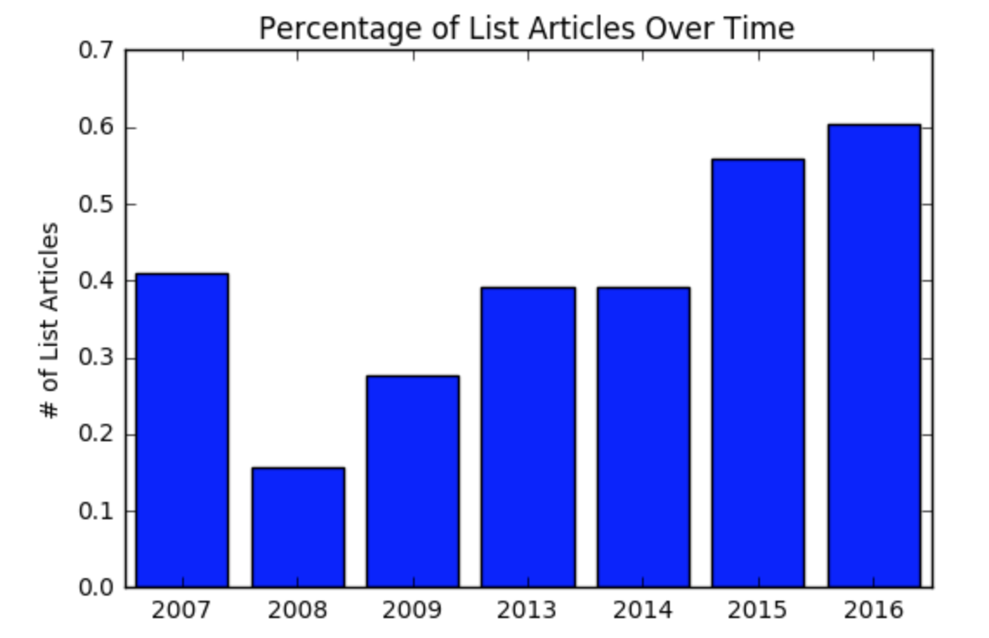
Graph 2

Graph 1, shows the number of list articles over time. Given the small sample size from earlier years, this graph is a bit misleading (only 18 articles total were posted in 2007).

However, Graph 2 further supports the trend that list articles are increasing over time. Represented as a percentage of all articles from that year, Graph 2 shows a steady increase in list articles over the past 4 years and an almost 33% increase in the percent occurrence over the past 9 years.

Which leads me to want to continue this research by comparing these trends over time, before Dan Lyons started working for HubSpot, while he was working there and after he left could be investigated. Similarly segmenting BuzzFeed titles could also be done.

This could quantify reports that BuzzFeed has made efforts to distance themselves from listicles, and unearth trends within BuzzFeed’s titles that would elaborate how mislead Lyons was when he first started working for HubSpot. He mentions, having thought that he would be working to improve the journalistic quality of HubSpot’s blog. This comparison would be a useful data point in understanding the disappointment he expresses in the book for not being allowed to make these changes.

It is also mentioned in Disrupted, and proved in my research that the HubSpot blog was reusing content, cross-posting it over 27% of articles under several different categories. However, in addition to the over 3,000 articles cross posted, there were over a hundred articles that were re-posted on different days, with on instance occurring a year after the initial post.

In addition to cross-posting articles, there were an unidentified number of articles posted by guest authors. These outside authors were identified as guest posting within the body of the article, however the article still listed a HubSpot employee in the heading as being the author. Finding trends as to which HubSpot employees were most frequently given credit for guest posts is another possible direction for further research.

Lastly, as an interesting aside, as I was looking for further information about HubSpot’s guest posting policy I found the following page https://blog.hubspot.com/marketing-guest-blogging-guidelines . In this page they clearly mention that they want posts that stay away from buzzwords and jargon only to go on and later list TOFU, as the third type of posts that they most commonly look for.

Lyons mentioned that the goal of HubSpot’s blog was to be the “top of the funnel” and continually exposed moments of frustrating hypocrisy within the company. I hope this investigation found a few as well.

