Parametric Design and Structural Analysis of Wind Turbine Blade Tips Using Finite Element Analysis
Shahad Alshamari *

Abstract
This study examines how blade-tip sweep angle, relative tip thickness and material selection affect the static structural response of a wind turbine blade tip. A three-dimensional solid model of the NREL 5-MW reference blade was created in SOLIDWORKS, and the tip sweep angle (0°–30°) and relative tip thickness (80%–120%) were each varied in four steps, giving 16 geometric configurations. Each configuration was analyzed with five linear-elastic isotropic material models (PEEK, CF-PA12, CF-PEEK, GFRP and CFRP), resulting in 80 parametric simulations, plus five simulations of the original blade (0° sweep, 100% thickness). All cases were subjected to a uniform pressure of 1000 N/m², and the maximum von Mises stress, maximum displacement, maximum equivalent strain and minimum factor of safety were evaluated. A mesh sensitivity study was also performed for one configuration. The influence of sweep angle and tip thickness on the structural response was non-monotonic, whereas material stiffness clearly governed deformation. The lowest maximum stress (1.272 × 10³ Pa) was obtained for GFRP with 30° sweep and 110% thickness, and the lowest maximum displacement (0.001978 mm) for CFRP with 20° sweep and 120% thickness. Some modified blade tips outperformed the original blade, but not for all criteria. Displacement results were strongly sensitive to mesh refinement, so mesh independence could not be established. The results therefore provide a comparative assessment of blade-tip configurations under simplified static loading rather than a prediction of operational wind turbine performance.
Keywords: Wind turbine blade, Blade-tip sweep, Parametric design, Finite element analysis, Composite materials, Structural response.

Introduction
As wind energy continues to grow in importance as a renewable source of electricity, so does the demand for efficient and reliable wind turbine designs. Wind turbine blades are one of the most critical parts of the overall structure because of how their geometry and materials affect deformation, stress distributions, and overall structural performance. As the size of wind turbine blades grows, it becomes increasingly difficult to provide sufficient rigidity and strength while minimizing the total weight of the blades. The blades of today's largest offshore turbines are greater than 100 meters long ¹.
Therefore, selecting the right material and performing a thorough structural analysis are both necessary when designing wind turbine blades ^{2,3}. The structural behavior of wind turbine blades is dependent upon two main factors: their geometric configuration and material properties. Both glass-fiber-reinforced polymer (GFRP) and carbon-fiber-reinforced polymer (CFRP) have been studied for use in blade applications due to their mechanical properties and high stiffness-to-weight ratios ^{1,4}. Variations in elastic modulus, strength, and density will cause changes in structural deformation and stress responses. Finite element analysis (FEA), a type of numerical modeling, is a viable tool for assessing these responses and comparing potential blade design alternatives prior to actual manufacturing ^{3,5}.
In addition to selecting the appropriate material, the geometric configuration of a wind turbine blade significantly impacts its structural behavior. Alterations to the blade-tip region of a wind turbine blade specifically the sweep angle and thickness can alter the geometry and ultimately impact the structural response. Sweep angle, which moves the blade axis relative to the rotor plane, has previously been studied primarily in relation to blade loads and aeroelastic behavior ^{6–9}. The previous research on sweep angles focused on the operational aerodynamic and aeroelastic behaviors of wind turbine blades; however, this study focuses on the static structural response.
Previous studies have investigated the blade materials of wind turbines as well as the structural modeling and aerodynamic performance of wind turbine blades with swept blades. A comparative study of the structural behavior of different configurations of the blade-tip sweep angle, relative tip thickness and different materials under static loading, however, has not yet been carried out.
The purpose of this study is to investigate the influence of blade-tip sweep angle, relative thickness of blade-tip and material selection on structural behavior of wind turbine blade. The investigation has been carried out using SOLIDWORKS Simulation.
1. How does the maximum von Mises stress, the maximum resultant displacement and the maximum equivalent strain change for different combinations of blade-tip sweep angle and relative thickness of blade-tip?
2. How does the material selection affect the calculated structural response and minimum factor of safety for the various blade-tip configurations?
The study compares 16 geometric configurations using five material models. All configurations have been subjected to the same pressure and boundary conditions in order to assess the relative performance of the simplified numerical model, rather than attempting to model the behavior of wind turbine blades in service.
A geometric model of the NREL 5-MW reference wind turbine blade was chosen as the baseline ¹⁰. Four sweep angles (0°, 10°, 20°, and 30°) and four relative tip-thickness levels (80%, 90%, 110%, and 120%) were evaluated, resulting in 16 geometric configurations. Five different materials (PEEK, CF-PA12, CF-PEEK, GFRP, and CFRP) were analyzed, resulting in 80 static finite element simulations. A uniform pressure of 1000 N/m² was applied as a simple prescribed loading condition. Maximum von Mises stress, maximum resultant displacement, maximum equivalent strain, and minimum factor of safety were determined for each configuration to assess their structural responses.

Methodology

Blade Geometry and Parametric Design
The reference blade used for the baseline model is the blade of the NREL 5-MW reference wind turbine with a blade length of 61.5 m ¹⁰. The geometric data used for the reconstruction of the blade in SOLIDWORKS was obtained from the COMSOL model documentation, Stress and Modal Analysis of a Wind Turbine Composite Blade ¹¹. The blade geometry used in this documentation is that of the NREL 5-MW wind turbine. The blade is composed of 19 spanwise stations and the sectional information for each of these is given, including the spanwise position, the chord length, the twist angle and the airfoil profile used for that section. This information was used to create the baseline three-dimensional blade model in SOLIDWORKS as summarized in Table 1.
Table 1. Reference blade sectional geometry
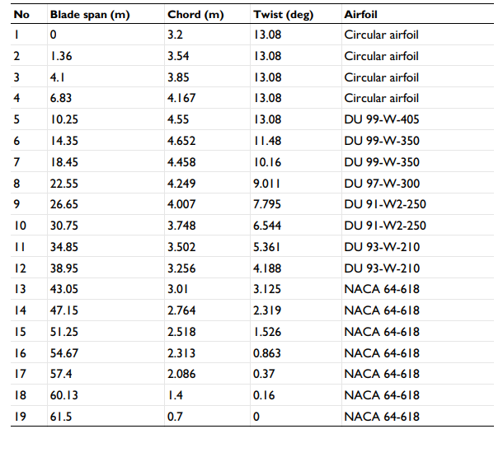
This reference blade has circular root sections which are followed by Delft University (DU) airfoil sections, and then NACA 64-618 airfoil at the end of the blade. The sectional data shows that the maximum chord length is 4.652 meters at a spanwise location of 14.35 meters; while the chord decreases to 0.7 meters at the tip. The associated twist angle at the tip is 0 degrees. These geometry features were used to create the baseline three-dimensional blade model. After creating the baseline geometry model, a parametric design method was used in SOLIDWORKS. Only the blade-tip region was modified regarding its shape. All other aspects of the blade geometry and chord distribution remained unchanged. A total of four different sweep angles were tested (0, 10, 20, and 30 degrees) along with four different relative thickness values for the tip of the blade (80%, 90%, 110%, and 120%).
The relative tip thickness of modified blade sections was calculated as percentage of the original thickness of the final airfoil section (i.e. 100% equals unmodified reference geometry). The blade section with the number 19 (located at the blade tip, i.e. at 61.5 m span) was chosen for thickness modifications. The modified airfoil sections were defined by means of their coordinated data (X, Y, Z) and imported into SOLIDWORKS to create the corresponding 3D blade geometries. Four different relative thickness levels were investigated, i.e. 80%, 90%, 110% and 120% of the original thickness of the blade tip. For the comparison with the modified blade designs the original blade model with 0° sweep angle was used as a geometric reference. The 100% thick blade section was not part of the parametric study on blade geometries but was investigated using the five material models to establish a baseline for comparison with the modified blade designs.
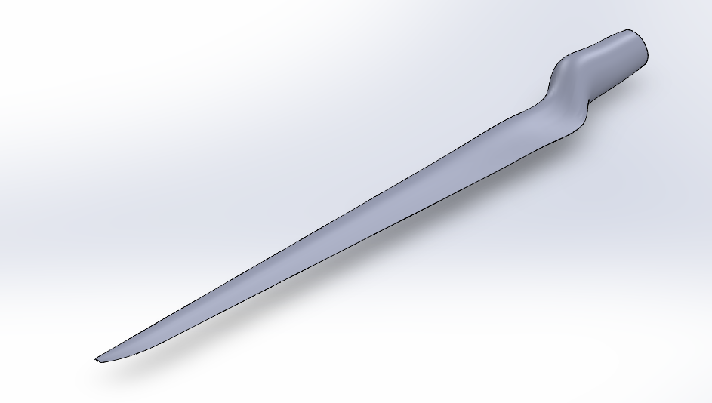
Figure 1. Three-dimensional solid model of the baseline wind turbine blade developed in SOLIDWORKS
$N_{geometry}=N_{sweep}×N_{thickness}$ | (1)
$N_{geometry}=4×4=16$
The design parameters investigated are summarized in Table 2.
Table 2. Parametric blade-tip design variables
Design parameter | Values
Baseline blade length | 61.5 m
Number of baseline spanwise sections | 19
Tip sweep angle | 0°, 10°, 20°, 30°
Relative tip thickness | 80%, 90%, 110%, 120%
Chord distribution | Maintained constant
Modified region | Blade tip only
Total geometric configurations | 16
The 16 modified geometric configurations were analyzed with the 5 material models in the main parametric study (80 analyses in total). The original blade geometry with 0° sweep angle and 100% relative tip thickness was also analyzed with the same 5 materials as a reference case. The finite element analysis procedure is described in detail in Section 2.3.

Material Selection and Properties
Five different materials were chosen to evaluate how material property characteristics affect structural performance of wind turbine blade tips. The five materials are polyetheretherketone (PEEK), carbon-fibre-reinforced polyamide 12 (CF-PA12), carbon-fibre-reinforced PEEK (CF-PEEK), glass-fibre-reinforced polymer (GFRP), and carbon-fibre-reinforced polymer (CFRP). PEEK, CF-PA12, and CF-PEEK are all polymer-based candidate materials, while GFRP and CFRP are composite benchmark materials that will be compared against each other.
The material properties of PEEK, CF-PA12, and CF-PEEK are derived from their definition within SOLIDWORKS Simulation. As for GFRP and CFRP, reference material definitions were created based on the mechanical characteristics of unidirectional E-glass/epoxy and standard-modulus carbon-fibre/epoxy composites presented in ACP Composites ¹². Reference materials were then represented within SOLIDWORKS as simplified isotropic materials. The elastic modulus of 40 GPa, density of 1900 kg/m³ and longitudinal tensile strength of 1000 MPa for the GFRP were taken from the reference properties of E-glass/epoxy composites as reported by ACP Composites ¹². This tensile strength was adopted as the strength limit for the simplified isotropic factor-of-safety assessment. The Poisson’s ratio was retained at 0.28, as used in the modeling, as opposed to the major Poisson’s ratio of 0.25 for the unidirectional composite. The GFRP factor-of-safety values were re-calculated using the new strength limit of 1000 MPa, but the linear-elastic stress, displacement and strain results from the original model were retained.
For CFRP, an elastic modulus of 135 GPa, a density of 1600 kg/m³, and a strength limit of 1500 MPa were utilized, consistent with the longitudinal properties reported for standard-modulus carbon-fibre/epoxy composites by ACP Composites ¹². A Poisson's ratio of 0.30 was utilized in the isotropic model. The reference provides this as a major Poisson's ratio for a unidirectional composite; however, it was utilized as an isotropic modeling parameter. The material properties used in finite element models are shown in Table 3.
Table 3. Material properties implemented in the finite element models
Material | Elastic modulus, E (GPa) | Poisson’s ratio, ν | Density (kg/m³) | Adopted strength/failure limit (MPa) | Shear modulus, G (GPa)
PEEK | 3.90 | 0.40 | 1310 | 95 | 1.393*
CF-PA12 | 3.86 | 0.35 | 1060 | 92 | 1.430*
CF-PEEK | 6.00 | 0.40 | 1300 | 112 | 2.143*
GFRP | 40.0 | 0.28 | 1900 | 1000 | 15.625*
CFRP | 135.0 | 0.30 | 1600 | 1500 | 51.923*
Note: *The shear modulus values were calculated using the isotropic elasticity relationship.
Using the relationship for linear-elastic isotropic materials; the shear modulus (G) was calculated from Young's modulus (E) and Poisson's ratio (ν) using the following formula:
$G=\frac{E}{2\left(1+ν\right)}$ | (2)
An example of how this calculation would be done for GFRP is shown below:
$G=\frac{40}{2\left(1+0.28\right)}$ | (3)
G = 15.625 GPa
The same calculations were applied to the remaining materials using their respective elastic moduli and Poisson's ratios. The shear modulus values obtained from these calculations were maintained consistent with the isotropic definitions of all of the materials. All the five materials were modeled in SOLIDWORKS Simulation as linear-elastic isotropic materials.
While the use of a single model type provides a consistent framework for comparison, fiber-reinforced materials typically exhibit directionally dependent mechanical behaviors. In particular, GFRP and CFRP generally exhibit anisotropic behavior where their mechanical behavior is determined by the direction of the fibers, the number of layers in the laminate, and the arrangement of those layers ¹.
Therefore, the isotropic modeling approach utilized in this study represents a simplification and does not accurately represent either the directional behavior or the failure modes of such composites. These limitations were taken into account when evaluating the simulation results. In order to assess the factors of safety of each of the materials, the assigned strengths were used as failure thresholds in the numerical models. When tensile strength was used as a failure threshold, it was not assumed to be equal to an experimentally measured yield strength.
As a result, the calculated factors of safety depend upon the assigned material properties and the failure criteria employed in SOLIDWORKS Simulation. Mohr-Coulomb failure criterion for PEEK and maximum von Mises stress criterion for CF-PA12, CF-PEEK, GFRP, and CFRP were used for the safety factor calculations, considering the used material strength values and SOLIDWORKS Simulation setting.

Finite Element Analysis
A static finite element analysis (FEA) was conducted using SOLIDWORKS Simulation software to determine how each of the examined wind turbine blade tip geometries would respond structurally. Each blade geometry was developed as a three-dimensional solid body. The same overall method of analyzing the structural response of each blade geometry was used regardless of the type of material or geometry of the configuration. A fixed geometry boundary condition was applied to the base of the blade root face. The fixed geometry boundary condition represented the restraint imposed on the structure at the connection of the blade to the hub of the turbine. The pressure applied to the outer surface of the blade was uniformly distributed across the surface and applied at 1000 N/m². The pressure was applied only to the outside of the blade, therefore, the root face was excluded from the application of pressure. A uniform pressure was chosen as a means of providing a standardized pressure for comparison purposes of the structural response of the various configurations examined. The uniform pressure was not based upon any particular wind speed or aerodynamic calculations and did not accurately represent the pressure distribution that would occur during operation of a full-scale wind turbine blade.
Therefore, the purpose of conducting this analysis was to compare the structural response of the various configurations based upon the defined pressure condition, and not to predict the operational performance of a full-scale wind turbine blade. The pressure was applied perpendicular to the selected surface.
The reaction force at the fixed root of the representative PEEK blade with 0° sweep and 80% relative tip thickness was calculated to be 7,317.25 N in the SOLIDWORKS Simulation. The blade was modeled with the selected surface of the blade’s exterior surface as the pressure load, not a typical one-sided aerodynamic bending load.
Thus, the resulting stresses, deflections, and safety factors must be evaluated with this difference in loading in mind. The blade geometries were meshed using a blended curvature based solid mesh with good quality elements. The solid meshing function was set up with 16 Jacobian points to evaluate the quality of each element.
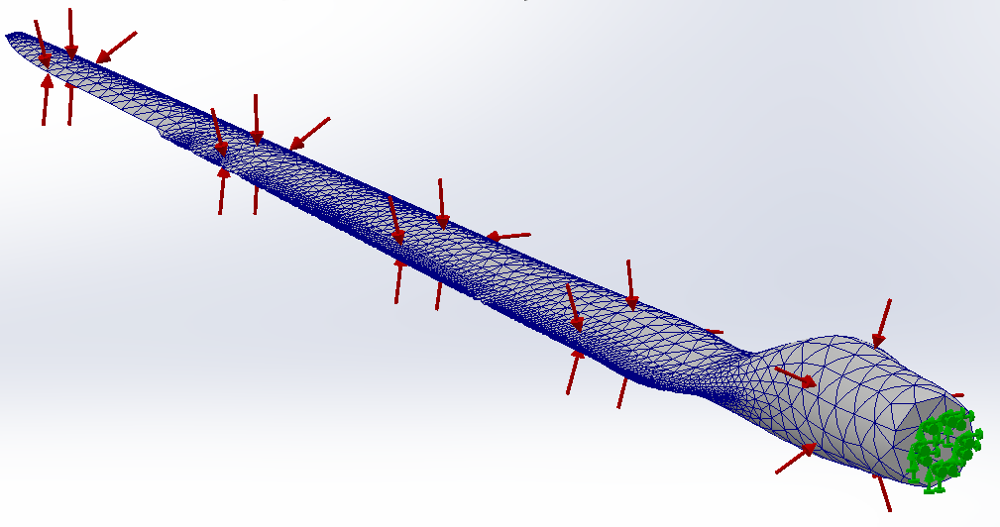
Figure 2. Representative SOLIDWORKS Simulation setup showing the finite element mesh, applied pressure arrows, and fixed root boundary condition
Although there were differences in the numbers of nodes and elements for each configuration due to variations in geometry, the same general meshing technique was utilized for all configurations in this study.
For example, the 10 degree sweep and 80 percent relative thickness configuration had 56,389 nodes and 30,292 elements and reported zero percent distortion by SOLIDWORKS. The mesh was generated using the blended curvature-based mesher in SOLIDWORKS Simulation using high-quality solid elements. The mesh sensitivity of the calculated structural response was studied for a representative CF-PEEK configuration with a 10° sweep angle and 80% relative tip thickness. For this configuration, three mesh levels were created by decreasing the maximum and minimum element sizes by 20% at each refinement level while keeping the material properties, the pressure distribution and the fixed-root boundary condition constant. The maximum von Mises stress and maximum resultant displacement were compared for the different mesh levels. The simulation matrix contained four different sweep angles, four different levels of relative thickness, and five different types of materials.
Therefore, the number of simulations in the main parametric study was determined as follows:
$N=N_{sweep}×N_{thickness}×N_{material}$ | (4)
$N=4×4×5=80 simulations$
Each of the 16 geometric configurations was simulated using PEEK, CF-PA12, CF-PEEK, GFRP, and CFRP under the specified static loading and boundary conditions. Four indicators of structural response were obtained from the simulations including maximum von Mises stress, maximum resultant displacement, maximum equivalent strain, and minimum factor of safety (FOS). These results were compiled to compare the effect of blade-tip sweep angle, relative thickness, and material selection on the structural response of each configuration. The stress values were reported in N/m² (Pa), displacement in millimeters, and equivalent strain and FOS as unitless quantities.
Five additional static simulations of the original blade design were conducted at 0° sweep angle with 100% relative tip thickness, one for each of the five material models.
Thus, a total of 85 structural simulations were completed (excluding the additional mesh sensitivity simulations). The baseline simulations incorporated the same prescribed pressure, material properties and fixed root boundary conditions as the main parametric study.

Results and Discussion
The main parametric study of the work comprised 80 static FEA of 16 modified blade-tip shapes using 5 different material models, as well as 5 additional simulations of the original blade shape. This results in a total of 85 structural simulations. All analytical results were evaluated using the following criteria: maximum von Mises stress, maximum resultant displacement, maximum equivalent strain and minimum factor of safety (FOS). Consistent root boundary condition and pressure were used across all simulations so that comparisons among the various cases could be made on a consistent basis. Tables 4-7 present the results of these analyses. The subsequent discussion will address how blade-tip swept-back angles, relative thicknesses and material selections affect the calculated structural behaviors. Since the analyses utilized a simplistic, uniform pressure applied perpendicular to the selected blade surface; the results should be viewed as a comparative analysis of the structural responses under the given loading conditions and not as predictive analyses of the actual operational aerodynamic performance of the blade.

Maximum von Mises Stress
Each analysis provided a maximum von Mises stress value which was utilized to assess the equivalent stress experienced by the blade under the specified loading condition. The stresses were reported by SOLIDWORKS Simulation in N/m² (Pa). The results for all the cases examined are provided in Table 4.
Table 4. Maximum von Mises stress for all investigated configurations (N/m²)
Sweep | Thickness | PEEK | CF-PA12 | CF-PEEK | GFRP | CFRP
0° | 80% | 1.922 × 10³ | 1.972 × 10³ | 1.922 × 10³ | 2.034 × 10³ | 2.022 × 10³
0° | 90% | 1.457 × 10³ | 1.501 × 10³ | 1.457 × 10³ | 1.555 × 10³ | 1.542 × 10³
0° | 110% | 1.691 × 10³ | 1.689 × 10³ | 1.686 × 10³ | 1.759 × 10³ | 1.729 × 10³
0° | 120% | 2.186 × 10³ | 2.238 × 10³ | 2.186 × 10³ | 2.289 × 10³ | 2.278 × 10³
10° | 80% | 1.674 × 10³ | 1.680 × 10³ | 1.674 × 10³ | 1.688 × 10³ | 1.686 × 10³
10° | 90% | 2.225 × 10³ | 2.239 × 10³ | 2.225 × 10³ | 2.269 × 10³ | 2.265 × 10³
10° | 110% | 1.648 × 10³ | 1.650 × 10³ | 1.648 × 10³ | 1.649 × 10³ | 1.652 × 10³
10° | 120% | 1.763 × 10³ | 1.780 × 10³ | 1.763 × 10³ | 1.798 × 10³ | 1.795 × 10³
20° | 80% | 1.870 × 10³ | 1.928 × 10³ | 1.870 × 10³ | 1.955 × 10³ | 1.943 × 10³
20° | 90% | 1.786 × 10³ | 1.788 × 10³ | 1.785 × 10³ | 1.813 × 10³ | 1.793 × 10³
20° | 110% | 2.272 × 10³ | 2.338 × 10³ | 2.272 × 10³ | 2.392 × 10³ | 2.373 × 10³
20° | 120% | 1.521 × 10³ | 1.549 × 10³ | 1.521 × 10³ | 1.583 × 10³ | 1.576 × 10³
30° | 80% | 1.919 × 10³ | 1.939 × 10³ | 1.919 × 10³ | 1.973 × 10³ | 1.971 × 10³
30° | 90% | 1.548 × 10³ | 1.570 × 10³ | 1.548 × 10³ | 1.590 × 10³ | 1.583 × 10³
30° | 110% | 1.329 × 10³ | 1.309 × 10³ | 1.329 × 10³ | 1.272 × 10³ | 1.318 × 10³
30° | 120% | 2.595 × 10³ | 2.600 × 10³ | 2.595 × 10³ | 2.600 × 10³ | 2.601 × 10³

Stress Unit and Factor-of-Safety Verification
The stress units were compared to the original SolidWorks Simulation reports to determine why the reported stresses were unusually low and why the factors of safety were extremely large. The SolidWorks reports verified that the stress units were given in N/m² (Pa), not MPa.
For example, the maximum von Mises stress for the CF-PEEK configuration with a 10 degree sweep angle and 90 percent relative tip thickness was found to be 2.225 × 10³ N/m². Converting this stress value to MPa yields:
$σ_{max}=2.225×{10}^{3} Pa$ | (5)
$σ_{max}=0.002225 MPa$
The assigned strength value for CF-PEEK is 112 MPa. Therefore, using the maximum von Mises stress criterion, the corresponding factor of safety can be determined as:
$FOS=\frac{σ_{limit}}{σ_{max}}$ | (6)
$FOS=\frac{112}{0.002225}≈50,337$
The calculated FOS value is very close to the minimum FOS value of approximately 50,350 as calculated by SolidWorks Simulation, with the difference being primarily due to rounding. This comparison confirms the consistency of the stress units and factor of safety calculation for the selected CF-PEEK case.
However, it must be emphasized that the large FOS values obtained cannot be used to represent the operational safety margin for a wind turbine blade since the applied pressure represents a simplified reference loading condition, rather than real-world aerodynamic loading conditions. As shown in Table 4, the maximum von Mises stress results indicate that the structural response was influenced by both the blade tip sweep angle and relative thickness. The relationship between sweep angle and thickness and maximum von Mises stress was non-monotonic; i.e., increasing either sweep angle or relative thickness did not consistently decrease the maximum stress.
Thus, it appears that the effect of tip geometry on the structural response depends on the combined effect of sweep angle and thickness, rather than on each of these two variables individually. The lowest maximum von Mises stress was 1.272 × 10³ N/m² and occurred in GFRP at a sweep angle of 30 degrees and a relative thickness of 110 percent. At the same sweep angle and relative thickness, GFRP also demonstrated relatively low stresses in comparison to other materials, ranging from 1.309 × 10³ N/m² to 1.329 × 10³ N/m².
Therefore, it appears that the 30 degree sweep/110 percent relative thickness configuration provided a favorable stress response to the prescribed loading condition. Conversely, the highest maximum von Mises stress was 2.601 × 10³ N/m² and occurred in CFRP at a sweep angle of 30 degrees and a relative thickness of 120 percent.
Additionally, at a sweep angle of 30 degrees, increasing the relative thickness of CFRP from 110 percent to 120 percent resulted in an increase in maximum von Mises stress from 1.318 × 10³ N/m² to 2.601 × 10³ N/m². This represents an increase in maximum von Mises stress of approximately 97.3 percent.
Thus, it is evident that increasing tip thickness does not necessarily lead to a decrease in maximum stress in the investigated numerical models. Non-monotonic trends were also apparent at other sweep angles.
Specifically, at a sweep angle of 20 degrees, the maximum von Mises stress in CFRP decreased from 2.373 × 10³ N/m² at 110 percent thickness to 1.576 × 10³ N/m² at 120 percent thickness. This represents a decrease in maximum von Mises stress of approximately 33.6 percent. Similarly, at a sweep angle of 10 degrees, the maximum von Mises stress values generated by the 110 percent thickness configuration were lower than those generated by both the 90 percent and 120 percent thickness configurations across all five materials. Typically, the maximum von Mises stress values for different materials within the same geometric configuration were similar, whereas greater differences were evident between various geometric configurations.
Therefore, it is reasonable to conclude that the specific tip geometry selected had a greater influence on the reported maximum von Mises stress than did material selection under the adopted linear elastic isotropic models and prescribed pressure loading. In general terms, it can be stated that among all cases considered herein, the 30 degree sweep/110 percent relative thickness configuration exhibited the lowest stress response, whereas the 30 degree sweep/120 percent relative thickness configuration exhibited the highest stress response.
However, it must be emphasized that these comparisons are limited to the simplified loading condition employed in this study and should not be interpreted as indicating superior performance under real-world aerodynamic wind loading.
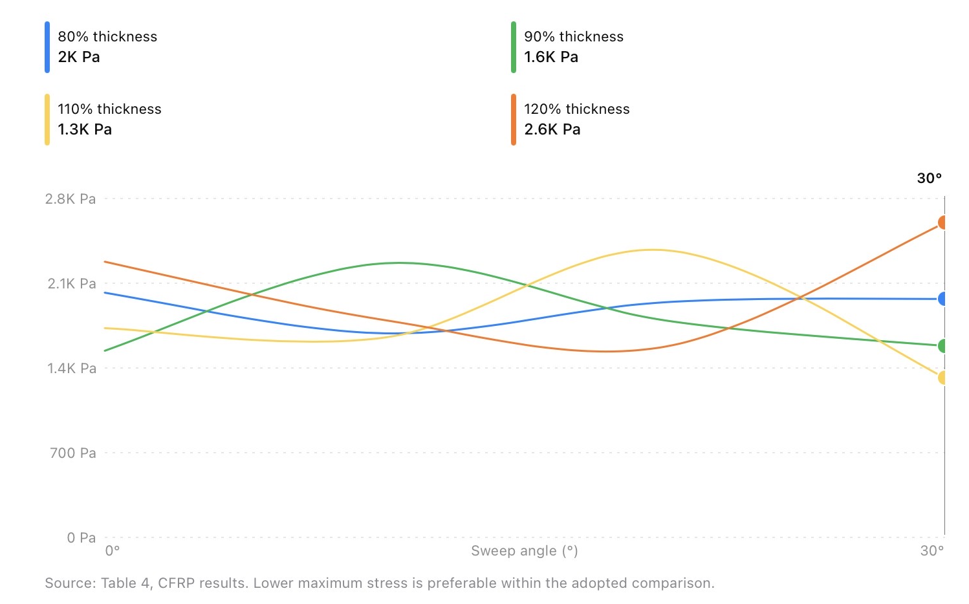
Figure 3. Effect of blade-tip sweep angle and relative thickness on maximum von Mises stress for the CFRP material model under the prescribed pressure loading condition
The maximum von Mises stress changes in a way that is not always linear with respect to sweep angle and relative tip thickness (see Figure 3). For CFRP, the minimum stress was found to be 30 degrees sweep and 110 percent thickness; however, the maximum stress occurred at 30 degrees sweep and 120 percent thickness. Therefore, it appears that an increase in tip thickness does not consistently result in a decrease of the maximum stress, given the loading conditions used.

Maximum Resultant Displacement
The deformation of the different blade tip designs tested during this study can be compared by their maximum resultant displacement when subjected to the specified pressure load. The displacement data generated using SOLIDWORKS Simulation is shown in Table 5 and is expressed in millimeters (mm).
Table 5. Maximum resultant displacement for all investigated configurations (mm)
Sweep | Thickness | PEEK | CF-PA12 | CF-PEEK | GFRP | CFRP
0° | 80% | 0.1837 | 0.1856 | 0.1193 | 0.01792 | 0.005310
0° | 90% | 0.4480 | 0.4529 | 0.2911 | 0.04370 | 0.01295
0° | 110% | 0.1252 | 0.1266 | 0.08135 | 0.01224 | 0.003625
0° | 120% | 0.07608 | 0.07695 | 0.04952 | 0.007438 | 0.002203
10° | 80% | 0.1025 | 0.1035 | 0.06665 | 0.009981 | 0.002958
10° | 90% | 0.09422 | 0.09517 | 0.06124 | 0.009185 | 0.002721
10° | 110% | 0.1495 | 0.1512 | 0.09719 | 0.01461 | 0.004328
10° | 120% | 0.6325 | 0.6393 | 0.4111 | 0.06171 | 0.01828
20° | 80% | 0.2830 | 0.2862 | 0.1840 | 0.02764 | 0.008188
20° | 90% | 0.08191 | 0.08282 | 0.05324 | 0.008012 | 0.002372
20° | 110% | 0.1450 | 0.1467 | 0.09428 | 0.01417 | 0.004198
20° | 120% | 0.06831 | 0.06909 | 0.04440 | 0.006680 | 0.001978
30° | 80% | 0.2300 | 0.2326 | 0.1495 | 0.02246 | 0.006654
30° | 90% | 0.1786 | 0.1806 | 0.1161 | 0.01744 | 0.005166
30° | 110% | 0.1209 | 0.1223 | 0.07860 | 0.01181 | 0.003498
30° | 120% | 0.2396 | 0.2422 | 0.1557 | 0.02338 | 0.006928
The results in Table 5 show that the stiffness of the material significantly affected the deformation of the tested blade models. Across all 16 geometries, CFRP consistently yielded the least maximum resultant displacement; it was followed by GFRP and CF-PEEK.
In contrast, PEEK and CF-PA12 typically generated greater resultant displacements than CFRP, due to their lower assigned elastic moduli. The smallest maximum resultant displacement (0.001978 mm) occurred for CFRP with a sweep angle of 20 degrees and a relative tip thickness of 120 percent. For the same geometry, PEEK and CF-PA12 produced maximum displacements of 0.06831 mm and 0.06909 mm, respectively. CF-PEEK and GFRP produced maximum displacements of 0.04440 mm and 0.006680 mm. As compared to PEEK, the CFRP model had approximately 97.1% less maximum displacement for this specific configuration. The largest maximum resultant displacement (0.6393 mm) occurred for CF-PA12 at a sweep angle of 10 degrees and a relative tip thickness of 120 percent. For the same geometric configuration, PEEK produced a maximum displacement of 0.6325 mm, while CFRP produced 0.01828 mm. These results illustrate that the stiffness of the material greatly influenced the computed deformation responses. The displacement behavior also differed based upon blade tip geometry. An increase in relative thickness did not consistently decrease maximum displacement. For example, for CF-PA12 with a sweep angle of 10 degrees, the displacement increased from 0.09517 mm at 90 percent thickness to 0.6393 mm at 120 percent thickness.
In contrast, for CF-PA12 with a sweep angle of 20 degrees, the displacement decreased from 0.08282 mm at 90 percent thickness to 0.06909 mm at 120 percent thickness. These examples demonstrate that the relationship between sweep angle, relative thickness, and displacement was non-monotonic under the given loading conditions. The observed material trend corresponds to what would be expected from linear elastic isotropic models, where increasing the elastic modulus will generally result in decreased displacement when all other variables remain constant.
The reported maximum resultant displacement values are the maximum values within each of the FE models. The location of the maximum displacement was also verified for the representative GFRP blade with 20° sweep and 120% relative tip thickness in SOLIDWORKS Simulation. It is located at the blade tip, but must be checked for each individual configuration.
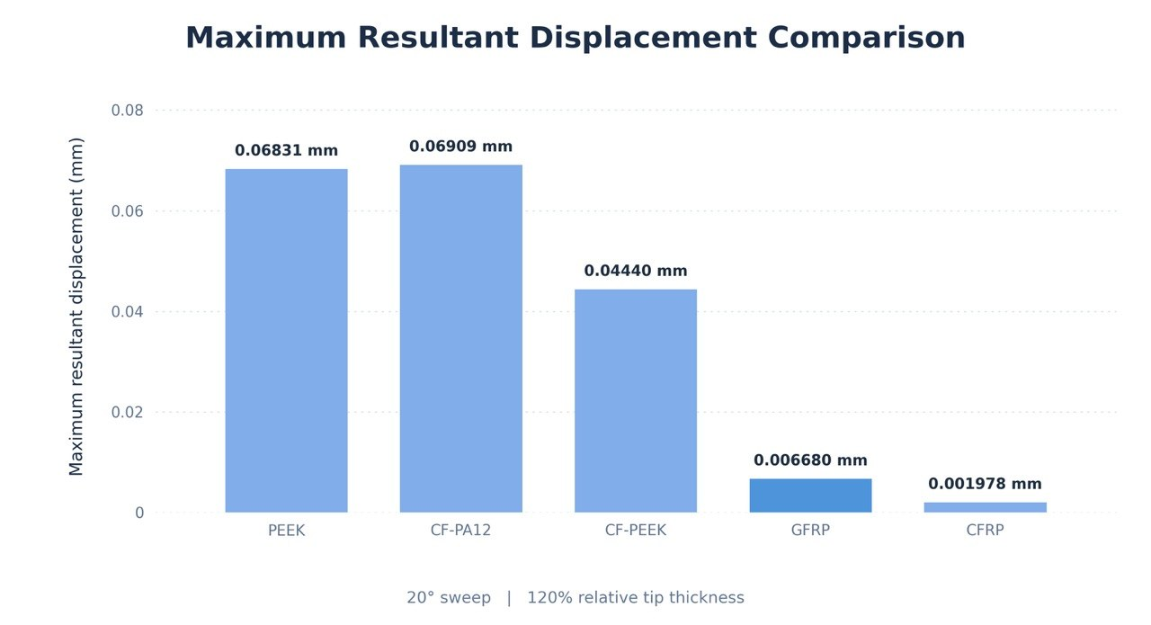
Figure 4. Comparison of maximum resultant displacement among the five material models at 20° sweep and 120% relative tip thickness

Maximum Equivalent Strain
The maximum equivalent strain value is used to evaluate how much each model deformed as compared to one another while subjected to the same loading conditions. Equivalent strain is a non-dimensional measure of the overall strain response in the 3D solid body. All maximum equivalent strain values determined using SOLIDWORKS Simulation for the 80 different material-geometry combinations were summarized in Table 6.
Table 6. Maximum equivalent strain for all investigated configurations
Sweep | Thickness | PEEK | CF-PA12 | CF-PEEK | GFRP | CFRP
0° | 80% | 2.401 × 10⁻⁷ | 2.343 × 10⁻⁷ | 1.560 × 10⁻⁷ | 2.145 × 10⁻⁸ | 6.447 × 10⁻⁹
0° | 90% | 3.398 × 10⁻⁷ | 3.312 × 10⁻⁷ | 2.208 × 10⁻⁷ | 3.026 × 10⁻⁸ | 9.113 × 10⁻⁹
0° | 110% | 2.218 × 10⁻⁷ | 2.161 × 10⁻⁷ | 1.442 × 10⁻⁷ | 1.979 × 10⁻⁸ | 5.955 × 10⁻⁹
0° | 120% | 2.631 × 10⁻⁷ | 2.566 × 10⁻⁷ | 1.710 × 10⁻⁷ | 2.383 × 10⁻⁸ | 7.173 × 10⁻⁹
10° | 80% | 2.237 × 10⁻⁷ | 2.180 × 10⁻⁷ | 1.454 × 10⁻⁷ | 1.998 × 10⁻⁸ | 6.012 × 10⁻⁹
10° | 90% | 3.161 × 10⁻⁷ | 3.080 × 10⁻⁷ | 2.054 × 10⁻⁷ | 2.820 × 10⁻⁸ | 8.487 × 10⁻⁹
10° | 110% | 2.314 × 10⁻⁷ | 2.255 × 10⁻⁷ | 1.504 × 10⁻⁷ | 2.066 × 10⁻⁸ | 6.218 × 10⁻⁹
10° | 120% | 2.622 × 10⁻⁷ | 2.556 × 10⁻⁷ | 1.705 × 10⁻⁷ | 2.341 × 10⁻⁸ | 7.047 × 10⁻⁹
20° | 80% | 2.239 × 10⁻⁷ | 2.181 × 10⁻⁷ | 1.455 × 10⁻⁷ | 2.001 × 10⁻⁸ | 6.019 × 10⁻⁹
20° | 90% | 2.250 × 10⁻⁷ | 2.191 × 10⁻⁷ | 1.463 × 10⁻⁷ | 2.007 × 10⁻⁸ | 6.044 × 10⁻⁹
20° | 110% | 2.497 × 10⁻⁷ | 2.432 × 10⁻⁷ | 1.623 × 10⁻⁷ | 2.224 × 10⁻⁸ | 6.694 × 10⁻⁹
20° | 120% | 2.629 × 10⁻⁷ | 2.563 × 10⁻⁷ | 1.709 × 10⁻⁷ | 2.340 × 10⁻⁸ | 7.046 × 10⁻⁹
30° | 80% | 2.235 × 10⁻⁷ | 2.179 × 10⁻⁷ | 1.453 × 10⁻⁷ | 1.997 × 10⁻⁸ | 6.005 × 10⁻⁹
30° | 90% | 2.327 × 10⁻⁷ | 2.265 × 10⁻⁷ | 1.513 × 10⁻⁷ | 2.069 × 10⁻⁸ | 6.230 × 10⁻⁹
30° | 110% | 2.545 × 10⁻⁷ | 2.495 × 10⁻⁷ | 1.654 × 10⁻⁷ | 2.297 × 10⁻⁸ | 6.901 × 10⁻⁹
30° | 120% | 2.758 × 10⁻⁷ | 2.683 × 10⁻⁷ | 1.793 × 10⁻⁷ | 2.453 × 10⁻⁸ | 7.382 × 10⁻⁹
In terms of strain response, it is clear from Table 6 that there is a strong correlation between material type and calculated strain response. The lowest maximum equivalent strain responses were obtained for CFRP over all of the tested configurations; GFRP and CF-PEEK gave the next lowest responses.
On the other hand, PEEK and CF-PA12 produced the highest equivalent strain responses due to their lower assigned elastic moduli. The lowest maximum equivalent strain of 5.955 × 10⁻⁹ was calculated for CFRP at 0 degrees sweep and 110 percent relative tip thickness. The highest maximum equivalent strain of 3.398 × 10⁻⁷ was calculated for PEEK at 0 degrees sweep and 90 percent relative tip thickness. Therefore, it is evident that there are significant differences in strain response between the various material models.
For instance, at 0 degrees sweep and 90 percent relative tip thickness, the maximum equivalent strain decreased by approximately 97.3 percent from 3.398 × 10⁻⁷ for PEEK to 9.113 × 10⁻⁹ for CFRP. This decrease is directly related to the higher elastic modulus assigned to CFRP in the isotropic material model.
Furthermore, the maximum equivalent strain response to changes in blade tip geometry (relative thickness) was not monotonic. At 0 degrees sweep, increasing the relative thickness of the tip from 80 percent to 90 percent resulted in an increase in the maximum equivalent strain for PEEK from 2.401 × 10⁻⁷ to 3.398 × 10⁻⁷. Increasing the relative thickness to 110 percent resulted in a decrease in the maximum equivalent strain to 2.218 × 10⁻⁷. Conversely, at 30 degrees sweep, increasing the relative thickness resulted in an increase in the maximum equivalent strain for PEEK from 2.235 × 10⁻⁷ at 80 percent relative thickness to 2.758 × 10⁻⁷ at 120 percent relative thickness.
In summary, the findings show that the stiffness of the material greatly affects equivalent strain, whereas the effects of sweep angle and relative thickness are dependent upon the specific geometric configuration.
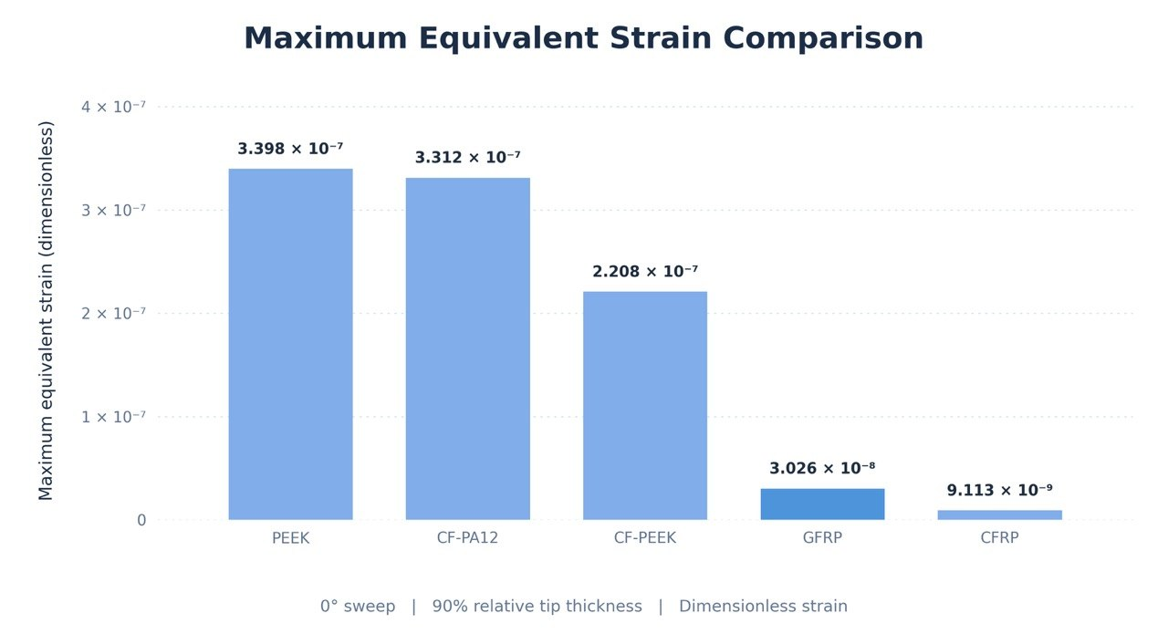
Figure 5. Comparison of maximum equivalent strain among the five material models at 0° sweep and 90% relative tip thickness. Values are dimensionless

Minimum Factor of Safety (FOS)
The Minimum Factor of Safety (FOS) is used to evaluate the difference in calculated stress values and material strength limits. A Minimum FOS indicates that there was at least one point where the stress value was closer to the failure limit than any other point on the part. The data presented in Table 7 shows the results of each of the 80 Material-Geometry Combinations simulated with SOLIDWORKS Simulation.
Table 7. Minimum factor of safety for all investigated configurations
Sweep | Thickness | PEEK | CF-PA12 | CF-PEEK | GFRP | CFRP
0° | 80% | 4.92 × 10⁴ | 4.665 × 10⁴ | 5.826 × 10⁴ | 4.917 × 10⁵ | 7.417 × 10⁵
0° | 90% | 5.47 × 10⁴ | 6.13 × 10⁴ | 7.69 × 10⁴ | 6.433 × 10⁵ | 9.73 × 10⁵
0° | 110% | 4.572 × 10⁴ | 5.447 × 10⁴ | 6.642 × 10⁴ | 5.683 × 10⁵ | 8.68 × 10⁵
0° | 120% | 4.548 × 10⁴ | 4.111 × 10⁴ | 5.123 × 10⁴ | 4.370 × 10⁵ | 6.585 × 10⁵
10° | 80% | 4.910 × 10⁴ | 5.477 × 10⁴ | 6.692 × 10⁴ | 5.925 × 10⁵ | 8.90 × 10⁵
10° | 90% | 3.891 × 10⁴ | 4.108 × 10⁴ | 5.035 × 10⁴ | 4.408 × 10⁵ | 6.624 × 10⁵
10° | 110% | 5.15 × 10⁴ | 5.576 × 10⁴ | 6.796 × 10⁴ | 6.064 × 10⁵ | 9.080 × 10⁵
10° | 120% | 4.79 × 10⁴ | 5.169 × 10⁴ | 6.353 × 10⁴ | 5.562 × 10⁵ | 8.357 × 10⁵
20° | 80% | 4.67 × 10⁴ | 4.772 × 10⁴ | 5.989 × 10⁴ | 5.115 × 10⁵ | 7.720 × 10⁵
20° | 90% | 4.94 × 10⁴ | 5.145 × 10⁴ | 6.274 × 10⁴ | 5.515 × 10⁵ | 8.367 × 10⁵
20° | 110% | 4.256 × 10⁴ | 3.935 × 10⁴ | 4.930 × 10⁴ | 4.181 × 10⁵ | 6.321 × 10⁵
20° | 120% | 5.63 × 10⁴ | 5.940 × 10⁴ | 7.363 × 10⁴ | 6.317 × 10⁵ | 9.518 × 10⁵
30° | 80% | 5.128 × 10⁴ | 4.746 × 10⁴ | 5.835 × 10⁴ | 5.068 × 10⁵ | 7.610 × 10⁵
30° | 90% | 5.068 × 10⁴ | 5.859 × 10⁴ | 7.236 × 10⁴ | 6.290 × 10⁵ | 9.474 × 10⁵
30° | 110% | 6.12 × 10⁴ | 7.028 × 10⁴ | 8.428 × 10⁴ | 7.862 × 10⁵ | 1.138 × 10⁶
30° | 120% | 3.70 × 10⁴ | 3.538 × 10⁴ | 4.316 × 10⁴ | 3.846 × 10⁵ | 5.767 × 10⁵
The results of the factor of safety analysis (FOS) shown in Table 7 clearly indicate significant variations in FOS based on both the type of material model and the geometry of the test samples. CFRP was found to have the highest minimum FOS for all 16 cases of geometric configurations, GFRP and CF-PEEK had the second and third highest minimum FOS, respectively. The relative ranking of PEEK and CF-PA12, however, changed from case to case for different blade-tip geometries. This is due to a combination of material strength limits and the calculated stresses for the applied loading conditions. The highest minimum FOS value was 1.138 × 10⁶ and occurred at a 30-degree sweep angle with a 110% relative thickness. Additionally, this same sample had a maximum von Mises stress of only 1.318 × 10³ N/m².
On the other hand, CF-PA12 with a 30-degree sweep angle and 120% relative thickness resulted in the lowest minimum FOS value of 3.538 × 10⁴. The effects of the blade tip geometry on the FOS were inconsistent. An example of this is the effect of changing the relative thickness from 110% to 120% at a 30-degree sweep angle. Changing the relative thickness resulted in a decrease in the minimum FOS value for CFRP from 1.138 × 10⁶ to 5.767 × 10⁵. This represents a decrease of nearly 49.3%, which is also consistent with the increase in maximum stress for the same change in geometry. The extremely large FOS values are due to the low equivalent stresses produced under the uniform pressure loading condition compared to the allowable material strength limits. A manual calculation for CF-PEEK using a strength limit of 112 MPa and a maximum von Mises stress of 0.002225 MPa would produce a FOS value of approximately 50,337. This manual calculation agrees well with the SOLIDWORKS calculation of 50,350.
The presented factors of safety (FOS) must be cautiously evaluated. The specified uniform pressure (1000 N/m²) on the selected outer surface of the blade is perpendicular to the selected area and is not indicative of the actual aerodynamic pressure distribution acting on a wind turbine blade during operation. Also, the use of simplified isotropic materials, prescribed strength limits and failure criteria will affect the calculated FOS values. Therefore, the FOS values presented in this paper reflect the numerical loading conditions and material assumptions made in this study; however, they cannot validate the safety margin under real wind turbine operating conditions.
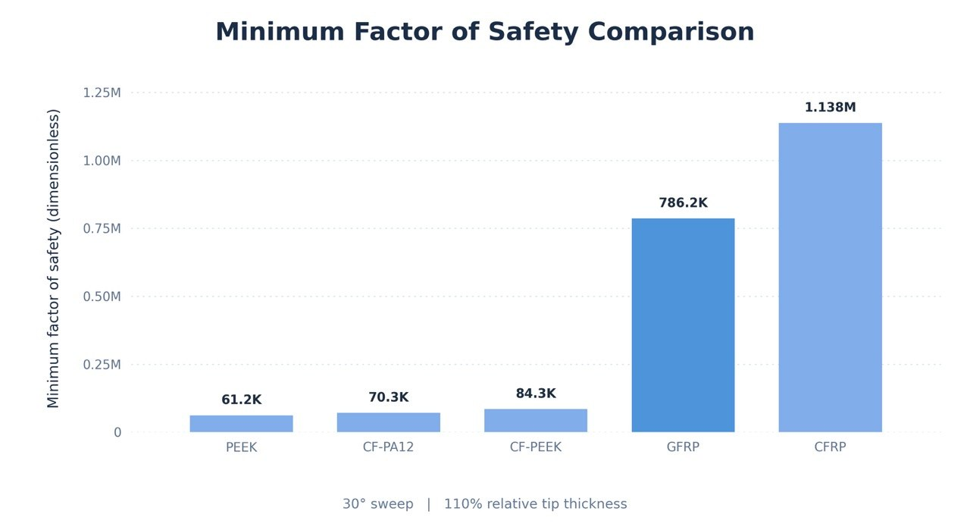
Figure 6. Comparison of minimum factor of safety among the five material models at 30° sweep and 110% relative tip thickness

Mesh Sensitivity Study
The mesh sensitivity study used the CF-PEEK blade with a 10° sweep angle and 80% relative tip thickness. Three different mesh levels were analyzed for the given load and boundary conditions. The mesh size was systematically reduced to assess its influence on the calculated results for maximum von Mises stress and maximum resultant displacement. The results are summarized in Table 8.
Table 8. Mesh sensitivity results for the CF-PEEK blade configuration at 10° sweep and 80% relative tip thickness
Parameter | Original Mesh | Refined Mesh 1 | Refined Mesh 2
Maximum element size (m) | 1.18836 | 0.950689 | 0.760551
Total elements | 30,292 | 38,047 | 45,920
Total nodes | 56,389 | 70,197 | 84,611
Maximum von Mises stress (Pa) | 1,674 | 2,426 | 2,531
Maximum resultant displacement (mm) | 0.06665 | 0.04179 | 0.03103
Resultant reaction force (N) | 7,316.19 | 7,561.52 | 7,693.82
Table 8 shows how mesh refinement affects the structural response of the model. Increasing the number of elements from 30,292 to 45,920 increases the maximum von Mises stress from 1,674 Pa to 2,531 Pa while the maximum resultant displacement decreases from 0.06665 mm to 0.03103 mm. The stress results change by 4.33% between the two levels of refinement while the displacement results change by 25.75%. The resultant reaction force also increases with refinement.
Although stress results improve with refinement, displacement results are sensitive to element size and therefore mesh independence has not been achieved. Results from structural analysis therefore must be used with caution, taking into account the finite element model discretization.

Original Blade Baseline Comparison
The original blade with 0° sweep angle and 100% relative tip thickness was also tested with the same five material models and the same static load conditions as the modified blade-tips. These results serve as a reference to compare the structural behavior of the modified blade-tips with the original blade. The results of the baseline calculations are given in Table 9.
Table 9. Structural response of the original blade configuration at 0° sweep and 100% relative tip thickness
Material | Max Stress  (Pa) | Max Displacement  (mm) | Max Strain  (dimensionless) | Min FOS
PEEK | 1,751 | 0.08526 | 2.541 × 10⁻⁷ | 4.980 × 10⁴
CF-PA12 | 1,751 | 0.08627 | 2.475 × 10⁻⁷ | 5.253 × 10⁴
CF-PEEK | 1,751 | 0.05542 | 1.651 × 10⁻⁷ | 6.398 × 10⁴
GFRP | 1,753 | 0.008343 | 2.262 × 10⁻⁸ | 5.704 × 10⁵
CFRP | 1,756 | 0.002471 | 6.808 × 10⁻⁹ | 8.542 × 10⁵
The maximum von Mises stress for the five different materials models was found to be almost identical for all cases, varying between 1,751 Pa and 1,756 Pa. However, the maximum displacement and the equivalent strain for the different materials models varied significantly. For the baseline cases the CFRP material model resulted in the lowest maximum displacement (0.002471 mm) as well as the lowest maximum equivalent strain (6.808 × 10⁻⁹). On the other hand, the minimum factor of safety for the CFRP material model was the highest for the baseline cases with a value of 8.542 × 10⁵. For the modified blade-tip configurations several configurations resulted in lower maximum stress, displacement or strain than the original blade, depending on the material as well as the geometric configuration of the blade-tip modification. However, these improvements were not consistent for all configurations and structural performance indicators.

Overall Structural Performance and Analytical Comparison
From the results presented in Tables 4–7, it can be concluded that both blade-tip geometry and the material of the blade have a significant impact on the structural behavior in the 80 parametric studies. The effects of the sweep angle and the relative tip thickness are not monotonic, i.e., increasing either of these two parameters does not necessarily lead to lower values of maximum von Mises stress, resultant displacement or equivalent strain.
Material selection influenced deformation in a more consistent fashion than blade-tip geometry. CFRP had the lowest maximum resultant displacement and maximum equivalent strain in all 16 modified geometric configurations because of its high assigned elastic modulus. Maximum von Mises stress, however, varied with the different geometric configurations and did not follow the same trends as the other structural performance measures. Minimum factor of safety (FOS) was also affected by the assigned strength limits of the materials and the resultant stresses from the analysis. CFRP had the highest minimum FOS in most cases followed by GFRP and CF-PEEK. PEEK and CF-PA12 had varying minimum FOS in different geometric configurations. Thus, while material stiffness affected deformation consistently, the influence of blade-tip geometry was more configuration specific under the static loading condition used in this study.
Further analysis of the effect of material stiffness on displacement was conducted by performing an analytical consistency check based upon the assumptions of linear elastic isotropic behavior. In cases where the same geometry, applied loads and Poisson’s Ratio are used, the displacement is inversely related to Young’s Modulus. Therefore, this relationship may be expressed mathematically as: $u∝\frac{1}{E}$.
For instance, at 20 degrees sweep and 120% relative tip thickness, the maximum resultant displacement was 0.06831 mm for PEEK and 0.001978 mm for CFRP. The displacement ratio was determined to be: $\frac{u_{PEEK}}{u_{CFRP}}=\frac{0.06831}{0.001978}≈34.54$ .The corresponding elastic modulus ratio was: $\frac{E_{CFRP}}{E_{PEEK}}=\frac{135}{3.90}≈34.62$. The close agreement between the two ratios is consistent with the expected inverse relationship between displacement and elastic modulus. The slight discrepancy in the ratios could potentially be attributed to variations in Poisson’s ratio and rounding errors in the calculations. This comparison serves as an internal analytical consistency check of the material-dependent displacement results; however, it does not represent an independent verification of either the numerical model or the applied loading conditions.
Overall, the CFRP-based configuration with 30° sweep and 110% thickness demonstrated several desirable attributes regarding various structural performance metrics including relatively low maximum stress and the highest reported minimum FOS. None of the tested configurations demonstrated superior performance for all structural performance metrics and the simulations utilized a simplistic uniform pressure loading condition and isotropic material models. Therefore, the results presented herein should serve as comparative evaluations among different structural designs within the context of the defined numerical modeling framework rather than as definitive statements regarding an optimal blade design under operational wind-turbine conditions.

Conclusions
This research examined how the blade tip sweep angle (relative to the axis of rotation) and thickness (relative to the base) as well as type of material (used to construct the blade) will affect the structural response of a wind turbine blade by employing SOLIDWORKS Simulation. A total of 16 different geometric configurations were created based upon four sweep angles (0°, 10°, 20°, and 30°) and four relative tip thickness levels (80%, 90%, 110%, and 120%).
Five material models (PEEK, CF-PA12, CF-PEEK, GFRP, CFRP) were evaluated across 16 modified geometric configurations in 80 parametric simulations. An additional 5 simulations of the original blade configuration at 0° sweep and 100% relative tip thickness were conducted. All 85 structural simulations were performed with a prescribed pressure of 1000 N/m².
The results showed that the effects of sweep angle and relative tip thickness on structural response were non-monotonic. That is, increasing either parameter did not consistently lead to a decrease in either the maximum von Mises stress or displacement. At the same time, the 30° sweep and 110% thickness configuration had relatively low maximum von Mises stress values across all of the materials studied. For example, GFRP had the lowest reported maximum von Mises stress value of 1.272 × 10³ N/m².
On the other hand, CFRP had the highest reported maximum von Mises stress value of 2.601 × 10³ N/m² at 30° sweep and 120% thickness. The choice of material had a large effect on how much a blade deformed. Across all of the materials examined, CFRP always had the lowest maximum resultant displacement and equivalent strain. This is likely due to the higher assigned elastic modulus of CFRP. CFRP also had the lowest reported maximum resultant displacement value of 0.001978 mm at 20° sweep and 120% thickness. CFRP also had the lowest reported equivalent strain value of 5.955 × 10⁻⁹ at 0° sweep and 110% thickness. The highest reported minimum factor of safety (FOS) was 1.138 × 10⁶ for CFRP at 30° sweep and 110% thickness.
In general, the combination of 30° sweep and 110% thickness in CFRP resulted in positive outcomes in terms of structural performance criteria (i.e. relatively low maximum stress and the largest reported minimum FOS). However, as stated above, no one design could be considered optimal based upon all criteria evaluated. It is evident from these findings that both the geometry of the blade-tip and the material properties used have an effect on how the structure responds when subjected to the prescribed numerical conditions. Static structural analysis was conducted using a simplified prescribed pressure and linear-elastic isotropic material models.
This study provided a comparative evaluation of several blade designs under static load with linearly elastic, isotropic material properties. Additional baseline studies revealed that some of the modified blade tips demonstrated better structural response than the original blade design, but none were better on all performance measures. Results from the mesh sensitivity study indicated that the computed blade deflection remained dependent upon the level of mesh refinement; therefore, mesh-independence could not be established.
Thus, while the CFRP blade configuration with 30 degrees of sweep angle and a 110 percent increase in tip thickness showed improved performance over the other blade configurations, this did not represent the most optimized design for a real wind turbine operating under actual conditions.

Acknowledgements
I would like to express my sincere gratitude to Dr. Yassmin Seid Ahmed, Assistant Professor in the Department of Mechanical Engineering at King Fahd University of Petroleum and Minerals (KFUPM), for her valuable guidance, continuous support, and constructive feedback throughout this research. I would also like to thank KFUPM for providing the academic environment and resources that supported the completion of this study.

References
- Hermansen, S. M. & Lund, E. Multi-material and thickness optimization of a wind turbine blade root section. Struct. Multidiscip. Optim. 67, 107 (2024). https://doi.org/10.1007/s00158-024-03811-0
- Werthen, E., Hardt, D., Balzani, C. & Hühne, C. Comparison of different cross-sectional approaches for the structural design and optimization of composite wind turbine blades based on beam models. Wind Energy Sci. 9, 1465–1481 (2024). https://doi.org/10.5194/wes-9-1465-2024
- Alrowwad, I., Wang, X. & Zhou, N. Numerical modelling and simulation analysis of wind blades: a critical review. Clean Energy 8, 261–279 (2024). https://doi.org/10.1093/ce/zkad078
- Hasirci, K., Yavas, D. & Irez, A. B. A review of advances in composite materials, structural optimization, and machine learning for wind turbine blades: challenges and future perspectives. Polym. Compos. 47, 16125–16154 (2026). https://doi.org/10.1002/pc.71353
- Finnegan, W., Jiang, Y., Dumergue, N., Davies, P. & Goggins, J. Investigation and validation of numerical models for composite wind turbine blades. J. Mar. Sci. Eng. 9, 525 (2021). https://doi.org/10.3390/jmse9050525
- Larwood, S., van Dam, C. P. & Schow, D. Design studies of swept wind turbine blades. Renew. Energy 71, 563–571 (2014). https://doi.org/10.1016/j.renene.2014.05.050
- Verelst, D. R. & Larsen, T. J. Load Consequences When Sweeping Blades – A Case Study of a 5 MW Pitch Controlled Wind Turbine. Report No. Risø-R-1724(EN) (Risø National Laboratory for Sustainable Energy, Technical University of Denmark, 2010).
- Fritz, E., Boorsma, K. & Ferreira, C. Experimental analysis of a horizontal-axis wind turbine with swept blades using PIV data. Wind Energy Sci. 9, 1617–1629 (2024). https://doi.org/10.5194/wes-9-1617-2024
- Ma, L. et al. Load reduction characteristics of swept blade for 15 MW wind turbine. Front. Energy Res. 13, 1591837 (2025). https://doi.org/10.3389/fenrg.2025.1591837
- Jonkman, J., Butterfield, S., Musial, W. & Scott, G. Definition of a 5-MW Reference Wind Turbine for Offshore System Development. Technical Report NREL/TP-500-38060 (National Renewable Energy Laboratory, 2009). https://doi.org/10.2172/947422
- COMSOL. Stress and modal analysis of a wind turbine composite blade. COMSOL Multiphysics Application Gallery, Application ID 68321, version 6.4 (COMSOL AB, accessed 13 October 2026). https://www.comsol.com/model/stress-and-modal-analysis-of-a-wind-turbine-composite-blade-68321
- ACP Composites, Inc. Mechanical properties of carbon fiber composite materials, fiber/epoxy resin (120 °C cure). Technical Reference Sheet, Rev. A (ACP Composites, Inc., 2014). https://acpcomposites.com/wp-content/uploads/2024/05/Mechanical-Properties-of-Carbon-Fiber-Composite-Materials.pdf

Undergraduate Author, Department of Mechanical Engineering, King Fahd University of Petroleum & Minerals, Dhahran 31261, Saudi Arabia. (*Corresponding Author; Email: s202273420@kfupm.edu.sa; ORCID XXXX-XXXX-XXXX-XXXX).

