Making TinyCAD and pcbnew (a part of KiCAD) work as a tool chain.

TinyCAD net list file format

Example of a TinyCAD net list file. This file consists of 2 resistances with art. code HMR001/0, R100 and R101.

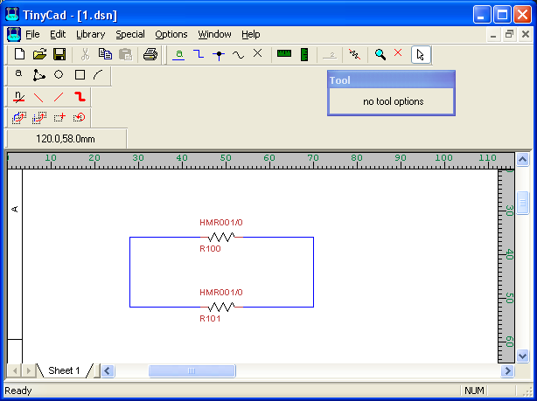

The file

; ====+ Net List for C:\svn\mbfiles\trunk\netconv\kicad\proj1\1.dsn +====

; ======+ The component list

COMPONENT 'R100' = HMR001/0
OPTION '$$SPICE_PROLOG_PRIORITY' = 5
OPTION '$$SPICE_EPILOG_PRIORITY' = 5
OPTION 'Package' = package name for PCB layout
COMPONENT 'R101' = HMR001/0
OPTION '$$SPICE_PROLOG_PRIORITY' = 5
OPTION '$$SPICE_EPILOG_PRIORITY' = 5
OPTION 'Package' = package name for PCB layout

; ======+ The net list

NET 'N000000' = (R100,1),(R101,1)
NET 'N000001' = (R101,2),(R100,2)

KiCAD net list file format
To import a net list into KiCAD it has to have the following structure. This assumes that the cvpcb tool has been run. With our method we will create a file that maps the art. codes to proper KiCAD foot-prints so this mapping can be done automatically and in a controlled way. The map file is later on called ComponentToSymbol.map. Here comes the net list:

( { Netlist by Cvpcb (2006-06-26), date = 24/11/2006-21:19:41 }
( 0 R3 R1 R
( 1 N-000001 )
( 2 N-000002 )
)
( 0 R3 R2 A
( 1 N-000001 )
( 2 N-000002 )
)
( 0 R3 R20 P
( 1 N-000001 )
( 2 N-000002 )
)
( 0 R3 R2200 W
( 1 N-000001 )
( 2 N-000002 )
)
)
*

Note that the “0” starting at every component is the time stamp for the creation or modification of the component or component connections in the schematics. I don’t have the syntax for the time stamp so for now on I just put a zero here.

R3 in the example above is the foot print for the component.

R1, R2, R20 and R2200 is the “POS”

R, A, P and W are ….

1 and 2 are the pin names for the components.

N-000001 and N000002 are the net names connected to the pin names.

