Kazakh-British Technical University
Data Collection & Preparation
SIS #1

Full name: Dilnaz Beisenova
ID: 24B031699

1. Introduction
The goal of this project was to study the relationship between education and economic development. I used literacy rates to represent education and GDP per capita to represent economic development. I wanted to find out whether countries with higher literacy rates also have higher GDP per capita.
2. Data Collection
I collected GDP per capita data for 2023 from the World Bank API using Python’s requests library. I also collected literacy rate data from Wikipedia using web scraping with BeautifulSoup. I used pandas to organize both datasets into DataFrames.
3. Data Cleaning
I removed missing values, cleaned unnecessary characters, and converted literacy rates into numerical values. I also standardized country names because some names were different between the two sources. After merging the datasets, I obtained 147 countries and 6 columns, with no missing values or duplicate countries.
4. Analysis and Results
I used describe() to calculate summary statistics and corr() to find the relationship between literacy rates and GDP per capita. The correlation coefficient was 0.419, showing a moderate positive relationship. This means countries with higher literacy rates generally tend to have higher GDP per capita.

5. Visualizations
I created three graphs using Matplotlib and Seaborn:
- Scatter plot: Shows the relationship between literacy rates and GDP per capita.
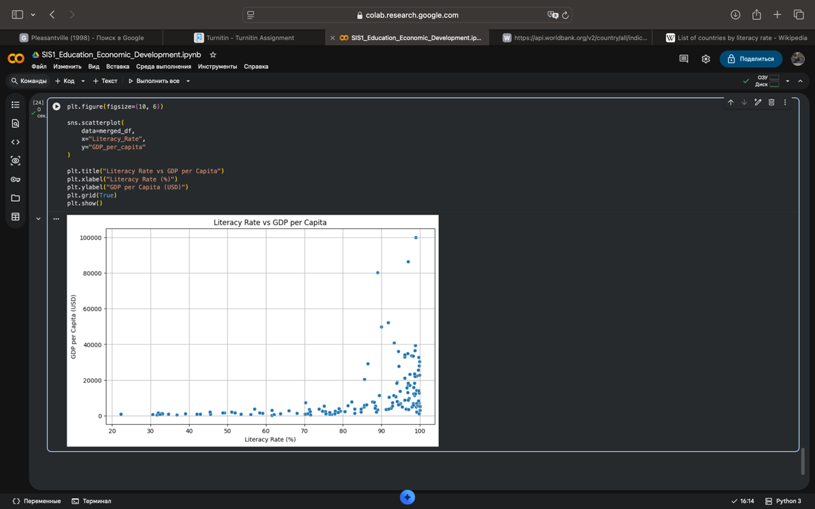
- Regression plot: Shows an upward trend, supporting the positive correlation.
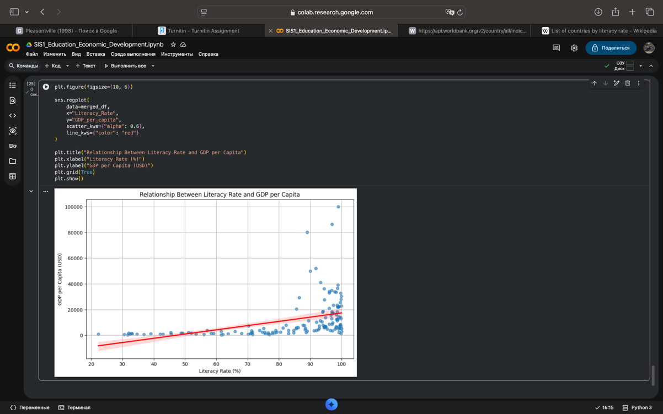

- Histogram: Shows that most countries have literacy rates between 90% and 100%.
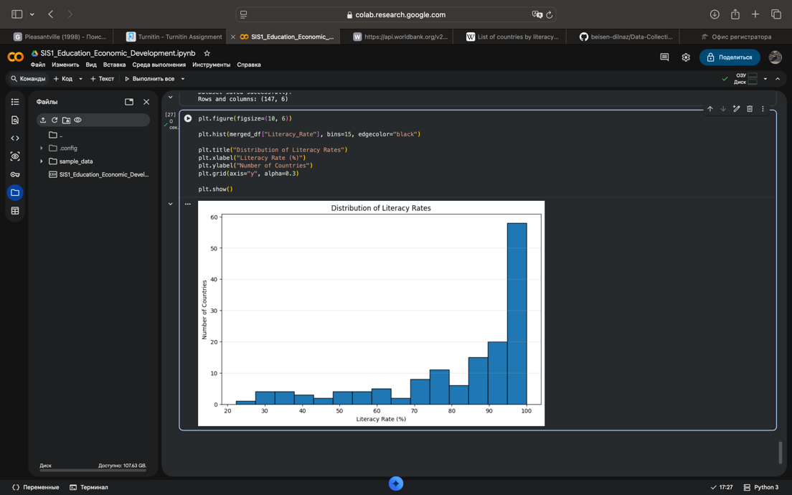

6. Conclusion
My analysis showed a moderate positive relationship between literacy rates and GDP per capita. However, correlation does not prove causation, and economic development depends on many other factors. One limitation is that GDP data is from 2023, while literacy data covers different years from 1983 to 2019. This project helped me practice data collection, cleaning, merging, and visualization using Python.

