1. 信号的时域描述与计算
   1. 绘制分段函数时域图形

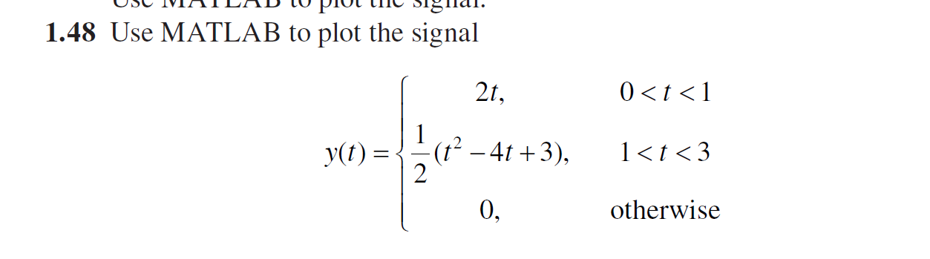

Matlab程序：

t1 = 0:0.01:1;

y1 = 2.\*t1;

t2 = 1:0.01:3;

y2 = 0.5.\*(t2.\*t2-4.\*t2+3);

y = [y1 y2];

t = [t1 t2];

plot(t,y)

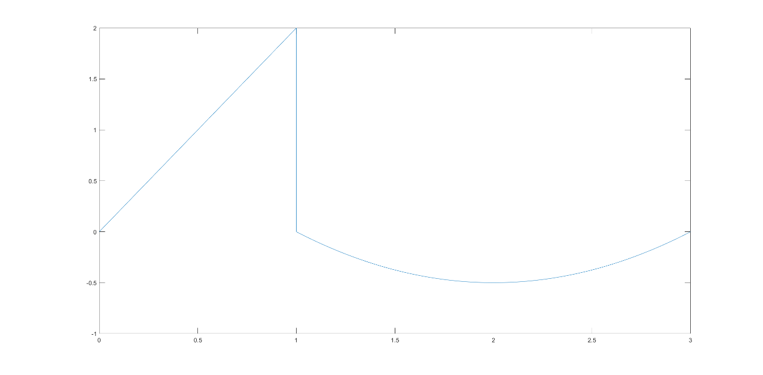

* 1. 绘制信号序列时域图

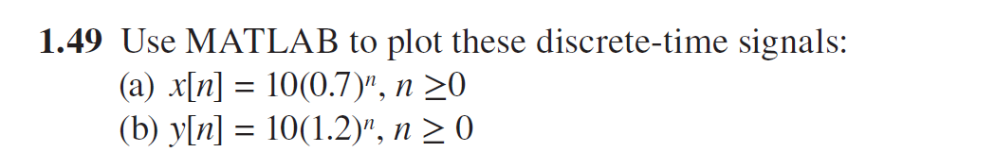

Matlab程序：

t = 0 : 1:100;

x = 10.\*(0.7).^t;

y = 10.\*(1.2).^t;

subplot(1,2,1);

stem (t,x,"filled");

subplot(1,2,2);

stem (t,y,"filled");

运行如图所示，左图为(a)图，右图为(b)图

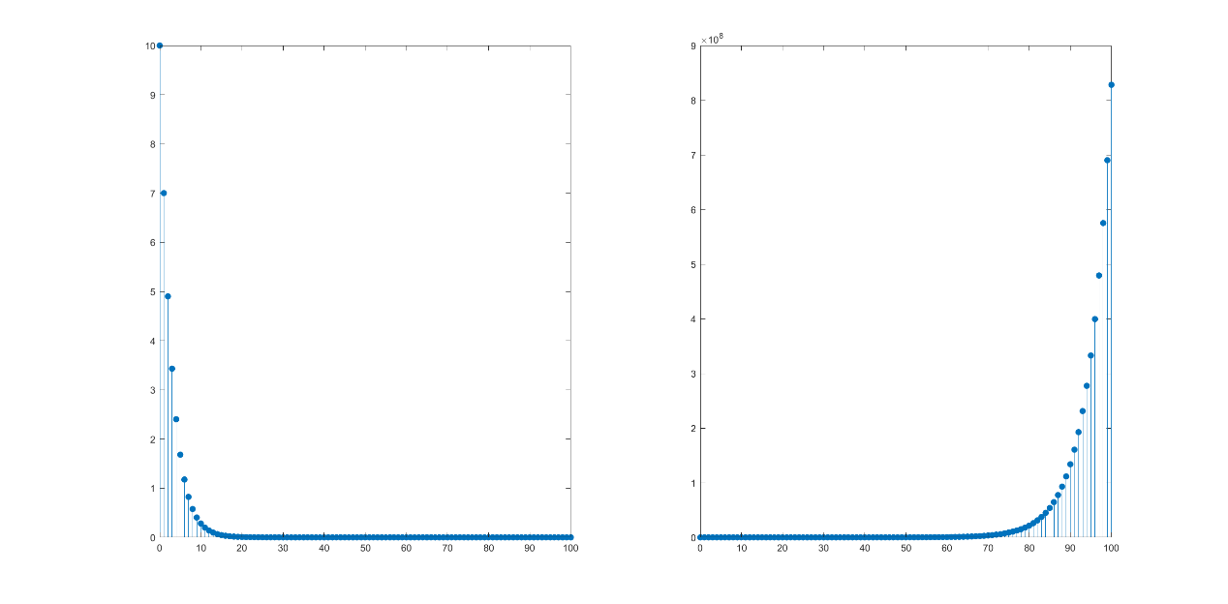

* 1. 绘制信号时域图

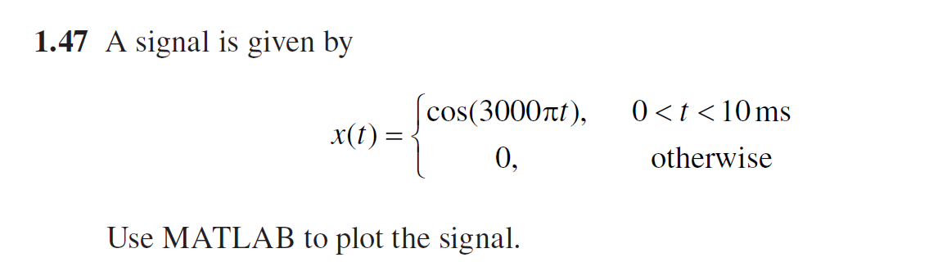

Matlab程序：

t = 0:0.01:10;

x = cos(3\*pi.\*t);

plot(t,x);

xlabel('时间（ms）');

ylabel('幅度');

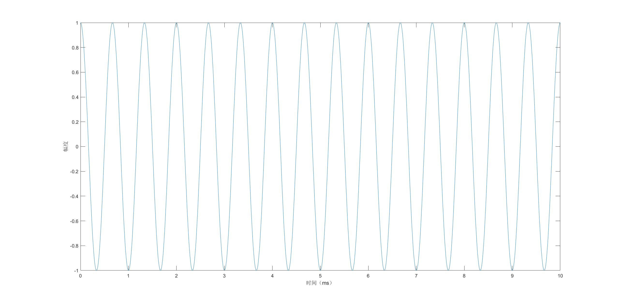

1. 系统的时域分析
   1. 计算系统传递函数并绘制冲激响应图

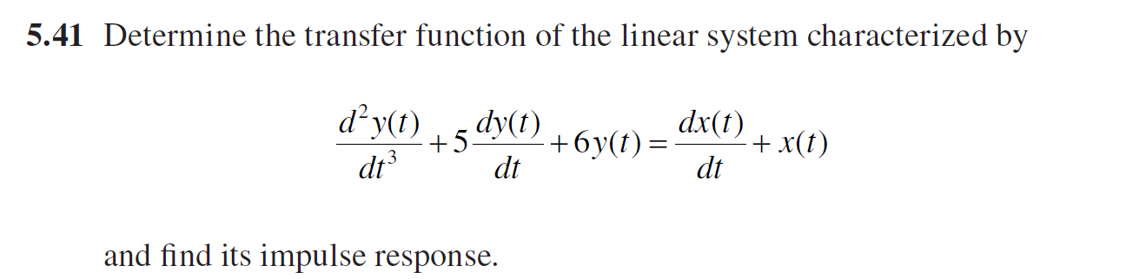

由于系统为线性系统

Matlab程序：

t = 0:0.1:10;

den = [1 5 6]; %构建系统函数

num = [1 1];

sys = tf(num,den);

y = impulse(sys,t);

figure();

plot(t,y);

xlabel('time(s)')

ylabel('y');

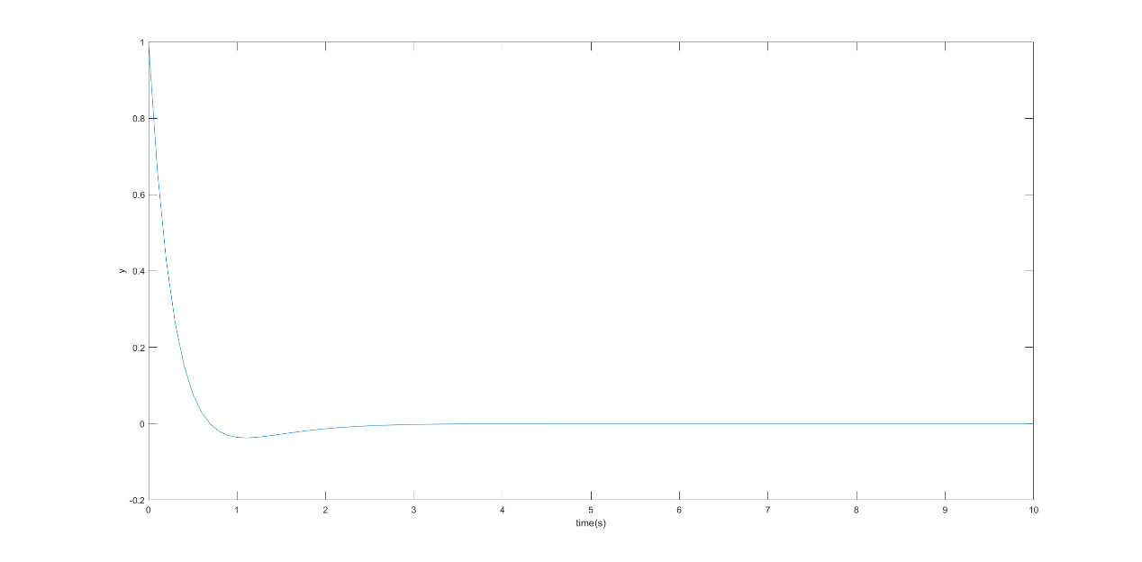

* 1. 、绘制系统输出y时域图

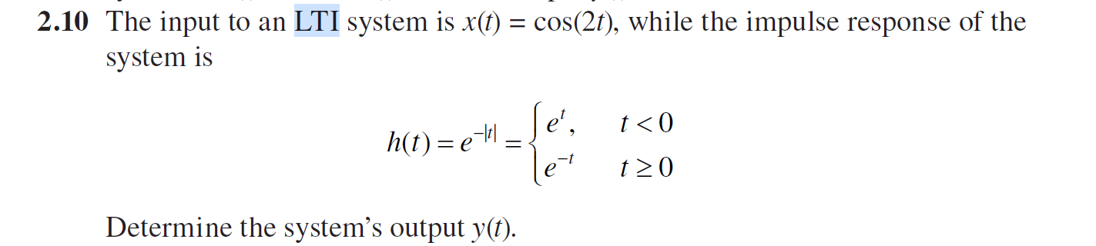

Matlab程序：

t =-10:0.01:10;

x1 = cos(2.\*t);

h = exp(-1.\*abs(t));

y = conv(x1,h);

plot(y);

绘图如下：

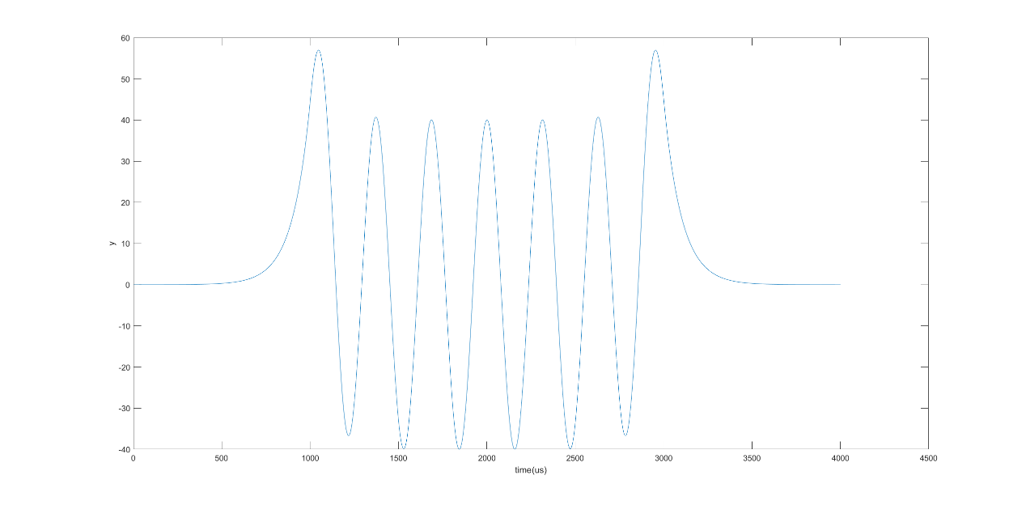

* 1. 计算离散系统h[n]

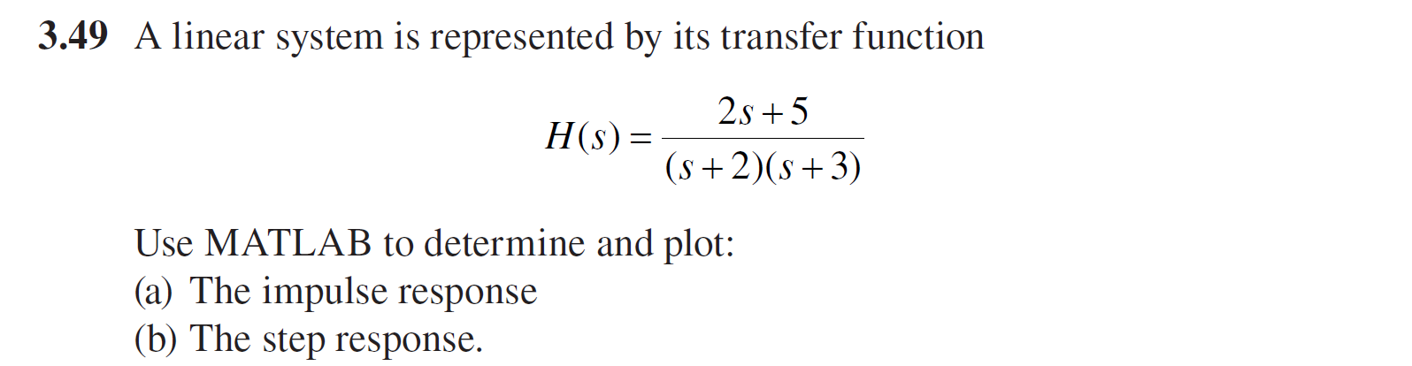

Matlab程序：

num = [2,5];

den = [1,5,6];

t = 0:0.1:10;

y1 = impulse(num,den,t);

y2 = step(num,den,t);

figure();

plot(t,y1);

title('冲激响应');

figure();

plot(t,y2);

title('阶跃响应');

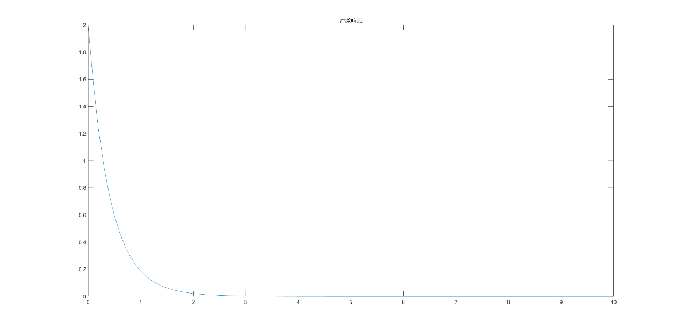

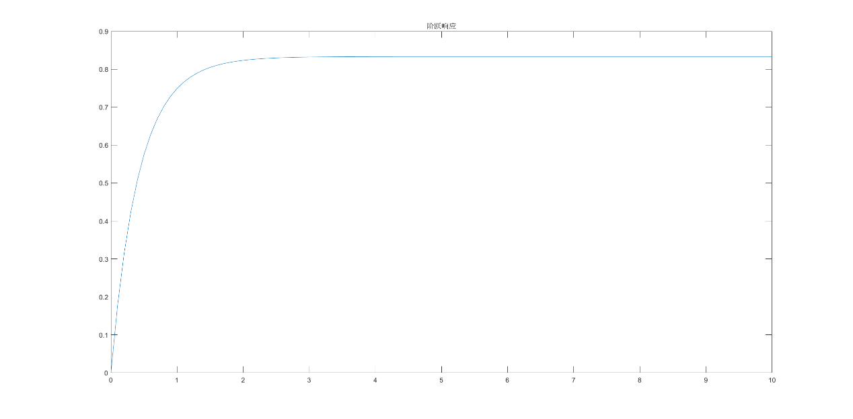

1. 信号的频域分析
   1. 单信号及多信号相乘

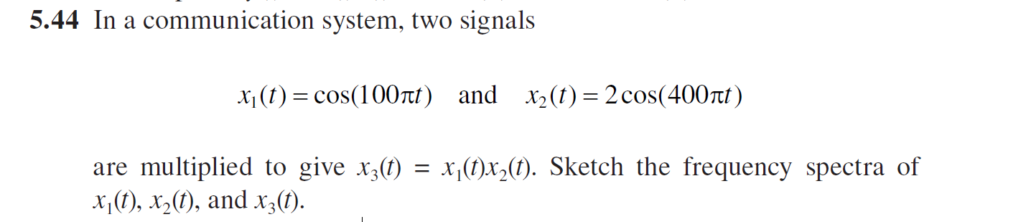

Matlab程序：

t =0:0.001:1;

x1 = cos(100\*pi.\*t);

x2 = 2\*cos(400\*pi.\*t);

x3 = x1.\*x2;

w = 0:pi/500:2\*pi;

X1 = fft(x1)/1000;

figure();

subplot(1,2,1);

plot(w,abs(X1));

xlabel('frequency(Π)');

ylabel('magnitude');

title('X1');

subplot(1,2,2);

plot(w,angle(X1));

xlabel('frequency(Π)');

ylabel('phase');

title('X1');

X2 = fft(x2)/1000;

figure();

subplot(1,2,1);

plot(w,abs(X2));

xlabel('frequency(Π)');

ylabel('magnitude');

title('X2');

subplot(1,2,2);

plot(w,angle(X2));

xlabel('frequency(Π)');

ylabel('phase');

title('X2');

X3 = fft(x3)/1000;

figure();

subplot(1,2,1);

plot(w,abs(X3));

xlabel('frequency(Π)');

ylabel('magnitude');

title('X3');

subplot(1,2,2);

plot(w,angle(X3));

xlabel('frequency(Π)');

ylabel('phase');

title('X3');

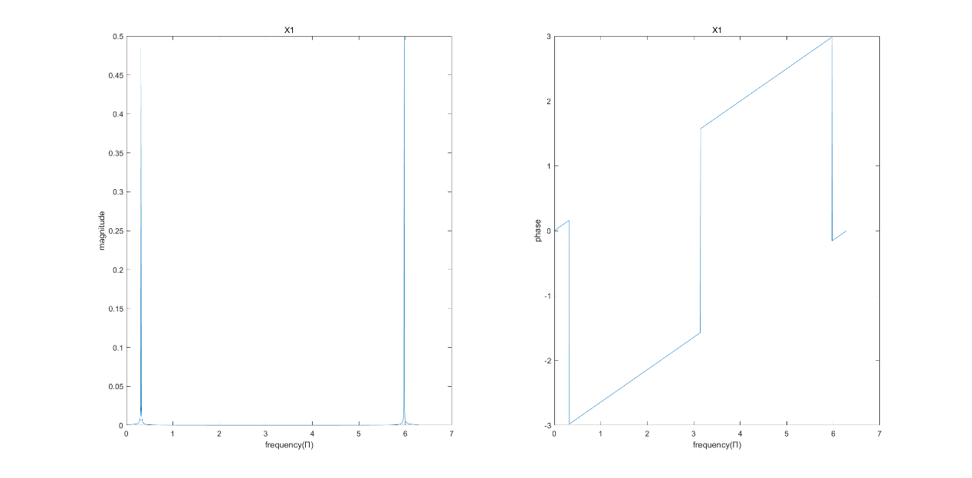

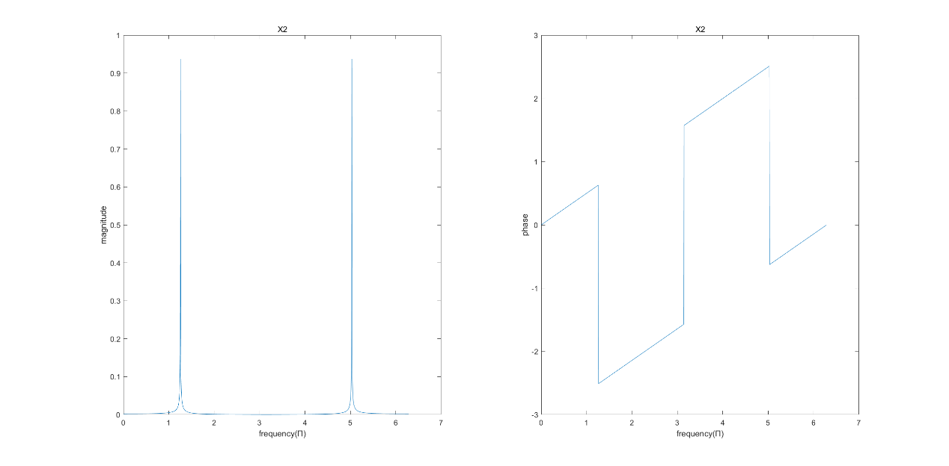

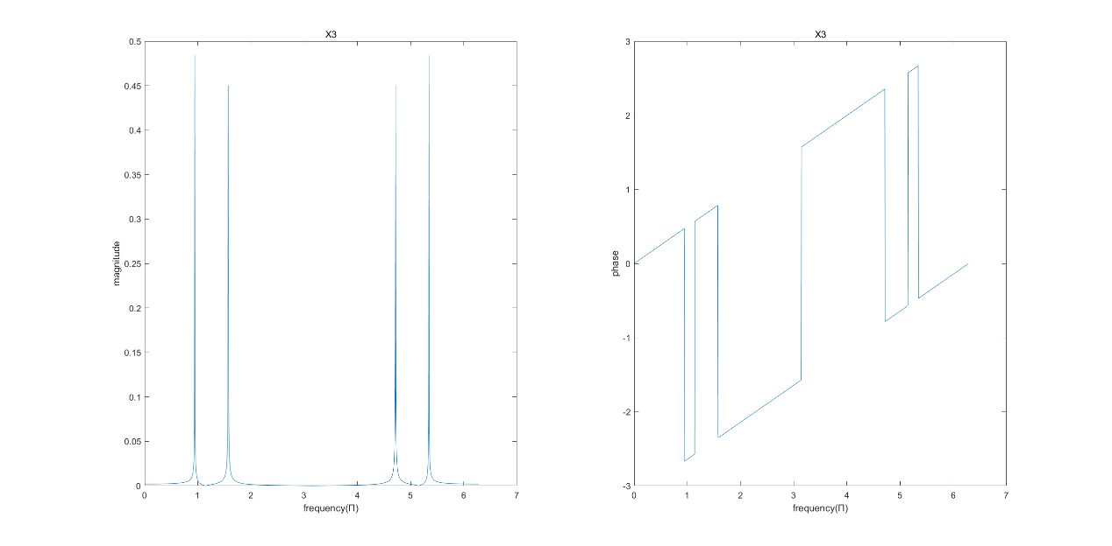

* 1. 单信号频谱分析

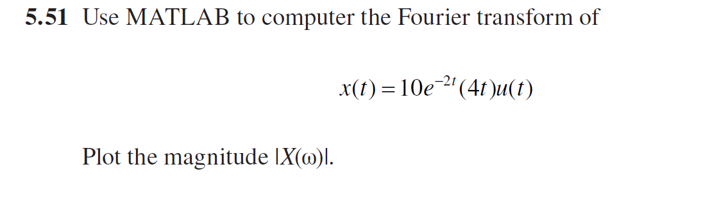

Matlab程序：

t =0:0.1:100;

x = 10\*exp(-2.\*t)\*4.\*t.\*heaviside(t);

X = fft(x);

mag1 = abs(X)/1000;

mag2 =2.\*mag1(1:501);

w = 0:0.1:50;

phase1 = angle(X);

figure();

plot(w/50,mag2);

xlabel('frequency(Π)')

ylabel('magnitude');

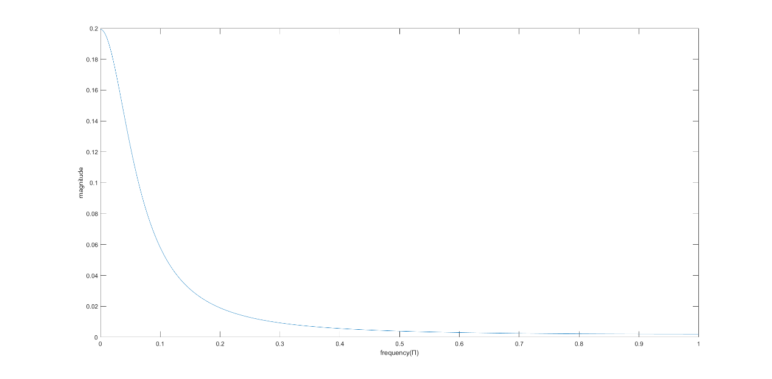

* 1. 信号的傅里叶逆变换

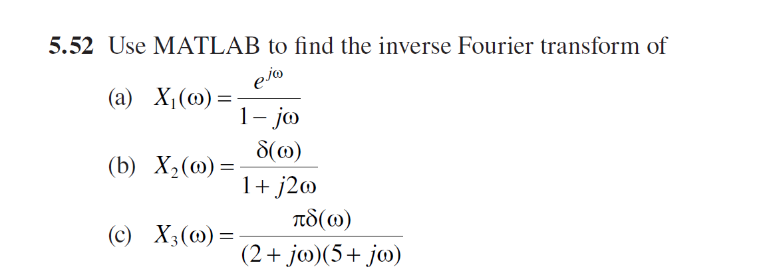

Matlab程序：

syms X1 X2 X3 x1 x2 x3 w;

X1 = exp(j\*w)/(1-j\*w);

x1 = ifourier(X1);

pretty(x1);

X2 =dirac(w)/(1+2\*j\*w) ;

x2 = ifourier(X2);

pretty(x2);

X3 =pi\*dirac(w)/((2+j\*w)\*(5+j\*w)) ;

x3 = ifourier(X3);

pretty(x3);

运行结果如下：

exp(x + 1) (sign(x + 1) - 1)

- ----------------------------

2

1

----

2 pi

1

--

20

1. 系统的频域分析
   1. 系统的频域响应分析

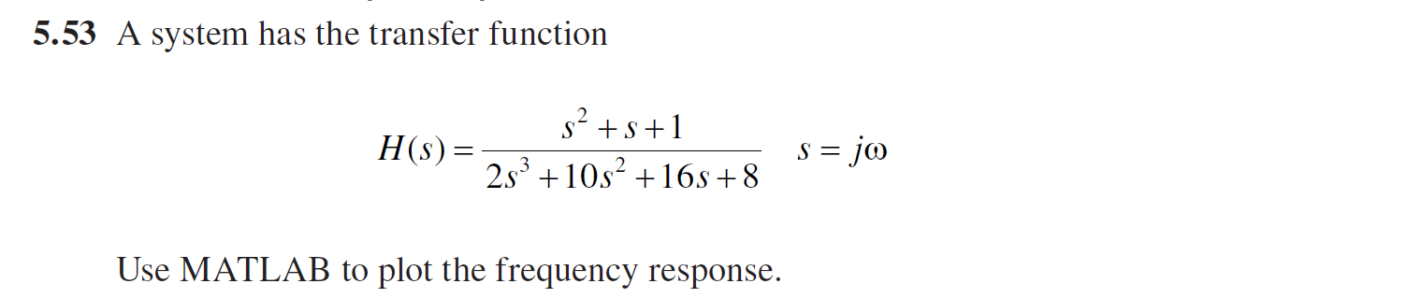

Matlab程序

num = [1 1 1];

den = [2 10 16 8];

w = 0:0.1:100;

H = freqs(num,den,w);

mag = abs(H);

phase = angle(H)\*180/pi;

subplot(1,2,1);

plot(w/(2\*pi),mag);

xlabel('frequency(Hz)')

ylabel('magnitude');

subplot(1,2,2);

plot(w/(2\*pi),phase);

xlabel('frequency(Hz)')

ylabel('phase(°)');

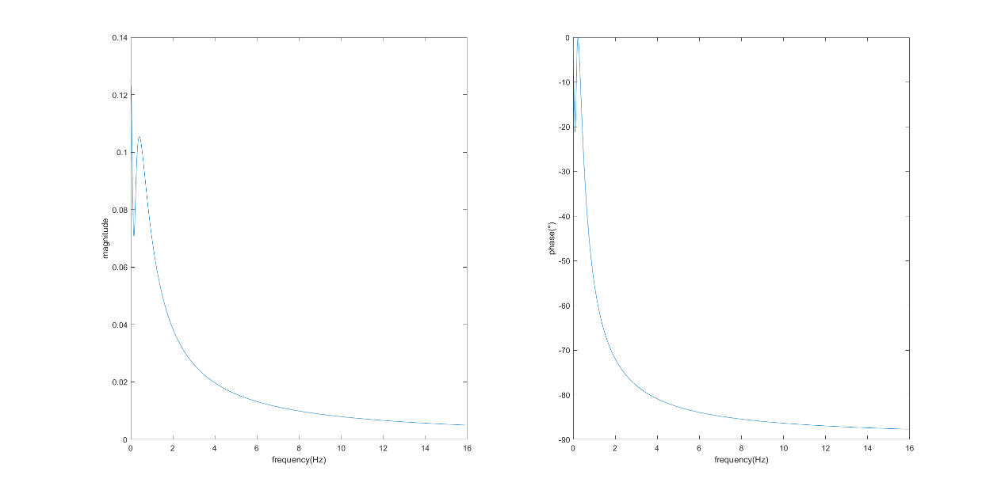

* 1. 绘制系统频域响应图

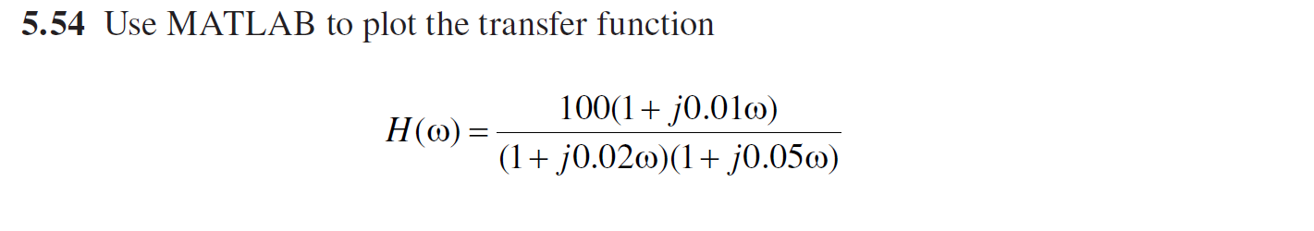

Matlab程序:

w = 0:1:2000\*pi;

H = 100\*(1+1j\*0.01.\*w)./(1+1j\*0.02\*w)./(1+1j \*0.05.\*w);

figure();

subplot(1,2,1);

plot(w,abs(H));

xlabel('frequency')

ylabel('magnitude');

subplot(1,2,2);

plot(w,angle(H));

xlabel('frequency')

ylabel('phase(°)');

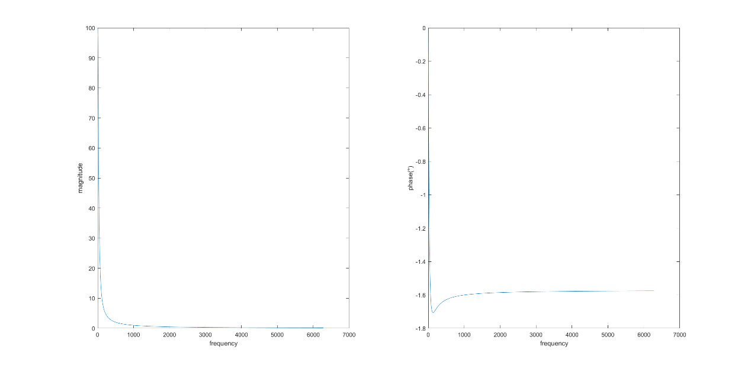

* 1. 绘制巴特沃兹滤波器频率响应图

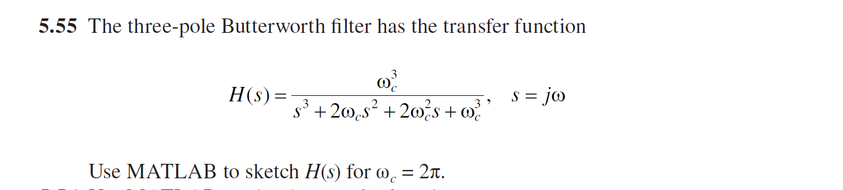

将代入上式可得：

Matlab程序:

num = [8\*pi^3];

den = [1 4\*pi 8\*pi^2 8\*pi^3];

w = 0:0.1:100;

H = freqs(num,den,w);

mag = abs(H);

phase = angle(H)\*180/pi;

subplot(1,2,1);

plot(w/(2\*pi),mag);

xlabel('frequency(Hz)')

ylabel('magnitude');

subplot(1,2,2);

plot(w/(2\*pi),phase);

xlabel('frequency(Hz)')

ylabel('phase(°)');

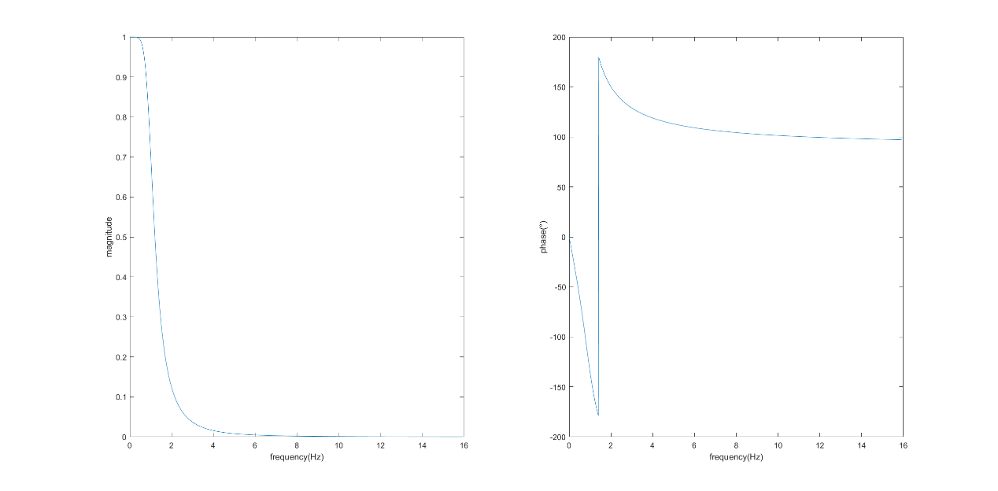

1. 系统的复频域分析
   1. 计算系统传递函数拉普拉斯逆变换

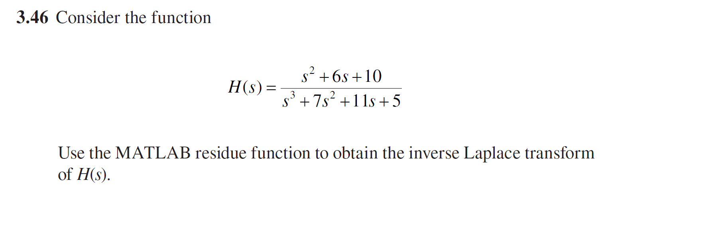

Matlab程序：

num = [1,6,10];

den = [1,7,11,5];

[r,p,k] = residue(num,den)

运行结果如下：

r =

0.3125

0.6875

1.2500

p =

-5.0000

-1.0000

-1.0000

k =

[]

所以：

对照表格可得

* 1. 绘制系统零极点图

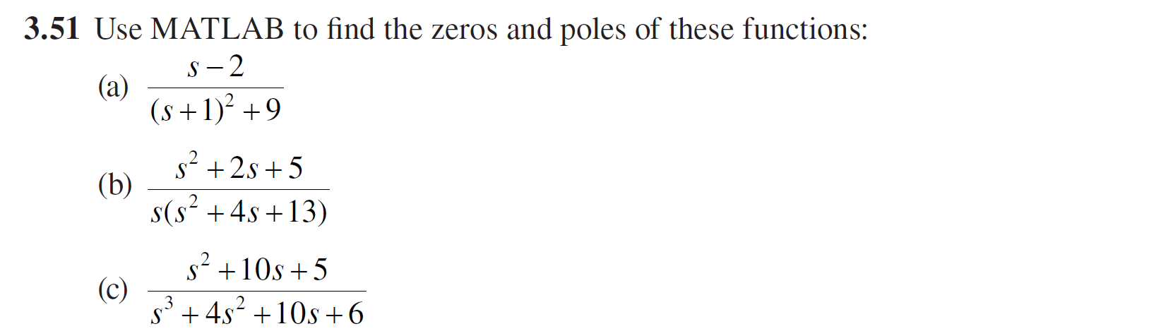

Matlab程序：

num1 = [1 -2];

den1 = [1 2 10];

num2 = [1 2 5];

den2 = [1 4 13 0];

num3 = [1 10 5];

den3 = [1 4 10 6];

H1 = tf(num1,den1);

H2 = tf(num2,den2);

H3 = tf(num3,den3);

figure();

pzmap(H1,'');

grid on;

title('a图');

figure();

pzmap(H2);

grid on;

title('b图');

figure();

pzmap(H3);

grid on;

title('c图');

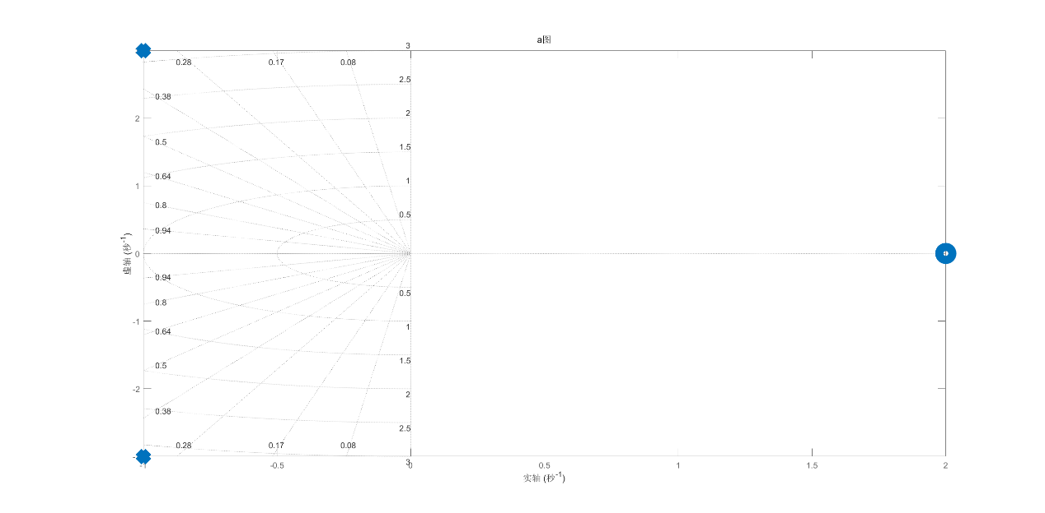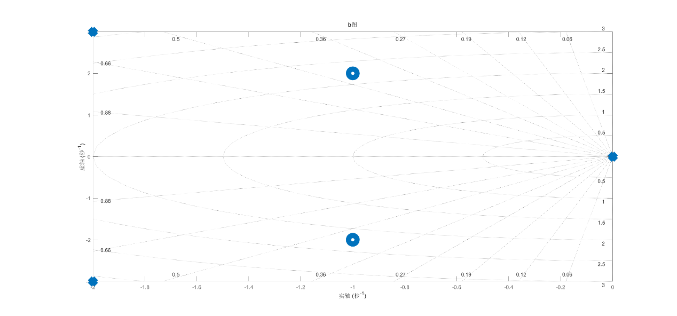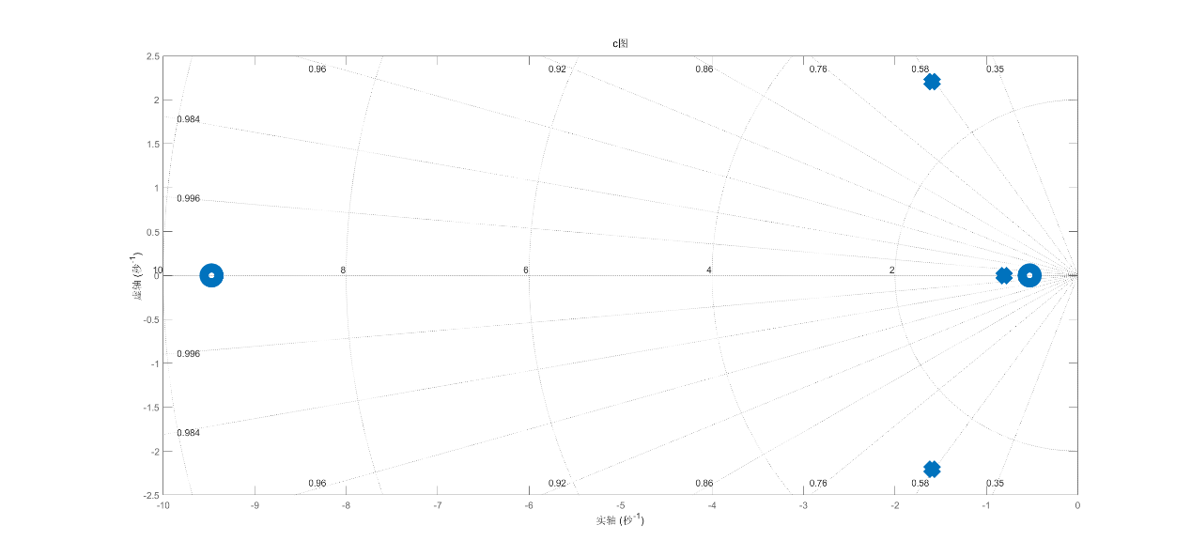

* 1. 绘制系统波特图

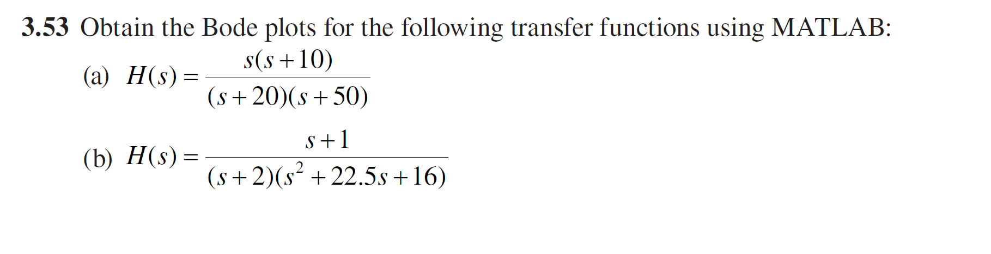

Matlab程序：

num1 = [1 10 0 ];

den1 = [1 70 1000];

num2 = [1 1];

den2 = [1 24.5 61 32];

figure();

bode(num1,den1);

grid on;

title('a图');

figure();

bode(num2,den2);

grid on;

title('b图');

