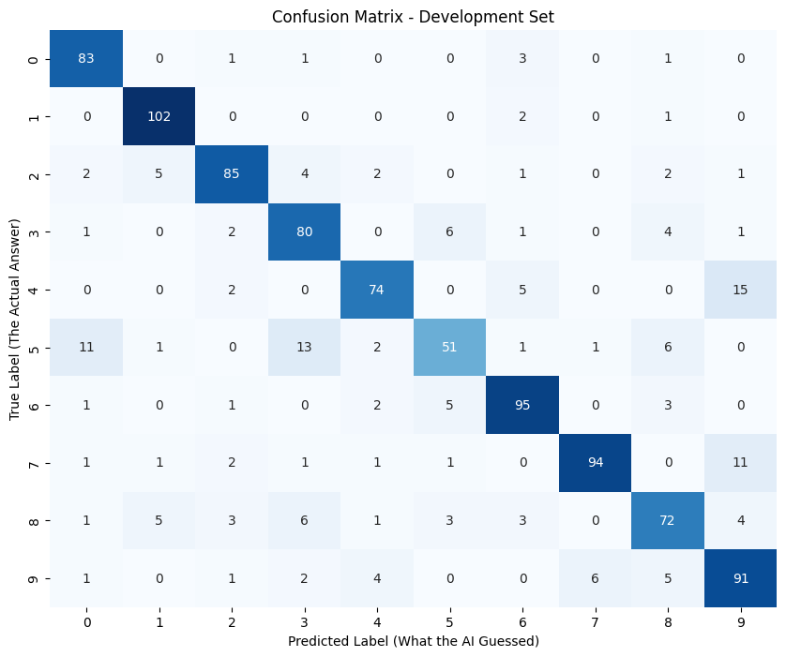

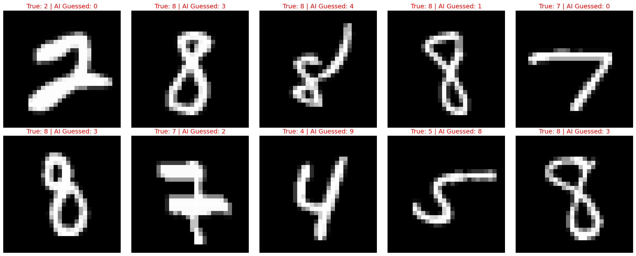
Image 1 (True: 2 | Pred: 0) Hypothesis: The top curve of this '2' loops back on itself to create a completely closed, circular shape. Combined with a very thick bottom stroke, the overall distribution of white pixels forms a large, continuous loop, heavily resembling a '0' to the network.
Image 2 (True: 8 | Pred: 3) Hypothesis: The stroke thickness here is highly uneven. The left side of both the top and bottom loops is very faint. The model likely over-indexed on the much thicker, prominent right-facing arcs, which perfectly match the structure of a '3'.
Image 3 (True: 8 | Pred: 4) Hypothesis: Extreme penmanship variance. This digit is drawn with sharp, angular diagonal lines rather than smooth curves. It completely lacks the closed double-loops of a standard '8', and the intersecting central lines closely mimic the crossed strokes of a '4'.
Image 4 (True: 8 | Pred: 1) Hypothesis: This '8' is severely compressed horizontally. Because it lacks distinct, wide loops and primarily consists of a single, tall, vertical mass of pixels, the model's feature detectors defaulted to the most common vertical-line digit: a '1'.
Image 5 (True: 7 | Pred: 0) Hypothesis: This '7' features an unusually thick, prominent horizontal crossbar (European style). The combination of the heavy top bar and the heavy crossbar creates strong horizontal activations in the upper and middle regions, which the model may have confused with the upper and lower boundaries of a '0' or '8' that didn't fully resolve.
Image 6 (True: 8 | Pred: 3) Hypothesis: Similar to Image 2, the left-side strokes connecting the top and bottom loops are faint and nearly disconnected. The neural network essentially only "saw" the right half of the image, leading to a confident '3' prediction.
Image 7 (True: 7 | Pred: 2) Hypothesis: The penmanship includes an exaggerated crossbar, and the bottom stem hooks sharply to the left. This exact visual sequence—a top horizontal line, a diagonal down to the left, and a heavy middle horizontal line—strongly mimics the classic zig-zag structure of a '2'.
Image 8 (True: 4 | Pred: 9) Hypothesis: The top of this '4' is drawn completely closed. For a neural network, a closed loop at the top of an image attached to a straight vertical stem is the exact geometric definition of a '9'.
Image 9 (True: 5 | Pred: 8) Hypothesis: The bottom curve of the '5' sweeps aggressively upward, nearly closing the bottom loop. Furthermore, the top horizontal stroke curves downward. This creates the illusion of two stacked, nearly closed circles, mimicking an '8'.
Image 10 (True: 8 | Pred: 3) Hypothesis: The central crossing point is drawn very thickly, while the upper-left and lower-left arcs are much thinner and somewhat distorted. The model likely lost the faint left-side pixels in the math, seeing only the dominant, dual-arc '3' shape on the right.
Comparison Table
Metric | From-Scratch (NumPy) | TensorFlow / Keras
Training Speed (Time per epoch) | 0.42 seconds | 4.64 seconds
Total Training Time | 211.24 seconds (for 500 epochs) | 232.15 seconds (for 50 epochs)
Final Accuracy | 83.53% | 95.02% (Train) / 89.50% (Dev)
Code Verbosity (Lines of code) | ~60 lines of complex calculus, loops, and manual dictionary tracking. | ~10 lines of highly readable, descriptive code.
Extensibility (Adding a 3rd layer) | Moderate: Our dynamic refactor made it easier but initially required rewriting the core backpropagation math using the chain rule. | Extremely Easy: Just type one single line: tf.keras.layers.Dense(nodes, activation) anywhere in the Sequential stack.
Optimization Method | Full-Batch Gradient Descent (Updates weights once per epoch) | Mini-Batch Gradient Descent (Updates weights 2,157 times per epoch)

