Question #2 (Topic: Topic 1, Implement and manage an analytics solution )
You have a Fabric workspace.
You have semi-structured data.
You need to read the data by using T-SQL, KQL, and Apache Spark. The data will only be written by using Spark.
What should you use to store the data?
A. a Lakehouse
B. an eventhouse
C. a datamart
D. a warehouse

Question #3 (Topic: Topic 1, Implement and manage an analytics solution )

You have a Fabric workspace that contains a warehouse named Warehouse1.
You have an on-premises Microsoft SQL Server database named Database1 that is accessed by using an on-premises data gateway.
You need to copy data from Database1 to Warehouse1.
Which item should you use?
A. a Dataflow Gen1 dataflow
B. a data pipeline
C. a KQL queryset
D. a notebook
Question #4 (Topic: Topic 1, Implement and manage an analytics solution )
You have a Fabric workspace that contains a warehouse named Warehouse1.
You have an on-premises Microsoft SQL Server database named Database1 that is accessed by using an on-premises data gateway.
You need to copy data from Database1 to Warehouse1.
Which item should you use?
A. an Apache Spark job definition
B. a data pipeline
C. a Dataflow Gen1 dataflow
D. an eventstream

Question #5 (Topic: Topic 1, Implement and manage an analytics solution )
You have a Fabric F32 capacity that contains a workspace. The workspace contains a warehouse named DW1 that is modelled by using MD5 hash surrogate keys.
DW1 contains a single fact table that has grown from 200 million rows to 500 million rows during the past year.
You have Microsoft Power BI reports that are based on Direct Lake. The reports show year-over-year values.
Users report that the performance of some of the reports has degraded over time and some visuals show errors.
You need to resolve the performance issues. The solution must meet the following requirements:
Provide the best query performance.
Minimize operational costs.
Which should you do?

A. Change the MD5 hash to SHA256.
B. Increase the capacity.
C. Enable V-Order.
D. Modify the surrogate keys to use a different data type.
E. Create views.
HOTSPOT
You have a Fabric workspace that contains a warehouse named DW1. DW1 contains the following tables and columns.
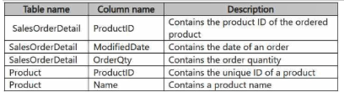
You need to create an output that presents the summarized values of all the order quantities by year and product. The results must include a summary of the order quantities at the year level for all the products.
How should you complete the code? To answer, select the appropriate options in the answer area.
NOTE: Each correct selection is worth one point.
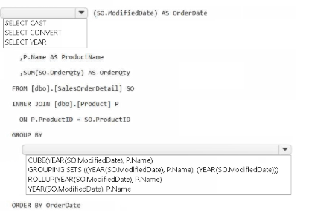

Question #7 (Topic: Topic 1, Implement and manage an analytics solution )
You have a Fabric workspace that contains a lakehouse named Lakehouse1. Data is ingested into Lakehouse1 as one flat table. The table contains the following columns.
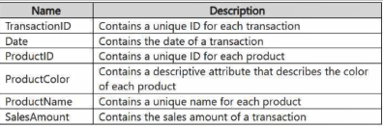
You plan to load the data into a dimensional model and implement a star schema. From the original flat table, you create two tables named FactSales and DimProduct. You will track changes in DimProduct.
You need to prepare the data.
Which three columns should you include in the DimProduct table? Each correct answer presents part of the solution.
NOTE: Each correct selection is worth one point.
A. Date
B. ProductName
C. ProductColor
D. TransactionIDE. SalesAmount
F. ProductID

Question #8 (Topic: Topic 1, Implement and manage an analytics solution )
You have a Fabric workspace named Workspace1 that contains a notebook named Notebook1.
In Workspace1, you create a new notebook named Notebook2.
You need to ensure that you can attach Notebook2 to the same Apache Spark session as Notebook1.
What should you do?
A. Enable high concurrency for notebooks.
B. Enable dynamic allocation for the Spark pool.
C. Change the runtime version.
D. Increase the number of executors.

Question #9 (Topic: Topic 1, Implement and manage an analytics solution )
You have a Fabric workspace named Workspace1 that contains a lakehouse named Lakehouse1. Lakehouse1 contains the following tables:
Orders
Customer
Employee
The Employee table contains Personally Identifiable Information (PII).
A data engineer is building a workflow that requires writing data to the Customer table, however, the user does NOT have the elevated permissions required to view the contents of the Employee table.
You need to ensure that the data engineer can write data to the Customer table without reading data from the Employee table.
Which three actions should you perform? Each correct answer presents part of the solution.
NOTE: Each correct selection is worth one point.

A. Share Lakehouse1 with the data engineer.
B. Assign the data engineer the Contributor role for Workspace2.
C. Assign the data engineer the Viewer role for Workspace2.
D. Assign the data engineer the Contributor role for Workspace1.
E. Migrate the Employee table from Lakehouse1 to Lakehouse2.
F. Create a new workspace named Workspace2 that contains a new lakehouse named Lakehouse2.
G. Assign the data engineer the Viewer role for Workspace1.

Question #10 (Topic: Topic 1, Implement and manage an analytics solution )

You have a Fabric warehouse named DW1. DW1 contains a table that stores sales data and is used by multiple sales representatives.
You plan to implement row-level security (RLS).
You need to ensure that the sales representatives can see only their respective data.
Which warehouse object do you require to implement RLS?
A. STORED PROCEDURE
B. CONSTRAINT
C. SCHEMA
D. FUNCTION

