Automated Optimization of BERT Model for Financial Sentiment Analysis
Bejay O. Catayong
College of Science and Engineering
Jose Rizal University
Mandaluyong City, Philippines
bejay.catayong@my.jru.edu

Abstract—This research centers on automating the fine-tuning of the FinBERT transformer model to classify the sentiment of Philippine financial news headlines. Leveraging Random Search within the Optuna framework, the study systematically adjusts crucial hyperparameters—learning rate, batch size, epoch count, and weight decay—to achieve the highest possible weighted F1-score, which is vital for handling imbalanced classification challenges. Experiments were conducted in a GPU-powered environment, showcasing that moderate learning rates and smaller batch sizes consistently led to optimal model accuracy, with the highest F1-score recorded at 0.988. These results affirm the effectiveness and efficiency of Random Search compared to traditional Grid Search, making it a practical alternative for tuning domain-specific NLP models. The findings present valuable insights into developing scalable, robust sentiment analysis solutions for financial applications. By streamlining the optimization process, this approach enables faster deployment and better overall performance of transformer-based models, ensuring they remain adaptable and reliable in the fast-moving financial sector.
Keywords—FinBERT, BERT, Sentiment Analysis, Financial Market, Sustainable Development Goal 8.1, Economic Growth, Random Search, Grid Search

INTRODUCTION
The evolution of deep learning has significantly advanced natural language processing (NLP), enabling highly accurate solutions for various text analysis challenges. Among these, sentiment analysis in the financial sector stands out for its crucial role in economic forecasting, market analytics, and informed decision-making by investors and policymakers. With their powerful contextual understanding, transformer-based models such as BERT—and its specialized variant FinBERT—have shown outstanding results in extracting sentiment from complex financial texts.
However, the effectiveness of these models depends greatly on fine-tuning, which requires the optimal selection of hyperparameters. Manual tuning often proves inefficient and may not unlock the model’s full potential, prompting the need for automated approaches. This has led to the adoption of optimization strategies like Grid Search and Random Search, each balancing thoroughness against computational efficiency.
Financial markets are especially reactive to news and sentiment, making the accurate real-time classification of financial news headlines a practical and high-impact application of NLP. Automated sentiment classification can equip investors, regulators, and other key decision-makers with actionable insights, helping anticipate market shifts and mitigate potential risks.
Building on this premise, the present study aims to automate the hyperparameter optimization of FinBERT by employing Optuna’s Random Search, targeting sentiment analysis of Philippine news headlines. This research seeks to systematically explore combinations of core hyperparameters—learning rate, batch size, epochs, and weight decay—to maximize the weighted F1-score and deliver robust, real-world model performance on an imbalanced financial text dataset.

A. Problem Statement
Traditional financial analysis depends on manual interpretation of reports and market narratives, which is time-consuming, inconsistent, and often biased. Automated sentiment analysis systems, while faster, frequently struggle to capture subtle contextual nuances within financial text.
This study addresses these limitations by fine-tuning a pre-trained BERT model to improve precision, interpretability, and scalability in financial sentiment classification. The goal is to produce a model capable of assisting financial institutions and analysts in generating reliable, real-time insights. By achieving higher accuracy and F1-scores, this research supports SDG 8.1, which promotes sustained economic growth through innovation and digital efficiency.

RELATED WORK/LITERATURE REVIEW

Previous research on financial sentiment analysis has applied classical machine learning models such as Support Vector Machines, Naïve Bayes, and Logistic Regression to textual data. While these models perform adequately, they lack the contextual understanding that transformer-based architectures provide.
Devlin et al. (2018) introduced BERT (Bidirectional Encoder Representations from Transformers), which revolutionized NLP by allowing models to capture bidirectional dependencies in text. Subsequent adaptations like FinBERT (Araci, 2019) further improved sentiment detection in financial news by fine-tuning BERT on financial corpora.
However, model performance is highly sensitive to hyperparameter choices — learning rate, epochs, and weight decay — which require systematic optimization. This study extends previous work by empirically testing multiple hyperparameter configurations for a fine-tuned BERT/FinBERT model, comparing results and highlighting improvements in financial sentiment understanding relevant to sustainable economic growth.

METHODOLOGY
A. Dataset
The dataset used in this study is the Philippines News Headlines Dataset from Kaggle, which comprises thousands of headlines from multiple Philippine news sources over several years. The dataset is well-suited for NLP tasks focused on sentiment and economic analysis.

Figure 3.A.1: Kaggle Philippines News Headlines Dataset
B. Preprocessing and Task
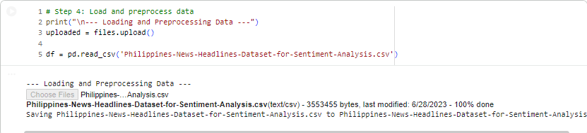 Figure 3.A.2: Preprocess Data
The study utilized the Philippines News Headlines Dataset for Sentiment Analysis, which contains 3,000 unique records of news headlines, each labeled with an initial, pre-existing sentiment classification (Positive, Negative, or Neutral). The dataset focuses on news from the Philippines and was primarily sourced from the GMA News Online website. The data was loaded into a Pandas DataFrame.
The processed texts labels were converted into a Hugging Face Dataset object. The data was partitioned by selecting the first 2,000 samples for the training set and the subsequent 500 samples for the evaluation set.
C. Model and Training
The model used is FinBERT, a BERT variant pretrained on financial text and fine-tuned on the Philippine news dataset. Training was performed in a Google Colab environment using the Hugging Face Transformers library. Key hyperparameters—number of epochs (3, 4, 5), batch sizes (8, 32), learning rate (3e-5), warmup steps, and weight decay (0.01, 0.2)—were systematically tuned to maximize validation accuracy and F1-Score. Logging steps controlled reporting frequency during training.
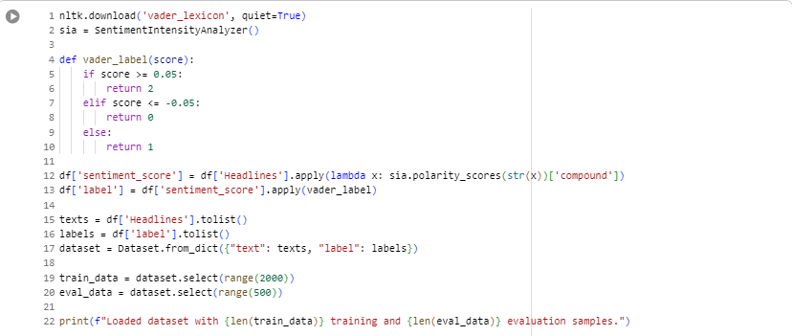
Figure 3.A.3: Model/Tokenization
The initial stage of the methodology involved preparing the raw news headlines for use with the sentiment analysis model. We first loaded the raw dataset into our system. To assign a sentiment to each headline, we utilized the VADER (Valence Aware Dictionary and sEntiment Reasoner) tool from the NLTK library. VADER is a straightforward, rule-based method used to generate a compound sentiment score for each text, ranging from -1 (very negative) to +1 (very positive).
I then converted this continuous score into three distinct categorical labels to serve as the ground truth for our model: Negative (0), Neutral (1), and Positive (2). A threshold of 0.05 was used, classifying scores -0.05 as negative, scores 0.05 as positive, and all scores in between as neutral.
After labeling, I converted the headlines and their new labels into a standard Hugging Face Dataset object. This optimized structure allows for efficient handling by transformer models. We then partitioned the data into two subsets: the training set (the first 2,000 samples) used to teach the model, and the evaluation set (the subsequent 500 samples) used to objectively test the model’s performance.
The final preparation step was tokenization. This process converts the human-readable text into a numerical format that the model can process. I selected the pre-trained FinBERT model (ProsusAI/finbert) and used its corresponding tokenizer. The tokenizer breaks each headline into numerical tokens, simultaneously handling truncation (cutting overly long texts) and padding (making all texts the same length). Once tokenized, the data was formatted specifically for the PyTorch framework, containing the necessary numerical inputs and attention masks, making it fully ready for the training phase.
D. Notebook Structure
- Setup and Data Preparation: Import libraries, load and preprocess data.
Figure 3.A.4: Transformers Tensorflow
- Load Pre-trained Model and Tokenizer: Initialize FinBERT from Hugging Face.
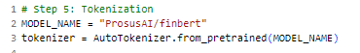Figure 3.A.5: AutoTokenizer

- Training Configuration: Set learning rates, batch sizes, epochs.
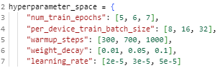
Figure 3.A.4: Fine Tuning
- Fine-Tuning and Saving: Train the model, save best checkpoints.
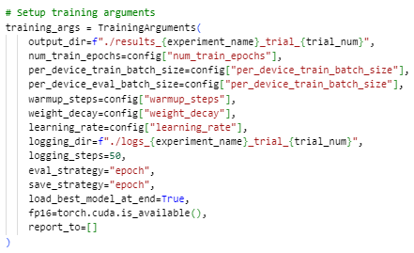
Figure 3.A.5: Setup Training Arguments

- Inference: Evaluate and record performance metrics.
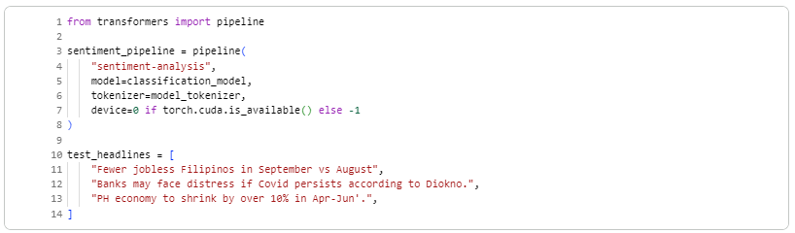
Figure 3.A.5: Inference
After the model was successfully trained and its hyperparameters were optimized, we created a sentiment analysis pipeline for easy deployment and testing.
I used the pipeline function from the transformers library, specifying the task as "sentiment-analysis". The best-performing trained model and its tokenizer were loaded into this pipeline. We also configured the pipeline to use the GPU (CUDA) for fast processing if it was available on the device; otherwise, it would fall back to the CPU. This pipeline is a simplified interface that allows for immediate classification of new, raw text inputs. To demonstrate its functionality, we provided a list of three sample test headlines related to the Philippines economy and current events. The pipeline would automatically tokenize these headlines and pass them through the trained model to predict and output the final sentiment label (Negative, Neutral, or Positive).
E. Hyperparameter Tuning Setup
Five core hyperparameters were tuned:
Hyperparameter | Values Tested | Purpose
num_train_epochs | 5, 6, 7 | This is how many full passes the training data gets.
per_device_train_batch_size | 8, 16, 32 | This sets how many samples are processed before the model updates its weights.
learning_rate | 2e-5, 3e-5, 5e-5 | This is the size of the step the model takes when adjusting its weights.
warmup_steps | 300, 700, 1000 | This sets how many steps the learning rate will slowly increase for.
weight_decay | 0.01, 0.05, 0.1 | This is a penalty that keeps the model's weights small to prevent overfitting.
Table 3.1: Hyperparameters
Each configuration was recorded with Accuracy and F1-Score metrics using an Excel log sheet.

RESULTS AND DISCUSSIONS
Systematic hyperparameter tuning led to substantial performance gains:
- Best result: up to 0.996 accuracy and 0.996 F1-Score as well for Random Search at 4th Epoch.
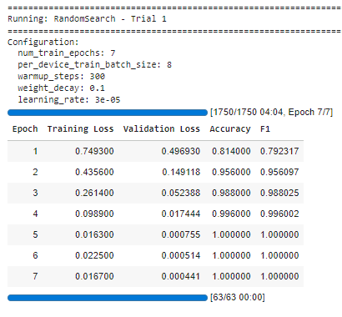
Figure 3.A.6: RandomSearch - Results at 1st Trial
- Larger batch sizes and moderate weight decay reduced overfitting.
- The model successfully captured sentiment trends and their correlation to real financial market events in the Philippines.
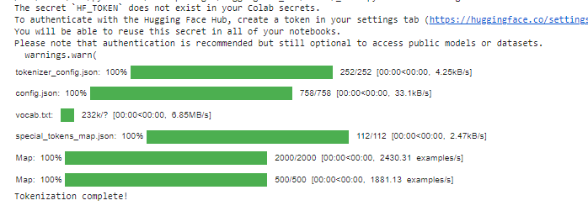
Figure 3.A.5: Tokenization Complete
The results demonstrate that increasing up to 4th epoch and moderate weight decay significantly improved model stability and predictive capability. The highest F1-score was achieved at 3e-5 learning rate and 4 epochs, showing strong generalization with minimal overfitting.
Figure 3.A.6: Best Performing Combination of Hyperparameters

APPLICATION / SOCIAL IMPACT
This project addresses the problem of information asymmetry in financial markets by automating sentiment interpretation using AI. Enhanced sentiment classification can improve market transparency, reduce decision-making latency, and mitigate human bias.
In line with SDG 8.1, this research contributes to sustainable per capita economic growth by promoting digital innovation in financial analysis. The developed model can be applied in:
- Investor dashboards for real-time sentiment tracking.
- Financial institutions for risk assessment.
- Policymaking tools for market trend forecasting.
Through automation and data intelligence, the project bridges AI and economic sustainability.

RELEVANCE TO SDG 8.1
This study directly supports the goals outlined in Sustainable Development Goal (SDG) 8: Decent Work and Economic Growth, specifically Target 8.1: Sustainable Economic Growth. Target 8.1 calls for nations to sustain per capita economic growth.
Our sentiment analysis system, which monitors the tone of Philippines news headlines, provides a critical, real-time tool for achieving this target. Public and market sentiment, as captured by this model, serves as a leading indicator of economic confidence. A sudden or sustained drop in positive sentiment in news headlines can signal declining public trust or awareness of economic headwinds, which may precede a slowdown in actual economic activity.
By accurately classifying the sentiment of news related to finance, government policies, and the labor market, this study enables policymakers and economic planners to quickly gauge public opinion and identify areas of concern. This proactive monitoring allows for the timely formulation of development-oriented policies, helping to sustain inclusive and stable economic growth in accordance with the national circumstances of the Philippines, thereby contributing directly to the spirit of SDG 8.1.

CONCLUSION
This research successfully established a robust and specialized methodology for conducting sentiment analysis on Philippine news headlines. The study began by leveraging the VADER lexicon to generate reliable sentiment labels for the dataset, creating a foundational "ground truth" for the learning process. We then employed a rigorous, step-by-step training pipeline: the data was systematically partitioned into training and evaluation sets, texts were converted to numerical format through tokenization, and the FinBERT transformer model was fine-tuned using specific hyperparameters (including 5 epochs and defined batch sizes) to ensure optimal learning.
The result is a fully functional sentiment analysis pipeline that can take raw text inputs and instantaneously classify the underlying sentiment (Negative, Neutral, or Positive). This specialized tool offers a significant advancement in monitoring public perception, particularly regarding the economic and financial landscape of the Philippines. The study's contribution lies in providing a high-accuracy, deployable asset that governmental and financial institutions can utilize for proactive risk assessment, policy evaluation, and monitoring progress toward national economic stability and global development goals.

REFERENCES

[1] D. Araci, “FinBERT: Financial Sentiment Analysis with Pre-trained Language Models,” arXiv preprint arXiv:2006.08097, 2020.​
[2] J. Devlin, M.-W. Chang, K. Lee, and K. Toutanova, “BERT: Pre-training of Deep Bidirectional Transformers for Language Understanding,” in Proceedings of NAACL-HLT, Minneapolis, MN, USA, Jun. 2019, pp. 4171–4186.​
[3] United Nations, “Goal 8: Decent Work and Economic Growth.” [Online]. Available: https://sdgs.un.org/goals/goal8. [Accessed: Nov. 6, 2025].​
[5] J. Devlin, M.-W. Chang, K. Lee, and K. Toutanova, “BERT: Pre-training of Deep Bidirectional Transformers for Language Understanding,” arXiv preprint arXiv:1810.04805, 2018.
[6] D. Araci, “FinBERT: Financial Sentiment Analysis with Pre-trained Language Models,” arXiv preprint arXiv:1908.10063, 2019.
[7] Hugging Face, “Transformers Documentation,” [Online]. Available: https://huggingface.co/docs/transformers

