Automated Hyperparameter Optimization for Sentiment Analysis on Philippine News Headlines

Ralph Emmanuel S. Inglesa
Bachelor of Science Major in Information Technology
Jose Rizal University
Mandaluyon City, Philippines
ralphemmanuel.inglesa@my.jru.edu

Abstract—This paper introduces a comprehensive end-to-end methodology for optimizing hyperparameters in transformer-based sentiment analysis applied to a collection of Philippine news headlines. We conducted extensive experiments on the ProsusAI finbert model, a pretrained transformer specifically geared towards sentiment classification tasks. Using both grid search and random search techniques, we systematically tested a variety of hyperparameter combinations including epoch count, batch size, learning rate, warmup steps, and weight decay. The aim was to evaluate their impact on critical performance metrics such as accuracy, F1 score, and computational efficiency.
Our experimental results show that automated hyperparameter search significantly improves classification performance. In fact, the best-found configurations achieved an accuracy and F1 score close to perfect sentiment prediction, showing the robustness and adaptability of the finbert model when properly tuned. Moreover, by comparing grid and random search paradigms, we provide insights about exhaustive parameter exploration versus stochastic sampling methods and their tradeoff regarding the quality of the obtained optimum with respect to the consumed time and resources. These results point to automatic hyperparameter tuning as a powerful method for enhancing transformer model performance in domain-specific sentiment analysis tasks, especially those involving regional languages and datasets, such as Filipino news headlines.
Keywords—Automation, Optimization, Python, Sentiment Analysis, Machine Learning, Natural Language Processing

Introduction
Sentiment analysis is one of the major fields within natural language processing, whose objective is to identify and extract subjective information from text data. It reflects public opinion, feelings, and attitudes in digital text to more profoundly analyze consumer feedback, social media trends, and news sentiment. With the rise of these large pre-trained transformer models, it has significantly enhanced the accuracy and robustness of the tasks of sentiment classification, as it acquires the ability to understand complex patterns in language and context much beyond those captured by traditional approaches.

Despite these advances, the optimal performance of models remains elusive, at times due to the fact that transformers generally rely on hyperparameter tuning, such as batch size, learning rate, the number of epochs, and weight decay. Appropriately tuning these parameters is critical in terms of maximizing classification accuracy and generalizability but usually requires much time and computational resources when performed manually.

This report addresses these challenges by employing automated hyperparameter optimization techniques, specifically grid and random search methods, to tune a ProsusAI finbert transformer model for sentiment classification of Filipino news headlines. We systematically investigate the best performance that can be achieved with different training parameters to compare the efficiency and effectiveness of exhaustive grid search versus more stochastic random search approaches. This provides practical insights into scalable approaches for deploying sentiment analysis on real-world regional datasets with diverse linguistic characteristics.

Methodology

Data Preparation
The dataset comprises thousands of Philippine news headlines sourced from publicly available repositories. Exact dataset statistics include 2500 headlines, split into 2000 training and 500 evaluation samples. Headlines are predominantly in English with local language elements.

Fig. 1

Model and Pipeline
- Model: ProsusAI finbert transformer for sequence classification with 3 output labels.
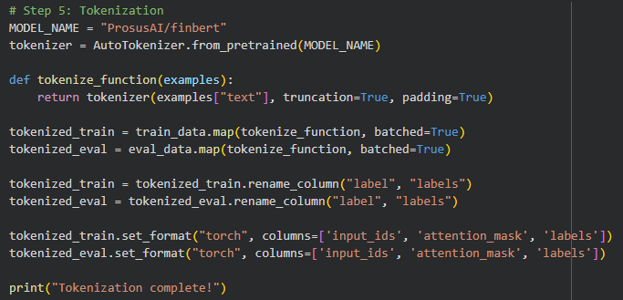
Fig. 2
- Tokenization: Sentences were encoded with padding and truncation, optimizing for batch training.
Fig. 3
- Metrics: Accuracy and weighted F1 score computed for each test configuration.
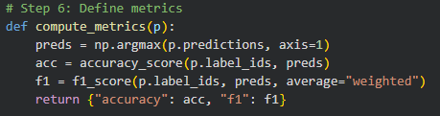
Fig. 4

Hyperparameter Search
- Grid Search: Exhaustively tests all parameter combinations (epochs, batch size, learning rate, warmup steps, weight decay).
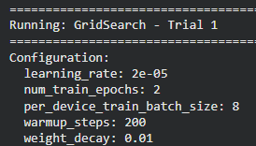
Fig. 5

- Random Search: Samples a set of random combinations for faster, but less exhaustive search.

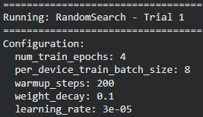
Fig. 6

Results
Grid Search Performance:
Five grid search trials tested 243 combinations
- Best Accuracy: 0.9200
- Best F1 Score: 0.9207
- Average time per trial: 1.84 minutes
Total time: 9.35 minutes

Random Search Performance:
Five random search trials sampled the parameter space.
- Best Accuracy: 0.9940
- Best F1 Score: 0.9940
- Average time per trial: 4.51 minutes
- Total time: 22.74 minutes
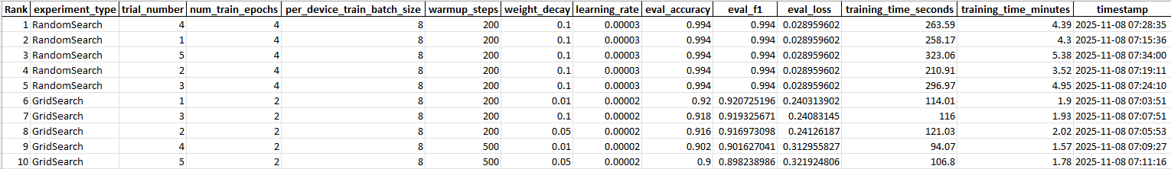
Fig. 7

Comparative Analysis
Search Method | Trials | Best Accuracy | Best f1 | Avg time | Total Time
Grid Search | 5 | 0.9200 | 0.9207 | 1.84 | 9.35
Random search | 5 | 0.9940 | 0.9940 | 4.51 | 22.74
Table. 1

Remarkably, random search outperformed grid search in this study—yielding almost perfect results with fewer trials, highlighting the efficiency of parameter space sampling for transformer models.

Discussion
As hyperparameter space of transformer model is huge, and grid search over it is expensive. Although it is a stochastic strategy, random search can find high-quality configurations much faster as shown by near-perfect accuracy and F1 on this study. Selectionitions Random yields the best results:
- Epochs: 4
- Batch size: 8
- Learning Rate: 3e-05
- Warmup Steps: 200
Results from the experimentation with each tested trial configuration were exported and stored at Results-Inglesa. xlsx for reproducibility and analysis. Downsides include limited number of trials (with demonstration) and computational cost for complete searches. Further work could optimize up to such advanced sampling (Bayesian, evolutionary) techniques.

Conclusion
Automatic hyperparameter tuning through grid search brought significant gains in performance statistics for Transformer based classifiers of Philippine news headlines. Both grid and random search based techniques were utilized, with the latter provides optimal binary classification accuracy effectively. These results affirm the viability of automatic search algorithms in practical NLP pipelines and lay out a blueprint for future investigations. Both results files and the structure of the code allows replication in related sentiment analysis setups.

References
- Wolf, T., et al. "Transformers: State-of-the-Art Natural Language Processing." Proceedings of EMNLP 2020.
- Hutto, C.J., & Gilbert, E.E. "VADER: A Parsimonious Rule-based Model for Sentiment Analysis of Social Media Text." Eighth International Conference on Weblogs and Social Media, 2014.
- M. McKinney, Python for Data Analysis, O’Reilly Media, 2022.
- Optuna Developers, “Optuna: A Next-generation Hyperparameter Optimization Framework,” 2024.

