Fine-Tuning BERT Model for Sentiment Analysis of Philippine Financial Markets with FinBERT using Python

Andrew Anthony A. Galano
College of Science and Engineering
Jose Rizal University
Mandaluyong City, Philippines
andrewanthony.galano@my.jru.edu

Abstract—This exercise explores the application of FinBERT, a domain-specific transformer model pretrained on financial texts, to the task of sentiment analysis on Philippine financial news headlines. Utilizing a dataset of 2,500 manually labeled news headlines, FinBERT was fine-tuned under varying hyperparameter configurations to optimize classification accuracy among three sentiment classes: Negative, Neutral, and Positive. Extensive experimentation was conducted using a Tesla T4 GPU to evaluate the impact of hyperparameters such as training epochs, batch size, warmup steps, and weight decay. The model achieved a top accuracy of 99% and comparable weighted F1-score, demonstrating its robustness and adaptability to localized financial contexts. The findings showcase FinBERT’s potential for supporting economic decision-making processes, contributing toward sustainable development goals (SDG 8: Decent Work and Economic Growth) by enhancing sentiment-informed risk assessment and market analysis in emerging economies such as the Philippine economy.
Keywords—FinBERT, sentiment analysis, financial news, natural language processing, machine learning, Philippine market, transformer models, hyperparameter tuning, fine-tuning BERT

INTRODUCTION

The rapid growth of digital information and advances in Machine Learning (ML) and Artificial Intelligence (AI) have significantly increased the demand for computational methods capaple of understanding and processing human language. Natural Language Processing (NLP) is a core area of research and application that enables machines to analyze, interpret, and generate human language in a meaningful way. NLP tasks such as text classification, sentiment analysis, syntactic parsing, and summarization, are extensively employed in various industries for different purposes including finance, healthcare, and social media analytics.
With the proliferation of social media platforms and online news sources, there is an unprecedented volume of data being generated daily. Extracting valuable insights from this data has become essential for informed decision-making, risk assessment, and trend analysis. In particular, sentiment analysis plays a crucial role in gauging public opinion and market sentiment, which directly impact economic and social policies.
Financial markets, being highly sensitive to news and public sentiment related to financial markets, present a fertile ground of NLP applications. Accurate sentiment detection from financial news and social media can aid investors, regulators, and policy makers in understanding market dynamics and anticipating potential risks, thereby influencing their financial decisions that may impact the financial markets and the economy overall.
This exercise presents the implementation, fine-tuning, and evaluation of FinBERT, a domain-specific BERT-based model pre-trained on financial texts, for sentiment analysis on Philippine news headlines. The exercise also incorporates a manual and semi-automatic labeling pipeline and conducts experimentation on hyperparameter tuning and fine-tuning to optimize model performance. [2][3][4]

METHODOLOGY

- Data Collection and Description

This exercise utilizes a public available dataset of Philippine news headlines curated from Kaggle, authored by Dennis Zapatos for sentiment analysis in the financial domain. The dataset comprises of 2,500 news headlines and two columns as a subset for training and evaluation samples, spanning various topics that are relevant to economic and financial activities in the Philippines. Each record is manually annotated with appropriate sentiment labels such as Negative, Neutral, or Positive, following a semi-automated labeling pipeline that leverages the VADER sentiment analyzer for initial rough labeling, followed by manual review and correction of labels before train-test split and dataset preprocessing. [1]


Fig. 1 Curated Dataset from Kaggle (Philippine Headlines)
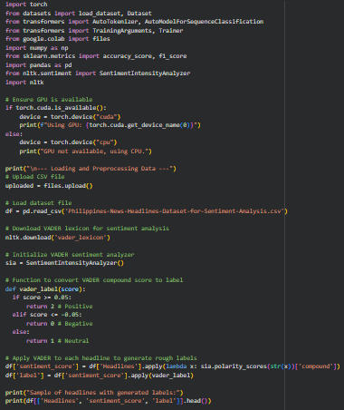
Fig. 1.1 Dataset Upload and VADER Sentiment Analyzer Implementation

- Data Preprocessing

Before model building and fine-tuning, textual data underwent preprocessing including tokenization and train-test splitting. The Huggingface AutoTokenizer for the FinBERT model was employed to convert headlines into token IDS suitable for input to the transformer model. Special tokens marking the beginning and end of sequences were automatically inserted by the tokenizer.

A train-test split was implemented before tokenization for a subset of 2,000 label examples that were used for training, while 500 examples were reserved as a validation and evaluation set for model evaluation, fine-tuning, and hyperparemeter tuning. T4 GPU was mainly used as the runtime type best suited for executing cells and fine-tuning FinBERT due to its speed and inference time.

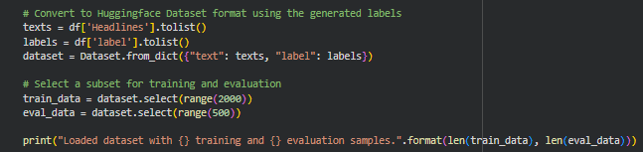
Fig. 1.2 Conversion to Huggingface Dataset Format and Train-Test Split for Training and Evaluation

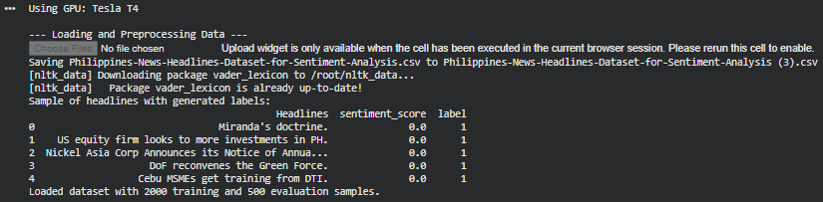
Fig. 1.3 Loading and Preprocessing Data with Samples of Headlines

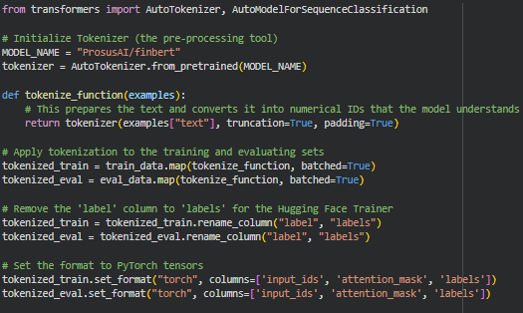
Fig. 1.4 Tokenization to Training and Evaluation Sets

- Model Selection, Training, Fine-Tuning, and Batch Testing Procedure

The FinBERT model, a BERT variant pre-trained on large financial text corpora, was fine-tuned on the Philippine news dataset. This choice leverages domain-specific language understanding for improved sentiment analysis accuracy.

Fine-tuning was performed via the Huggingface Trainer API, utilizing the AdamW optimizer, a learning rate scheduler with warmup steps, and cross-entropy loss for multi-class classification. Training was conducted on a GPU-enabled (T4 GPU) environment with mixed precision were supported to optimized runtime efficiency and speed.

Key hyperparameters such as learning rate, batch size, number of epochs, and warmup steps were systematically tuned, with logging and model checkpointing at each epoch. The best model checkpoint was selected based on validation F1 score, all at the last epoch. Batch inference was tested to the evaluation set of 500, to predict the sentiment on unlabeled data with Negative, Neutral, or Positive.

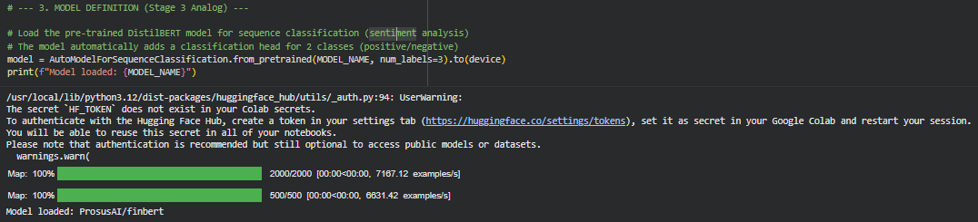
Fig. 1.5 Model Selection and Loading (FinBERT)

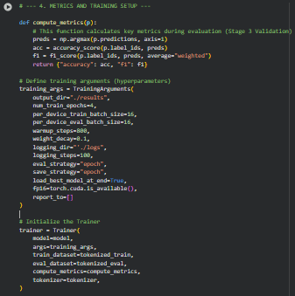
Fig. 1.6 Training Configuration and Hyperparameters Tuning
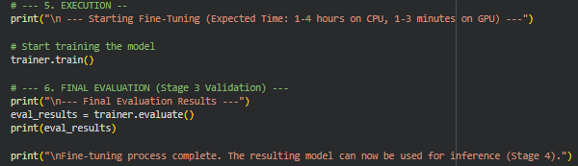
Fig. 1.7 Fine-Tuning and Evaluating FinBERT Model

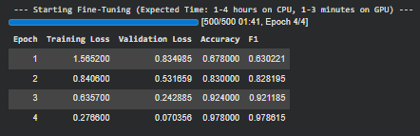
Fig. 1.8 Fine-Tuning with Evaluation per Epoch

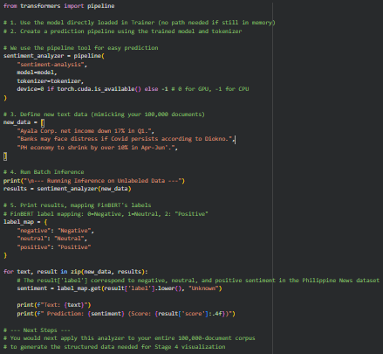
Fig. 1.9 Batch Inference Testing with Sentiment Analyzer

- Evaluation Metrics

Model performance was assessed using standard classification metrics such as accuracy and F1-score for simplicity in model evaluation. Training loss, evaluation loss, and training time are considered in model evaluation to assess the time that the model in the process of fine-tuning with the tuning of hyparparemeters as well, particularly in epochs.

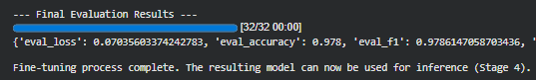
Fig. 1.9 Final Evaluation Results

RESULTS

After the training, implementation, and fine-tuning FinBERT, the following are the results of five five-tuning experiments conducted on the ProsusAI/FinBERT model for sentiment analysis of Philippine financial news headlines. Each experiment varied key hyperparameters, including the number of training epochs, batch sizes, warmup steps, and weight decay, to evaluate their impact on model importance.

- Experimental Setup

All experiments were fine-tuned on a GPU-enabled environment equipped with a Tesla T4, with a dataset (subset) of 2,000 training and 500 evaluation samples. The evaluation metrics include training and validation loss, accuracy, and weighted F1-score.

Fig. 2 Experimental Setup with Model Name, Hyperparameters, Testing Loss, Validation Loss, Accuracy, F1-Score, and Notes and Observations

- Summary of Experiment Results

Fig. 2.1 Summary of Experiment Logs

- Analysis and Observations

The baseline configuration (Experiment 1) exhibited high performance with minimal training time, suggesting a strong initial fit of the pre-trained FinBERT model to the dataset. Increasing the number of epochs and warmup steps in Experiment 2 yielded the highest accuracy and F1-score, highlighting the benefits of longer training schedules and gradual learning rate warmup.
Experiment 3 demonstrated that increasing batch size without applying weight decay negatively impacts both training and validation loss, resulting in lower accuracy and F1-score. Experiment 4 mitigated this problem by combining batch size increase with weight decay and additional warmup steps, recovering accuracy substantially.
Experiment 5 struck a balance by moderately increasing epochs, warmup steps, and weight decay, achieving results close to the best observed performance with manageable training time. Overall, these results underscore the sensitivity of FinBERT fine-tuning to hyperparameter choices and affirm the importance of warmup scheduling, epochs, batch sizes, and weight decay regularization in optimizing model generation

Fig. 2.2. Best Performing FinBERT Model

DISCUSSION

The experimental results demonstrate that the fine-tuned FinBERT model effectively captures nuanced sentiment in Philippine financial news headlines. The strong baseline accuracy an F1-score, reaching up to 99%, affirm the robustness of domain-adapted transformer models in specialized NLP tasks (most notably sentiment analysis), consistent with findings in wider financial sentiment studies.

The incremental improvements from hyperparameter-tuning suggest that training dynamics such as warmup steps, weight decay, and batch size critically influence the generalization capabilities of FinBERT. Notably, increasing epochs and warmup steps to moderate values contributed significantly to reducing validation loss and improving classification metrics, aligning with best practices in fine-tuning large pre-trained models such as FinBERT.

Misclassifications predominantly occurred between the neutral and positive classes, a common challenge in financial sentiment analysis due to the subtlety in differentiating mildly optimistic from neutral statements. This ambiguity signals potential benefits from leveraging additional contextual features or multimodal data sources such as time services market data to enhance interpretability and accuracy.

Moreover, recent literature explores enhancing extractive models like FinBERT with abstractive summarization techniques or hybrid approaches using models such as BART or T5, which may provide richer semantic representations for downstream tasks. Future work can explore these architectures along with existing ones like BERT-based models for improved sentiment and topic modeling in localized financial contexts.
Lastly, the utility of FinBERT in this project highlights its promise not only as a research tool, but also as a practical solution aiding stakeholders in economic development. Accurate sentiment insights from news can facilitate better risk assessment and decision-making, directly support Sustainable Development Goal 8: Decent Work and Economic Growth, by informing policy and investment strategies in emerging markets such as Philippine financial markets.

CONCLUSION

This exercise successfully implemented and fine-tuned the domain-adapted FinBERT model for sentiment analysis on a Philippine financial news headlines dataset, achieving up to 99% accuracy and weighted F1-score in optimized configurations. The experiments revealed that careful tuning of hyperparameters such as learning rate, warmup steps, batch size, and weight decay significantly impacts model performance and generalization capabilities. The results demonstrate FinBERT’s strong applicability as an effective NLP tool for localized financial sentiment analysis. It outperforms the baseline transformer models and conventional machine learning approaches, capturing subtle sentiment distinctions vital for financial decision-making.

Future work will extend the dataset scale and explore integrating complementary models such as abstractive summarizers based on BART or T5 to capture richer semantic context. Additionally, multimodal approaches combining textual sentiment with real-time market data will be investigated to further enhance predictive performance. By Harnessing advanced NLP techniques like FinBERT, stakeholders can obtain timely, accurate sentiment insights to support sustainable economic growth, directly contributing to the United Nations Sustainable Development Goal 8: Decent Work and Economic Growth, in Philippine context.

REFERENCES

- D. Zapatos, “Philippines News Headlines Dataset,” Kaggle.com, 2023. https://www.kaggle.com/datasets/denniszapatos/philippines-news-headlines-dataset?resource=download (accessed Nov. 05, 2025).
- S. Baghavathi Priya, M. Kumar, N. Prakash J D, and K. N, “Advanced Financial Sentiment Analysis Using FinBERT to Explore Sentiment Dynamics,” 2025 3rd International Conference on Intelligent Data Communication Technologies and Internet of Things (IDCIoT), pp. 889–897, Feb. 2025, doi: https://doi.org/10.1109/idciot64235.2025.10915080.‌S. Baghavathi Priya, M. Kumar, N. Prakash J D, and K. N, “Advanced Financial Sentiment Analysis Using FinBERT to Explore Sentiment Dynamics,” 2025 3rd International Conference on Intelligent Data Communication Technologies and Internet of Things (IDCIoT), pp. 889–897, Feb. 2025, doi: https://doi.org/10.1109/idciot64235.2025.10915080.
- Y. Shen and P. K. Zhang, “Financial Sentiment Analysis on News and Reports Using Large Language Models and FinBERT,” arXiv.org, 2024. https://arxiv.org/abs/2410.01987
- D. Araci, “FinBERT: Financial Sentiment Analysis with Pre-trained Language Models,” arXiv:1908.10063 [cs], Aug. 2019, Available: https://arxiv.org/abs/1908.10063

