**SPORTY SHOES PROJECT DOCUMENT**

Model

1. Admin

p**rivate** **long** ID;

**private** String adminId;

**private** String pwd;

1. CartItem

**private** **long** productId;

**private** String name;

**private** BigDecimal rate;

**private** BigDecimal price;

**private** **int** qty;

1. Category

**private** **long** ID;

**private** String name;

1. Products

**private** **long** ID;

**private** String name;

**private** BigDecimal price;

**private** Date dateAdded;

**private** **long** categoryId;

1. User

**private** **long** ID;

**private** String fname;

**private** String lname;

**private** String address;

**private** **int** age;

**private** Date dateAdded;

**private** String emailId;

**private** String pwd;

1. Purchase

**private** **long** ID;

**private** **long** userId;

**private** Date Proddate ;

**private** BigDecimal total;

1. PurchaseItem

**private** **long** ID;

**private** **long** purchaseId;

**private** **long** productId;

**private** **long** userId;

**private** BigDecimal rate;

**private** **int** qty;

**private** BigDecimal price;

**MYSQL Database tables**

1. Admin

Create table admin(ID int primary key,

adminId varchar(10),

Pwd varchar(10));

1. CartItem

Create table cartitem(productId int primary key,

Name varchar(40),

Rate float(10,2),

Price float(10,2),

Qty int);

1. Category

Create table category(ID int primary key,

Name varchar(10));

1. Products

Create table products(Id int primary key,

Name varchar(40),

Price float(10,2),

dateAdded date,

categoryId int, foreign key(categoryId) references category(id));

1. User

Create table user(Id int primary key,

**f**Name varchar(40),

LName varchar(40),

address varchar(40),

age int,

Dateadded date,

emailid varchar(40),

Pwd varchar(40));

1. Purchase

Create table purchase(Id int primary key,

Userid int ,

Proddate date,

Total float(10,2),foreign key (userid) references user(id) );

1. PurchaseItem

Create table purchaseitem(Id int primary key,

purchaseId int ,

productId int ,

Userid int ,

rate float(10,2),

Qty int ,

Price float(10,2),foreign key (purchaseId) references purchase(id) ,

foreign key (productId) references products(id) ,

foreign key (userid) references user(id));

SCREEN SHOTS

1. DASHBOARD

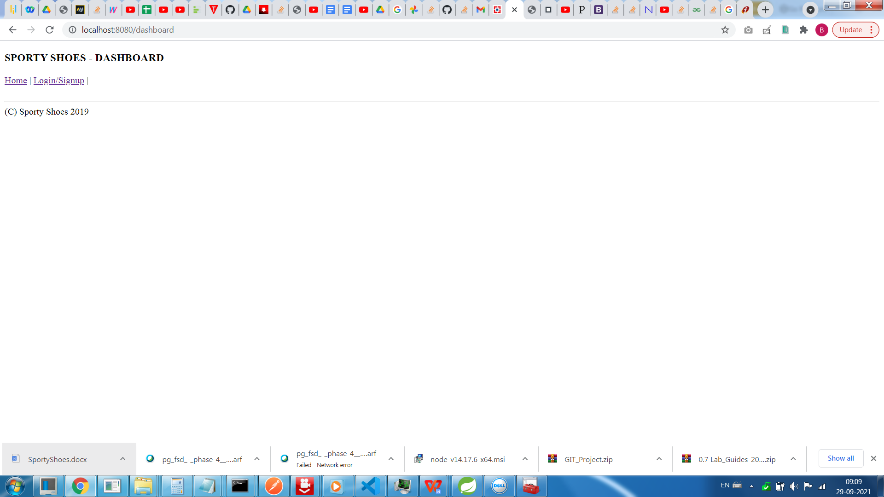

1. LOGIN SCREEN

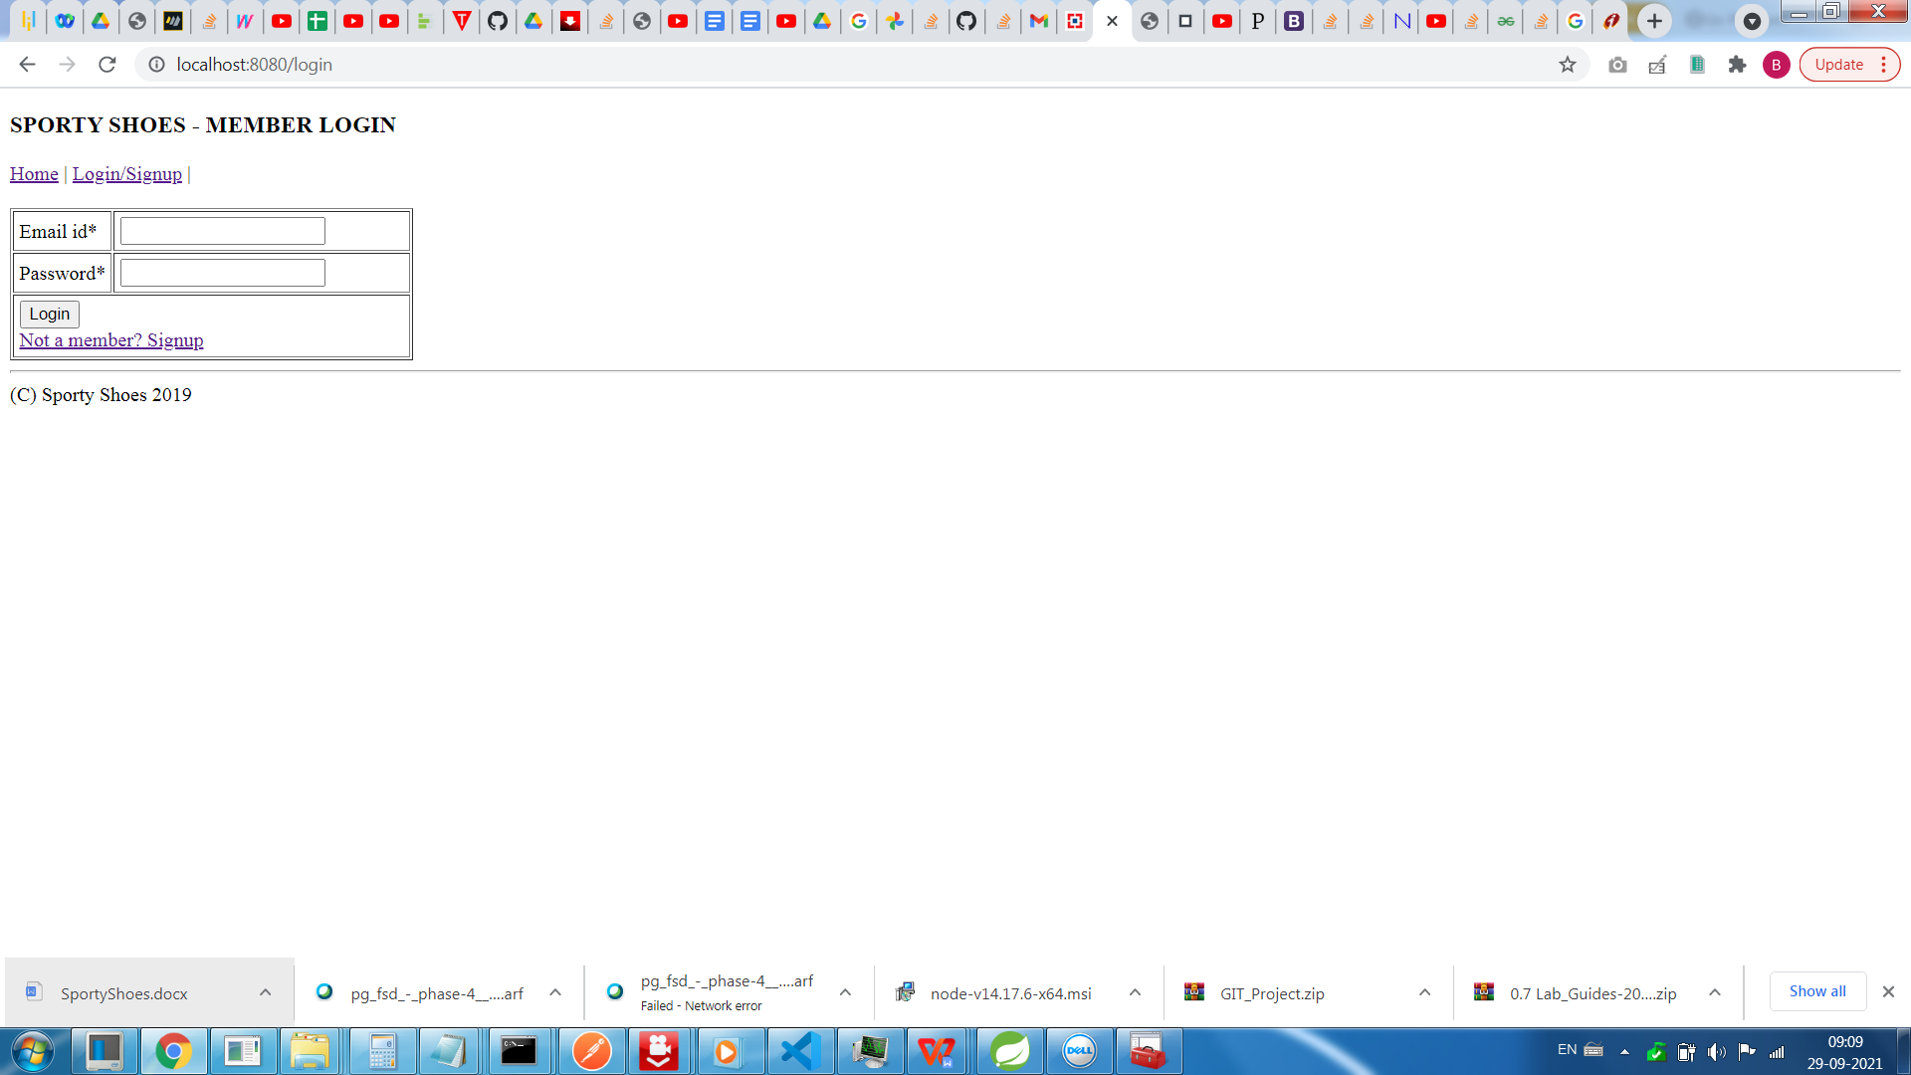

1. SIGN UP SCREEN

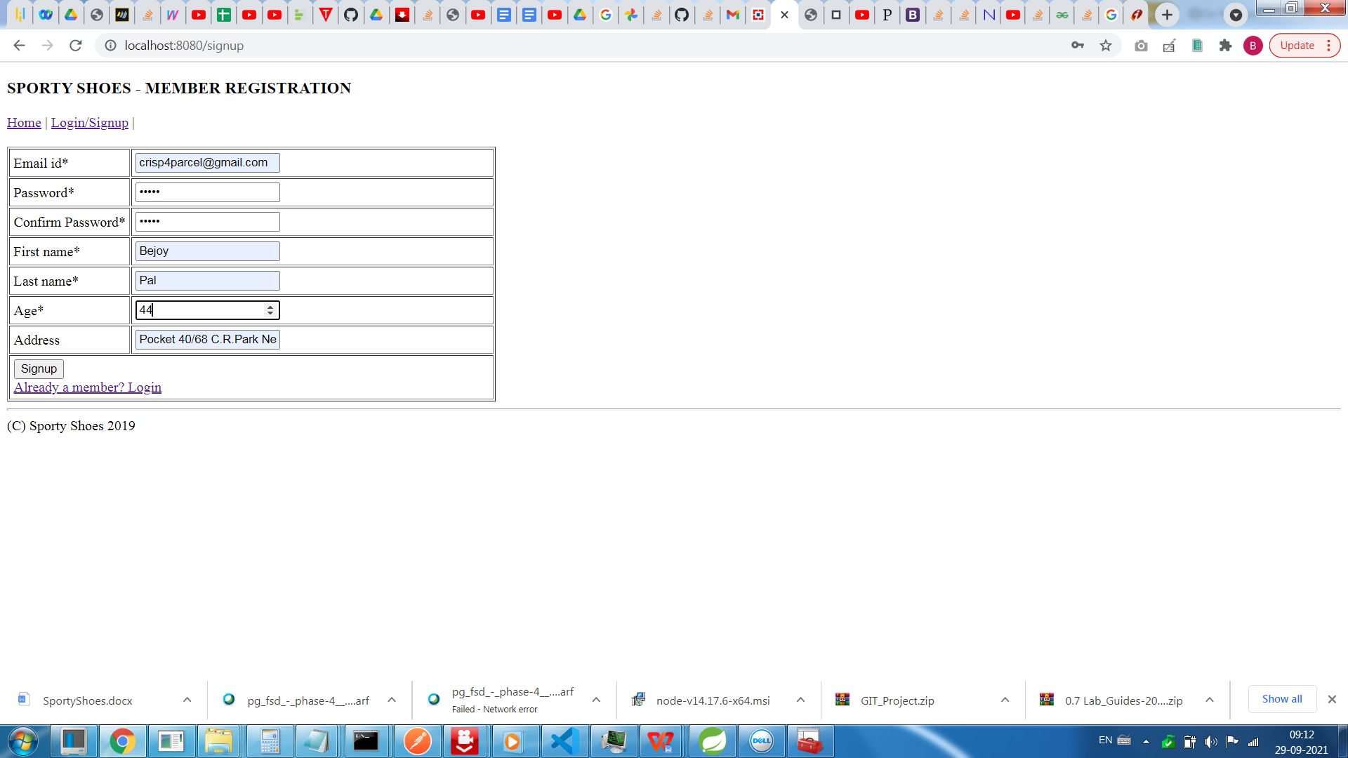

1. SIGN-UP SUCCESS SCREEN

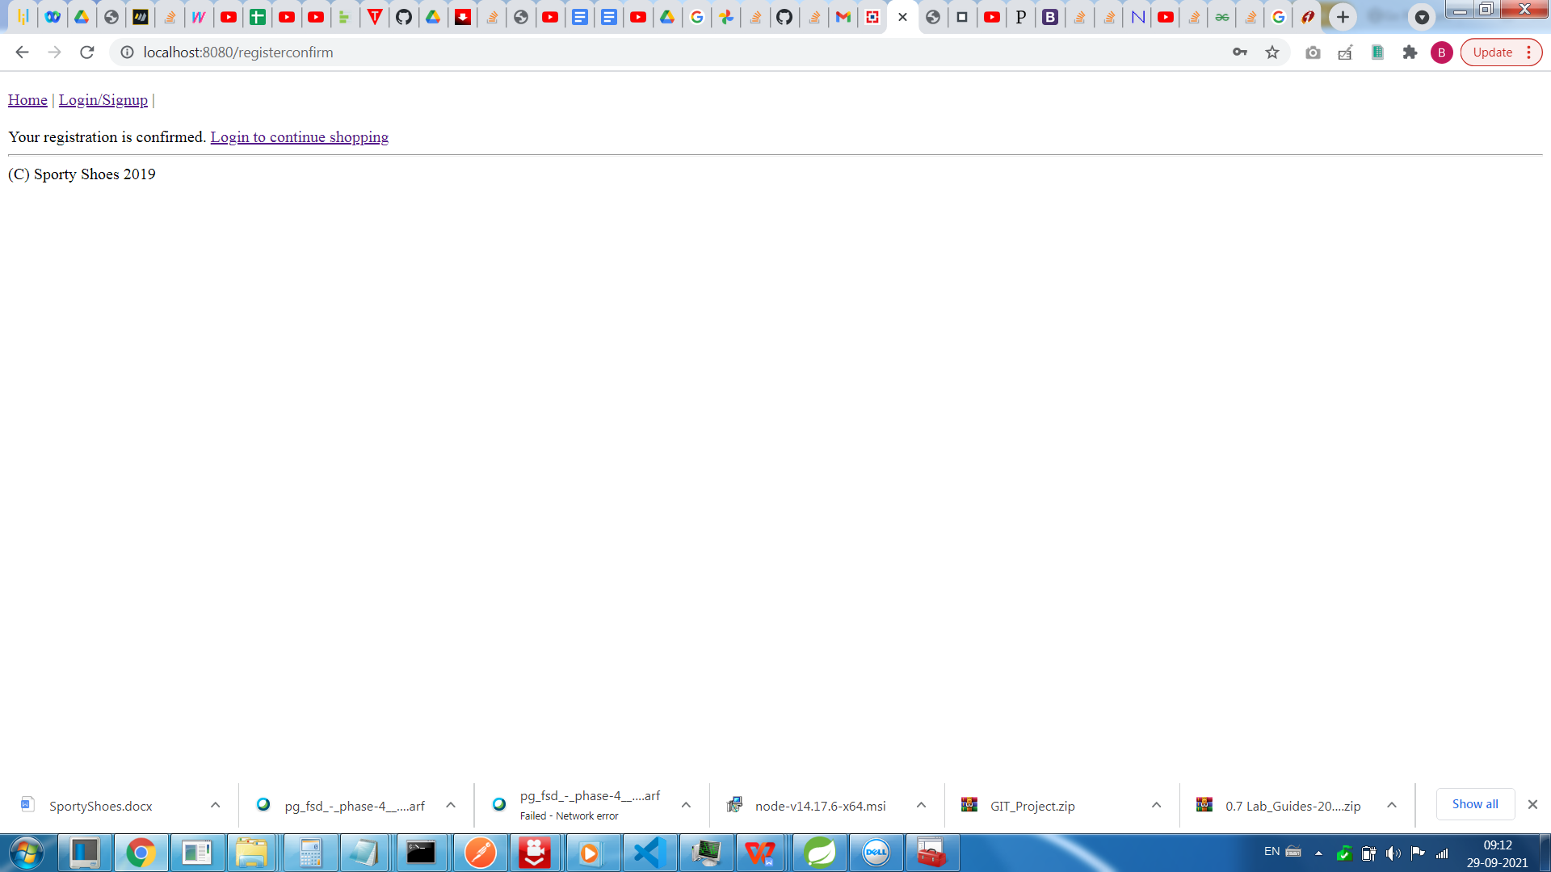

1. LOGIN FOR SHOPPING

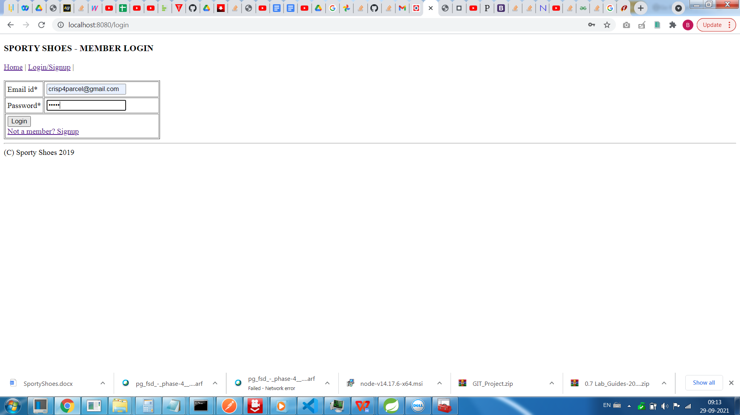

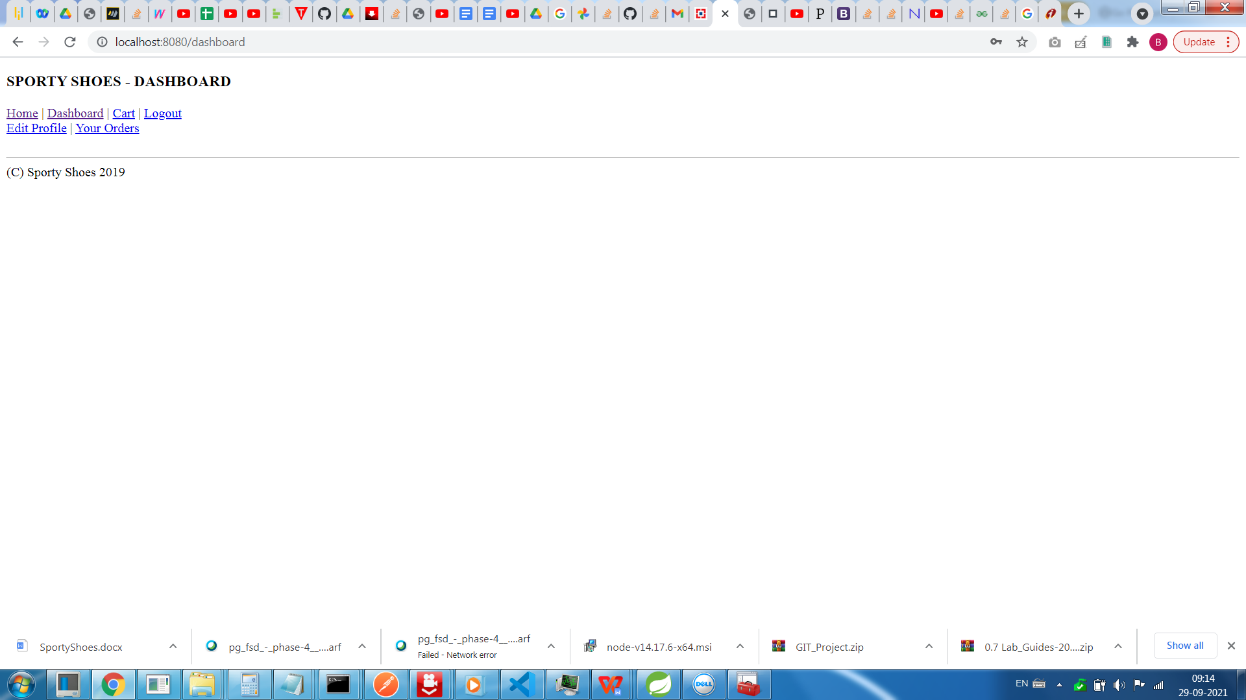

1. EDIT PROFILE SCREEN

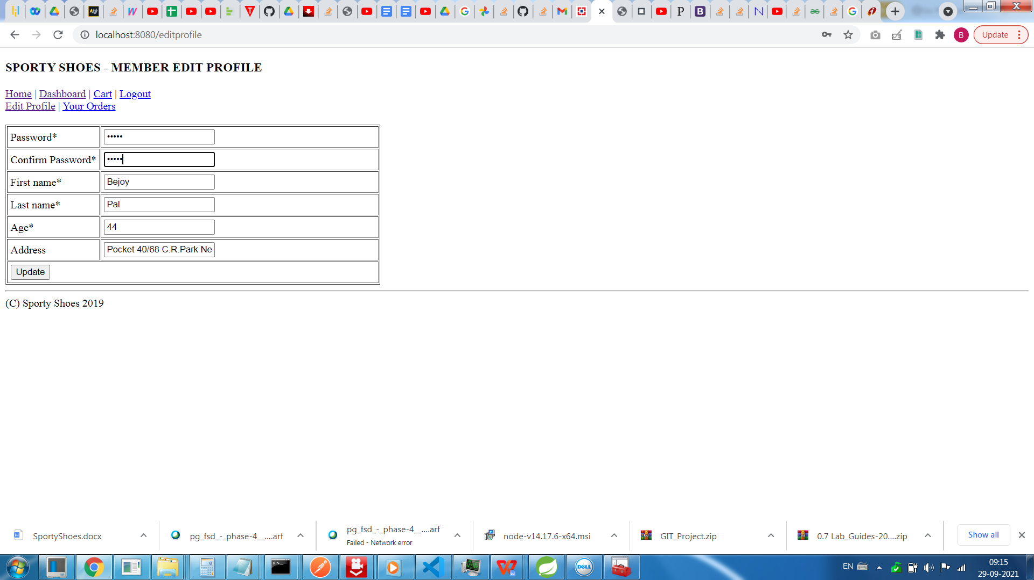

1. SUCCESS ON UPDATE SCREEN

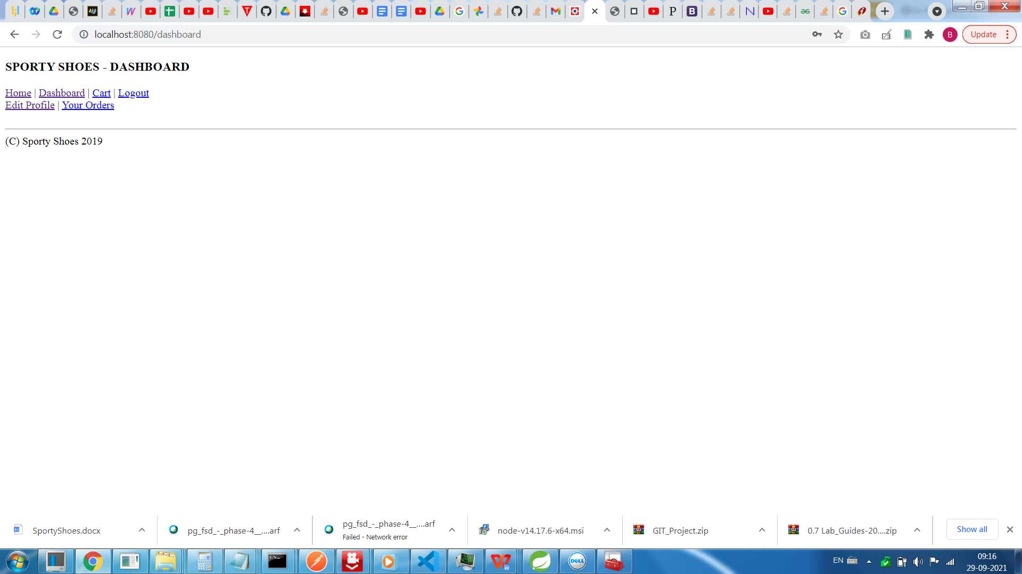

1. CART SCREEN

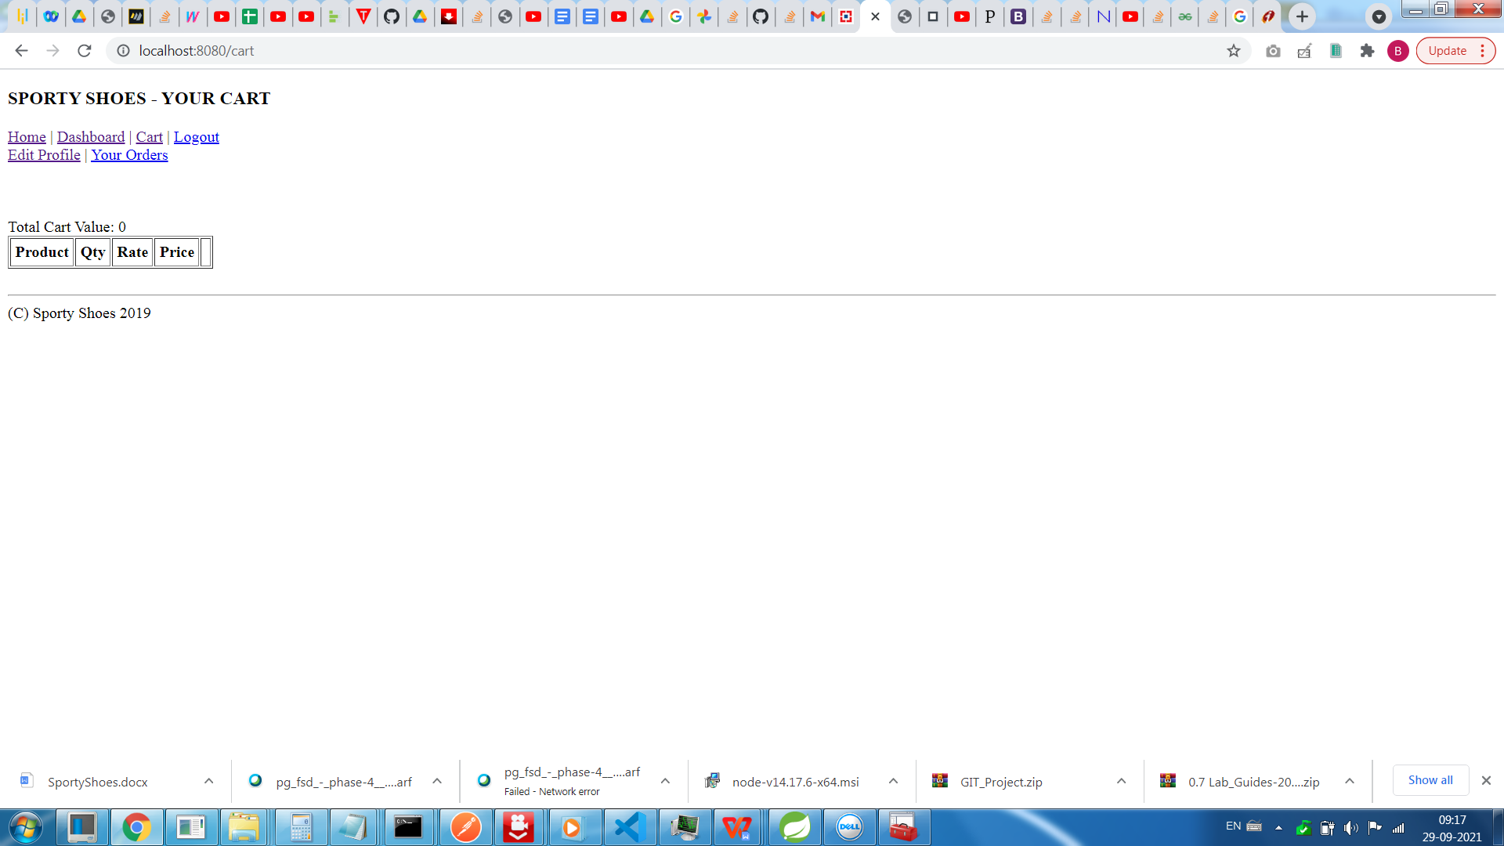

8.