**Volume on Chinese Environmental History**

**for the new edition of a General History of China**

The Chinese Environmental History volume is a newly established component of the ongoing national project to compile a revised General History of China. As the first time that environmental history has been formally included as an independent volume within a major state-led general history initiative, this project marks a significant milestone in the institutional recognition of environmental history as a specialized field. It provides a rare opportunity to bring together the growing body of research on China’s environmental past, to advance theoretical reflection, and to enhance academic discourse—all in service of contemporary efforts toward environmental protection and the construction of ecological civilization. The launch of this volume carries both important scholarly value and broad social relevance.

The main goals of the project are to tell compelling stories about the evolving relationship between humans and nature in Chinese history; to systematically identify and interpret the ecological wisdom embedded in Chinese cultural traditions; to support China's ecological civilization initiative; and to share Chinese perspectives on historical ecology with the wider world. The volume focuses on three key tasks:

* Drawing on China's long history and vast geographical diversity to develop an environmental historical perspective grounded in the country’s own historical experience.
* Summarizing existing research practices to begin shaping a conceptual and narrative framework for environmental history with distinct Chinese characteristics.
* Synthesizing and refining current research achievements to build a relatively comprehensive, coherent, and temporally integrated body of knowledge on Chinese environmental history.

As a landmark undertaking in the field of Chinese environmental historiography, this project situates historical environmental change at its core, while also emphasizing the ecological dimensions of China’s interactions with other civilizations. The project moves beyond the limits of nation-bound historiography by adopting a globally informed narrative framework. In the ancient history section, it explores the ecological connections and cross-continental species exchanges enabled by the land and maritime Silk Roads, revealing China's material and cultural exchanges with Eurasia and the Americas. The modern history section analyzes the effects of Western colonial activities and imperial knowledge systems on China's resource extraction, industrial development, and changing environmental perceptions. The contemporary section turns to environmental governance in the People’s Republic of China, situating it within the global environmental movement and highlighting China’s engagement with international ecological ideas since the 1960s and 1970s.

While grounded in China’s own historical experience, the project embraces a global perspective and actively engages in international environmental historiography. As an ongoing research endeavor, it is shaping an autonomous Chinese environmental knowledge system while contributing valuable insights and collaborative efforts toward the shared goal of sustainable environmental development worldwide.

——————————————————

**Volume Chapter Summaries**

This volume has one chief editor and eight core authors (as listed below). The compilation team includes nearly 30 contributors, and the project is expected to be completed around 2026. This volume is currently structured into ten chapters, systematically tracing the historical evolution of the relationship between humans and nature in China. Since the chapter manuscripts are still being collected and assembled, the following is a preliminary outline of the overall editorial framework.:

**Chapter 1** covers the prehistoric period, providing an overview of the basic natural environment from the origin of humanity to the end of the Neolithic era, as well as early human adaptation to the environment.

**Chapter 2 and 3**, focusing on the early imperial period, respectively explore environmental transformations during the Xia, Shang, Zhou, and Spring and Autumn eras, and the Warring States, Qin, and Han dynasties—a span of over 4,200 years. These chapters examine the emergence of early state civilizations, the formation of the Huaxia system, and the development of agrarian society.

**The chapter 4, on the middle imperial period** centers on the millennium of change from the Three Kingdoms to the Southern Song dynasty, analyzing how political instability in the north triggered economic and environmental fluctuations, while resource development and the rise of rice-based civilization in the south reshaped human–nature relations.

**Chapters 5 and 6**, which focus on the late imperial period, detail the expansion of traditional agriculture from the Yuan and Ming dynasties to the early Qing era, as it extended into broader geographic regions and more diverse natural environments. They examine the transformation of the agrarian economy during this process, highlighting the historical causes of increasing environmental degradation, ecological decline, resource challenges, and natural disasters, as well as the societal responses to these issues.

**Chapter 7** on the modern period reveals the multiple crises of the socio-economic-ecological system from the late Qing to the Republican era—such as war, famine, and epidemics—while examining new environmental challenges brought about by capitalist encroachment and the rise of industry and commerce, as well as early attempts at modern environmental governance under the influence of Western knowledge.

**Chapter 8 to 10, devoted to the contemporary period**, are divided around the founding of the People’s Republic of China. The first part addresses the dilemmas of development and early governance efforts during the quest to alleviate poverty and hunger. The middle part documents the struggles from the 1972 United Nations Conference on the Human Environment to the formative years of China’s environmental protection system. The final part focuses on the comprehensive advancement and historic achievements of ecological civilization construction in the new era.

Together, these chapters present a full picture of the Chinese civilization’s historical trajectory—from adapting to nature, to transforming it, and ultimately striving for harmonious coexistence.

_____________________________

**Chief Editor and Core Authors of This Volume**

* **Chief Editor of this volume:**
* **Wang Lihua**, Professor at Nankai University
* **Core Authors of This Volume:**
* **Xia Mingfang** – Professor at Renmin University of China, Director of the Center for Ecological History, Advisor to the Environmental History Committee of the Chinese Society for Environmental Sciences
* **Zhang Jingping** – Professor at Lanzhou University, Member of the Environmental History Committee of the Chinese Society for Environmental Sciences
* **Zhao Jiuzhou** – Professor at Qingdao University, Member of the Environmental History Committee of the Chinese Society for Environmental Sciences
* **Yu Xinzong** – Professor at Nankai University, Dean of the School of History
* **Guan Yongqiang** – Professor at Nankai University
* **Wang Linran** – Associate Professor at Nankai University
* **Fang Wanpeng** – Associate Professor a tNankai University, Deputy Secretary-General of the Environmental History Committee of the Chinese Society for Environmental Sciences
* **Cao Mu** – Associate Professor at Nankai University, Member of the Environmental History Committee of the Chinese Society for Environmental Sciences

Pic. 1 The School of History Building at Jinnan Campus, Nankai University

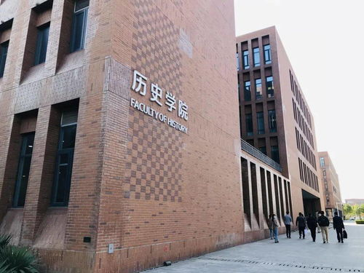

Pic.2 A bird’s-eye view of the main campus of Nankai University

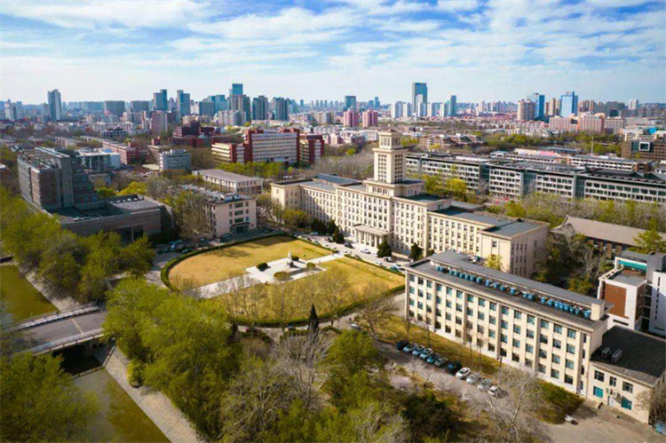

Pic.3 The sunset glow over the Jinnan Campus of Nankai University

