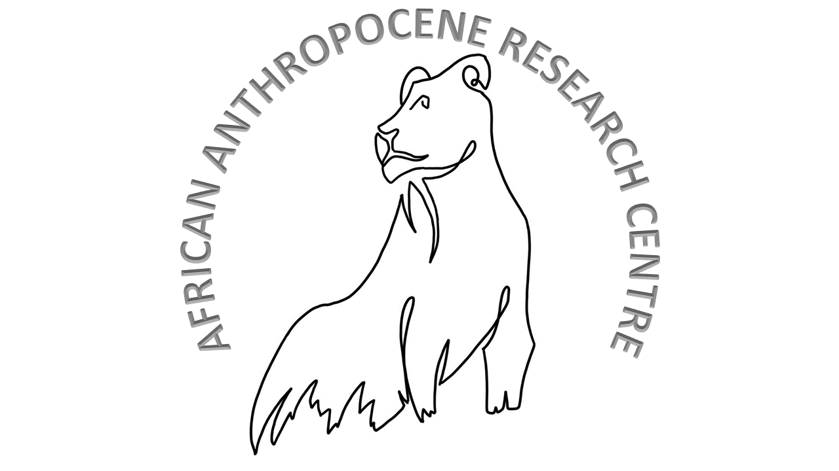**The African Anthropocenes Research Centre**

**History Department, Stellenbosch University, South Africa**

Phone: +27 21 8082390 Mobile: +27 83 654 2794 E-mail: [sss@sun.ac.za](mailto:sss@sun.ac.za)

Our planet has entered the so-called age of Anthropocene/s-a post-Holocene epoch defined by anthropogenic impact on geological, biotic and climatic planetary processes. 'Anthropocene' is a useful way to express both the novelty and urgency of our era, but poses a homogenising label that risks masking uneven power distributions in terms of responsibility for and vulnerability to global environmental problems. Thus the African Anthropocenes Research Centre insists on the locatedness and plurality of *'African* Anthropocenes'. The growing currency of the term ‘Anthropocene’ signals a key shift in how humans are coming to understand our relation to the environment: we can no longer imagine our species other than entangled in planetary, ecological, climatological and geological processes and we accept that we are in crisis. This underlines the urgent need for research - both pure and applied, long term and contemporary – into how we got here to understand what we should do next. We need a deeper, longer understanding of the more-than-human world, especially from the global south. AARC intends to help us not only understand our place in the world better but to make our world - however slightly - a better place. We want to promote a novel, inter-disciplinary, integrated approach to the past, present and, therefore, the future of anthropogenic environmental change. We move from the premise that History can be an essential sense-making, context-giving and navigational tool for deeper understanding of our contemporary world. The Anthropocene necessitates interdisciplinary collaboration to address its multifaceted nature. AARC could serve as a hub for researchers from various disciplines to collaborate and integrate their expertise.

**HUB** **Director Brief Bio**

SANDRA SWART (left) is Professor and Chair of the Department of History at Stellenbosch University, South Africa. She received her DPhil in Modern History from Oxford University in 2001, while simultaneously obtaining an MSc in Environmental Change and Management, also at Oxford. She studies the socio-environmental history of southern Africa, with a particular focus on the shifting relationship between humans and animals. She is an editor of the Brill book series African and Asian Anthropocene: Studies in the Environmental Humanities. She is current co-vice president of the European Society of Environmental History. Among other books, she authored *Riding High* - *Horses, Humans and History in South Africa* (Witwatersrand University Press, 2010 and *The Lion's Historian: Africa's Animal Past* (Jacana Media, 2023, Ohio University Press, 2025).