FREEZING MEMORY:

COLLECTING IN TROPICAL AMERICA BETWEEN THE 18th AND 20th CENTURIES

Nicolás Cuvi, FLACSO Ecuador

Delfín Viera, Universidad de los Andes, Venezuela

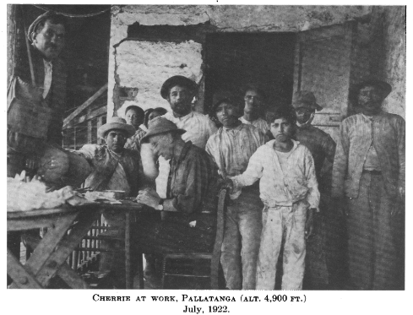

Source: Chapman, Frank M. 1926. "The Distribution of Bird-Life in Ecuador. A Contribution to a Study of the Origin of Andean Bird-Life." *Bulletin of the American Museum of Natural History* 55:1-784.

We investigate the collecting of natural, geological, ethnological, archaeological and linguistic samples, publications, photos and other visual records in tropical America during the XVIII-XX centuries. The aim is to understand and unravel the collection, plus the subsequent movement and destination of objects collected, captured, acquired in these territories, and their destination: natural history museums, botanical gardens, cabinets of curiosities, zoos, herbariums, private collections, and sometimes the bottom of the sea.

Among other things, we intend to highlight the role of local and other “invisible” actors in these activities, proposing a connected and decolonial history beyond the limits of nation-states, on networks and circulation of knowledge. Likewise, we are particularly interested in investigating the impact that this may have had on populations and species, especially endemic ones, causing an iatrogenesis of collecting.

The project is financed by the Academic Development Fund of [FLACSO Ecuador](https://www.flacso.edu.ec/). It has been underway since 2024 and will culminate its first phase in 2026, with the publication of two scientific articles, presentations at national and international events, conferences and a course on the history of collecting.

Nicolás [Cuvi](https://www.flacso.edu.ec/index.php/docentes/perfil?id=4241) investigates the intersections between environmental humanities, environmental history and history of science, especially in the tropical Andes. He is a research professor at FLACSO Ecuador.

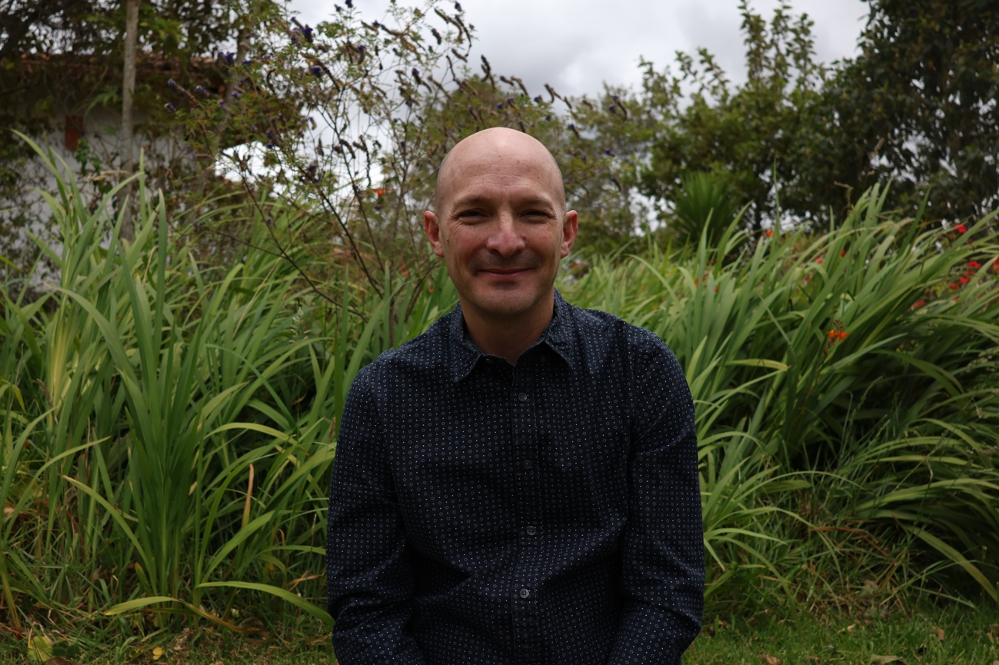

Delfín Viera is a historian of science and medicine. He works on the scientific/cultural perception of American nature in the 19th-20th centuries. He is a retired professor at the Universidad de los Andes, Trujillo-Venezuela.

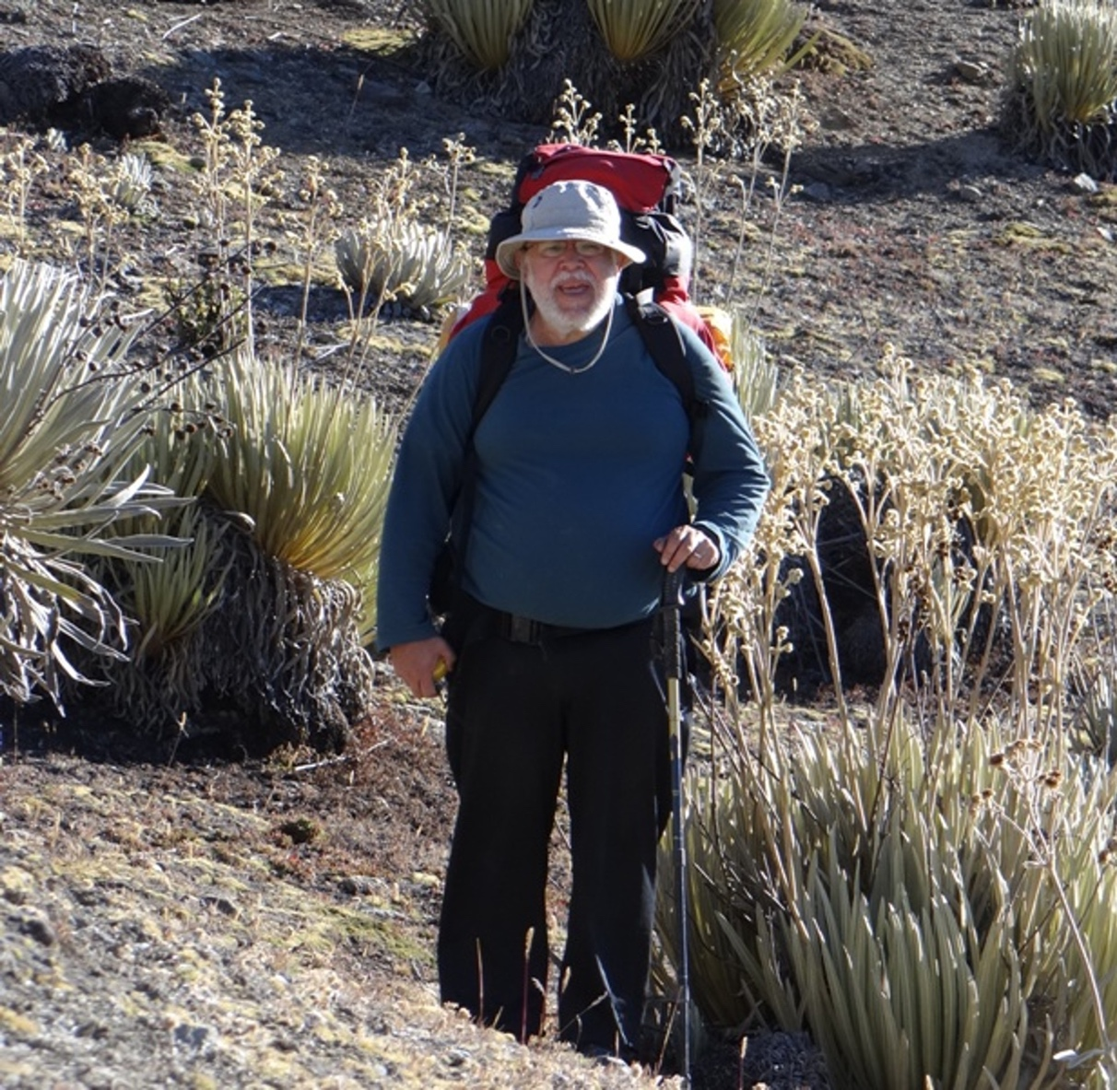

Joint publications:

Cuvi, Nicolás, Delfin Viera, and Carlos Acosta Rizo. In press. "Unfolding the networks and circulation of geological knowledge in the 19th century Northern Andes." *Earth Sciences History* 44 (2).

Cuvi, Nicolás, and Delfin Viera. 2024. "Land Use in the Andes from the Mid-Nineteenth Century to 1950. Plantationocene, Extractivisms, Conservationisms, and Contested Lands." In *Land Use – Handbook of the Anthropocene in Latin America*, edited by Olaf Kaltmeier et al. Bielefeld: Bielefeld University Press.

Cuvi, Nicolás, and Delfín Viera. 2022. "History and the Quest for a Historiography of Scientific Explorations and Evolutionism in the American Tropics." In *Handbook of the Historiography of Latin American Studies on the Life Sciences and Medicine*, edited by Ana Barahona. Cham: Springer International Publishing.