EchoCoach Stage 2 — Admin Account & Data Initialization
Functional / UI Specification · v1.0 · Approved product decisions · 27 October 2026

1. Scope and actors
One coherent Admin module covers Account Management and initial/occasional Student + Class Series initialization. Admins may manage all accounts and authorized platform data. Coaches can access only their authorized coaching records. Everyday Student/Class creation is outside this Admin initialization flow.

2. Account Management (ADM-01)
- Entry: Settings → Administration → Account Management; deny unauthorized direct routes and API requests.
- Account list: name, email, role (Admin/Coach), invitation/account status; search and manage account.
- Invite: Admin provides full name, email and role; Clerk sends/handles secure invitation and password setup; Admin never handles plaintext passwords.
- First Admin: authorized one-time developer bootstrap outside ordinary UI; protect against replay and disable after initialization.
- Manage: edit display name and assign role through confirmation with server-side validation; no permanent deletion in Stage 2.
- Deactivate/reactivate: revoke/deny authenticated access including existing sessions as supported, retain Coach record and full coaching history.
- Protect last active Admin and prevent privilege escalation through UI or direct backend calls.
- Coach role accounts map one-to-one to Coach records; Admin accounts need Coach link only if also authorized as coaching actors.

3. Student & Class Initialization (ADM-02)
Separate Admin-only entries for Student Initialization and Class Initialization share one five-step wizard: (1) source upload/select; (2) preview and map; (3) validate; (4) confirm changes; (5) outcome summary with audit reference. Supports Excel/CSV and controlled read-only source extraction from Stage 1 Convex.

3.1 Student initialization
- Required: normalized Student identity, Sport, assigned Coach, sport-specific status; optional DOB and basic notes.
- Resolve existing Student by trusted keys/manual review; do not merge solely on name. Link CoachStudent for each authorized Coach.
- Create/reuse StudentSport and its single learning profile for each Student+Sport; preserve migration `sequenceBaseline` from authoritative records.
- Do not manufacture missing historical sessions, attendance, reviews or media from cumulative baseline.

3.2 Class Series initialization
- Only after Student and CoachSport/StudentSport relationships exist; exact Student Set may contain 1–4 students.
- Identity remains Coach + Sport + normalized exact Student Set; reject or link existing series on duplicate rather than silently creating another.
- Class ratio 1:1 to 1:4 derives from membership and appears in generated/editable Class Series display name.
- Optional location, status and recurring time slots (weekday, time range, every 1–4 weeks and anchor).
- Do not generate historical Class Sessions, Class Plans, Class Reviews or Media from initialization baseline.

4. Cross-coach shared Student and Learning Profile
APPROVED: One global Student identity can be linked to multiple coaches. When two authorized coaches teach that same student in the same sport, both may view and edit the SAME StudentSport Learning Profile. Edits to learning goal, milestone status/achievement dates and latest-only capability ratings are visible to both authorized coaches.
- Authorize against authenticated Coach, active CoachStudent relationship, applicable sport, and resource-specific access rules on every query and mutation.
- Do not infer rights to another Coach’s private class reviews, media or session-specific notes merely from shared Student identity.
- Existing LearningMilestone history remains preserved; CapabilityRating remains latest-only (no additional rating history).
- Rare multi-coach edge case: document future improvement for edit provenance, conflict resolution/optimistic versioning, notifications and audit; define minimum safe concurrent update behavior during implementation.

5. Validation, confirmation, failures
- Every import is dry-run validated before Admin confirmation; record create/link/update/skip/reject by row and block unresolved errors.
- Idempotent source namespace + source record key, environment validation and repeatable import results required.
- Import batch and row outcome logs identify actor, source, timestamp, mapping, counts and errors without retaining passwords or unnecessary sensitive content.
- Stage 1 source access is read-only and explicitly environment-scoped; no production deployment or database writes implied by approving this document.
- Partial failures: show committed records and remaining failures; support controlled retry without duplicates.

6. Acceptance criteria
☐ Coach is denied Admin routes and mutations, even with direct URL/API calls.
☐ Initial Admin bootstrap cannot be repeated and invitations do not create duplicate Coach records.
☐ Admin role changes cannot remove the last Admin.
☐ Coach deactivation blocks access without deleting history.
☐ Student CSV and Stage 1 migration follow comparable validation, review, confirmation and summary rules.
☐ Repeat import creates no duplicates, Stage 1 sequenceBaseline is preserved.
☐ Two authorized Coaches can update one shared StudentSport learning profile, but cannot see unauthorized private reviews/media.

7. Deferred and pending technical details
- Coach self-service initialization (future).
- Enhanced shared-profile edit-history, provenance and concurrency UX (future robustness).
- Exact Clerk provisioning, Convex authorization and import batch mutation strategy (technical review).
- Import templates and operational roll-back/resume policy (technical review).

8. Visual reference
ADM-01_Account-Management_Approved_v1.png
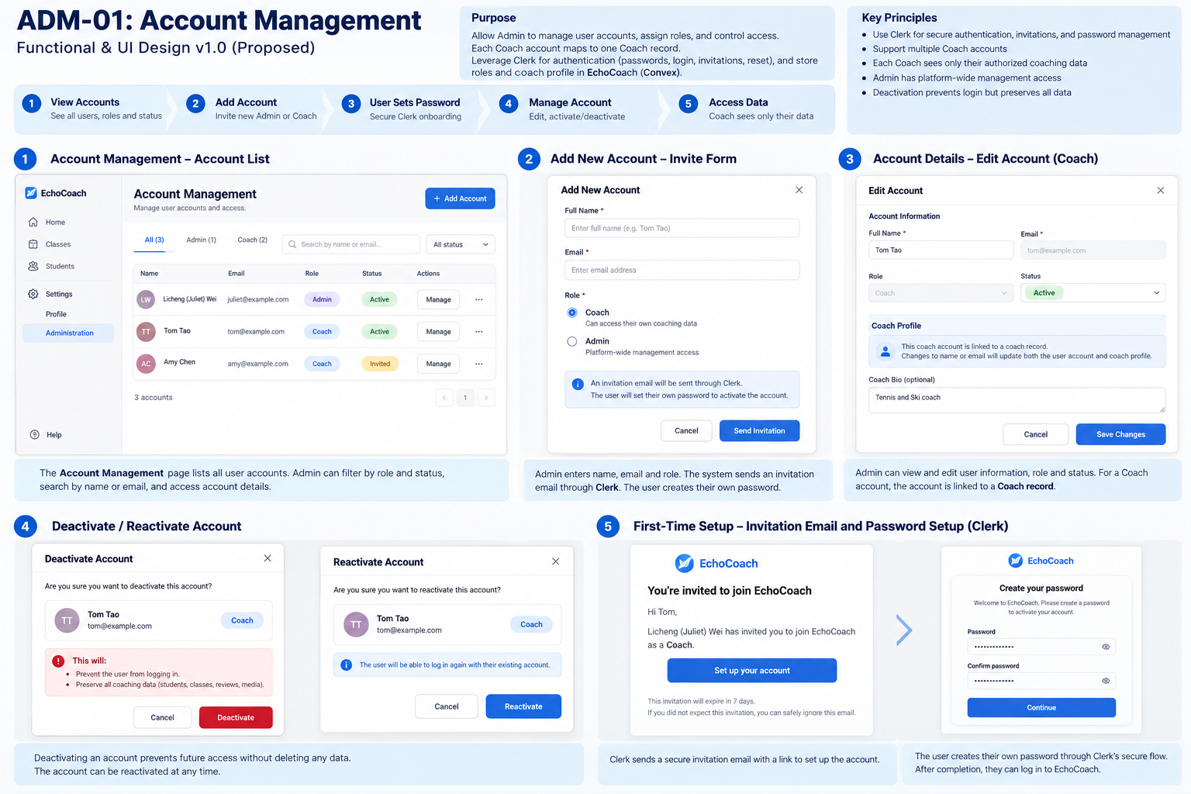
ADM-02_Student-Class-Initialization_Reference_v1.png
