EchoCoach Stage 2
Home Page — Functional & UI Specification | v1.0 | 15 October 2026
Status: Approved product decisions; implementation details proposed for repository validation. Audience: product owner, Cursor/Codex, developers, QA.

1. Purpose and scope
Coach/admin landing screen after successful authentication. Mobile-first, action-first (Option A). Preserve EchoCoach logo and sport photography; provide fast access to two creation workflows. The page must adapt to a persistent, coach-specific active sport.
In scope | Out of scope / separate specifications
Homepage UI, greeting, sport selector, settings entry | Detailed Class Review, Class Plan, Classes, Students workflows
Home / Classes / Students navigation | Class-centric future homepage; booking and scheduling
Sport theme, sport-scoped UI/data, persistence | Media, profile creation, student-facing WeChat app

2. Approved decisions
- Action First homepage: two prominent buttons, New Class Review and New Class Plan.
- Bottom navigation: Home / Classes / Students, consistent across sports.
- Sport selector in top header; language selection lives in Settings.
- Retain existing EchoCoach logo; sport-specific background/skin.
- Class-centric homepage is deferred until future class-booking capabilities exist.

3. UI hierarchy and layout
Zone | Component | Interaction / display
Header | EchoCoach logo + Settings icon | Settings opens configuration destination (detail deferred).
Greeting row | Hello, {coachDisplayName}! | Use authenticated coach profile; safe fallback “Hello, Coach!”
Greeting row | Active Sport chip (e.g. Tennis ▾) | Opens available-sports selector.
Main action | New Class Review | Launch existing Review flow with activeSportId as context.
Secondary action | New Class Plan | Launch Plan flow with activeSportId as context; destination implemented separately.
Footer | Home / Classes / Students | Three fixed destinations; Home highlighted on homepage.
Visual guidance: mobile viewport ~390 × 844 logical px; respect safe areas; keep actions visible without scrolling on common phone sizes. Use legible overlays over background photography, adequate contrast and ≥44×44 px touch targets. Maintain the same layout for Tennis and Ski; only configured theme assets/colors/labels vary.

4. Sport configuration rules (approved)

SC-01 — Sport Selection
Coach can select active sport from the homepage.

SC-02 — Sport-Specific Theme
Changing active sport updates the homepage background and relevant workflow screens.

SC-03 — Sport-Specific Configuration
Changing active sport updates relevant workflow content, terminology, selectors and records; sport-specific workflows show only records associated with the selected sport.

SC-04 — Persistent Preference
Save selected sport as the coach’s default; persist across logins and devices until changed.

SC-05 — Consistent Navigation
Home / Classes / Students structure remains identical across sports; use configuration, not separate navigation designs.

SC-06 — Switching During Active Workflow
Prevent loss of unsaved work. MVP: sport switching is available on Home; if a switch is initiated from a workflow in the future, require confirmation when unsaved work is affected.

5. State and data contract
Logical model only; adapt names to actual Convex schema after repository inspection. Do not create a second Coach table or duplicate existing Sport records.
Logical item | Proposed representation / requirement
Coach identity | Authenticated coachId and displayName; never trust client-supplied coachId for authorization.
Sport catalog | sportId, displayName, enabled, themeKey; accessible sports scoped to coach authorization.
Coach preference | activeSportId (or defaultSportId) stored per coach account, not browser-only.
Theme config | themeKey → background asset, overlay, accent, icon, sport-specific UI terminology.
Workflow context | activeSportId passed into Review / Plan entry routes and data queries.
First login without preference: if exactly one eligible sport, use it; if multiple, prompt selection before sport-scoped work. If preference points to disabled/unavailable sport, ask coach to select another. These are proposed MVP defaults, not previously approved decisions.

6. Interaction flow
- After login → resolve authenticated coach, permitted sports and saved preference → render Home with selected sport theme.
- Tap sport chip → list only permitted sports → select sport → persist preference → update theme and sport-scoped context; reflect selection immediately after successful save.
- Tap New Class Review → open Review intake with selected sport; downstream dropdowns filter by sport.
- Tap New Class Plan → open Plan entry with selected sport; detailed Plan workflow is separate.
- Tap Classes / Students → navigate to destination with selected sport as default filter; destination specifications follow.
- Tap Settings → open settings destination; language controls belong there.

7. States and exceptions
Condition | Expected behavior
Loading / slow network | Show stable skeleton or branded loading state; do not show wrong sport temporarily.
Sport save failure | Show error, retain previous confirmed sport, allow retry.
No permitted sports | Show clear empty state and support/admin path; disable sport-dependent actions.
No classes/students for sport | Homepage actions remain available; destination pages show empty states.
Session expires | Return to authentication, preserve server-stored sport preference.
Active unsaved work | Never silently discard. Confirm before switch if switching supported in that context.
Unavailable image asset | Use accessible sport color/gradient fallback; maintain readable text.

8. Acceptance criteria / QA
☐ Authenticated coach sees greeting, logo, two actions and exactly three bottom tabs.
☐ Sport selector displays only sports available to that coach.
☐ Selecting Ski changes theme and sport-scoped filters without changing core navigation.
☐ Selection persists after logout/login and on another device.
☐ Review and Plan launch with selected sport context.
☐ Classes and Students receive active sport as filter context.
☐ No cross-sport data leakage, including direct navigation or cached queries.
☐ No duplicate Coach/Sport records introduced solely for UI preference.
☐ Error, loading, no-sports, and theme-fallback states behave as defined.
☐ Keyboard and screen-reader labels, contrast and touch targets are accessible.

9. Implementation guardrails
- Before editing code, inspect current Next.js routes, Convex schema, auth identity, existing sport model, UI components, and Stage 1 review entry route.
- Reuse existing theme/assets and preserve current review functionality; avoid unrelated refactors.
- Implement sport preference via authorized backend query/mutation; validate ownership and sport eligibility server-side.
- Centralize active-sport context and theme tokens so all workflows consume one source of truth.
- Add automated tests for preference persistence, sport filtering, unauthorized access, and navigation; test mobile layouts manually.
- Do not implement Class Plan, Classes, Students, or Settings details beyond agreed entry points until their specifications are approved.

10. UI visual reference
The companion UI visual illustrates the desired hierarchy and tennis/ski skins. Treat any additional details in the visual as illustrative; this document governs behavior and acceptance criteria.
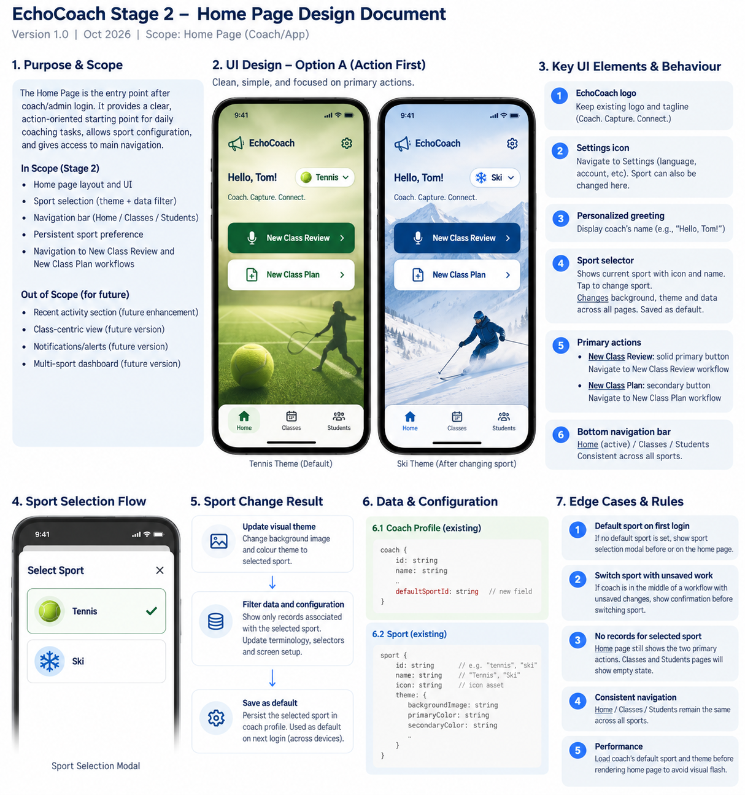

11. Open items before coding
- Confirm actual route names and whether Class Plan currently has an entry screen.
- Confirm existing Coach and Sport entity field names and available sport assets.
- Confirm whether the coach/admin roles share the same landing screen and sport permissions.
- Approve the proposed first-login sport fallback and failure handling.

