EchoCoach Stage 2 — Settings Module
Functional/UI Specification (Approved v1.0)
Updated: 2026-10-27

1. Scope
This document defines the approved Settings module for EchoCoach Stage 2. It covers the Settings entry point from Home, Settings landing pages for Coach and Admin, My Profile, App Preferences, App Info, and Log Out. It does not fully design Account Management, Student Initialization, or Class Initialization workflows; those remain separate admin-only workflows.

2. Approved visual
SET-01 — Settings Module Visual
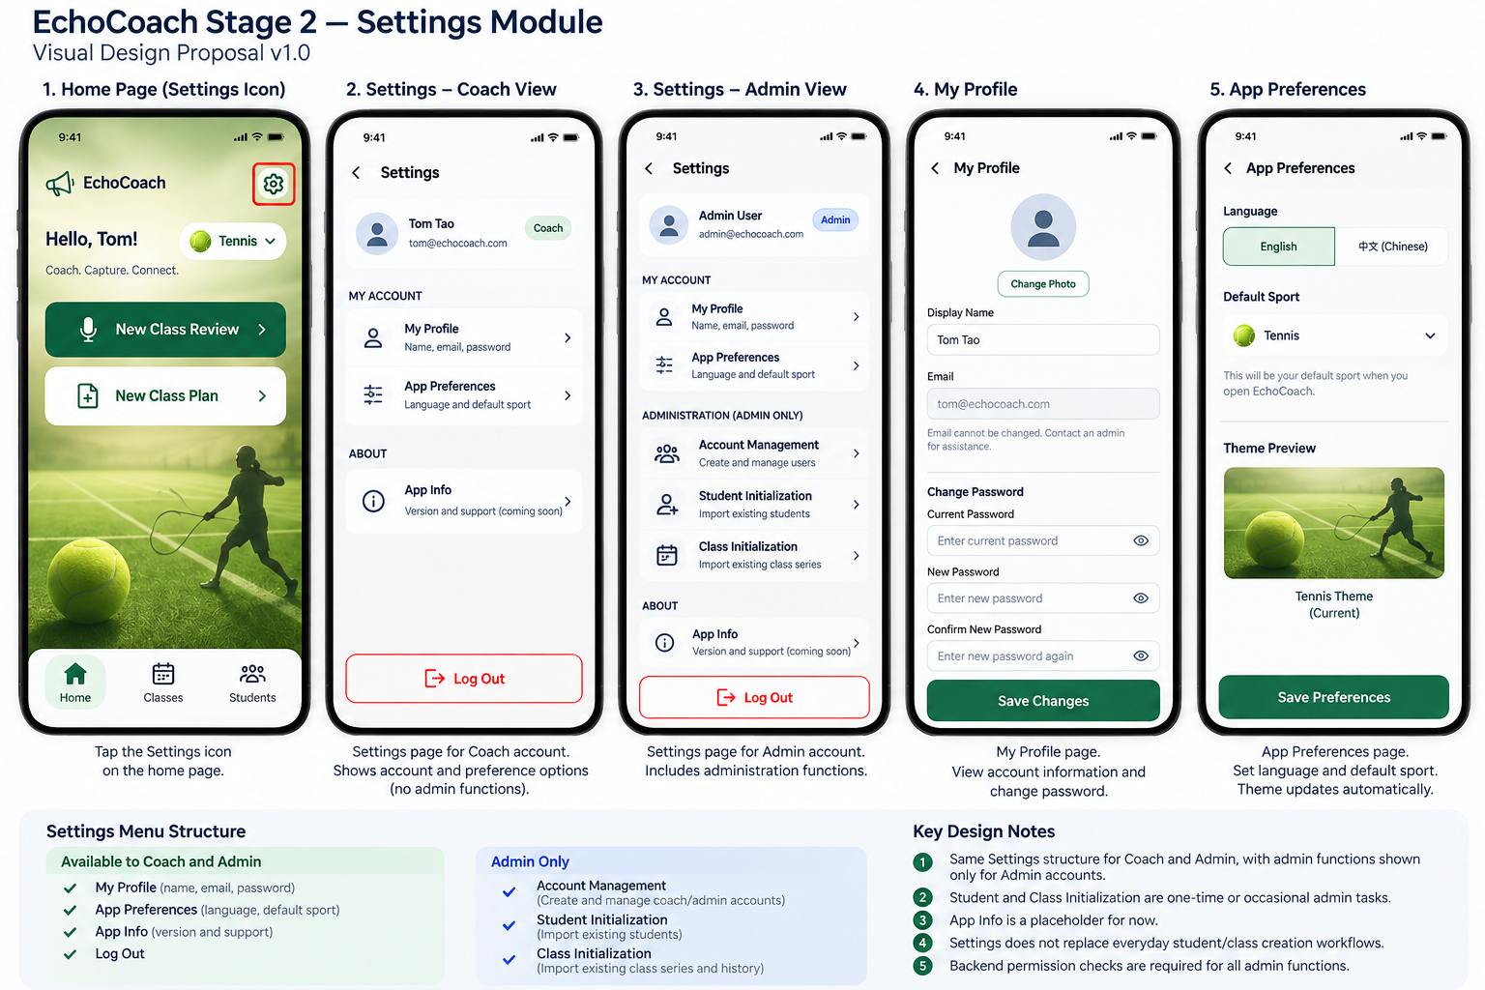
SET-01_Settings-Module_Approved_v1.png

3. Navigation entry
- A Settings icon appears on the top-right of the Home Page.
- Tapping the icon opens the Settings landing page.
- Users return to Home by standard back navigation.

4. Settings landing
Shared sections available to Coach and Admin:
- My Profile
- App Preferences
- App Info
- Log Out
Admin-only section:
- Account Management
- Student Initialization
- Class Initialization

5. Screen requirements
5.1 Settings — Coach view
- Show signed-in user summary at top.
- Show My Profile and App Preferences under My Account.
- Show App Info under About.
- Show Log Out action at bottom.
- Do not show admin-only options.
5.2 Settings — Admin view
- Use the same overall structure as Coach view.
- Additionally show Administration section with Account Management, Student Initialization, and Class Initialization.
- Backend permissions must also enforce admin access.
5.3 My Profile
- Allow editing of display name.
- Allow change of password.
- Show email as read-only for Stage 2.
- Save Changes persists updates and returns success feedback.
5.4 App Preferences
- Allow language selection: English / 中文.
- Allow default sport selection: Tennis / Ski.
- Saved default sport persists across sessions and devices, consistent with the sport preference requirement.
- Preference changes must not discard unsaved work in other flows.
5.5 App Info
- Keep as a lightweight placeholder for now.
- Future content may include app version, support, privacy, and release notes.
5.6 Log Out
- Selecting Log Out prompts for confirmation or executes a standard sign-out pattern.
- Log Out ends the authenticated session and returns the user to the Login page.
- Saved preferences remain stored.

6. Access and permissions
- Coach: My Profile, App Preferences, App Info, Log Out.
- Admin: all Coach functions plus Account Management, Student Initialization, and Class Initialization.
- Student/Class Initialization and Account Management are admin-only in Stage 2. Potential coach self-service is future work.

7. Acceptance checks
- Coach does not see admin-only entries.
- Admin sees all approved entries.
- Profile changes save successfully.
- Language and default sport preferences save successfully.
- Log Out returns user to Login page.
- Unauthorized users cannot open admin-only screens by deep link or direct URL.

8. Out of scope
- Detailed Account Management workflow.
- Detailed Student Initialization workflow.
- Detailed Class Initialization workflow.
- Billing, notifications, and advanced support features.

