EchoCoach Stage 2
Student Workflow — Functional & UI Specification
Version 1.0 | 2026-10-27 | Functional/UI approved; implementation pending

1. Purpose and scope
One unified coach-facing Students workflow covering the sport-filtered roster; creation and management of a student; the learning profile (goals, milestones, capability ratings); and context-preserving access to existing review history and media gallery. Tennis and Ski use the same workflow with sport-configured content. This is a functional/UI design approval, not a record of completed schema migration or code deployment.

2. Entry, scope, and navigation
- Bottom navigation: Home / Classes / Students. Selecting Students opens the list for the coach’s active sport, inherited from the homepage persistent sport preference.
- Tennis mode never displays a Ski milestone, Ski capability, or Ski-specific student-only record; Ski mode likewise filters to Ski. Student identity may span sports, but each sport has its own StudentSport association and learning profile.
- Show both active and inactive students together, sorted active first. Search matches students within the current sport. Display sport-specific status label on each card.
- From a student card, Edit, Class Review History, Gallery and Learning Profile are direct actions. Maintain current student and sport context on drill-down and Back.

3. Students roster (STU-01)
Element | Approved behavior
Header | Coach greeting, active-student count and active-Class-Series count for chosen sport; selected sport visible in page chrome.
Student card | Student name and stable ID, sport-specific Active/Inactive status, descriptive Active Class Series, Next Milestone, Total Classes Taken.
Active Class Series | Show descriptive name, e.g., Harper & Andrew · 1:2 · Weekly Thursday class. If no active series, show None. Multiple series need compact readable overflow.
Actions | Edit, Class Review History, Gallery, Learning Profile — visible without overflow menu.
Counts | Total classes = student attended classes for current sport, respecting authoritative Stage 1 baseline and Stage 2 participation; not count of Class Reviews.
Visual correction | In Tennis screen, Lucas next milestone is tennis-related, not a Ski Level.

4. Add New Student (STU-02)
- Required: student name. Optional: date of birth (date picker), photo and general notes. No learning goal or capability fields on the creation screen.
- Student ID is a stable system identifier; final UI treatment of manual ID entry vs auto-generation needs technical reconciliation. Never use a manually editable internal database ID.
- Student status is associated with the selected sport, default Active in the new-student flow.
- When an existing person is enrolled in another sport, reuse the common Student identity instead of creating a duplicate, and create/access a sport-specific StudentSport and learning profile.
- Creation of a Class Series is optional. Offer Save Student and Save & Create Class Series; the latter enters the already-approved Class Series creation workflow with the new student preselected.
- On successful creation, show Student Added confirmation with View Student Profile, Create Another Student, and What’s Next quick links to goals/milestones, capability profile, and class planning.
- Creation of a Class Series must not itself create class sessions, plans, or reviews.

5. Edit / manage student (STU-03)
- Edit name, photo, date of birth and notes. Student ID is read-only. A coach may change sport-specific Active/Inactive status, subject to deactivation safeguards.
- View linked Class Series directly from student edit. Active 1:1 deactivation automatically deactivates its Class Series while preserving all historical records; reactivation remains possible.
- For group 1:2–1:4 Class Series, warn and require safeguards; never silently change identity-defining membership or damage other students’ sessions/reviews/media. Precise group mutation sequence remains for implementation review.
- Delete Student is distinct and destructive: show explicit warning and confirmation. Product intent is removal of the target student’s records, with group-shared data protected and multisport identity/dependency semantics resolved before coding.
- Export student data (history, reviews, photos/videos) before deletion is a deferred future feature, not a current Stage 2 deliverable.

6. Class Series integration and naming
- ClassSeries business identity is coach + sport + normalized student set; changing the student set creates another series, not an edit of membership.
- Class ratio 1:1 through 1:4 is derived from ClassSeriesStudent membership count, not persisted as a separate classType field.
- The auto-generated Class Series display name includes the derived ratio, e.g., Harper & Andrew · 1:2 · Weekly Thursday. Coach may finalize a custom name; the UI should keep the derived ratio visible in series naming/display to avoid ambiguity.
- Reuse the approved Classes & History Class Series creation/edit form. Recurring slots, location and schedule are governed by that upstream design.

7. Student Learning Profile (LP-01 Tennis, LP-02 Ski)
- Student header shows name, stable ID, status, active sport and calculated age when optional dateOfBirth exists; do not persist age separately.
- Learning Goals & Milestones shows long-term goal, current milestone, next milestone, achieved milestone list with dates and Edit / Pathway Reference actions.
- Capability Assessment shows latest 1–5 coach ratings for the current sport; omitted ratings remain unrated, not zero.
- Class & Learning Context shows total attended classes, first-known class date, most recent class date, latest available review, and buttons to Review History and Gallery.
- Stage 1 history may be incomplete: do not fabricate first dates, reviews, or a fully enumerated attendance history from a cutover baseline.

8. Edit goals and milestones (LP-03)
- Coach may edit long-term learning goal, current milestone and next milestone as free text independently of any Class Review.
- Achieved milestones are saved as separate LearningMilestone records with achievedDate. Add Achieved Milestone asks milestone name and date; achievements remain historically visible.
- Pathway Reference opens a separate read-only static page, not a controlled milestone selector. Coach may reference it or choose customized milestones.
- Tennis reference: the supplied Tennis for Life pathway chart. Ski reference: static Glen Eden Levels 0–8 information; brief level summaries may be refined later.
- Coach edits are authoritative: references and age do not auto-certify or determine a student’s skill level.

9. Edit capability assessment (LP-04)
Tennis (7) | Ski (6)
Forehand | Control
Backhand | Turning
Serve | Balance
Volley | Edges
Agility | Movement
Eye-hand Coordination | Terrain & Independence
Stamina | —

- Each sport dimension supports optional rating 1–5. Display latest value; coach can directly update each value and Save or Cancel.
- CapabilityRating is keyed by learningProfileId + capabilityKey and upserted; the data model retains current ratings only, with updatedAt. Do not create an assessment-history collection.
- No editable Assessment Date or freeform capability-notes field in the final functional specification (earlier illustrative mockup fields are superseded). A read-only Last Updated label may be shown.
- Common rating labels: 1 Introduced, 2 Developing, 3 Functional, 4 Consistent, 5 Advanced/Independent.

10. Student Review History and Gallery integration
- Reuse approved Classes & History Review History (CH-10) and Gallery (CH-12) rather than implementing separate student-specific screens.
- Entering from a student automatically applies student ID and current sport; Class Series and Session filters only offer relevant records of that student.
- Review list is most recent first and includes actual per-student Class Reviews; a logged attendance without Review does not create a review card.
- Gallery supports student-associated media, including assets tagged to multiple students. Preserve selected student/series/session filters on open and Back.
- Do not treat attendance counts as review counts; partial Stage 1 migration baseline may be larger than saved reviews.

11. Data model and safeguards
Area | Approved direction | Implementation status
StudentSport.status | Sport-specific active/inactive status. | Schema migration and global Student.status reconciliation needed.
Student.dateOfBirth | Optional; age derived. | Schema and UI input validation needed.
Class ratio | Derived from ClassSeriesStudent count; reflected in display name. | Naming and member-count consistency logic needed.
LearningMilestone | Historical achievedDate preserved. | Retain current model.
CapabilityRating | Only latest rating, no history. | Retain current model.
1:1 deactivation | Automatically inactivate linked active 1:1 series. | Transactional safeguard needed.
Group delete/deactivate | Protect other students’ shared records. | Exact mutation/retention and multi-sport deletion rules unresolved.
History/gallery context | Reuse existing student+sport-filtered views. | Query/index and navigation integration needed.

12. Acceptance checklist
☐ Tennis mode shows only Tennis students and tennis milestones; Ski mode shows only Ski records.
☐ Active and inactive are on one roster, with active first and direct per-student actions.
☐ DOB optional; age correct as of viewing date and omitted when DOB blank.
☐ Create student without Class Series; optional Create Series handoff preselects student.
☐ Derived class ratio is visible in Class Series name/display, including 1:2 group case.
☐ 1:1 student deactivation deactivates linked series without deleting history.
☐ Group deletions cannot erase another student’s shared review/media/session data.
☐ Milestone achievements retain dates; capability re-rating overwrites current score only.
☐ Student-originated History/Gallery remain context-filtered when navigating Back.

13. Visual design register
The following source images are included at full resolution in the Visuals folder. Illustrative data is not production data. Superseded controls in visual mockups yield to the approved functional rules above.

Students Page — corrected single-sport Tennis illustration
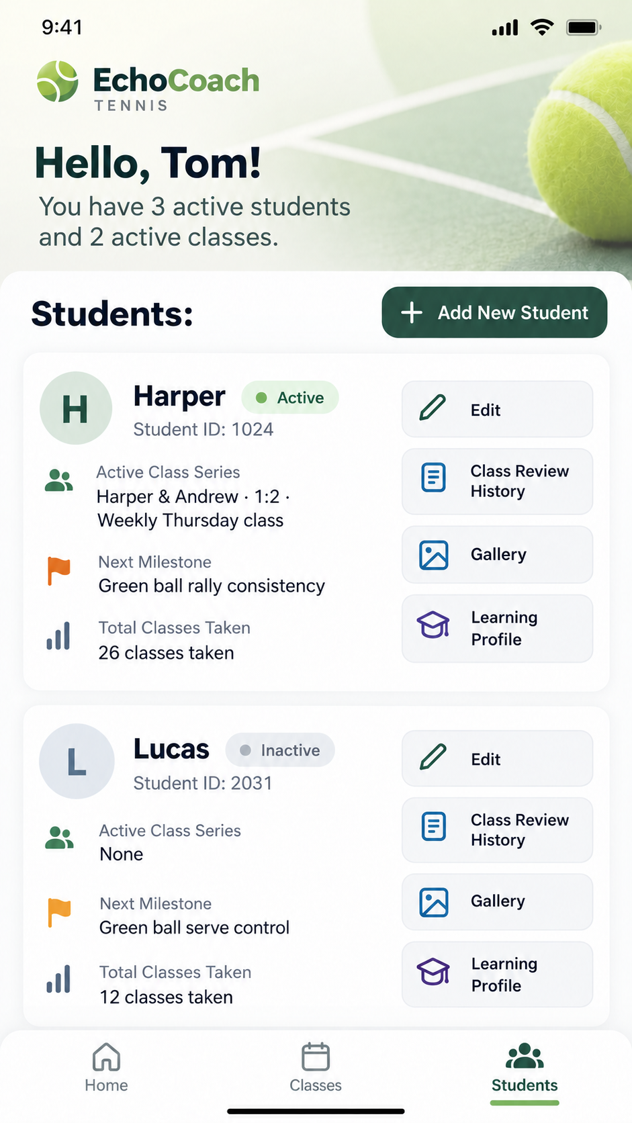
STU-01_Students-Page_Tennis_Approved_v2.png

Student creation and optional Class Series transition
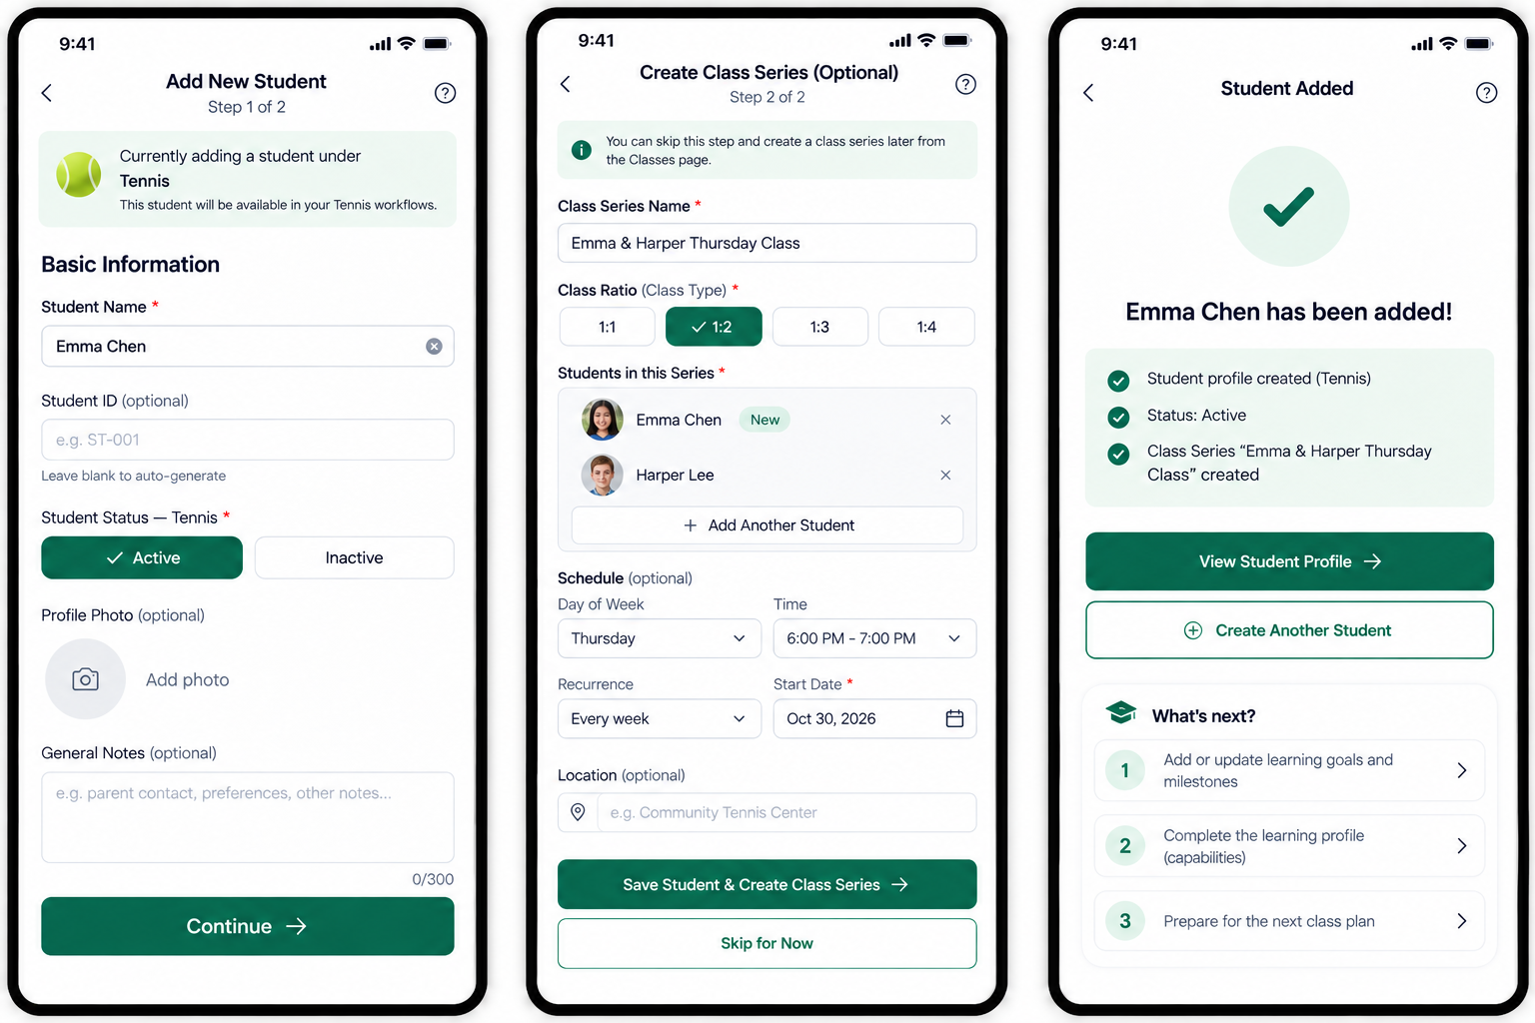
STU-02_Add-New-Student_Tennis_Approved_v1.png

Edit/deactivate/delete screens
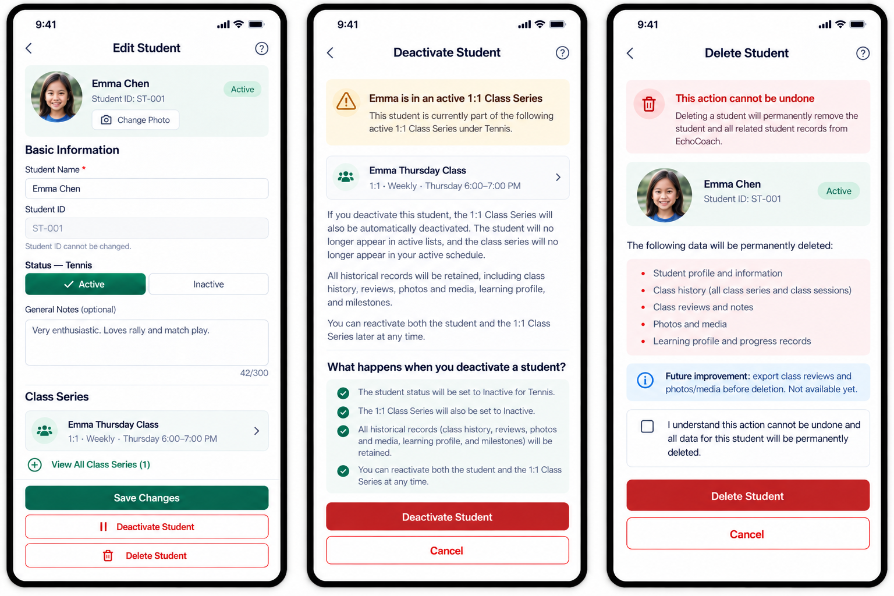
STU-03_Edit-Manage-Student_Tennis_Approved_v1.png

Tennis Learning Profile
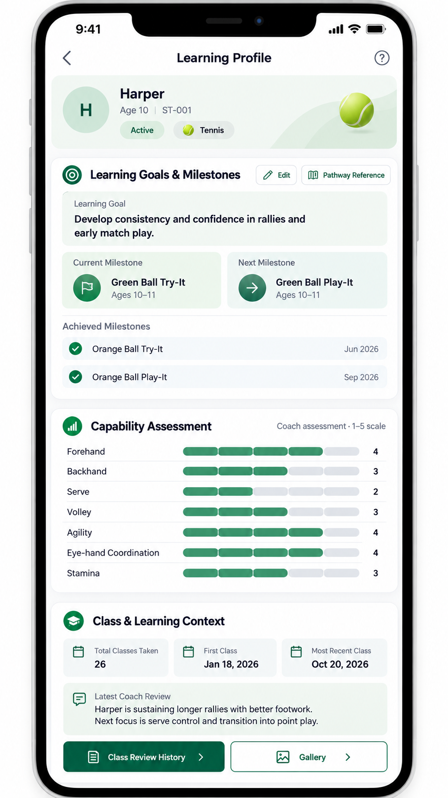
LP-01_Learning-Profile_Tennis_Approved_v1.png

Ski Learning Profile
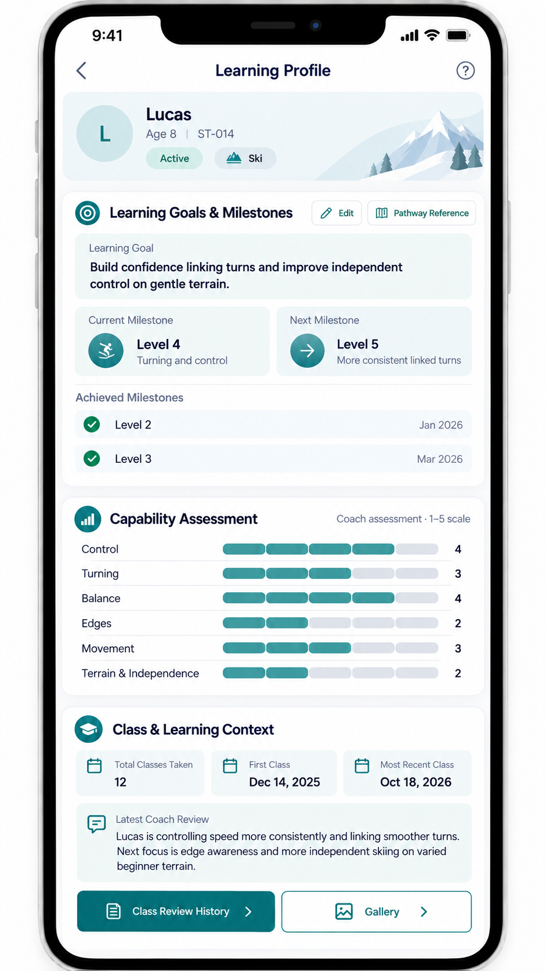
LP-02_Learning-Profile_Ski_Approved_v1.png

Goal and achieved milestone editing
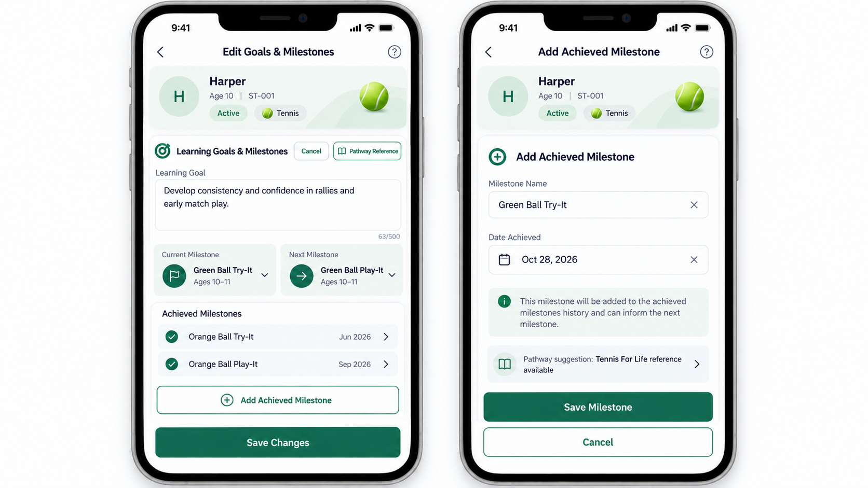
LP-03_Edit-Goals-and-Achieved-Milestones_Tennis_Approved_v1.png

Tennis and Ski capability editing
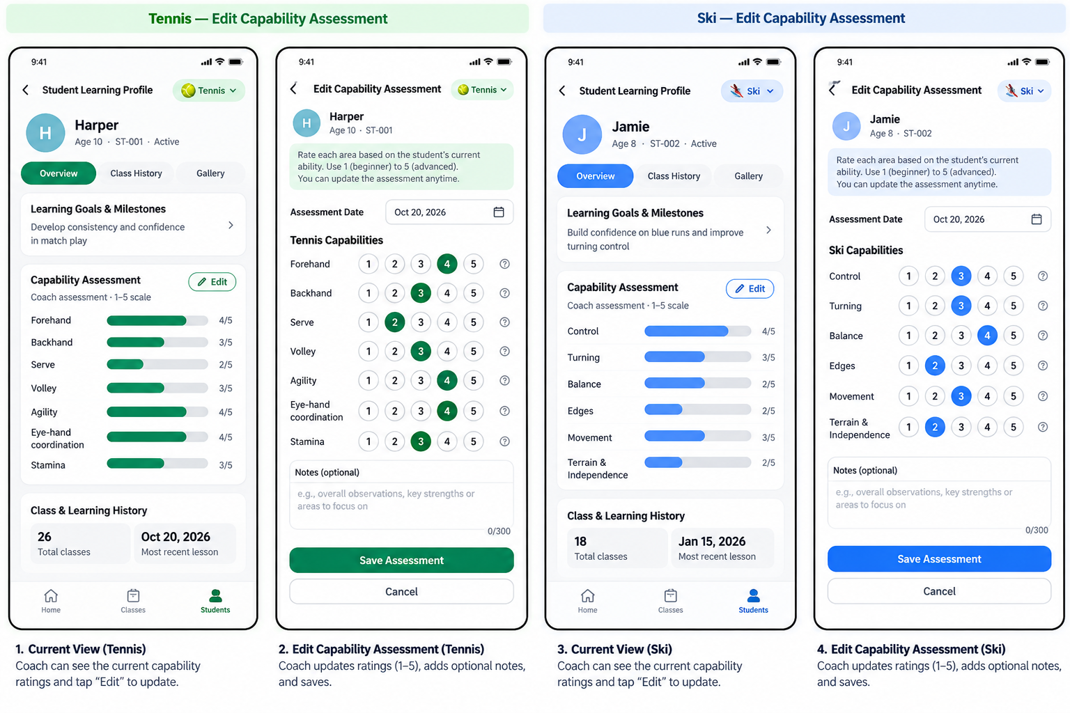
LP-04_Edit-Capability-Assessment_Approved_v1.png

