Development of the Qadam Platform for Business Task Formulation Using Artificial Intelligence
Pre-defense preparation report
Team members
- Bekasyl Zhaksylyk
- Mereke Myrzakhan
- Amantai Zere
Supervisor — Altynbek Seitenov
Diploma repository — https://github.com/bekasyl00/Qadam_Diplom
This report presents Qadam, its research basis, requirements, architecture, implementation and planned evaluation of AI-assisted business task formulation. Experiments and user interviews are planned; their results are not claimed here.
Astana, 2026

1 Project proposal

Problem and intended users
An initial business request often states a desired solution without making the inputs, constraints, expected deliverable, and acceptance conditions explicit. A student team then has to reconstruct what the customer means before it can estimate or implement the task. Qadam addresses this handover between a business representative and a student team. The frequency and severity of this problem in the intended local user population remain hypotheses to be checked through interviews.
The primary user is a business representative who owns a task and can confirm its facts. The second user is a student team that evaluates published tasks and proposes a solution. An educational coordinator is a research stakeholder; a dedicated coordinator account is outside the current prototype.

Aim and research question
The aim is to develop and evaluate a web platform that helps a business representative turn an informal request into a structured, reviewable task brief through AI-assisted clarification and explicit human confirmation.
Research question: compared with manually completing the same structured template, does AI-assisted clarification reduce task-formulation time and improve independently assessed brief quality without increasing unsupported information?

Objectives and expected outcomes
1. Elicit requirements from 3–5 representatives or document substantive agreement with an actual client.
2. Critically compare research, existing systems, and technology alternatives.
3. Specify and implement a traceable flow from description and clarification answers to a confirmed task snapshot.
4. Support publication, team proposals, human selection, and confirmation of one delivered milestone.
5. Evaluate the assisted flow against a manual baseline, documenting quality, time, usability, and failure cases.
Expected deliverables are the requirements and design package, a reproducible local prototype, automated checks, an anonymized evaluation dataset where consent permits, and an analysis of results. Improvement is an intended outcome, not an already demonstrated result.

Scope and engineering complexity
Included: text and optional recorded voice input; contextual questions; a 16-field brief; source-linked suggestions; deterministic completeness scoring; versioned drafts and public confirmed snapshots; proposals and milestone confirmation. Complexity lies in keeping generated suggestions, user edits, confirmation state, access rules, and persistent data consistent across the browser, API, database, and external AI service.
Excluded: payments, automatic team selection, business-data processing, continuous voice calls, model training, and full project management. Production authentication is a prerequisite for public real-user deployment, not a completed feature of the demo-role prototype.

2 Evidence of relevance

What is known and what still needs evidence
The prototype demonstrates technical feasibility; research identifies opportunities and limits of language-model assistance [1–4]. Neither establishes local user demand. Synthetic tasks are test inputs. No discussions or client agreement have been supplied; fieldwork is pending.
Hypothesis | Evidence to collect | Requirement affected
Business representatives omit acceptance conditions | A recent real task, its first brief, and an explanation of later clarifications | Clarification and brief review
Student teams cannot judge feasibility from initial briefs | Examples of questions asked before accepting a project | Catalog and proposals
Reviewing suggestions is easier than filling a blank form | Observed manual and assisted formulation, including corrections | Editable suggestions and usability
Voice is useful in this context | Optional trial and participant preference, including privacy concerns | Voice input
A completeness indicator aids decisions | Explanation of what users think the score means and observed misuse | Score explanation

Planned discussions
Recruit two business representatives, two student-team representatives, and one educational coordinator. Confirm recruitment arrangements by 21 October and target the initial discussions before 24 October; report any outstanding fieldwork explicitly. If only three discussions are possible, include both primary user groups and state the limitation. Record role, date, consent, process example, observations, and implications using EVIDENCE_FORMS.md. Avoid unnecessary personal or confidential data.
Use a 20–30 minute semi-structured discussion: ask about the last concrete task; what information was absent; how requirements were clarified; what counts as acceptance; who may approve changes; and what information may be sent to an external AI provider. Show the prototype only after discussing the current process to reduce leading responses.

Analysis and decision rules
Keep a separate record for each discussion and distinguish verbatim statements from researcher interpretation. Group observations by missing information, coordination, trust, and constraints. Link each retained finding to a named requirement or a scope decision. Preserve contradictory cases rather than reporting only positive reactions.
If participants do not identify formulation as a substantial difficulty, revise the problem statement and intended workflow. If voice has low value or is unacceptable for privacy reasons, retain text as the primary path. If the score is mistaken for guaranteed project success, change its explanation before a usability evaluation.

3 Critical literature review

Review scope and evidence
The focused review asks which established findings support assisted clarification, what remains untested, and which design choices follow. It is not an exhaustive systematic review. Eight scientific publications cover requirements engineering, unsupported generation, human control, and speech input. Product documentation supports the separate comparison in Section 4.
For this revision, the full texts of the four central requirements-engineering publications were consulted, including their methods and limitations. The supporting publications retain the narrower reading basis stated below. This document is a reading synthesis, not evidence that each team member has personally studied every publication. Before the presentation, each member will explain the method, limitation, and Qadam implication of the papers relevant to their work.

What previous studies have achieved
Norheim and colleagues [1] examine applications of language models across requirements-engineering tasks. Their analysis identifies requirements-specific data limitations, inconsistent annotation, and inadequately defined use cases. This is a critical review rather than a controlled user study, and the authors acknowledge that it is not systematic. Qadam therefore targets a specific handover problem and evaluates observable user outcomes rather than assuming that a stronger model automatically produces a useful engineering tool.
Hemmat and colleagues [2] synthesize 29 studies and organize applications, methods, evaluation practices, and open challenges. The review reports promising generation and validation work while retaining concerns about hallucination, output verification, and data quality. Heterogeneous studies do not establish an effect size for business-to-student task formulation. Qadam consequently fixes the task template and provider configuration during evaluation and records both successful and failed attempts.
Luitel and colleagues [4] use BERT masked predictions and learned filtering to suggest terminology missing from requirements. Their evaluation simulates incompleteness by withholding existing content; the authors identify the absence of domain-expert identification of genuine omissions as a limitation. Terminology recovery is different from producing a correct business brief. Qadam uses contextual questions and a reviewable form, then measures brief quality and unsupported facts with people rather than equating field coverage with correctness.
Ebrahim and colleagues [3] propose a conceptual framework involving smaller models, knowledge augmentation, and prompting guidance. Section 5 explicitly states that the framework has no practical implementation proving the concept. Its contribution is a structured research direction, not demonstrated end-to-end effectiveness. Qadam adopts explicit context and output validation while testing a narrower implemented workflow. It does not claim to implement that paper's retrieval or model-orchestration architecture.

3 Research gap and design response

Gap addressed by this project
The reviewed work supports assistance with requirements but does not establish whether Qadam's complete workflow helps a business representative prepare a useful brief for a student team. The unresolved question is whether contextual clarification plus source review and explicit confirmation improves the final brief enough to justify generation and correction time. This is a bounded application and evaluation gap, not a claim that no other system uses AI for requirements.
Qadam's proposed contribution is a reproducible implementation and a comparison with manual completion of the same form. Its distinctive combination is a student-project handover, editable suggestions linked to supplied input, a confirmed public snapshot, and human team selection. Section 4 documents overlap with existing products; novelty is not claimed for AI brief drafting alone.
Finding or limitation | Qadam response | Evidence to collect
General language performance does not prove workflow value [1–2] | Bound the task to formulation of a business brief | Paired manual and assisted attempts
Detecting missing content does not establish factual correctness [4] | Ask for missing facts and retain an editable review stage | Independent brief rubric and unsupported-fact counts
A conceptual framework still needs empirical validation [3] | Evaluate the running Vue and Go workflow | Reproducible protocol, outputs, times and failures
Fluent output may be unsupported [5–6] | Check source references and require owner confirmation | Raw, filtered and final statements assessed separately

Limits of the safeguards
A matching source quote establishes textual provenance, not semantic truth. A quote may be irrelevant, misinterpreted, negated, or itself incorrect. Evaluate wrong field assignments, negation, units, and invented values. Human confirmation records a review decision; it is not independent proof of accuracy.
The 0–100 score is a fixed-weight completeness heuristic. Two briefs with the same score can differ in clarity and feasibility. Keep the score visible in both study conditions but exclude it from the independent quality outcome. Report time savings and quality changes separately, including contradictory results.

3 Publication analysis and reading preparation
Publication and reading basis | Relevant contribution and boundary | Qadam implication
[1] Norheim et al.; full text | Critical review identifies requirements data and use-case limitations; not a controlled user trial. | Define a specific workflow and test with users.
[2] Hemmat et al.; full text | Synthesis of 29 studies; heterogeneous tasks limit transfer of results. | Fix conditions and include failed attempts.
[3] Ebrahim et al.; full text | Conceptual framework without implemented validation. | Treat architecture ideas as hypotheses to test.
[4] Luitel et al.; full text | Missing terminology is simulated by withholding content. | Evaluate genuine task clarity and factual support.
[5] Ji et al.; survey abstract and manuscript overview | Organizes hallucination mechanisms and evaluation approaches; no generic mitigation certifies a specific application. | Count unsupported factual statements and investigate false acceptances.
[6] Lin et al.; proceedings abstract | TruthfulQA evaluates falsehoods reproduced by language models; its benchmark is not business-task elicitation. | Use task-specific cases and never present benchmark results as Qadam results.
[7] Radford et al.; proceedings abstract and metadata | Describes multilingual speech recognition with weak supervision; aggregate results do not guarantee local recording accuracy. | Make transcripts editable and assess errors and correction effort separately.
[8] Amershi et al.; publication summary | Human–AI guidance supports clear expectations, correction, and control; adaptation still needs usability checks. | Label assistance, expose failure, permit manual work, and require explicit confirmation.

Preparation for the architecture discussion
Mereke leads AI literature and validation; Zere explains data integrity; Bekasyl explains human review and interaction. Each member should explain a relevant paper's method, finding, limitation and Qadam implication. Reading notes provide section pointers; individual reading and rehearsal remain to be completed.
Sources [1–17] are used in the research and comparison sections, including eight scientific publications [1–8]. Seven scientific publications date from 2022–2025; the 2019 human–AI interaction guidance is retained as foundational work. Source counts exclude internal project records. No external study is presented as a measured Qadam result.

4 Existing system comparison
The comparison covers four relevant systems and eight consistent criteria. It is based on official documentation reviewed on 11 October 2026, not hands-on testing of paid accounts. “Not established” means the reviewed source does not establish the capability; it does not mean that the product lacks it. Features can depend on product plan or rollout.
Criterion | Upwork Uma [9] | Fiverr briefs [10] | Riipen [11] | Jira Product Discovery [12]
Primary audience | Clients and freelancers | Clients and freelancers | Employers, educators and learners | Product teams
Work item | Job post and project assistance | Project brief and offers | Experiential learning project | Product idea and supporting insights
Brief authoring | AI-assisted job-post drafting | AI-assisted brief creation and editing | Employer project description | Structured idea records and fields
Clarification support | AI guidance described; availability varies | Brief generation and refinement described | Collaboration with educators and learners | Insights and discussion around ideas
Educational workflow | Not established | Not established | Central to the documented workflow | Not established
Source evidence in task record | Qadam-style field provenance not established | Qadam-style field provenance not established | Qadam-style field provenance not established | Insights attach evidence to ideas; a different granularity
Fixed confirmed-field 0–100 measure | Not established | Not established | Not established | Custom prioritization fields; not the same measure
Downstream coordination | Hiring and proposal assistance | Matched offers and client choice | Project collaboration and feedback | Prioritization and links to Jira delivery

Position and limits of the proposed solution
Qadam combines a business brief with student-team proposals. Its distinctive design choices within this comparison are the explicit confirmed snapshot and a transparent field-completeness calculation. Riipen is particularly relevant to the educational context; Upwork and Fiverr demonstrate that assisted brief creation itself is an existing capability. Jira Product Discovery illustrates evidence-linked decision records in another setting.
Qadam currently has a smaller scope, demo identities, synthetic examples, and no established network of clients or teams. The comparison supports a focused diploma prototype and evaluation; it does not support claims of commercial superiority. The unmet local need must still be validated through the discussions in Section 2.

5 Technology decisions
The alternatives below are design comparisons, not performance benchmark results. Choices are constrained by the existing prototype, the team's Vue and Go experience, and the need for a reproducible local demonstration.
Decision | Alternatives and trade-offs | Selected approach and requirement link
Browser application | Vue offers continuity with existing components; React would require a rewrite; Angular provides a larger prescribed structure with added migration work. | Vue 3 with TypeScript, Pinia and Router. Preserve the implemented editor, task state and proposal flow. Vue's official setup supports this build workflow [17].
API platform | Go fits both backend contributors; Node.js could share TypeScript; Python could ease some ML-library integrations but Qadam calls remote inference and does not train models. | Go and net/http [15]. Explicit handlers and tests support confirmation, milestone awards and conflict handling.
Persistent storage | PostgreSQL supports relational transactions; SQLite simplifies single-machine storage; MongoDB offers document flexibility but would change the existing relational design. | PostgreSQL for task versions, proposals and one-time awards. Atomicity and integrity support reliable saving and prevent duplicate awards [16].
Component interaction | REST maps to the existing resource operations; GraphQL adds a schema/query layer; gRPC introduces browser integration work for this UI. | REST/JSON for browser–API calls; multipart upload for audio. Clear request formats and error responses support the task workflow and AI assistance.
AI execution | Groq and OpenAI provide hosted inference; local inference removes remote dependence but competes with the app for memory and disk on the available 8 GB Mac. | Retain configurable hosted Groq/OpenAI adapters. Test provider-specific structured output and transcription rather than assuming full API equivalence [13–14].

AI configuration and boundaries
The code supports AI_PROVIDER=openai and AI_PROVIDER=groq. OpenAI defaults are gpt-4.1-mini and gpt-4o-mini-transcribe. Groq defaults are openai/gpt-oss-20b and whisper-large-v3-turbo. These are code defaults, not a claim that credentials, model access, or quota are currently available. Actual study runs must record the configured provider and model.
The system uses prompts, structured responses, validation, and human review. Fine-tuning is not implemented and is not necessary for the current research question. A rules-only manual form is the evaluation baseline. Free provider quotas are external constraints and cannot be treated as a permanent deployment guarantee.

6 Functional requirements
Requirements are marked Required or Recommended. “Present” means that the current prototype contains the feature; it does not mean that every acceptance check has passed. The supporting requirements checklist links each named feature to its code and planned checks.
Priority | Requirement and current status | Verifiable acceptance criterion
Required | Demo-role context; present | Guest reads published tasks. Business and team actions require the corresponding demo actor. UI identifies the demo context; it does not claim verified identity.
Required | Persist private drafts; present | Save and reload retain the owner's draft. Guest and another actor cannot read that draft through task endpoints.
Required | Contextual clarification; present | With a working live provider, a valid description returns 3–5 questions. Invalid/provider-failure responses are shown as errors rather than fabricated questions.
Required | Traceable suggestions; present | Suggested values carry a source reference. An invented quote is rejected; an accepted quote can be located in supplied input. Semantic mistakes remain reviewable.
Required | Editable brief and manual path; present | All 16 fields can be edited without successful AI inference. AI does not silently replace a confirmed snapshot.
Required | Confirmation and deterministic rating; present | The same confirmed field set always yields the same score. Editing an unconfirmed draft does not alter the published snapshot.
Required | Public catalog and details; present | Only published snapshots are public. Search/filter selection produces matching cards and an explicit empty state.
Required | Team proposal; present | A team submits the required proposal fields for a published task and can retrieve its proposal after reloading. Invalid input is rejected.
Required | Human selection; present | Only the owning business accepts or rejects proposals. Selecting one does not imply automatic AI selection or prevent multiple accepted teams.

Data requirements
The 16 fields cover context, need, data source, data format, data access, deliverable, delivery format, success metric, success target, acceptance method, deadline, constraints, users, usage scenario, contact, and feedback format. Source identifiers and quotes support review. Working revision and confirmed snapshot serve different purposes and must not be conflated.
Personal details in public task content must be supplied deliberately. Research materials should use pseudonyms and synthetic business examples unless explicit consent permits otherwise.

6 Requirements continued
Priority | Requirement and current status | Verifiable acceptance criterion
Required | Milestone and one-time award; present | A selected team's submitted milestone can be confirmed by the owner. Repeating confirmation never grants more than one 10-point award for that proposal.
Recommended | Contextual AI chat; present | Chat uses only the task context accessible to the selected actor. An inaccessible draft is not included; a failed provider request shows an actionable error.
Recommended | Voice transcription; present | A permitted recording produces editable text. UI stops at 60 seconds; backend rejects uploads above 15 MiB. Denied microphone access leaves text entry available.
Required | Revision conflict handling; present | Saving from a stale revision returns a conflict rather than silently overwriting newer content. UI informs the user and supports recovery.
Required before public deployment | Verified authentication; not implemented | Identity is verified server-side and cross-user access tests pass without trusting a client-selected actor header. This is a future deployment gate, not a checkpoint deliverable claim.

Quality | Non-functional requirement and proposed acceptance target
Performance | For non-AI endpoints, p95 response below 1 second over 200 requests at 20 concurrent clients against 1,000 synthetic tasks on a documented local setup. Record DB state and warm-up. Target is unmeasured.
Reliability | Provider timeout, quota error and malformed output leave the draft recoverable; no silent switch to invented live results. Repeat the failure cases in the test plan.
Usability | At least 80% of pilot users complete the core create–confirm–publish path without facilitator rescue. Report sample size and observed problems; do not infer population-wide success.
Explainability | UI labels the score as confirmed brief completeness and identifies AI suggestions. Pilot participants can explain the distinction from project quality.
Confidentiality | API keys stay on the server and out of repository/browser assets. AI context is access-checked. Demo actor headers are explicitly excluded from production security claims.
Reproducibility | A clean checkout can follow README setup and execute the documented checks. Record commit, versions, provider configuration without secrets, and test conditions.

7 Architecture and system context
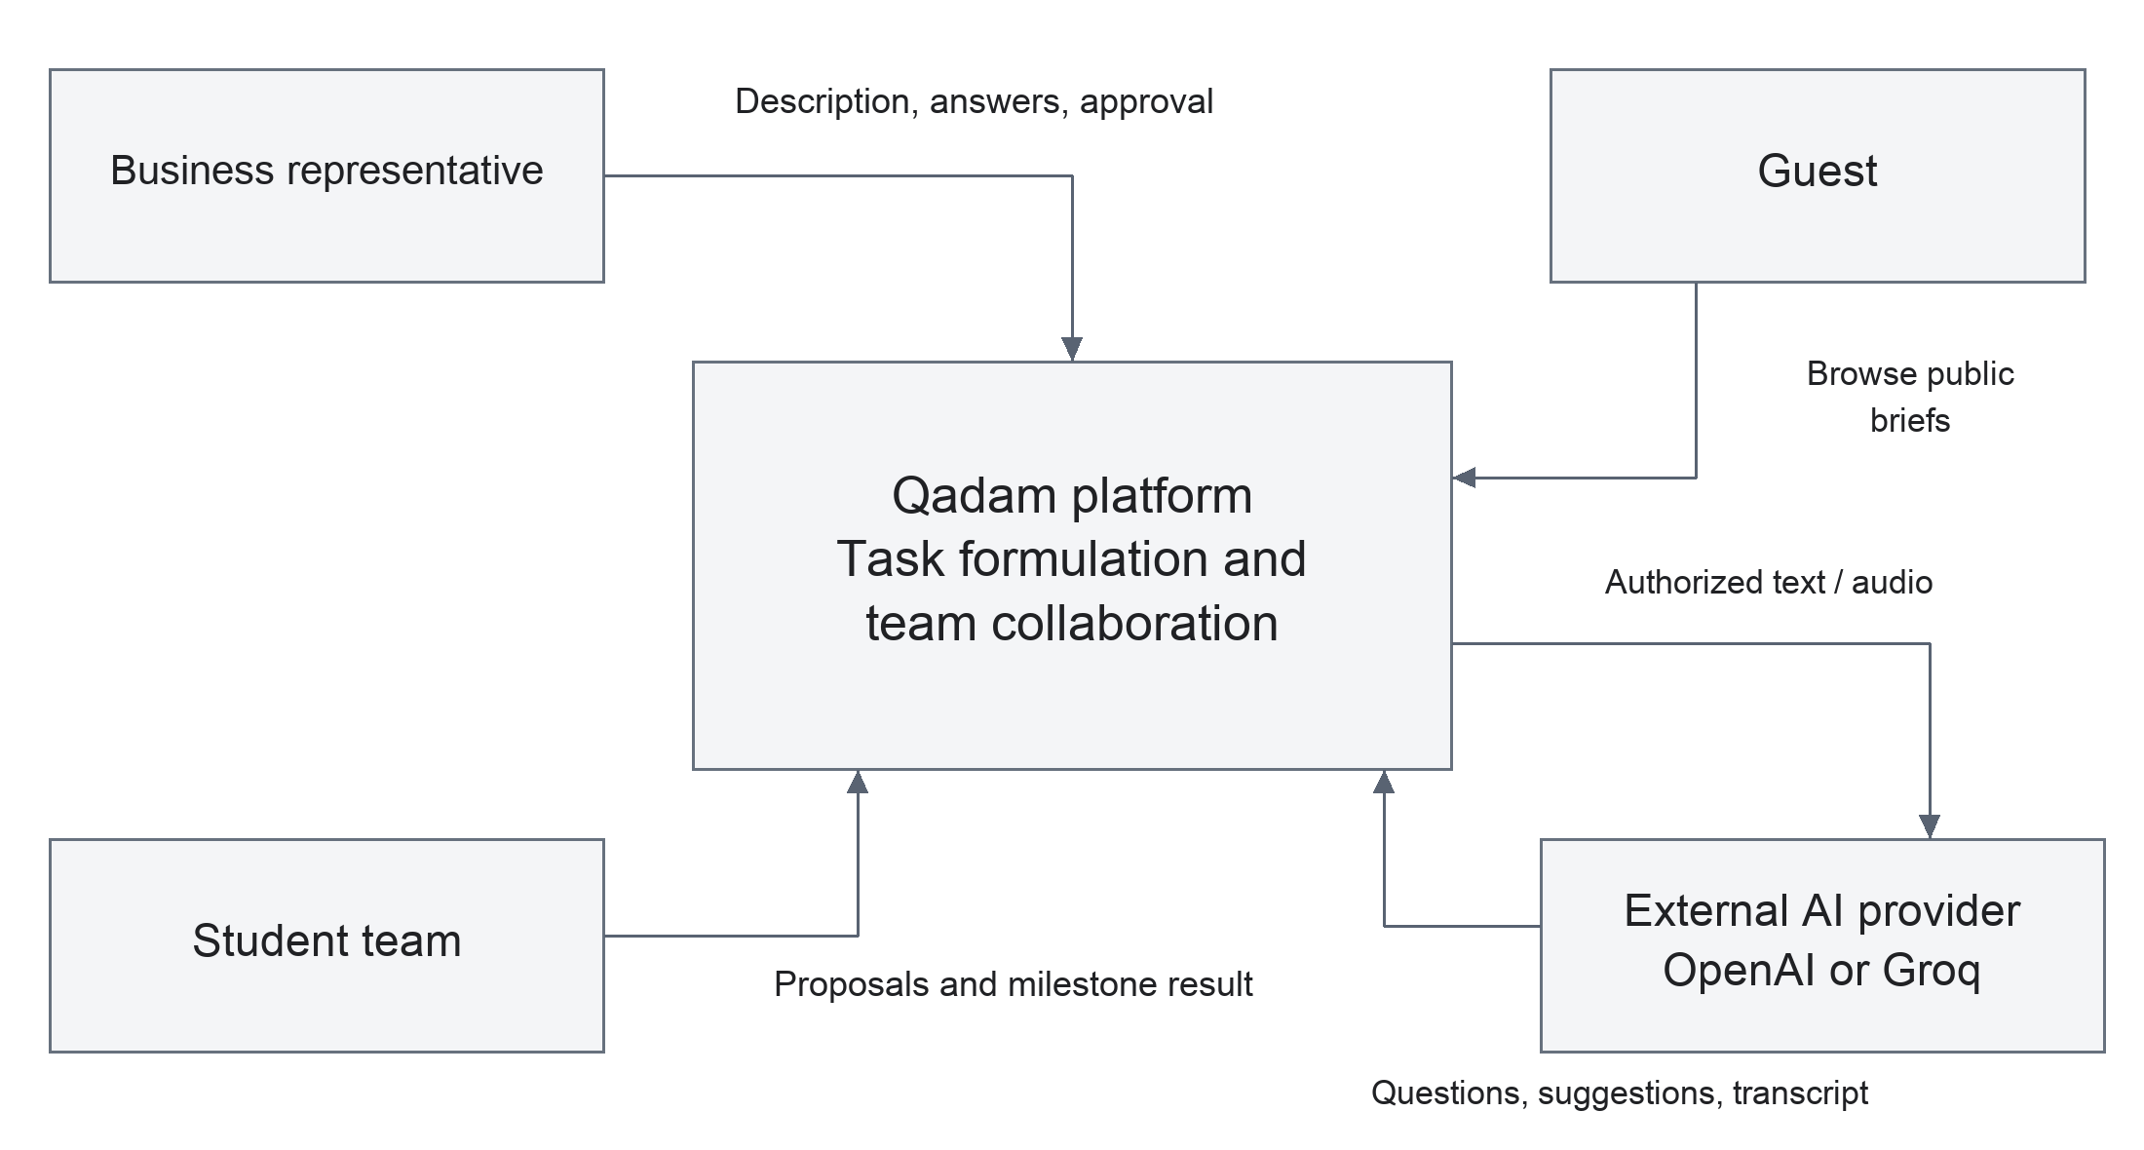
System context diagram
The context boundary is the Qadam platform. A business representative provides descriptions, answers, confirmation, and selection decisions. A student team reads published briefs, submits proposals, and supplies a milestone result. Guests browse public tasks. Qadam sends authorized text or audio to the configured AI provider and receives suggestions or transcripts. The AI provider is an external dependency, not the authority for publication or awards.
PostgreSQL is part of the implementation boundary and appears in the component diagram. GitHub and the YouTrack board support development rather than runtime task processing. No payment processor, CRM, or student-information-system integration is claimed.

Information lifecycle
1. Raw description and answers are saved as working input.
2. AI returns questions or source-linked candidate field values.
3. The business representative edits and explicitly confirms the brief.
4. The API calculates the score and persists a confirmed snapshot.
5. Publication exposes that snapshot in the catalog.
6. Team proposals and the business's decision form separate records.
7. Confirmation of one delivered milestone triggers an idempotent award.
A provider error may interrupt assistance but must not corrupt saved input. The current synchronous inference path does not provide continuous speech streaming. Audio transcription is a separate request whose text can enter the same clarification flow.

7 Use case model
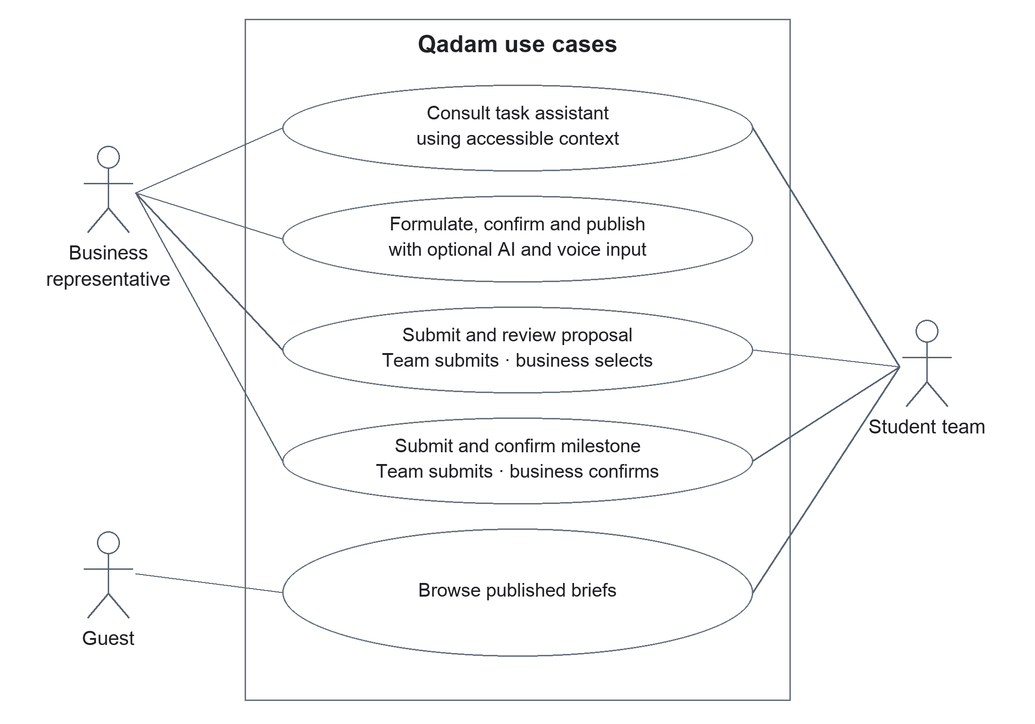
Use case diagram
The diagram groups the main user goals inside the Qadam boundary. The actors are roles in a demonstration flow; they are not evidence of production authentication. Both primary actors can consult the assistant on accessible context. Guests have the narrower public browsing use case.

Main use case
The Formulate and publish a task scenario begins with a business representative's informal description. AI assistance is optional. The owner reviews a structured draft, resolves missing information, confirms facts, and publishes the snapshot. The successful outcome is a brief that a team can inspect and discuss, not an automatically implemented business solution.
Alternative paths include manual completion when inference is unavailable, transcript correction, saving an incomplete private draft, and resolving a revision conflict. Publication is not blocked solely by a low completeness score.
The Propose and select a team scenario begins with a published task. The team supplies a plan and proposed result; the business accepts or rejects the proposal. The Confirm a milestone scenario ends with an award only after human confirmation. These use cases preserve the intended separation between AI assistance and accountable decisions.

7 Component model
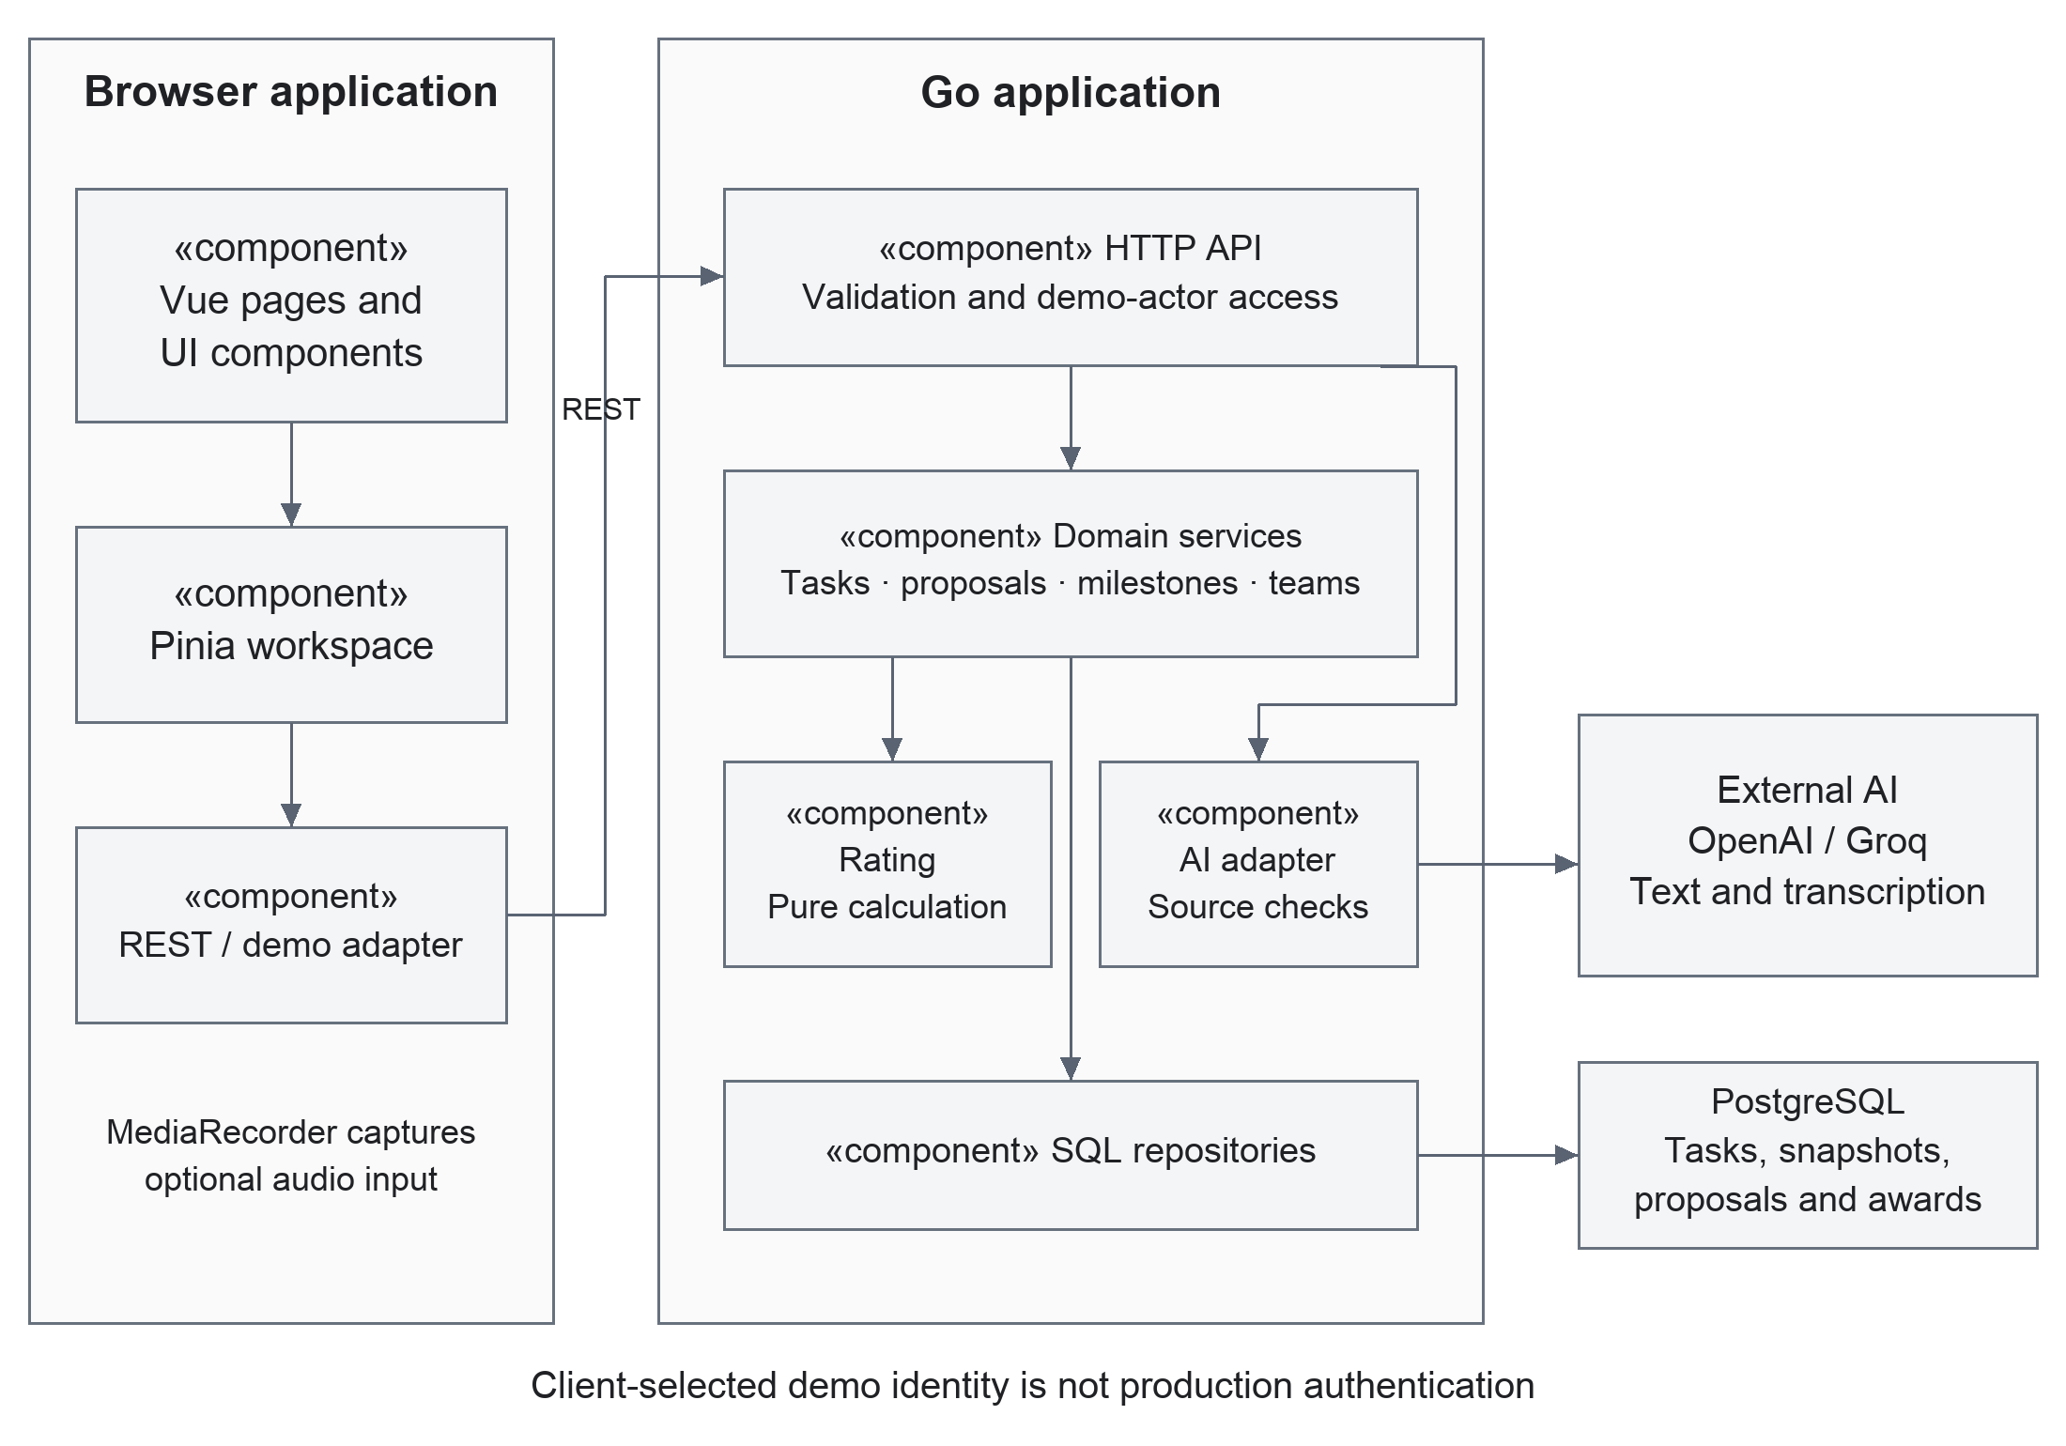
Component diagram
The Vue application contains pages, components, Pinia state, and service adapters. The HTTP adapter translates frontend models into API DTOs; an explicitly configured local demo adapter is available for isolated demonstrations. It is not an automatic substitute after a server failure.
The Go application wires HTTP routing and demo-actor resolution to task, proposal, milestone, team, rating, and AI modules. SQL migrations define PostgreSQL persistence. The rating module computes deterministic coverage; the AI module calls the configured provider and filters source references before suggestions reach the user.

Consistency and trust boundaries
Task revisions guard against stale writes. The confirmed snapshot separates public information from working edits. Database constraints and transactional operations support one-time awards. Ownership checks apply to task and proposal operations, but the demo actor can be selected by the client; those checks must not be described as secure login.
Provider outputs and uploaded audio are untrusted inputs. Model output requires structural checks and review, and generated text is not executable application logic. Keys belong in server-side environment variables. Future public deployment requires verified identity, deployment-specific access controls, and a reviewed data-retention policy.

7 Entity relationship model
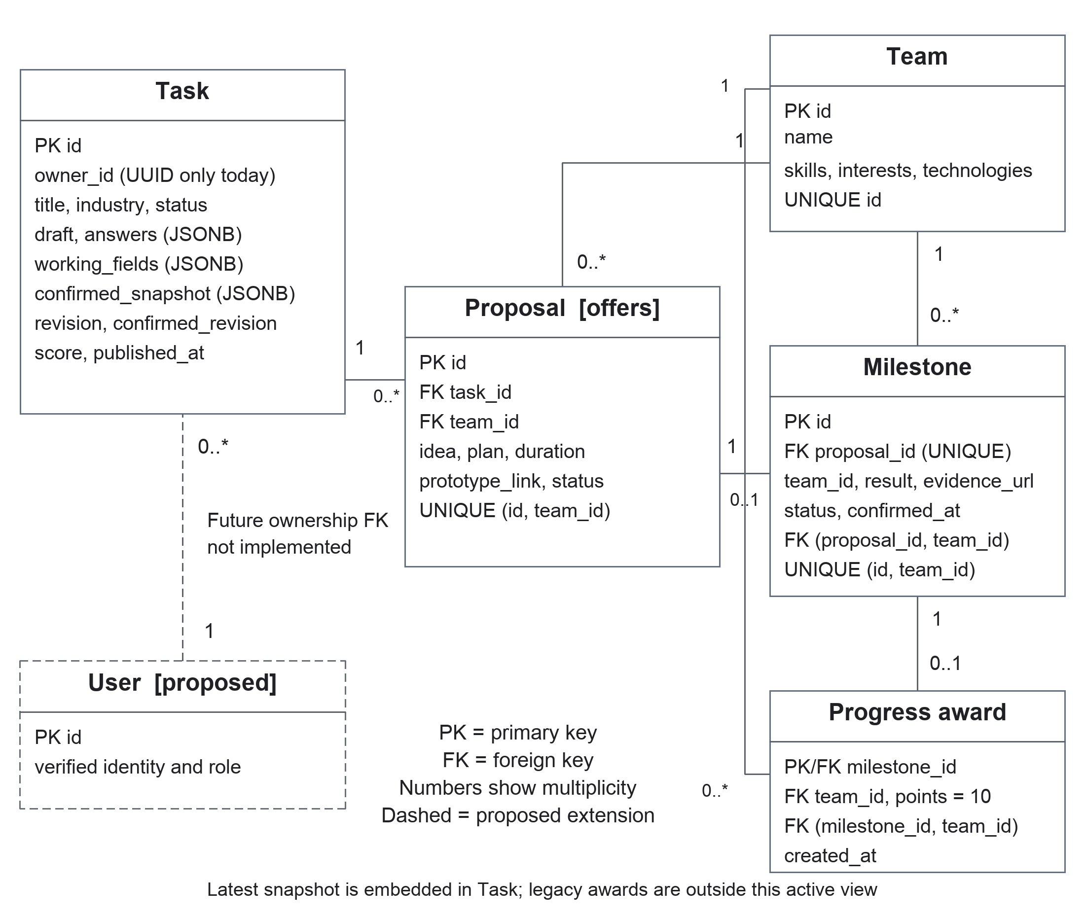
Entity relationship diagram showing current data and a proposed identity extension
The solid entities correspond to the SQL migrations. A task has many proposals; a team may submit many proposals. Each proposal has at most one milestone, enforced by a unique proposal reference. Each milestone has at most one progress award, whose milestone identifier is its primary key. Composite foreign keys keep proposal, milestone, and award team identities consistent.
Answers, working fields, and the latest confirmed snapshot are JSONB values within the task record, not separate relational tables. Revisions detect stale writes. This stores the latest confirmed state, not a complete history of every snapshot. The retained legacy point-award table is omitted from this active-workflow view because it does not contribute to displayed progress.
The dashed User entity is a proposed public-deployment extension. Currently owner_id is a UUID without a user-table foreign key, and the client chooses a demonstration actor. Verified accounts and team membership must be designed before a public deployment; the diagram does not claim that login exists.

7 Activity model
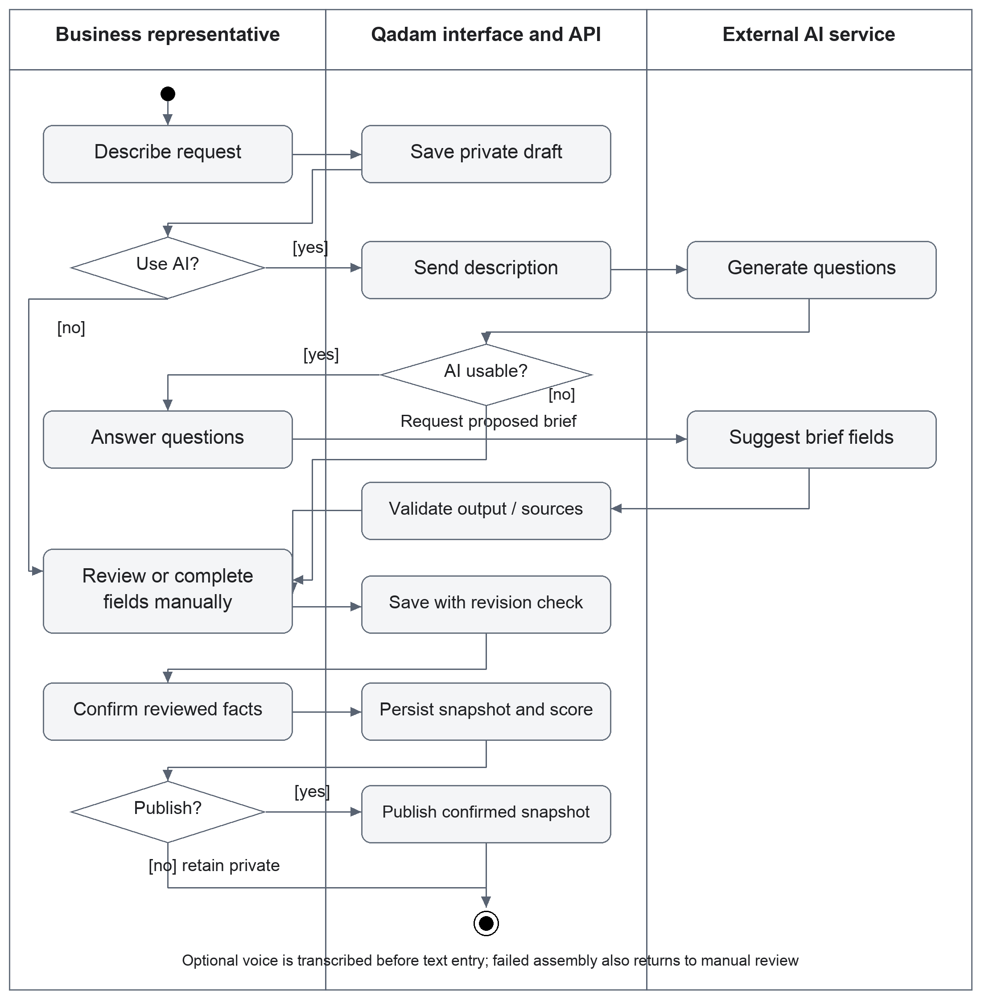
UML activity diagram from request to confirmed and published task
The activity begins with a business request. Voice transcription is optional and remains editable. The user can request AI clarification or complete the form manually. If assistance fails, the same manual path remains available. Answers lead to proposed brief fields; the business reviews and saves them before making an explicit confirmation decision.
A confirmed task may remain private or be published. Saving unconfirmed edits keeps the previous public snapshot intact. Conflict recovery returns the user to review rather than overwriting a newer revision. The flow ends with a saved confirmed task or its published snapshot; proposal selection and milestone delivery are downstream use cases.

7 Sequence model
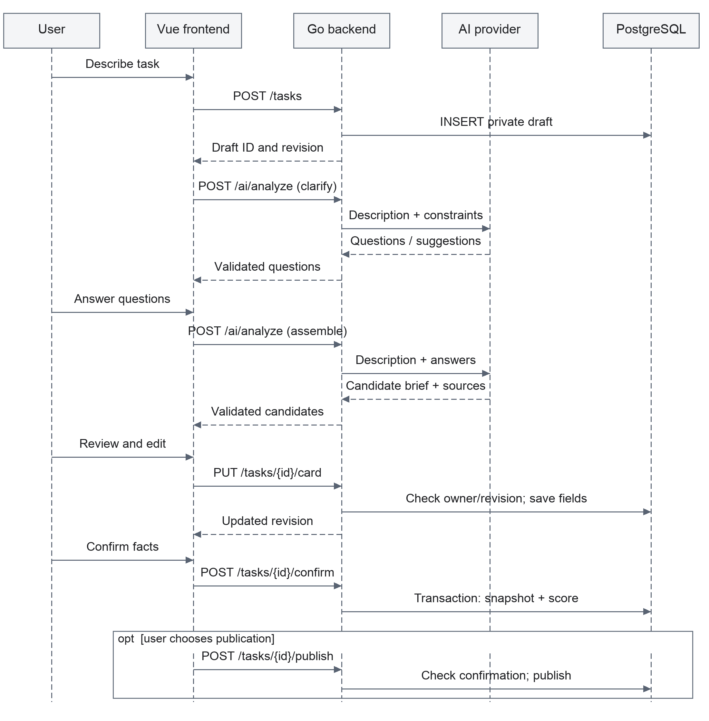
UML sequence diagram of the main formulation and confirmation flow
This sequence uses the implemented REST operations. Clarification and assembly call the same analysis endpoint with different stages. The analysis request contains the description and answers; AI output is not automatically saved as a confirmed task. The business edits and saves the working fields before confirmation.
Confirmation and publication are separate database transactions. Each checks ownership and the expected revision. The API returns a conflict for a stale revision; provider failure returns an error and leaves manual completion available. The model summarizes the successful path with an optional publication fragment. Error recovery and optional voice transcription are shown in the activity view and described in the API contracts.

8 UX and prototype
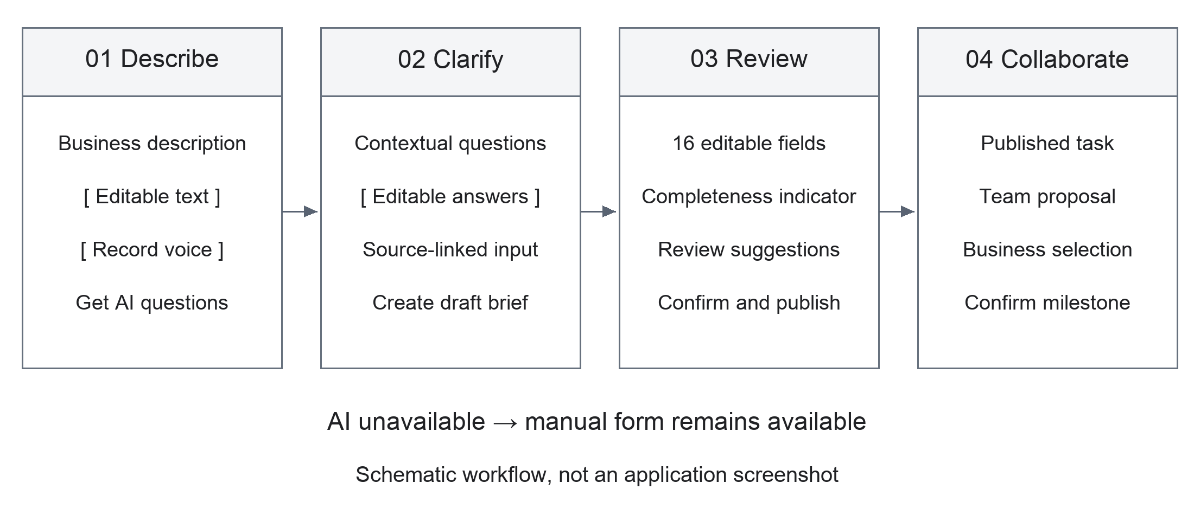
Key workflow wireframe
This figure is a schematic of the implemented flow, not a screenshot or a claim that every wording and layout detail is already identical. The runnable Vue prototype is the primary UX artifact.
User goal | Existing route | Required interaction and feedback
Explore tasks | /catalog | Browse without an account; search, filter and inspect public cards.
Choose demo context | /start | Select business or a prepared team; communicate that identities are for demonstration.
Formulate a task | /tasks/new | Description, optional recorded voice, generated questions, and editable fields.
Review the brief | /tasks/:id/edit | Distinguish working edits from confirmation; explain completeness and missing information.
Propose a solution | /tasks/:id | Read the confirmed task and submit idea, plan, timeframe and prototype link.
Select and review | /business/tasks/:id | Business reviews proposals and confirms a submitted milestone.
Follow team work | /applications | Team inspects its proposals and submits its milestone result.

Failure and accessibility considerations
Preserve input while awaiting AI; explain failures near the action; permit manual completion. Microphone denial must not block text entry. Confirmed-state and score changes should be conveyed in text as well as color. Verify keyboard navigation, visible focus, readable labels, modal closing, and access to the bottom of long forms at narrow screen sizes. These are acceptance checks to perform, not a declaration of accessibility certification.

8 Demonstration scenario
Use synthetic data to avoid exposing a real customer. Start the services using README instructions and record the commit and AI provider used. Live inference requires a valid server-side key and available quota; a successful application build alone does not establish live AI availability.

Input and observable result
Enter this scenario as the business representative: “A small shop keeps sales and stock in CSV files. The manager spends an hour preparing an order. We need a web prototype within 14 days that prepares a purchase list in 10 minutes.”
Request clarification and answer only with supplied facts. For missing access, acceptance, or contact information, provide explicit synthetic details as user input. Do not describe model-invented values as facts. Review the candidate fields and their sources, edit if necessary, save, confirm, and publish.
Switch to a prepared team, open the published task, and propose a plan with a prototype link. Switch back to the owner, accept the proposal, then submit a milestone as the team and confirm it as the business. Verify that the team's award increases by exactly 10 once and remains unchanged when confirmation is repeated.

Reproducible checks during the demonstration
- Reload a saved draft and a published task to demonstrate persistence.
- Change an unconfirmed field and verify that the public snapshot remains unchanged until confirmation.
- Show an AI question and a reviewed suggestion; avoid promising fixed generated wording.
- Demonstrate editable voice transcription if microphone permission and provider access are available.
- Explain the manual path for quota/network failures without presenting it as live AI.

Suggested presentation sequence
A six-minute demonstration can allocate one minute to the problem and audience, two minutes to task formulation, one minute to proposal and selection, one minute to architecture and evaluation, and one minute to limitations and next steps. A separate evidence view should show a real issue, linked change, review, and test result once that chain exists.

9 Verification plan
Automated checks and evaluation answer different questions. Tests check software behavior; the user study tests whether the proposed workflow improves formulation. Neither should be replaced by a persuasive demo video.
Layer | Cases and expected evidence
Unit and contract tests | Rating weights and dependencies; input validation; DTO mapping; AI-output validation; frontend adapters. Preserve test reports with the commit.
Database integration | Private/public snapshots, proposal ownership, concurrent stale updates, duplicate milestone confirmation and award atomicity. Use isolated test schemas.
End-to-end workflow | Guest browsing; draft–clarify–edit–confirm–publish; proposal–selection–milestone; reload persistence. Capture actual outcomes and defects.
AI robustness | Vague input, missing facts, negation, conflicting deadlines, fabricated quotes, prompt injection in task content, provider error and malformed JSON. Inspect false acceptances as well as rejections.
Voice and browser | Permission denial, cancellation, empty recording, size limit, transcript editing, supported MIME types, keyboard access and long-page scrolling.

Reproducible conditions
Pin the repository commit and dependency lockfile. Record OS, available memory, browser, Go/Node/PostgreSQL versions, dataset, provider, model, prompt version and sampling settings if exposed. Separate cold start from warm requests and external-inference latency from ordinary CRUD latency. Rate limits and timeouts must remain in the denominator of reliability results.
For AI robustness, prepare 30 labeled synthetic cases and run each three times under a documented configuration. Use cases with deliberately absent values to measure unsupported additions. Keep human annotations separate from expected output text; multiple reasonable question phrasings should not be treated as failures.

Status of technical verification
The repository includes Vitest tests, Go tests, database integration tests and build commands. Dated historical command results are recorded in VERIFICATION.md; they are not a fresh runtime check. Database tests require TEST_DATABASE_URL and must be reported as skipped when it is absent. No live-provider, microphone, or complete browser-run claim follows from unit-test success.

9 Evaluation design

Comparison and recruitment
Compare manual completion of the same 16-field form with AI-assisted clarification and suggestions. Both conditions use the same field definitions, confirmation step, score display, and source facts. Disable voice and general chat during the primary comparison so they do not confound the effect of clarification. Test voice separately.
Plan an exploratory pilot with six business-side participants performing formulation and six student-side participants evaluating whether they can understand the brief and propose a next step. This is a feasible pilot target, not a statistically powered effectiveness trial. Recruit by role, record prior AI experience, obtain consent, and use synthetic or permission-cleared facts. No participant data have been collected for this report.

Paired procedure
Each business participant completes two different, matched scenarios: one manually and one with assistance. Assign three participants to manual first and three to assisted first; balance the two scenario assignments as closely as the sample allows. Use a separate practice case. A common fact sheet is available in both conditions. Facilitators may repeat instructions but must not invent business facts or solve the task.
Start timing when the scenario and fact sheet are revealed. Stop when the participant confirms the brief. Include reading, provider waiting, and correction time. Set a provisional 20-minute limit per attempt; retain a timed-out or abandoned attempt as an incomplete result, not a successful 20-minute completion. Record any rescue separately. The 12 attempts are paired within six people, not 12 independent participants.
Randomize output labels and remove visible condition markers before two assessors score the briefs independently. Preserve their original scores before reconciliation. Where possible, assessors should not be the people who implemented the assisted flow. Student-side interpretability feedback is a separate qualitative result, not added to the business formulation sample.

Primary and secondary outcomes
The primary quality outcome is a five-dimension rubric totaling 0–10. Completion time is a co-reported practical outcome. Assess unsupported content in both manual and assisted final briefs; also inspect raw and filtered AI suggestions to locate errors. A faster but less faithful brief is not evidence of an unqualified improvement.
Targets of at least one additional quality point and 20% lower median paired completion time are exploratory engineering goals. They are not results or validated minimum effect sizes. Any unsupported final fact is reported and investigated; zero observed errors does not establish zero risk.

9 Measurement and analysis plan
Measure | Operational definition and reporting
Brief quality | Two assessors score clarity, completeness, verifiability, consistency, and source faithfulness from 0 to 2 each. Report individual dimensions, total scores, and paired differences.
Completion time | For complete pairs, calculate assisted minus manual minutes and per-person percentage change. Report individual pairs, median, and range; list incomplete attempts separately.
Unsupported facts | Split statements into factual claims and compare with the supplied fact sheet and recorded answers. Report unsupported claims / factual claims for each stage and condition; zero claims is not a zero error rate.
Task completion | Confirmed within the time limit without facilitator rescue / all assigned attempts. Report counts by condition and failure reasons.
AI reliability | Usable valid responses / all requests, with failed requests and retries reported separately. Report median and p95 latency for the 90-request robustness set, not a tiny user sample.
Voice utility | Separate optional test on at least ten consented clips. Word error rate = substitutions + deletions + insertions, divided by reference words; also report correction time.

Rubric anchors and example
For each dimension, 0 means a material defect or absent information, 1 means partly adequate, and 2 means adequate for the supplied case. Clarity asks whether the requested deliverable is understandable. Completeness checks scenario-relevant facts, not all possible fields. Verifiability checks observable acceptance conditions. Consistency checks contradictions, units, and dates. Source faithfulness checks whether claims are supported without invented commitments.
For example, “make purchasing faster” is weakly verifiable; “generate the purchase list within 10 minutes from the supplied CSV” is observable when those facts appear in the scenario. An invented budget remains unsupported even if it fills another field and raises the platform score.

Analysis and validity
Treat the pilot descriptively: show all six paired results rather than relying on a p-value. Report assessor exact agreement per dimension and the distribution of score differences before reconciliation. Expand the sample only under a revised protocol; do not promise population-wide effectiveness from this pilot.
Record model, provider, prompt, application version, date, language, and network conditions. Keep configurations fixed within the primary comparison; analyze unavoidable changes separately. Counterbalancing reduces order effects but cannot remove task differences, recruitment bias, assessor expectations, or learning. Field interviews and a later larger study are needed for generalization. Completed experiments are not required for the first pre-defense.

10 Individual contributions and responsibilities

Contributions supported by the repository
The table summarizes authored changes visible in the repository history reviewed on 19 October. It identifies the submitted artifacts rather than claiming to reconstruct every discussion or line of original work. Team members must explain these artifacts and their decisions at the presentation.
Team member | Repository evidence to date | Current and remaining responsibility
Bekasyl Zhaksylyk | Vue and TypeScript setup; task models, scoring preview, service adapters and tests; pages and components; frontend documentation; provider configuration and integration changes. | Frontend and UX; review and correction controls; end-to-end integration; demonstration and presentation coordination.
Mereke Myrzakhan | Product and implementation specifications; visual and UX contracts; reproducible fixtures; setup, demonstration, and integration documentation. | AI development, prompts, source validation, provider behavior, and AI evaluation. Current AI work is in progress and not yet in the repository, as confirmed by Bekasyl.
Amantai Zere | Go module and environment; database migrations and HTTP infrastructure; tasks and teams; proposals and milestones; the existing AI, chat, and transcription implementation; backend and API documentation. | Backend and database; revision and snapshot consistency; access boundaries; integration tests; integration of Mereke's AI changes.

The existing AI implementation appears under Amantai Zere's authored changes. Mereke's current AI responsibility does not retroactively change that authorship. His new work should be submitted through his own changes and reviewed on its merits. No unpublished work is marked as merged or verified.

How responsibilities meet
Mereke prepares AI behavior and its test cases; Zere reviews server contracts, persistence, and failure handling; Bekasyl integrates the user-facing flow and checks that users can correct suggestions. Research synthesis is shared: Mereke leads AI papers and evaluation cases, Zere explains data integrity, and Bekasyl explains interaction design and usability.
Before the presentation, each member prepares a two-minute explanation of one concrete artifact, one technical decision, one limitation, and the next planned change. Review partners should be different from implementers, and the resulting review should be linked to the task.

10 Schedule and issue tracking
Target date | Deliverable and completion evidence
19 October | Consolidate project documentation and clarify current AI responsibility.
20 October | Review the revised research gap, ERD, activity and sequence models; prepare YouTrack tasks and confirm account access.
21 October | Team review of architecture, evaluation protocol and individual contributions.
22 October | Resolve review actions; execute local database, live AI and browser checks with actual results.
23 October | Peer-review the presentation, inspect task links, and rehearse a reproducible demonstration.
24 October | First pre-defense checkpoint; submit the reviewed project materials.

Dates are proposed targets, not records of completed work. Field discussions are still outstanding and should be completed where recruitment permits; otherwise present their actual status and the agreed follow-up plan.

YouTrack workflow
The Qadam project and Kanban board were created on 19 October 2026. Project: https://bekasyl00.youtrack.cloud/projects/QADAM. The task register records responsible students, reviewers, target dates, acceptance criteria and evidence. Its live stages are Backlog, Development, Review, Test, Staging and Done. Prepared material stays in Review until checked; Done requires evidence.
The administrator is currently the only project member. Named ownership and target dates are recorded in descriptions; mapping to each student's own account remains pending. YOUTRACK_TASKS.md contains the issue links and BACKLOG.csv is a dated planning snapshot. No past work is backdated as though the board already existed.
Use a separate task branch with its issue ID, include that ID in the commit or pull request, and link the change back to the task. Another team member must review before merging into main. Preserve history and original authorship. Create the pre-defense-1 tag only on the reviewed submission version; do not move a submitted tag. Technical tracking IDs remain in supporting records rather than academic requirement labels.

10 Repository evidence and risks

Current evidence and workflow gaps
The diploma repository contains contributions associated with all three team members, including frontend development, backend AI integration, and project documentation. The development history records authorship, but each member must also explain their own work and show how it was reviewed.
The shared branch is now main, verified against the remote repository on 19 October. The history contains separate frontend, backend, and documentation contributions. This is evidence of submitted changes, not proof that every change received an independent review. Record future reviews explicitly and show one traceable issue, change, review, and test chain at the checkpoint.
Keep original authorship and commit history intact. Create a checkpoint tag only after the submission is reviewed, and verify supervisor and committee access to the required materials. A document revision does not establish fresh live AI or database test results.
Risk | Impact and response | Owner
Insufficient field evidence | Problem remains assumed. Recruit early; report contradictions and missing evidence. | Mereke
Unsupported AI content | Misleading brief. Source checks, editable suggestions, human confirmation and negative cases. | Mereke
Provider quota or outage | Demonstration interruption. Preflight live access; preserve manual flow; label recorded evidence by date. | Mereke
Demo identity exposed publicly | Unauthorized actions. Keep controlled local use until verified authentication is designed and tested. | Zere
Score mistaken for success probability | Overconfidence. Explain completeness; independently assess brief quality. | Bekasyl
Weak contribution and review trail | Checkpoint requirements unmet. Assign real issues, separate reviews, and record meaningful revisions. | All
Limited memory, disk or network | Unreliable local setup. Avoid local model downloads for this checkpoint; rehearse on the target laptop. | Bekasyl

Dependencies include participant availability, supervisor availability, external AI quota, PostgreSQL, and browser microphone permission for the optional voice path. The checkpoint does not require a finished production platform.

References
Scientific publications [1–8] form the core literature review. Product and technical sources [9–17] support the comparisons and implementation choices. Product and technical sources were reviewed on 11 October 2026; the four central research papers were revisited on 19 October for this revision. Titles are retained to make source verification straightforward.
[1] Norheim, J. J., Rebentisch, E., Xiao, D., Draeger, L., Kerbrat, A., and de Weck, O. L. (2024). Challenges in applying large language models to requirements engineering tasks. Design Science, 10, e16. https://doi.org/10.1017/dsj.2024.8
[2] Hemmat, A., Sharbaf, M., Kolahdouz-Rahimi, S., Lano, K., and Tehrani, S. Y. (2025). Research directions for using LLM in software requirement engineering: a systematic review. Frontiers in Computer Science, 7, 1519437. https://doi.org/10.3389/fcomp.2025.1519437
[3] Ebrahim, M., Guirguis, S., and Basta, C. (2025). Enhancing Software Requirements Engineering with Language Models and Prompting Techniques: Insights from the Current Research and Future Directions. Proceedings of the 63rd Annual Meeting of the Association for Computational Linguistics, Student Research Workshop, 486–496. https://aclanthology.org/2025.acl-srw.31/
[4] Luitel, D., Hassani, S., and Sabetzadeh, M. (2024). Improving requirements completeness: automated assistance through large language models. Requirements Engineering, 29, 73–95. https://doi.org/10.1007/s00766-024-00416-3
[5] Ji, Z., et al. (2023). Survey of Hallucination in Natural Language Generation. ACM Computing Surveys, 55(12). https://doi.org/10.1145/3571730 . Author manuscript: https://arxiv.org/abs/2202.03629
[6] Lin, S., Hilton, J., and Evans, O. (2022). TruthfulQA: Measuring How Models Mimic Human Falsehoods. Proceedings of the 60th Annual Meeting of the Association for Computational Linguistics, Volume 1, 3214–3252. https://aclanthology.org/2022.acl-long.229/
[7] Radford, A., Kim, J. W., Xu, T., Brockman, G., McLeavey, C., and Sutskever, I. (2023). Robust Speech Recognition via Large-Scale Weak Supervision. Proceedings of Machine Learning Research, 202, 28492–28518. https://proceedings.mlr.press/v202/radford23a.html
[8] Amershi, S., et al. (2019). Guidelines for Human-AI Interaction. Proceedings of CHI 2019. https://www.microsoft.com/en-us/research/publication/guidelines-for-human-ai-interaction/

References continued
[9] Upwork. Uma, Upwork's Mindful AI. Product documentation and availability statements. https://www.upwork.com/uma/
[10] Fiverr Help Center. Post a project brief, get tailored offers for your project. https://help.fiverr.com/hc/en-us/articles/37552341279633-Post-a-project-brief-get-tailored-offers-for-your-project
[11] Riipen Help Center. How employers use Riipen. https://help.riipen.com/en/articles/7321556-how-employers-use-riipen
[12] Atlassian Support. What is Jira Product Discovery? https://support.atlassian.com/jira-product-discovery/docs/what-is-jira-product-discovery/ . Supporting guide: https://www.atlassian.com/software/jira/product-discovery/guides/ideas/overview
[13] Groq Documentation. Structured Outputs. https://console.groq.com/docs/structured-outputs
[14] Groq Documentation. Speech to Text. https://console.groq.com/docs/speech-to-text
[15] Go standard library. Package net/http. https://pkg.go.dev/net/http
[16] PostgreSQL 16 Documentation. Transactions. https://www.postgresql.org/docs/16/tutorial-transactions.html
[17] Vue Documentation. Quick Start. https://vuejs.org/guide/quick-start.html

Repository and assignment evidence
[18] Diploma repository. https://github.com/bekasyl00/Qadam_Diplom . Includes the Vue interface, Go server, task and proposal logic, AI integration, and configuration examples.
[19] Qadam repository history and branch metadata, inspected 19 October 2026. https://github.com/bekasyl00/Qadam_Diplom/commits/main/ . Authored changes support the contribution summary; they do not establish independent review or unpublished work.
[20] Supplied assignment “До 24 октября.docx”. Eleven checkpoint components and Git repository requirements. The source file was supplied by the student; its text defines the coverage checklist for this report.
[21] Local verification and traceability records in this package: VERIFICATION.md, TRACEABILITY.md, BACKLOG.csv, and EVIDENCE_FORMS.md. Planned tasks and empty forms are not results or approvals.

