ASTANA IT UNIVERSITY | RESEARCH METHODS AND TOOLS

Accuracy of LLM Answers on Established and Recent Computer Science Topics
Assignment 4 Experiment Execution Results and Discussion
Bekassyl Zhaksylyk, Zere Amantai and Mereke Myrzakhan
Group SE-2418

1 Research Question Aim Objectives and Hypotheses

Research question
How does factual accuracy differ between established computer science concepts and software features first released in 2025–2026, within and between selected model conditions instructed to answer the same applied questions without external search?

Aim and objectives
We aimed to compare answer accuracy using genuine responses, version-specific reference sources and the same scoring rule for all three model conditions.
- Define the two topic groups using dated official sources and build a balanced question bank.
- Make the questions comparable by using applied scenarios, explicit checkpoints and shared collection instructions.
- Collect genuine answers and score them with the same rubric, keeping uncertainty and missing data separate.
- Compare accuracy within and between model conditions and explain the limits of the comparison.

Hypotheses
For each original condition, H₀ states established full-correct probability is no higher than recent; H₁ predicts a higher probability. These directional hypotheses continue Assignment 2 and the question selected in Assignment 1. A positive gap supports direction; zero or a negative gap does not. Exploratory statistical support requires Holm-adjusted p < 0.05; non-significance does not establish equality. Tests and thresholds were not pre-specified for the historical collection. Rankings between original model conditions remain descriptive.

2 Deviations from the Frozen Protocol
The historical questions, responses and rubric are unchanged. The archive records a bank freeze on 22 October 2026 at 21:28:32 UTC; the team confirms no separate pre-collection Moodle upload. Actual generation time, fresh-chat compliance, tool states and access tiers were not independently observed. The prompt mistakenly supplied for Gemini Block 4 was excluded as nonresponse material; genuine answers later completed those ten records. No scored answer was removed.
Assignment 3 specified descriptive proportions and gaps. Its exact tests, Holm correction and bootstrap intervals were added after the archived answers and remain exploratory. We subsequently completed a separately documented baseline comparison on the unchanged bank. That extension introduces controlled access to documentation and does not replace the original no-search experiment. The question bank was reused after its original results were known; it was not an unseen evaluation set. No pre-run Moodle submission or instructor approval is claimed.

3 Final Experimental Setup
We evaluated the RMT-CS-v2 archive of 120 English answers: 40 questions for each of three recorded model conditions. Twenty items cover concepts documented before 2020; twenty meet the 2025–2026 recent-feature rule, although all selected recent features first appeared in 2025. Python, PostgreSQL, TypeScript, Node.js and Git each contribute four items per topic group. Twenty pairs match ecosystem and applied task, such as diagnosing a configuration; equal difficulty is not established. The complete fixed bank is the evaluation set, with no training or validation split. No questions, answers or scores changed for this analysis. Appendix A identifies the archive and recorded bank hashes.
Four fixed ten-question blocks each contain five established and five recent items and two items per ecosystem. Pair members appear in different blocks. A fresh chat per block and condition was prescribed, giving twelve requests in one collection round. The common instruction requests concise English answers to parts (a), (b) and (c), using existing knowledge without search, retrieval or code execution; reference keys are withheld. Model labels and the two Medium reasoning settings are student-reported interface labels. Provider hardware, temperature, seeds, runtime, exact backend versions and actual tool states are unavailable. Identical questions and scoring support comparability, but equal compute and time limits cannot be verified.
Each answer has three binary checkpoints grounded in version-specific official sources. Equivalent correct wording is accepted. Full correctness requires all three checkpoints and no material added factual error. Partial means one or two checkpoints, or three with an added error; Incorrect, Abstain and Missing remain separate labels. The primary metric is fully correct answers / observed answers × 100, because it measures complete-answer factual reliability. The secondary metric is checkpoint points / available points × 100. Original response wording is preserved; only display formatting is cleaned. Ratings were AI-assisted, and independent human agreement was not measured. Analysis is deterministic and uses Python’s standard library; the current verification environment is recorded in Appendix C.
Table 1 Conditions and shared settings
Item | Recorded setting
GPT-6 Luna | ChatGPT interface. Medium reasoning reported.
Sonnet 5.5 | Claude interface. Medium reasoning reported.
Gemini 3.8 Flash | Gemini interface. Reasoning setting unconfirmed.
Question bank | RMT-CS-v2. 20 established and 20 recent items per condition, forming 20 matched pairs.
Collection | One archived collection round. Four blocks per condition with the same wording and question order.
Scoring and analysis | Three checkpoints per answer. Deterministic standard-library analysis; current check with Python 3.12.14 on macOS 26.3 arm64. Original release lists Python 3.12+.

The questions, responses, ratings and version-specific source links are available in the RMT-CS-v2 evidence archive

Supplementary baseline setup
A new local comparison evaluated keyword extraction, Qwen2.5-Coder-3B-Instruct without documents, and the same 4-bit model with three BM25-ranked document chunks. All forty questions were retained. The corpus contains 1552 frozen chunks from 56 official sources. Both model conditions used greedy decoding, a 192-token cap, seed 17 and a fresh context per item on the same 8 GB Apple Silicon host with Python 3.12.14, MLX 0.32.4 and mlx-lm 0.32.2. One deterministic pass per condition gives 120 new records; no across-seed SD is claimed. Reference checkpoints and old answers were withheld from generation. Keyword responses are unedited attributed passages. The existing explicit-content rubric is applied to all three conditions.

4 Main Results
The complete archive contains 120 unique condition–question records: 101 Correct and 19 Partial, with no Incorrect, Abstain or Missing answers. It contains 344 of 360 checkpoint points. Integrity checks confirmed the full answer grid, binary checkpoint values, score sums, group quotas and twenty complete pairs. Checkpoints within an answer and answers to the same question across conditions are related measurements, not independent replications.
Table 2 reports every condition under both measures. Established-topic full correctness is 100.0% for GPT-6 Luna, 95.0% for Sonnet 5.5 and 90.0% for Gemini 3.8 Flash. Recent-topic results are 75.0%, 85.0% and 60.0%, respectively. The absolute established-minus-recent differences are +25, +10 and +30 percentage points: five, two and six additional fully correct answers per twenty. These are the practical effect sizes for the primary comparison.
For example, GPT’s recent score is 15/20 × 100 = 75.0%, while its checkpoint score is 54/60 × 100 = 90.0%. The latter retains credit for correct facts in partial answers. Overall full-correct scores are 35/40 for GPT, 36/40 for Sonnet and 30/40 for Gemini. Sonnet’s lead over GPT is one answer, or 2.5 percentage points; it is a descriptive comparison.
Pooling gives 57/60 established and 44/60 recent fully correct answers, a 21.7-point difference. Their checkpoint totals are 179/180 and 165/180, a 7.8-point difference. These pooled summaries describe the archive and are not treated as sixty independent matched pairs. Figure 1 displays the six group accuracies; each bar has the same denominator of twenty answers.
Table 2 Fully correct answers and checkpoint points by condition
Condition | Established  full answers | Established  checkpoints | Recent  full answers | Recent  checkpoints | Overall  full answers | Overall  checkpoints
GPT-6 Luna | 20/20  (100.0%) | 60/60  (100.0%) | 15/20  (75.0%) | 54/60  (90.0%) | 35/40  (87.5%) | 114/120  (95.0%)
Sonnet 5.5 | 19/20  (95.0%) | 60/60  (100.0%) | 17/20  (85.0%) | 59/60  (98.3%) | 36/40  (90.0%) | 119/120  (99.2%)
Gemini 3.8 Flash | 18/20  (90.0%) | 59/60  (98.3%) | 12/20  (60.0%) | 52/60  (86.7%) | 30/40  (75.0%) | 111/120  (92.5%)
All conditions | 57/60  (95.0%) | 179/180  (99.4%) | 44/60  (73.3%) | 165/180  (91.7%) | 101/120  (84.2%) | 344/360  (95.6%)

Source results/main_results.csv. All answers below full correctness were partial.
Figure 1 Fully correct answers by topic group and condition
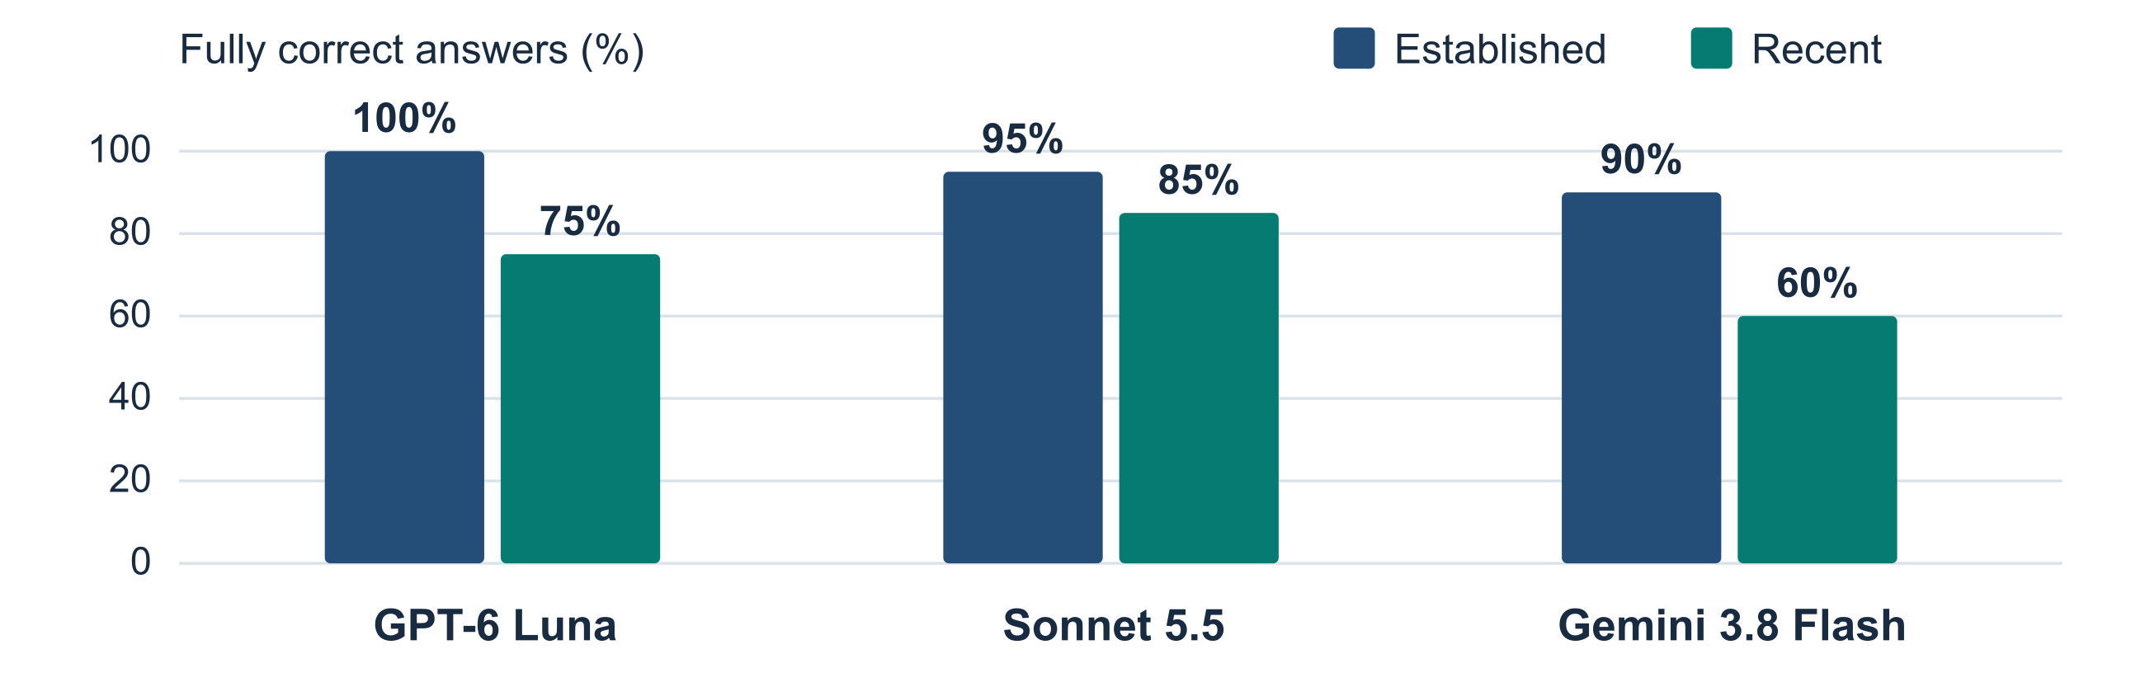
Each bar uses 20 answers. Source results/main_results.csv.

Paired Comparisons and Uncertainty
We used one-sided exact McNemar tests on twenty established–recent pairs within each condition. Let b be pairs with only the established answer fully correct and c pairs with only the recent answer fully correct. The exact statistic is b among b+c discordant pairs; at the equality boundary of H₀ it follows Binomial(b+c, 0.5). Concordant pairs do not contribute to that conditional test.
GPT has b=5 and c=0, giving p=1/32=0.03125. Sonnet has b=2 and c=0, giving p=1/4=0.25. Gemini has b=7 and c=1, giving p=9/256=0.03515625. Holm correction is applied to this family of three directional tests at α=0.05. Adjusted values are 0.09375, 0.25000 and 0.09375; none crosses the threshold (Table 3).
The 95% intervals resample twenty complete pairs within each condition. We calculated the exact empirical paired-bootstrap distribution and took its 2.5th and 97.5th percentiles, so no random seed or Monte Carlo run count is required. Intervals for the gap are [10,45], [0,25] and [5,55] percentage points. Figure 2 shows these pointwise intervals. They are not multiplicity-adjusted and can exclude zero while Holm-adjusted tests remain inconclusive.
Only one archived answer exists per question and condition. These intervals describe variation across sampled pairs, not repeated-generation variability; mean ± SD across three runs cannot be calculated. Pair independence is an assumption, not a verified fact: questions share prompt blocks and ecosystems. No normality assumption or large-sample chi-square approximation is used. With a small purposive sample and post hoc analysis, the tests are exploratory and do not establish a population-wide or causal recency effect.
An independent audit reproduced the probabilities and interval endpoints using binomial and multinomial enumeration. No additional model queries or changes to the archived ratings were needed.
Table 3 Exploratory paired comparisons for established versus recent topics
Condition | E only / R only | Gap (pp) | 95% paired  interval (pp) | Raw p | Holm p
GPT-6 Luna | 5 / 0 | +25 | 10 to 45 | 0.0312 | 0.0938
Sonnet 5.5 | 2 / 0 | +10 | 0 to 25 | 0.2500 | 0.2500
Gemini 3.8 Flash | 7 / 1 | +30 | 5 to 55 | 0.0352 | 0.0938

E only and R only are discordant pairs. Each comparison has 20 pairs. Source results/paired_topic_comparisons.csv.
Figure 2 Established minus recent accuracy with 95 percent intervals
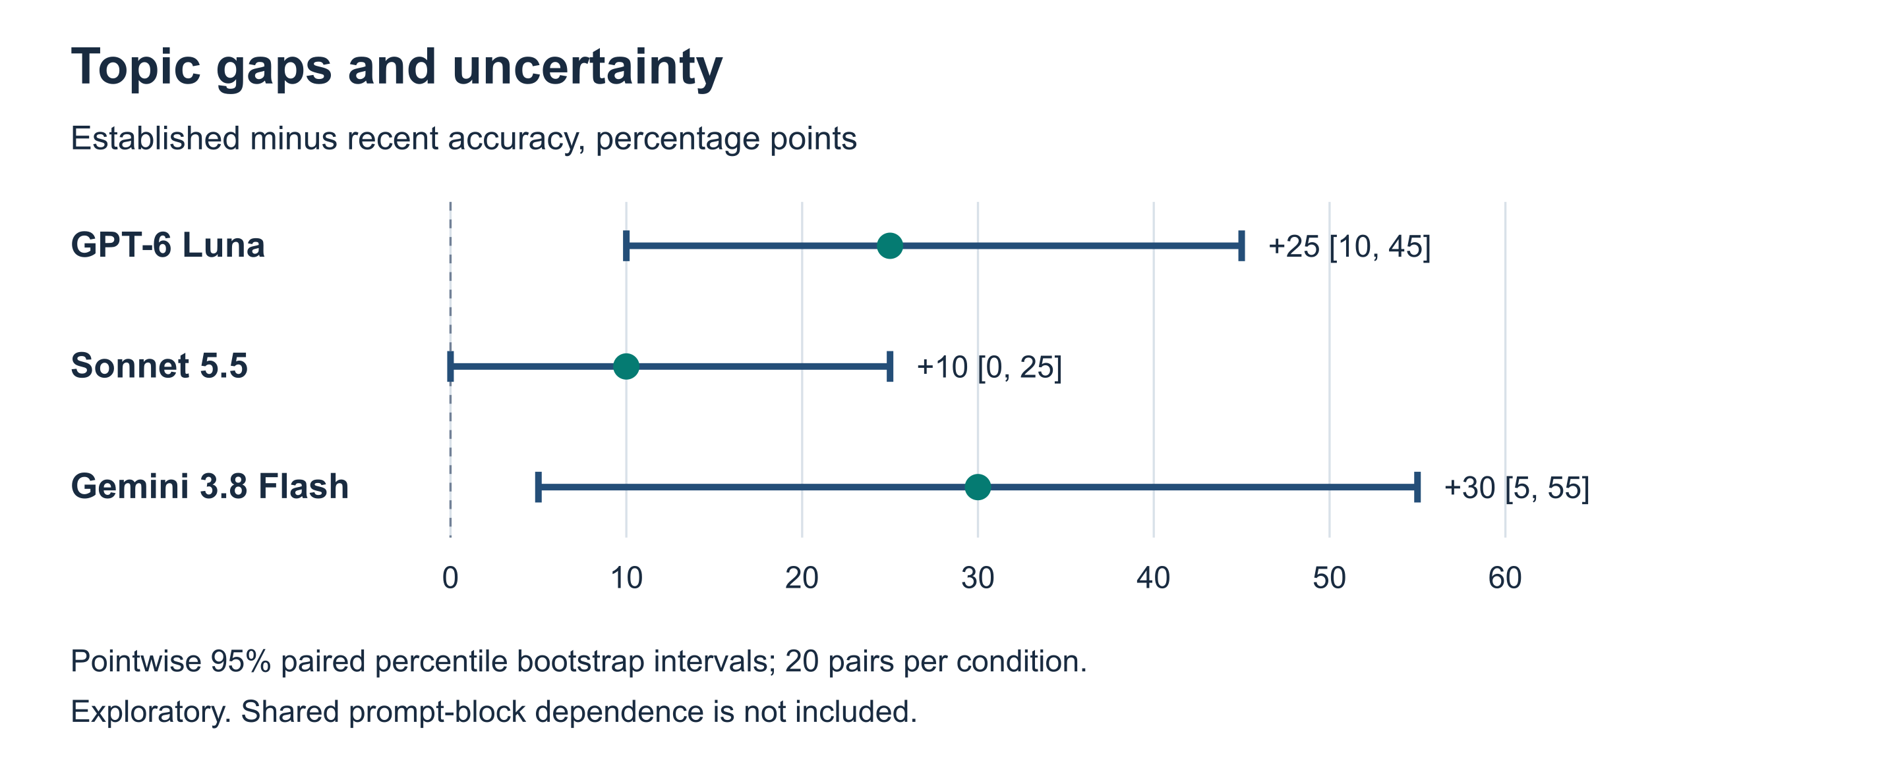
Twenty matched pairs per condition. Pointwise intervals exclude shared-block dependence and multiple-comparison adjustment. Source results/paired_topic_comparisons.csv.

Supplementary baseline results
Table S1 New baseline full correctness and checkpoint scores
Condition | Established correct | Recent correct | Overall correct | Overall checkpoints | Overall 95% CI
Keyword extraction | 2/20 | 2/20 | 4/40 (10.0%) | 52/120 (43.3%) | 4.0 to 23.1%
Qwen without documents | 4/20 | 0/20 | 4/40 (10.0%) | 44/120 (36.7%) | 4.0 to 23.1%
Qwen with BM25 documents | 2/20 | 4/20 | 6/40 (15.0%) | 65/120 (54.2%) | 7.1 to 29.1%

Figure S1 Supplementary accuracy by topic with 95 percent Wilson intervals
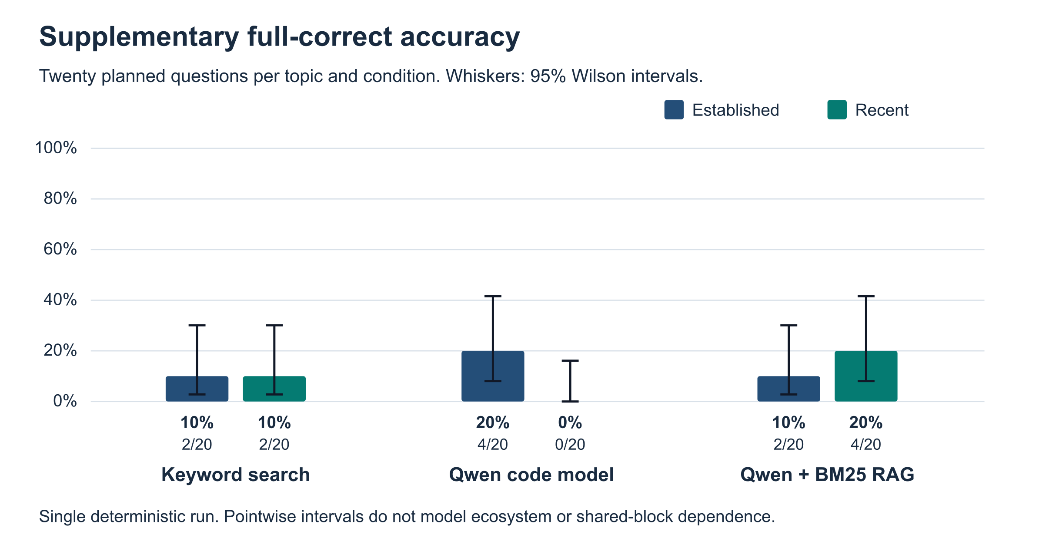
With supplied documents, the model returned 6/40 fully correct answers, compared with 4/40 without documents: an absolute difference of +5.0 percentage points. The observed retrieval-assisted result was higher. Table S1 uses Wilson intervals for single-pass proportions; these do not estimate variation across repeated chats. Historical commercial-model results are retained separately and have no matched-hardware comparison with the local model. Sources: supplement/raw/answers.jsonl, ratings.jsonl and supplement/results/main_results.csv.
Table S2 Exact paired tests for the supplementary family
Comparison | Discordant A / B | Difference pp | 95% paired interval pp | Raw p | Holm p
Model minus keyword | 3 / 3 | +0.0 | -12.5 to 12.5 | 1.0000 | 1.0000
RAG minus keyword | 5 / 3 | +5.0 | -7.5 to 20.0 | 0.7266 | 1.0000
RAG minus model | 4 / 2 | +5.0 | -7.5 to 17.5 | 0.6875 | 1.0000
Model established minus recent | 4 / 0 | +20.0 | 5.0 to 40.0 | 0.0625 | 0.3125
RAG established minus recent | 2 / 4 | -10.0 | -35.0 to 15.0 | 0.8906 | 1.0000

The five-test family includes three between-method two-sided exact McNemar tests and two established–recent one-sided tests for the local model conditions. Holm correction applies to all five. Between-method bootstrap intervals resample the forty shared questions; topic intervals resample twenty matched pairs. Intervals are pointwise, not multiplicity-adjusted. The reused purposive questions and possible ecosystem dependence limit population inference. Source: supplement/results/paired_comparisons.csv.
For H1, the local model without documents shows the expected direction (4/20 established versus 0/20 recent) but its adjusted p=0.3125 is inconclusive: partly supported descriptively. RAG reverses the direction (2/20 established versus 4/20 recent): H1 is not supported there. H2 has a positive RAG-minus-model difference of five percentage points but adjusted p=1.0000: partly supported descriptively, without statistical rejection. These results do not change the historical comparison of the original three conditions.

Additional baseline diagnostics
The supplementary ratings identify 106 answers below full correctness. The reviewed primary error codes are ADD: 3, API: 29, OMIT: 30, OTHER: 27, REL: 9, TYPE: 8. Table B5 records 30 cases; the complete ratings retain every case. AI-assisted scoring is disclosed and does not constitute independent human agreement. The same strict-versus-checkpoint-only check is available in supplement/results/sensitivity.csv. Timing results in supplement/results/efficiency.csv concern actual local calls only and exclude archived provider runtimes.
Eight closed-book and five RAG outputs reached the fixed 192-token cap; truncated text was scored as saved. At least one originally referenced source ID was retrieved for 32/40 keyword and 38/40 RAG items; this measures document-ID coverage, not semantic correctness. Ignoring added-error penalties changes RAG full correctness from 6/40 to 9/40; the other conditions remain 4/40. These checks help explain why retrieving a relevant document did not ensure a correct applied answer.
Median per-item elapsed time [Q1, Q3]: Keyword extraction 0.00 s [0.00, 0.00]; Qwen without documents 6.86 s [5.45, 9.21]; Qwen with BM25 documents 11.85 s [9.37, 14.75]. Local retrieval and generation are included; model loading is recorded separately.

5 Additional Analysis

Error Analysis
We reviewed all 19 partial answers. For each case, we checked the original response, the required checkpoints and the archived scoring notes. We assigned one main code per answer. A missed checkpoint took priority when an answer also contained an extra error. We used the added-claim code when all three checkpoints were met but the answer still included an important factual mistake. Appendix B lists the categories, examples and all individual cases.
Sixteen of the 19 partial answers involved recent topics. The most common category was a wrong API or configuration detail, with seven cases. Five answers misstated a release or platform boundary. For instance, in V2Q32, GPT and Sonnet included Linux when describing the initial system CA flag in Node.js 23.8.0. Gemini did not give a clear answer about Linux support. The archive’s version-specific source lists macOS and Windows for that release. The answers broadly understood the purpose of the flag but missed a detail that would affect whether someone could use it.
Five answers passed all three checkpoints and still added an important factual error. In V2Q34, Sonnet correctly described the TypeScript 5.8 setting asked about in the question, then suggested that changing the types option could remove the selected DOM declarations. The lib option controls which standard-library declarations are included. Advice that goes beyond the question can make an otherwise correct answer less reliable. Our codes describe the visible mistakes, and the possible causes in Appendix B are interpretations.
The smaller categories include one omitted command and one inaccurate type. A post hoc ecosystem check found positive overall gaps after removing any one ecosystem: GPT +18.75 to +31.25, Sonnet +6.25 to +12.50 and Gemini +12.50 to +43.75 percentage points. Thus no single ecosystem accounts for the direction. However, Gemini’s TypeScript subgroup reverses it (3/4 established versus 4/4 recent); the overall pattern is not universal. Table B3 reports all subgroups and Table B4 reports intervals preserving the five ecosystem quotas. These checks do not control shared prompt-block context.

Sensitivity to the Scoring Rule
We then counted any answer that passed all three checkpoints, even if it contained an added error. The answers, checkpoint judgments and denominators were the same under both rules. The alternative rule added five fully correct answers, raising the overall count from 101 to 106 of 120, or from 84.2% to 88.3%.
Established topics still had higher accuracy in all three conditions. Sonnet’s gap narrowed from 10 to 5 percentage points because its recent group gained two answers and its established group gained one. Gemini gained one in each group and its gap stayed at 30 points. GPT’s gap stayed at 25 points. The change in Sonnet’s gap shows why it is worth reporting both versions of the score.
Table 4 Strict accuracy compared with checkpoint-only accuracy
Condition | Established | Recent | Gap (pp) | Overall
GPT-6 Luna | 100.0% → 100.0% | 75.0% → 75.0% | 25.0 → 25.0 | 87.5% → 87.5%
Sonnet 5.5 | 95.0% → 100.0% | 85.0% → 95.0% | 10.0 → 5.0 | 90.0% → 97.5%
Gemini 3.8 Flash | 90.0% → 95.0% | 60.0% → 65.0% | 30.0 → 30.0 | 75.0% → 80.0%
All conditions | 95.0% → 98.3% | 73.3% → 78.3% | 21.7 → 20.0 | 84.2% → 88.3%

Values show strict → checkpoint-only. The gap is established minus recent. Source results/sensitivity.csv.

6 Answering the Research Question and Hypotheses
Table 5 Evidence for the directional hypothesis
Hypothesis by condition | Evidence | Result | Assessment
H₁ · GPT-6 Luna | Tables 2 and 3 | +25 pp, Holm p = 0.0938 | Partly supported
H₁ · Sonnet 5.5 | Tables 2 and 3 | +10 pp, Holm p = 0.2500 | Partly supported
H₁ · Gemini 3.8 Flash | Tables 2 and 3 | +30 pp, Holm p = 0.0938 | Partly supported

Partly supported means that the observed gap was positive but the adjusted test did not reject H₀.
For this question bank, established topics had higher factual accuracy in all three model conditions. The gaps were 25 percentage points for GPT-6 Luna, 10 for Sonnet 5.5 and 30 for Gemini 3.8 Flash. Across the conditions, 57 of 60 established answers and 44 of 60 recent answers were fully correct. Sonnet had the highest observed overall accuracy, with 36 of 40 correct answers, one more than GPT. When we changed the scoring rule to count all answers that met the three checkpoints, the established group still scored higher in every condition. These results support the direction of H₁ on the tested questions. However, none of the exploratory comparisons reached the 0.05 threshold after Holm correction, so we did not reject H₀.

7 Discussion

What the Results Mean
The main result is that the models missed more details on recent features. Some answers captured the idea but gave the wrong API name, option or platform boundary. For someone following the answer, a mistake in one of those details can make the suggested steps fail even when the rest of the explanation is correct. The Node.js platform example is useful here because it was missed in all three conditions. It shows a problem with the specific release information rather than a lack of general knowledge about what the flag does.
We also saw differences in how the models lost points. Sonnet met nearly all of the checkpoints on recent topics but lost some fully correct answers because of extra claims. The strict rule counts those claims because a reader may act on them. Checkpoint-only scoring can still show that the main facts were present. Gemini had a larger gap and a lower recent-topic checkpoint score, so dropping the penalty for added claims did less to change the pattern. The fact that the ranking and the gap answer different questions is also important. Sonnet’s higher overall score does not make its 10-point topic gap stronger statistical evidence.
We did not see any completely incorrect answers or abstentions in this sample. That was worth noting because the recent-topic gap came from answers that were partly right. A user who only checks the main idea could miss the specific detail that made an answer incomplete.

Comparison with Previous Studies
Kabir et al. (2024) found that ChatGPT answers to Stack Overflow questions could look useful while containing wrong information. We saw a similar issue in the five responses that met all required checkpoints but added a factual error. Their study used open-ended programming questions and examined user preferences, while we scored shorter questions about specific software versions. The two error rates measure different tasks.

Comparison with Previous Studies Continued
Kandpal et al. (2023) found that models were more likely to answer factual questions correctly when relevant information appeared more often in their training data. Established topics might have better coverage, but we had no access to the providers’ training data. We grouped the questions by release timing. We cannot tell from our results how often the models saw the relevant material.
Vu et al. (2024) reported that models struggled with facts that change quickly in FreshQA and that search could improve their answers. This is consistent with our lower scores on recent features. Their questions concern changing facts about the wider world, while ours specify software releases. The prompt in our study asked for answers without external search, so we did not measure what search would have changed.
Wang et al. (2025) found that models sometimes suggested deprecated APIs when completing code. We saw related mistakes about API details, configuration and platform support. They studied APIs that had become outdated, while we looked at recently introduced features and used explanatory answers. Both studies give a reason to check the version that an answer applies to.

Threats to Validity and Limitations
Internal validity. We matched the questions by ecosystem and task type, but recent questions may still have asked for finer details or been harder. We also could not independently verify every model backend, account tier, fresh-chat setting or tool state. The observed gaps may reflect some of these differences as well as topic recency.
External validity. The 40 English questions were selected from five ecosystems and all sampled recent features first appeared in 2025. Our results apply most directly to these questions and recorded model conditions. We might see different gaps on 2026 releases, in other languages or on longer programming tasks.
Construct validity. The three checkpoints make it possible to inspect what each answer got right. The strict score still depends on deciding whether an added claim contains a material error. The archived ratings were AI-assisted and we did not measure independent rater agreement. The sensitivity analysis shows what happens when we remove that penalty.
Statistical conclusion validity. We had only 20 matched pairs per condition and one saved answer per question for each model. Questions in the same block may have shared context. The exploratory tests and intervals summarize the archived comparison, with limited evidence for a general effect or for repeatability across new runs.

Practical Implications and Future Work
A student or developer can use a model answer to get started, then check API names, flags and platform support in the official documentation for the version they use. If we repeated the experiment, we would include 2026 releases, log the model and tool settings, repeat the blocks across fresh chats, and plan the statistical analysis before seeing the results. Independent raters could score answers without knowing the model names so that we could measure agreement. We could then run a separate randomized comparison to see whether providing version-specific documentation reduces the errors listed in Appendix B.
The original question in Assignment 1 asked whether topic recency matters for the accuracy of technical answers. The checkpoint-only sensitivity analysis still gave established topics a 20.0 percentage point advantage overall. This makes the direction of the gap less dependent on our choice to penalize added claims. The same questions and saved responses were used for both scoring rules. Differences in question difficulty and variation across fresh chats remain unresolved by this check.
The supplementary comparison tests a practical information-access change rather than a new claim about the original model ranking. Lewis et al. (2020) motivate combining generation with retrieved evidence; this sparse, untrained implementation is not their dense trained RAG model. Qwen2.5-Coder (Hui et al., 2024) supplies a code-specialized, resource-feasible model baseline. Retrieval may supply new version facts, but its benefit depends on which passages are retrieved and how they are used. The corpus source list was originally selected for this bank, so it may favor document-assisted conditions. The supplementary scores therefore do not constitute an independent unseen-test benchmark.

8 Reproducibility Statement
The reproducibility package retains the saved questions, original answers, checkpoint scores and added-error flags. The original script validates the JSON checksum and regenerates five reference CSVs; the error coding sheet rebuilds Appendix B counts. The accompanying audit independently verifies the arithmetic and statistical endpoints and exports answer-level and matched-pair records. This reproduces analysis of saved answers. Asking the models to respond again would constitute a new collection.
Table 6 Files needed to reproduce the results
File or folder | Contents
README.md | Setup instructions, exact commands and a guide to the files.
data/ | Archive JSON with questions, sources, answers and scores, plus the Appendix B error codes.
reproduce.py and results/ | Analysis script and five reference CSVs for results, paired tests, sensitivity and errors.
figures.py and figures/ | Original figure script and two reference SVGs. figures_bekasyl.py creates all three figures used in this report.
environment.txt | Python 3.12 or newer. Both scripts use the standard library.
LICENSE and verification_log.txt | Code license and original check log. verification_bekasyl.txt records the current check.
audit_bekasyl.py and audit/ | Independent arithmetic checks; 120 answer rows, 60 condition–pair rows and exact test probabilities.

In a clean Python 3.12+ environment, run python reproduce.py --verify, then follow README_BEKASYL.md to regenerate and compare the original and report SVGs. Run python audit_bekasyl.py for the independent arithmetic audit and python robustness.py for Tables B3–B4. All calculations and SVG generation use the standard library. The README contains the complete commands; no model access or credentials are required.
The completed study and saved-data reproduction are published at https://github.com/bekasyl00/rmt-cs-accuracy-assignment4 with release tag assignment-4. The original release at zere0802/rmt-assignment-4, commit 396789c99dc41c3526d1466d2683aa966cf7d01f, remains the source of the unchanged historical data. Run python reproduce_all.py --verify in the completed package; no model download is required for saved-data reproduction.
Open the question bank and item-level evidence in the RMT-CS-v2 evidence archive
The supplementary package adds the frozen questions and corpus manifest, model revision, exact prompts, raw local outputs, reviewed checkpoint ratings, runtime metadata and scripts that rebuild Tables S1–S2 from those saved records. Fresh generation is a separate command with MLX and the fixed model snapshot. Any independent teammate record for the old release applies only to that release; no new teammate reproduction is inferred from an automated check.

References
Assignment 1 defines the question; Assignment 2 reviews all four studies below. Official documentation supplies the answer keys.
Kabir, S., Udo-Imeh, D. N., Kou, B., & Zhang, T. (2024). Is Stack Overflow obsolete? An empirical study of the characteristics of ChatGPT answers to Stack Overflow questions. CHI 2024. Source
Kandpal, N., Deng, H., Roberts, A., Wallace, E., & Raffel, C. (2023). Large language models struggle to learn long-tail knowledge. ICML, 202, 15696–15707. Source
Vu, T., Iyyer, M., Wang, X., Constant, N., Wei, J., Wei, J., Tar, C., Sung, Y.-H., Zhou, D., Le, Q., & Luong, T. (2024). FreshLLMs: Refreshing large language models with search engine augmentation. Findings of ACL 2024, 13697–13720. Source
Wang, C., Huang, K., Zhang, J., Feng, Y., Zhang, L., Liu, Y., & Peng, X. (2025). LLMs meet library evolution: Evaluating deprecated API usage in LLM-based code completion. ICSE 2025, 885–897. Source
Version-specific manuals and release notes used for marking are listed under each question in the evidence archive
Hui, B., et al. (2024). Qwen2.5-Coder Technical Report. arXiv:2409.12186. https://arxiv.org/abs/2409.12186
Lewis, P., et al. (2020). Retrieval-Augmented Generation for Knowledge-Intensive NLP Tasks. NeurIPS 2020. https://arxiv.org/abs/2005.11401

Appendix A Experiment Protocol Freeze Record
The archive records a question-bank freeze at 02:28:32 Almaty time on 23 October 2026 (22 October, 21:28:32 UTC). This record identifies archived decisions; it is not evidence of a pre-run Moodle submission. The team confirms that no separate pre-run protocol was uploaded to Moodle; this submission requirement was not met. Exact answer-generation times remain unverified. The inferential analyses below were added retrospectively. The supplementary experiment has a separately timestamped protocol and any pre-output amendment. Its single deterministic runs are new data. This does not recreate a pre-run Moodle upload for either stage.
Required field | Archived decision or current status
Primary research question | How does factual accuracy differ between established computer science concepts and software features first released in 2025–2026, within and between selected model conditions instructed to answer the same applied questions without external search?
Hypotheses | For each condition, H₀: established full-correct probability ≤ recent; H₁: established > recent. The exact tests and threshold were added after results were available.
Primary outcome and reason | Share of answers meeting all three checkpoints with no material added error. This measures whether the full response can be used without a factual correction.
Secondary outcome | Checkpoint points earned out of those possible. Each topic group has 60 possible points per condition.
Simple baseline | None in the archived design.
Strong baseline and proposed method | Three peer comparisons and no separate intervention. Recorded conditions were GPT-6 Luna (Medium), Sonnet 5.5 (Medium) and Gemini 3.8 Flash.
Dataset and test set | RMT-CS-v2. All 40 questions formed the evaluation set, with 20 matched pairs and 120 answers overall.
Runs and settings | One archived collection round, four fixed blocks of ten questions per model condition. Twelve requests were prescribed. Seeds and exact runtime were unavailable.
Statistical plan and later analyses | The original analysis reported proportions and gaps. We later added exploratory one-sided exact McNemar tests, Holm correction and pointwise paired bootstrap intervals.
Evidence supporting H₁ | Positive gap supports the direction descriptively. A positive gap and Holm-adjusted p < 0.05 would meet the exploratory test criterion; no condition met it.
Evidence failing to support H₁ | Zero or negative gap does not support the predicted direction. Adjusted p ≥ 0.05 leaves H₀ unresolved and does not prove equality.
Additional analyses | Review all answers below full correctness and recompute accuracy under a checkpoint-only rule.

Archived question-bank SHA-256
afcd21f4e6bbd7c764e2b38a95be06140ee79b64e99eb3f2564513fd6d0ff95d
Original JSON export SHA-256
7ff20f027235b6d4c840b2ee82b0add6bb620b9374ada004779035bd2e34fe1d

Appendix A Supplementary protocol addendum
This addendum concerns new outputs only. The protocol and single-run amendment were saved before the first supplementary response. No Moodle upload or instructor approval is claimed. The full protocol and its earlier three-seed planning version are preserved in supplement/protocol.
Decision | New supplementary experiment
Question and hypotheses | Keep the historical question; additionally compare keyword search, a fixed code model and the same model with retrieved documents. H1 expects established > recent within each model condition; H2 expects RAG > model overall.
Primary and secondary metrics | Full correctness requires 3/3 checkpoints and no material added error. Secondary: checkpoint percentage, error categories, topic gap, retrieval-ID coverage and latency.
Simple baseline | Keyword overlap, top three unedited 180-word chunks from the frozen 56-source corpus; deterministic chunk-ID tie-breaking.
Literature-backed model baseline | Qwen2.5-Coder-3B-Instruct, MLX 4-bit revision 3dd939c621c08e5753d5b89f35a2642cd83b98ca. Resource-feasible code-specialized baseline; not an assertion of equal capacity to commercial conditions.
Proposed condition | Same model plus top-three BM25 chunks, k1=1.5 and b=0.75. Reference answers, old responses and per-question reference-source mappings withheld from generation.
Evaluation and runs | Same forty questions and twenty matched topic pairs; reused bank, not an unseen set. One greedy pass per condition, seed 17, max 192 generated tokens. Total 120 actual new records.
Uncertainty and tests | Wilson 95% rate intervals; paired bootstrap intervals. Family of five exact McNemar tests, three two-sided method comparisons and two one-sided topic comparisons, with Holm correction. No artificial across-seed SD.
Support rules | Positive predicted difference supports direction; statistical support also requires Holm p<0.05. Zero/opposite differences do not support direction. Non-significance does not prove equality.
Additional evidence | Score sensitivity, source-ID coverage, token-cap diagnostics, all 106 below-full cases coded; thirty cases shown across all three conditions.
Actual local freeze UTC | 2026-11-08T14:58:08.774502+00:00
Pre-run Moodle submission | Not submitted. The absence is declared and is not replaced by a fabricated date.

Appendix B Error Analysis
A case is one answer from one model to one question. We used one primary code per case. The possible causes below are interpretations of the response text.
Table B1 Error categories and examples
Error type | Definition | Count | Share | Example | Possible cause
API API or configuration detail | Wrong identifier, field, module or argument. | 7 | 36.8% | V2Q08 · node instead of nodeOptions. | Similar names or configuration conventions.
REL Release or platform boundary | Misstates or leaves ambiguous what the specified release supports. | 5 | 26.3% | V2Q03 · rejects valid Python 3.14 syntax. | An older rule or broader support assumed.
ADD Added claim error | All checkpoints passed, with a material error in an added claim. | 5 | 26.3% | V2Q34 · inaccurate types advice. | Unverified extra detail or advice.
OMIT Required detail omitted | A requested fact is left unanswered without a concrete substitute. | 1 | 5.3% | V2Q18 · leaves out reflog drop. | Uncertainty about a new command.
TYPE Type precision | Gives an overly specific or inaccurate type for the exact checkpoint. | 1 | 5.3% | V2Q11 · literal 1 instead of number. | Conflation of assigned value and flow type.
Total | All failed answers | 19 | 100%

Figure 3 Primary error categories across the 19 partial answers
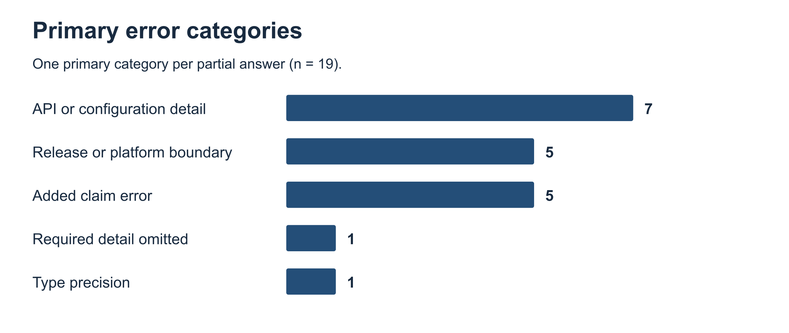
One code per partial answer. Sources results/error_summary.csv and Appendix B.
Table B2 Record of all 19 partial answers
E = established. R = recent. A plus sign marks a material added error. Question IDs link to the archive. Codes in brackets identify the reference sources.
Question | Model | Group | Score | Code | Observed issue and reference ID
V2Q03 | GPT | R | 2/3 | REL | Rejected the bare multi-type except clause. Python 3.14 accepts it without as. [S25]
V2Q03 | Gemini | R | 2/3 | REL | Treated the bare multi-type except clause as obsolete syntax. It is valid here. [S25]
V2Q08 | Gemini | R | 2/3 | API | Gave node as the JSON key. The required key is nodeOptions. [S34]
V2Q10 | GPT | R | 2/3 | API | Listed type and size. The two optional fields are path and type. [S41]
V2Q11 | Gemini | E | 2/3 | TYPE | Specified the literal type 1. The documented flow type is number. [N01]
V2Q14 | GPT | R | 2/3 + | API | Treated script as source text and added a separate-thread claim. It names a script file and execution occurs on the target main thread. [S26]
V2Q14 | Gemini | R | 2/3 | API | Allowed a source string as an alternative. The script argument names a file. [S26]
V2Q16 | Gemini | E | 3/3 + | ADD | Added nextTick as a later-turn alternative. It runs before the event loop continues. [N04]
V2Q18 | Sonnet | R | 3/3 + | ADD | Said reflog drop predated Git 2.50. It was introduced in that release. [S42]
V2Q18 | Gemini | R | 2/3 | OMIT | Expressed uncertainty and left out the requested git reflog drop command. [S42]
V2Q22 | GPT | R | 1/3 | API | Suggested a polyfill and omitted the planned version. The built-in import is node:url and the planned major version was 24. [S33]
V2Q24 | Gemini | R | 2/3 | API | Named typing.Template. The type is string.templatelib.Template. [S05]
V2Q29 | Gemini | R | 3/3 + | ADD | Implied a single network connection for backfill. Batching provides no such guarantee. [S39]
V2Q32 | GPT | R | 2/3 | REL | Included Linux in the initial release. Node.js 23.8.0 supported macOS and Windows. [S33]
V2Q32 | Sonnet | R | 2/3 | REL | Included Linux despite uncertainty about details. Linux support was still planned. [S33]
V2Q32 | Gemini | R | 2/3 | REL | Left Linux support ambiguous. The 23.8.0 release supported only macOS and Windows. [S33]
V2Q34 | Sonnet | R | 3/3 + | ADD | Suggested types could remove bundled DOM declarations. The lib setting selects those libraries. [S32]
V2Q37 | Sonnet | E | 3/3 + | ADD | Suggested --all could delete the whole reflog. In Git 2.24, it scopes reflog expire across refs. [N08]
V2Q40 | Gemini | R | 1/3 | API | Used zstandard or zlib. The required calls are compression.zstd.compress and compression.zstd.decompress. [S06]

Sources data/error_codes.csv, results/error_audit.csv and the RMT-CS-v2 evidence archive.
Supplementary analysis of ecosystem sensitivity
These retrospective diagnostics retain all archived answers. Each ecosystem contributes four established–recent pairs per condition. E and R denote fully correct answers out of four; gaps are percentage points. Small subgroup counts support descriptive interpretation only.
Table B3 Full correctness within each ecosystem
Condition | Ecosystem | E correct | R correct | Gap pp
GPT-6 Luna | Git | 4/4 | 3/4 | 25.0
GPT-6 Luna | Node.js | 4/4 | 2/4 | 50.0
GPT-6 Luna | PostgreSQL | 4/4 | 4/4 | 0.0
GPT-6 Luna | Python | 4/4 | 2/4 | 50.0
GPT-6 Luna | TypeScript | 4/4 | 4/4 | 0.0
Sonnet 5.5 | Git | 3/4 | 3/4 | 0.0
Sonnet 5.5 | Node.js | 4/4 | 3/4 | 25.0
Sonnet 5.5 | PostgreSQL | 4/4 | 4/4 | 0.0
Sonnet 5.5 | Python | 4/4 | 4/4 | 0.0
Sonnet 5.5 | TypeScript | 4/4 | 3/4 | 25.0
Gemini 3.8 Flash | Git | 4/4 | 2/4 | 50.0
Gemini 3.8 Flash | Node.js | 3/4 | 2/4 | 25.0
Gemini 3.8 Flash | PostgreSQL | 4/4 | 4/4 | 0.0
Gemini 3.8 Flash | Python | 4/4 | 0/4 | 100.0
Gemini 3.8 Flash | TypeScript | 3/4 | 4/4 | -25.0
Table B4 Robustness of the established minus recent gap
Condition | Stratified 95% interval pp | Gap range after one ecosystem removed pp
GPT-6 Luna | 10 to 40 | 18.75 to 31.25
Sonnet 5.5 | 0 to 25 | 6.25 to 12.5
Gemini 3.8 Flash | 15 to 45 | 12.5 to 43.75
The stratified percentile bootstrap resamples four pairs within each ecosystem and combines the five exact distributions. It preserves the fixed ecosystem composition; it does not model dependence from shared prompt blocks. Removing one ecosystem retains sixteen pairs. All fifteen resulting gaps remain positive. No additional significance claims or model rankings are inferred. Sources diagnostics/ecosystem_results.csv, diagnostics/robustness_summary.csv and diagnostics/leave_one_ecosystem_out.csv; regenerated with python robustness.py.

Table B5 Reviewed supplementary failures
The supplement contains 106 answers below full correctness. This table shows thirty cases, ten per condition, selected in fixed question order. The complete unfiltered case records are retained in supplement/raw/ratings.jsonl.
Condition and question | Score | Code | Observed issue
simple V2Q01 | 0/3 | OTHER | The extracted TypeScript 2.0 null-checking passages do not state enum runtime representation, State.Ready, or string-enum reverse mapping.
simple V2Q02 | 2/3 | OMIT | The Python 3.8 sorting excerpts state stable preservation of equal-key order and show descending reverse=True sorting without reversing ties. They do not give the requested complete A/C/B result.
simple V2Q03 | 0/3 | OTHER | The response returns Python 3.8 exception syntax and unrelated Zstandard parameters, not the Python 3.14 bare-except rule or the required bound two-type handler.
simple V2Q04 | 2/3 | OMIT | The CommonJS excerpt explicitly says reassigned exports detaches the alias and shows assigning the replacement to module.exports. The API correction pattern is credited without requiring literal ready variable names. The requested resulting object is not supplied.
simple V2Q05 | 2/3 | OMIT | The TypeScript 5.8 excerpts explicitly allow require-to-ESM under nodenext and exclude top-level-await ESM from synchronous require. They do not supply dynamic import and its asynchronous loading strategy.
simple V2Q07 | 0/3 | OTHER | The returned Git range text, PostgreSQL self-join example, and foreign-key discussion do not address the requested LEFT JOIN filter effect, remaining IDs, or corrected ON condition.
simple V2Q08 | 2/3 | OMIT | The release excerpt explicitly identifies JSON and shows command-line options nested inside nodeOptions. That direct nesting pattern is credited with watch substituted for the example coverage option. It does not explicitly distinguish configuration parsing from executing a JavaScript module.
simple V2Q09 | 2/3 | OMIT | The PostgreSQL 18 UUID excerpt explicitly describes uuidv7 as version 7 and time-ordered with timestamp and random components. It does not address transaction commit-order guarantees.
simple V2Q10 | 1/3 | OMIT | The Git 2.49 excerpt explicitly prints the missing object ID with print-info. The selected chunk ends before identifying path/type fields or their conditional availability.
simple V2Q11 | 1/3 | OMIT | The TypeScript 2.0 flow-analysis example explicitly assigns x=1 and labels x as number. It does not assess x.length or provide the requested correction preserving the original string length.
model V2Q01 | 2/3 | API | Correctly says the enum is not erased and Ready is READY, but incorrectly asserts a numeric-style reverse mapping and numeric enum values.
model V2Q02 | 2/3 | OTHER | The concrete sorted list and stability explanation in parts (a) and (b) are correct. Part (c) falsely says reverse=True reverses equal-key order; saved output truncates during that claim.
model V2Q03 | 1/3 | REL | Correctly accepts handler A, but wrongly accepts unparenthesized handler B with as and does not supply the required parenthesized rewrite.
model V2Q04 | 1/3 | API | The proposed module.exports assignment is a valid correction. The reported require result and explanation of exports rebinding are wrong.
model V2Q05 | 0/3 | API | Part (a) falsely qualifies require-to-ESM support as allowing a nonblocking top-level-await graph; part (b) repeats that error. Bundling is not the required asynchronous import strategy.
model V2Q06 | 0/3 | OTHER | Wrongly creates a local branch for every remote branch and says no branch is initially checked out.
model V2Q07 | 0/3 | OTHER | Reports both customers, attributes the effect to a nonexistent column rather than NULL rejection, and keeps the status predicate in WHERE instead of moving it into ON.
model V2Q08 | 1/3 | API | Correctly identifies JSON, but puts watch under scripts rather than nodeOptions and incorrectly calls the configuration an executed JavaScript module.
model V2Q09 | 2/3 | OTHER | Identifies version 7 and correctly rejects guaranteed commit order. Part (b) overstates timestamp ordering as strictly chronological generation, so its ordering explanation is not fully correct.
model V2Q10 | 1/3 | API | Reports the missing object ID, but invents commit-message and author fields instead of path and type, and bases availability on an incorrect commit-only rule.
rag V2Q01 | 1/3 | API | Ready is correctly identified as READY. The explanation incorrectly leaves a type in JavaScript and wrongly claims a reverse mapping.
rag V2Q02 | 0/3 | OTHER | Gives the wrong sorted sequence, denies guaranteed stability for A and C, and incorrectly endorses reversal of equal keys.
rag V2Q03 | 1/3 | REL | Incorrectly rejects A and accepts B. The supplied rewrite except (ValueError, TypeError) as err is correct.
rag V2Q04 | 2/3 | API | Reports only ok and gives a valid module.exports replacement. The explanation wrongly says exports is assigned to module.exports later instead of explaining the detached alias.
rag V2Q05 | 1/3 | API | Correctly rejects synchronous loading of the given graph in part (b). Part (a) specifically claims support for ES modules with top-level await, and part (c) substitutes bundling for asynchronous import.
rag V2Q06 | 1/3 | OTHER | Part (a) correctly denies a local branch per remote branch. Part (b) contradicts this with one local branch per remote, and part (c) wrongly says nothing is initially checked out.
rag V2Q07 | 0/3 | OTHER | Reports both IDs, misstates the missing-row mechanism, and supplies the same filtering WHERE condition rather than the needed ON predicate.
rag V2Q08 | 2/3 | API | Correctly identifies JSON and non-executed configuration, but repeats top-level watch instead of the nodeOptions nesting.
rag V2Q09 | 3/3 + | ADD | Identifies UUIDv7, timestamp-plus-random ordering, and lack of guaranteed commit order. It adds the false claim that the timestamp component is only used for uniqueness.
rag V2Q10 | 1/3 | API | Correctly reports the missing object ID. It does not name path and type, and incorrectly bases field availability on promisor-object status rather than whether details are known.

Appendix C Reproduction Test Record
The supplied teammate record reports that Mereke Myrzakhan reproduced the original release on 6 November. A separate automated check on 8 November reproduced the five reference CSVs and two original SVGs and independently audited the calculations. The teammate record concerns the original release; it does not attest to the later audit script or third report figure.
Required field | Local software verification | Independent teammate record
Who reproduced the results | Automated local reproduction and independent arithmetic audit; no additional human-rater claim. | Mereke Myrzakhan.
Date and environment | 8 November 2026, macOS 26.3 arm64, Python 3.12.14; clean virtual environment, standard library only. | 6 November 2026. MacBook Air, macOS 15.0, Python 3.14.0.
Commit or tag | Original assignment-4 release (396789c), plus the accompanying local audit supplement. The full commit is given in Section 8. | assignment-4 release archive (396789c).
Commands | python reproduce.py --verify; python figures.py --results reproduced --out reproduced/figures; diff -r figures reproduced/figures; python audit_bekasyl.py; python figures_bekasyl.py --results reproduced --out reproduced/report_figures; diff -r report_figures reproduced/report_figures. | Created and activated .venv. Ran python reproduce.py --verify, python figures.py --results reproduced --out reproduced/figures and diff -r figures reproduced/figures.
Did the results reproduce? | Yes. Five CSVs and two original SVGs matched byte for byte. All three report charts regenerated identically. Independent audit confirmed 101/120 full answers and 344/360 points, tests, intervals and sensitivity. | Yes. Five CSVs verified and two SVG charts regenerated. The run returned 101/120 fully correct and 344/360 checkpoint points.
Differences observed | No numerical differences. The updated report adds a gap-interval figure; this is an additional visualization of the same results. | The SVG comparison returned no differences.
README fixes after the test | Original commands worked. README_BEKASYL.md adds exact commands and provenance for the supplement. | Completed the README steps as written.

Completed package reproduction by Bekasyl
On 8 November 2026, Bekasyl Zhaksylyk confirmed personally running python3 reproduce_all.py --verify and supplied the successful terminal output. It verified both the original 120 answers and all 120 supplementary outputs/ratings and regenerated 22 CSV/SVG files. The reported supplementary totals were 4/40 keyword, 4/40 model and 6/40 RAG, with zero missing records. The terminal excerpt came from the MacBook Air; exact Python version and execution time were not included. This confirms execution of the saved-data calculation package, not independent human re-rating. The full record is bekasyl_reproduction_record.json.

