Assignment 5 JavaScript Basics
Student: Beken Inzhu
Group: IT-2513
GitHub: [Paste repository URL]
Three separate pages use plain JavaScript, HTML and one shared CSS file. Each task has its own JS file. Open task1.html to start.

Task 1 Higher or Lower
Option A. Guess whether the next number is higher or lower. The game has 3 lives, a streak and a best streak. Equal numbers are correct. A wrong guess removes one life. Restart resets the game without reloading and keeps the best streak.
randomNumber() generates an inclusive random value. move() checks the guess. render() updates the page. The guess buttons stop working when all lives are lost.
Figure 1 Game number, counters and feedback
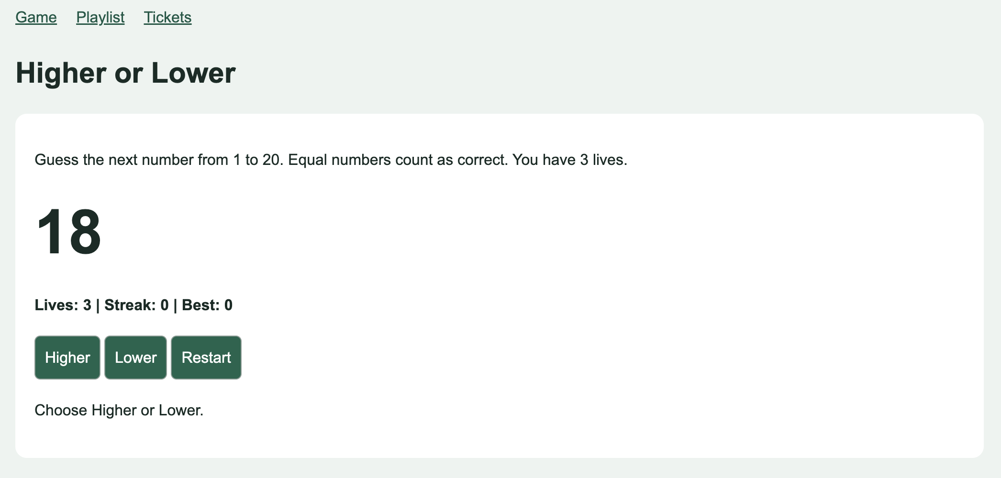

Task 2 Playlist
Listed alternative idea: a playlist with total duration. Ten objects contain an id, title, duration, tags and selected status. render() creates the cards from the array. The HTML list is initially empty.
Search filters songs by title. One listener on the list handles every Add and Remove button using dataset.id. A loop calculates the number of selected songs and total seconds. Adding a fourth song is blocked with a message. Removing a song frees a place.
Figure 2 Playlist with three selected songs and the limit message
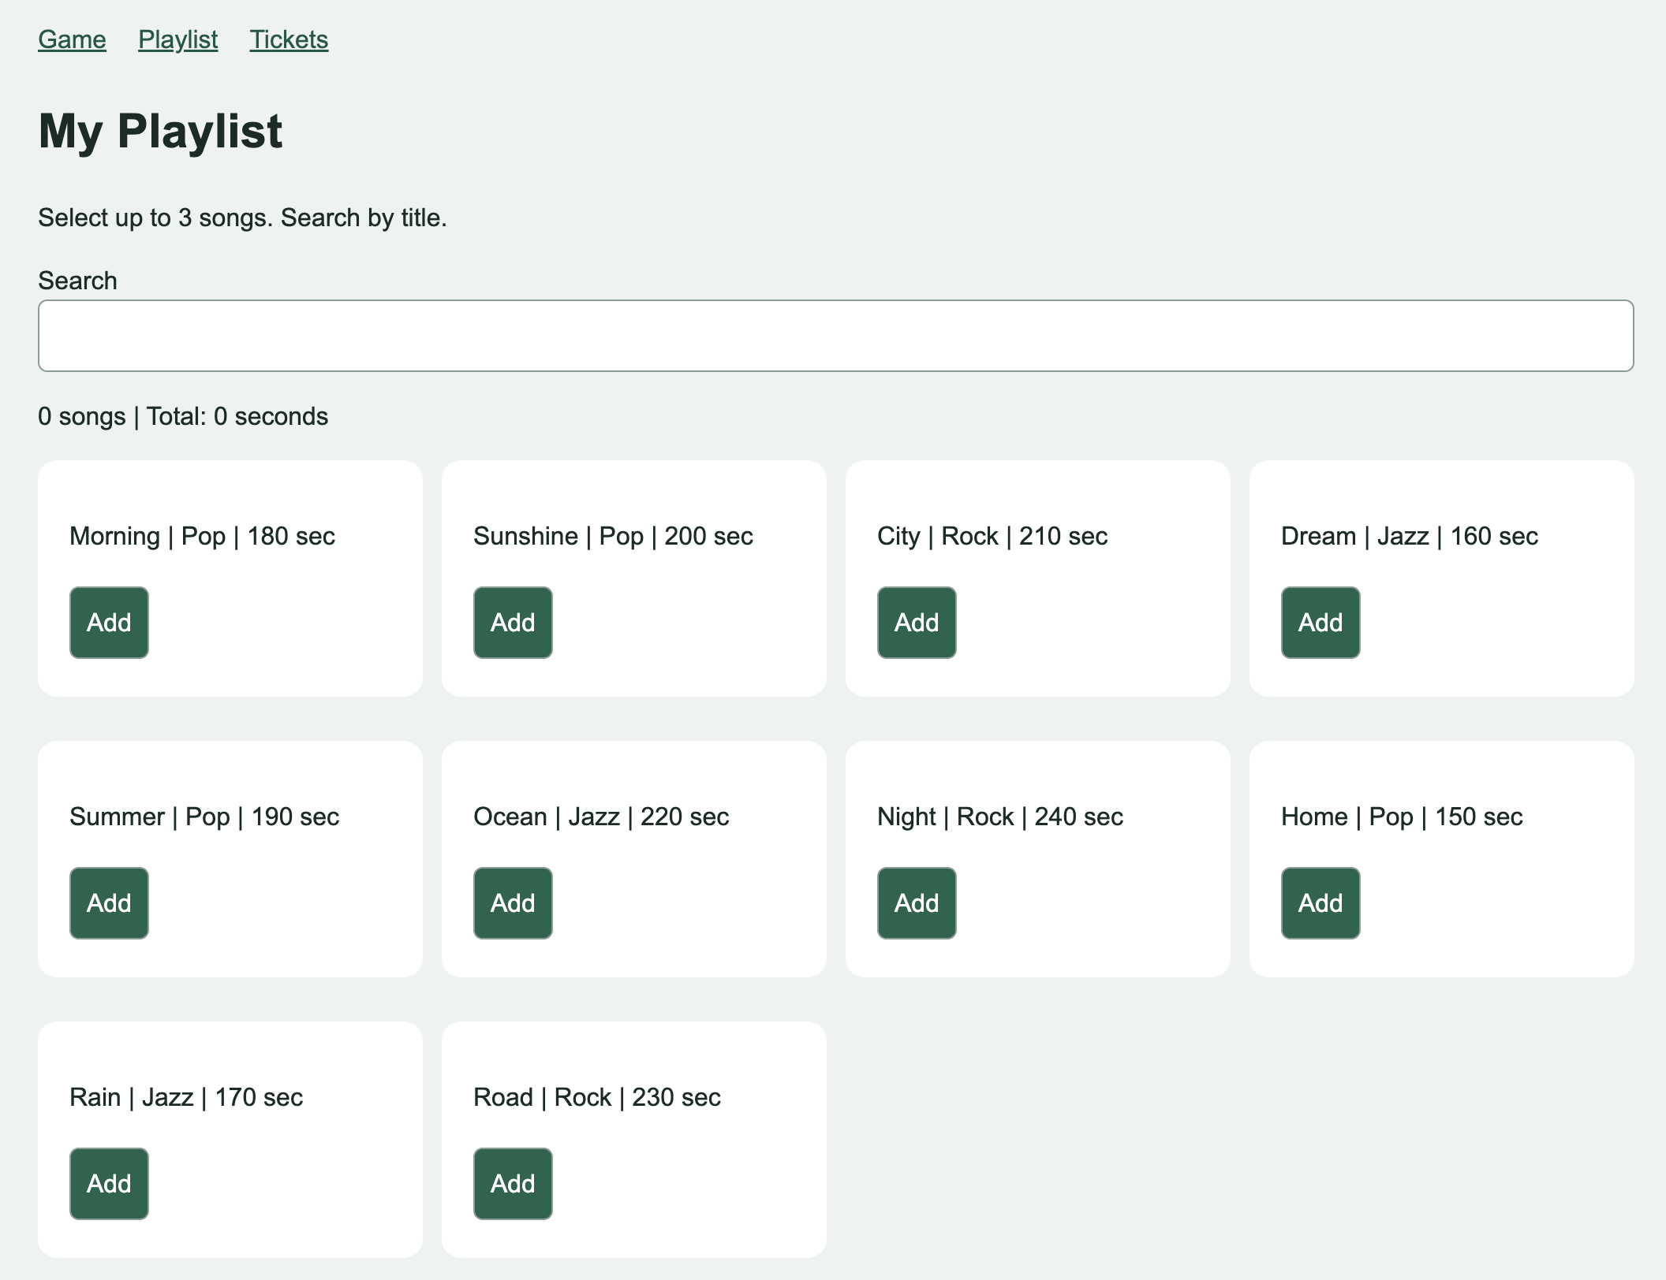

Task 3 Ticket Builder
Option A. Seven fields: event, date, ticket type, quantity, full name, email and promo code. The preview updates while typing. A field is checked on blur and then on input. Errors appear under fields with aria-invalid.
form.noValidate turns off browser messages. HTML constraints and checkValidity() remain active. Submission shows the error count and focuses the first error. Correct data creates a ticket with a random booking code, then resets the form.
Field | Rule | Valid | Invalid
Date | 11 Jan 2027 is sold out. | 12 Jan 2027 | 11 Jan 2027
Quantity | Cannot exceed seats left. | VIP: 2 | VIP: 4
Full name | First and last name required. | Inzhu Beken | Inzhu
Promo | Empty or a listed code. | STUDENT10 | SAVE50
Email | HTML email format. | a@example.com | abc
Quantity | Whole number from 1 to 10. | 2 | 0 or 1.5
Standard: 3000 KZT, 10 seats. VIP: 6000 KZT, 3 seats. Dates: 10 to 12 January 2027. STUDENT10 gives 10% off. Example: 2 VIP tickets cost 6000 × 2 × 0.9 = 10800 KZT.
Figure 3 Ticket preview or successful booking
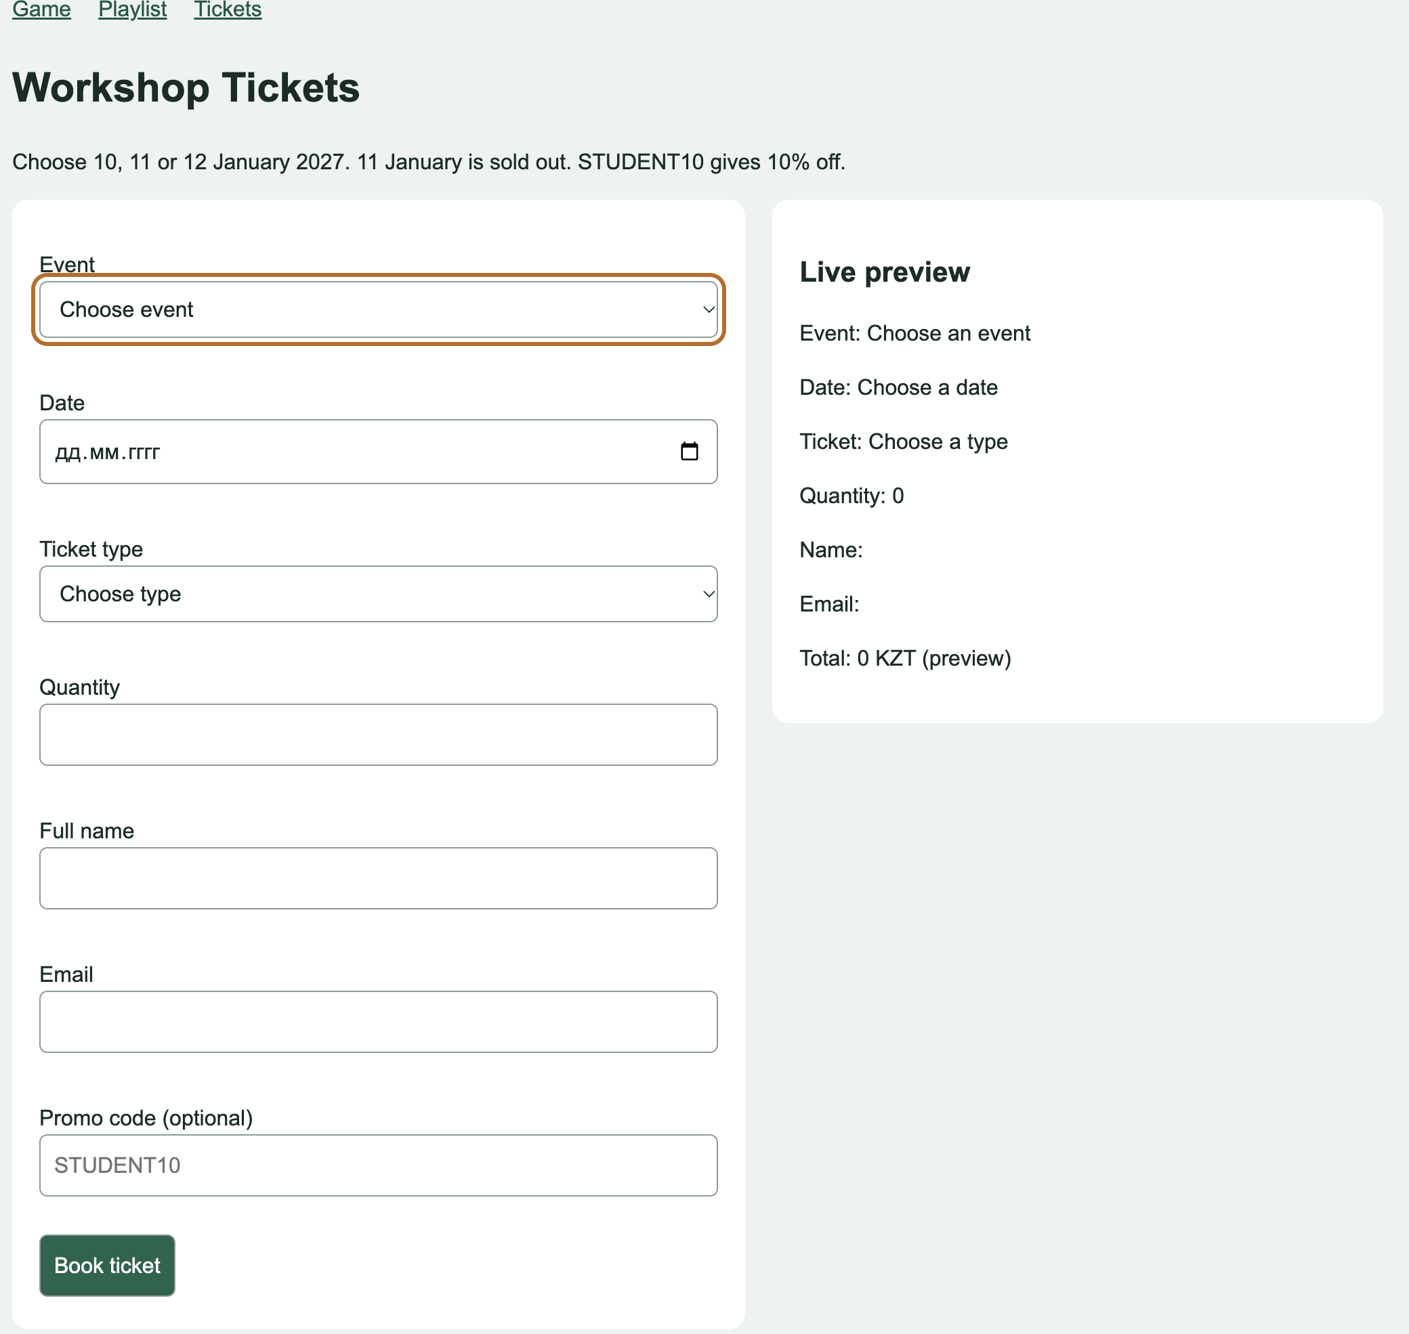

Conclusion and Sources
The tasks use functions, arrays, loops, DOM creation and event listeners. The form adds live feedback and checks the data before creating a result.
Sources: Week 7 (1).pdf for functions, arrays, loops, DOM and events; Assignment 5.pdf for task rules, random numbers and validation requirements.

