

Course Name: Computer Graphics Fundamentals
Project Title: Assignment 2 — Interaction, Windows, Menus, Animation and 3D Transformations in OpenGL
Team Members: Beknur Tanibergen
Instructor: Zhanabilov Almas
Date of Submission: 2 October 2026
1. Introduction
This report documents Assignment 2 of Computer Graphics Fundamentals. The assignment has two parts. The first part extends the Assignment 1 programs with interaction: double buffering, several windows and a sub-window, pop-up menus, keyboard and mouse callbacks, and animation driven by the idle callback. The second part moves from 2D to 3D: a coloured cube is defined, drawn with the depth test enabled, and transformed by the user from the keyboard through scaling, rotation and translation matrices that are applied in the vertex shader.
Both parts are built with the same modern, shader-based pipeline as Assignment 1 (OpenGL 4.1 core profile, GLSL 410, vertex array objects). No deprecated fixed-function calls (glBegin, glVertex, glRotate, the matrix stack) are used. The windowing layer changes from GLFW to GLUT, because GLUT is the toolkit that provides menus, sub-windows and the idle/redisplay callback model that the assignment is about [11]. The expected outcomes are two runnable programs, interaction and cube, a Makefile whose default target builds both, and the rendered images shown in Section 5.
2. Literature Review
Interactive computer graphics began with Sutherland's Sketchpad, which already combined a display, a pointing device and a program that redrew the picture in response to the user [12]. Shneiderman later named the resulting style “direct manipulation”: visible objects, rapid incremental actions and immediate feedback [13]. Myers' history of human–computer interaction technology traces how windows, pop-up menus and mouse-driven input moved from research systems into every desktop toolkit [14]. The main window, the sub-window and the right-click menus of Part 1 are small instances of exactly these ideas: every key press or menu choice changes program state and the picture is redrawn at once.
Window systems structure that interaction. The X Window System described a hierarchy of windows and sub-windows, each with its own event stream, managed by a server that sends input and expose events to clients [15]. GLUT adopts the same model in a portable form: a program registers display, reshape, keyboard, mouse and idle callbacks per window and then hands control to an event loop [11]. Pop-up menus are a classical alternative to keyboard commands; Callahan et al. compared linear and pie menus and showed that menu layout measurably affects selection time and errors [16]. GLUT menus are linear menus with cascading sub-menus, which is the layout requested for the “Square Colors” entry in this assignment.
Smooth animation depends on how frames reach the screen. With a single buffer the viewer sees the image while it is being drawn, which causes flicker. Double buffering renders into a hidden back buffer and swaps it with the visible front buffer when the frame is complete; this is part of the OpenGL framebuffer model [18] and of the textbook presentation used in the course [19]. Lasseter's principles of traditional animation, such as timing and squash-and-stretch, explain why a periodic change of size reads as “breathing” rather than as a jump [17]. The breathing circle in Part 1 uses a sine of time for its scale, a minimal form of that timing curve.
Part 2 relies on the theory of geometric transformations. Riesenfeld explained homogeneous coordinates and why 4×4 matrices let translation, rotation and scaling be combined by matrix multiplication [3]. Carlbom and Paciorek classified planar geometric projections and showed that an orthographic projection keeps the size of an object independent of its depth [4]; this is why translating the cube along Z in this assignment has no visible effect. Rotations built from three axis angles are easy to control from a keyboard but depend on the order of the axes; Shoemake introduced quaternions to interpolate rotations without this problem [5], and Chen et al. studied how 2D input devices can best control 3D rotation [6]. The cube in this project keeps the simpler axis-angle scheme that the assignment asks for, and fixes the order Rz·Ry·Rx.
Correct 3D display also needs hidden-surface removal. Sutherland, Sproull and Schumacker compared ten hidden-surface algorithms [7], and Catmull's depth-buffer (z-buffer) method stores one depth per pixel and keeps the nearest fragment [8]. The OpenGL depth test used in Part 2 is that z-buffer in hardware [18]. Faces are coloured with flat per-face colours; Gouraud's interpolation [1], used in Assignment 1, is still what the rasteriser does with the colour attribute. Finally, the matrices are applied in a programmable vertex shader, the stage introduced by languages such as Cg [2] and executed on unified GPU cores [9], [10]. Together these works give the background for every callback and every matrix in the submitted code.
3. Project Description
3.1 Objective
The objective is to implement both parts of Assignment 2 on macOS with a core-profile OpenGL pipeline. Part 1 must (i) enable double buffering, (ii) show the black-and-white square in a main window, (iii) show an ellipse in a sub-window of the main window with its own background colour, (iv) give the sub-window its own menu for that background colour, (v) draw a circle and a triangle of the same colour in a separate window titled “window 2” whose colour is chosen with the keys r, g, b, y, o, p and w, (vi) animate the shapes with the idle function (squares counter-clockwise, triangle clockwise, circle breathing), and (vii) attach a right-click menu with Stop Animation, Start Animation and a Square Colors sub-menu to the main window. The extra-credit task adds a breathing circle of random colour wherever the user left-clicks in the main window.
Part 2 must display a 3D coloured cube with the depth test enabled, provide a menu that selects SCALE, ROTATE or TRANSLATE, define six keys that increase and decrease the X, Y and Z components of the selected transformation, two keys that change the per-transformation delta and one key that resets everything. The transformations must be combined in the order scale, rotation, translation, applied to the vertices in the vertex shader, without a camera or projection matrix, and the only terminal output must be the instructions.
3.2 Problem Statement
Assignment 1 produced static pictures in a single GLFW window. GLFW has no menus and no sub-windows, so the first problem is to move the existing modern-OpenGL code to GLUT while keeping the core profile and the shader pipeline. On macOS this means using Apple's GLUT framework with the GLUT_3_2_CORE_PROFILE flag. The second problem is that every GLUT window, including a sub-window, has its own OpenGL context, so shader programs and vertex arrays cannot simply be shared between them. The third problem is to describe motion and 3D placement with matrices instead of editing vertex data: rotation, breathing and the cube transformations must all be expressed as a model matrix sent to the vertex shader.
3.3 Scope
In scope: GLUT windows, a sub-window and callbacks (display, reshape, idle, keyboard, mouse, menu); double buffering; menus with a sub-menu; idle-driven animation and NULL idle callback for stopping; 2D model matrices for rotation and scaling; mouse-to-clip-space mapping; a 36-vertex colour cube; depth testing; scale, rotation and translation matrices built in the application and applied in GLSL; keyboard control with per-transformation deltas; screenshots. Out of scope: camera (view) and perspective projection matrices, lighting models, texture mapping, quaternion or arcball rotation, and mouse-driven 3D manipulation. These topics are mentioned as future work in Section 7.
4. Technical Implementation
4.1 Tools and Technologies Used
The implementation language is C++17, compiled with Apple Clang. Windows, sub-windows, menus and callbacks come from Apple's GLUT framework, which ships with macOS, so no extra package has to be installed. The display mode GLUT_3_2_CORE_PROFILE | GLUT_RGBA | GLUT_DOUBLE (plus GLUT_DEPTH for the cube) gives an OpenGL 4.1 core context. Headers are <OpenGL/gl3.h> and <GLUT/glut.h>; the macro __gl_h_ is defined between them so that the legacy gl.h is not included. Shaders are GLSL 410 core. A POSIX Makefile builds two executables, interaction (Part 1) and cube (Part 2), and the helpers in src/common.cpp provide shader loading, mesh upload, a column-major Mat4 type and a PPM screenshot function.
4.2 Development Process
Development started from the Assignment 1 helpers. The GLFW window code was replaced by GLUT, and the mesh upload code was generalised so that a mesh can have 2D or 3D positions. A small matrix module (identity, multiplication, translate, scale, rotateX/Y/Z) was written once and used by both programs. Part 1 was built step by step in the order of the brief: double buffering, the main window with the nested square, the sub-window with the ellipse and its menu, window 2 with the keyboard colours, the idle animation, the main menu, and finally the extra-credit mouse handler. Part 2 was written as a separate program: cube geometry, depth test, the model matrix, the menu, and the keyboard. Each step was compiled and run on the author's MacBook (Apple Silicon).
For verification the programs have a test mode controlled by environment variables. A2_SCREENSHOT makes the program read back its back buffer into a PPM file after a fixed number of animation frames and then exit; A2_KEYS, A2_MENU and A2_SUBMENU call the same keyboard and menu callbacks that the user would trigger. This mode is silent and does not change normal behaviour. It was used to produce the animation frames and colour variants in Section 5; the other figures are captures of the live macOS windows.
4.3 Algorithms and Techniques
Per-window resources. Because each GLUT window has its own context, a Renderer structure (program and uniform locations) and the needed VAOs are created right after each glutCreateWindow / glutCreateSubWindow call, while that window is current. All 2D shapes are uploaded once as unit shapes and placed with a model matrix uModel; their colour comes from a uniform uColor.
Double buffering. GLUT_DOUBLE is requested at start-up, every display callback draws into the back buffer and ends with glutSwapBuffers(), so a frame is shown only when it is complete.
Idle animation. The idle callback measures the time since its previous call with glutGet(GLUT_ELAPSED_TIME) and advances three values: the square angle (+40°/s), the triangle angle (−60°/s) and the breathing phase (+2.5 rad/s). It then calls glutPostRedisplay() for the main window, the sub-window and window 2. In OpenGL a positive rotation about Z is counter-clockwise, so the squares use a growing angle and the triangle a decreasing one. The model matrices are:
squares: M = Rz(squareAngle) · S(size)
triangle: M = T(0.45, 0) · Rz(triangleAngle) · S(0.38)
circle: M = T(-0.45, 0) · S(0.28 · s), s = 1 + 0.35 · sin(phase)
Stopping and starting. Stop Animation calls glutIdleFunc(NULL), which removes the idle callback, so nothing changes and no redisplay is requested. Start Animation registers idle again and first resets the stored time, so the shapes continue smoothly instead of jumping by the length of the pause.
Menus. The main menu is created with glutCreateMenu, two glutAddMenuEntry calls and glutAddSubMenu for “Square Colors” (White, Red, Green), then attached with glutAttachMenu(GLUT_RIGHT_BUTTON) while the main window is current. The colour choice replaces the white layers of the nested square while the black layers stay black, so the nested pattern remains visible. The sub-window menu (Light Yellow, Light Cyan, Pink, Gray, White) is created while the sub-window is current, so it is attached to the sub-window only.
Mouse to clip space (extra credit). GLUT reports mouse positions in window pixels with y pointing down. A left click at (x, y) is converted to clip coordinates and stored with a random colour and a random breathing phase:
x_ndc = 2x / width - 1
y_ndc = 1 - 2y / height
Cube geometry. The cube follows the lecture colorcube: eight vertices at ±0.5, eight vertex colours (black, red, yellow, green, blue, magenta, white, cyan) and six quad(a, b, c, d) calls. Each quad is split into two triangles, giving 36 vertices, and every face takes the colour of its first vertex.
Transformation pipeline. The application keeps three vectors, scale (sx, sy, sz), rotation angles (θx, θy, θz) and translation (tx, ty, tz), and builds the model matrix on every update:
S = scale(sx, sy, sz)
R = Rz(θz) · Ry(θy) · Rx(θx)
T = translate(tx, ty, tz)
M = T · R · S
Because the matrix is applied to a column vector, the right-most factor acts first: the cube is scaled, then rotated, then translated, exactly as required. M is sent as a uniform and the vertex shader computes gl_Position = uModel * vPosition. No view or projection matrix is applied, so the default orthographic view volume [−1, 1]³ is used.
Keyboard control. Each transformation has its own delta (scale 0.1, rotation 5°, translation 0.05). The six component keys add or subtract the delta of the current transformation, the + and − keys double or halve that delta, and r restores all values and deltas. Because no idle callback is registered in this program, the cube changes only when a key is pressed.
Key | Action (current transformation)
q / a | increase / decrease X
w / s | increase / decrease Y
e / d | increase / decrease Z
+ / − | double / halve the delta
r | reset all transformations and deltas
1 / 2 / 3 | shortcut for SCALE / ROTATE / TRANSLATE
right click | menu: SCALE, ROTATE, TRANSLATE
Table 1. Keyboard and menu controls of the cube program.
5. Graphics and Rendering
5.1 2D/3D Rendering Techniques
Part 1 is 2D in clip space, as in Assignment 1, but now each shape is positioned with a model matrix instead of fixed vertex coordinates. Figure 1 shows the live main window: the nested black-and-white square from Assignment 1 rotating in the centre and the sub-window in the top-left corner, which draws an ellipse over its own light-yellow background.
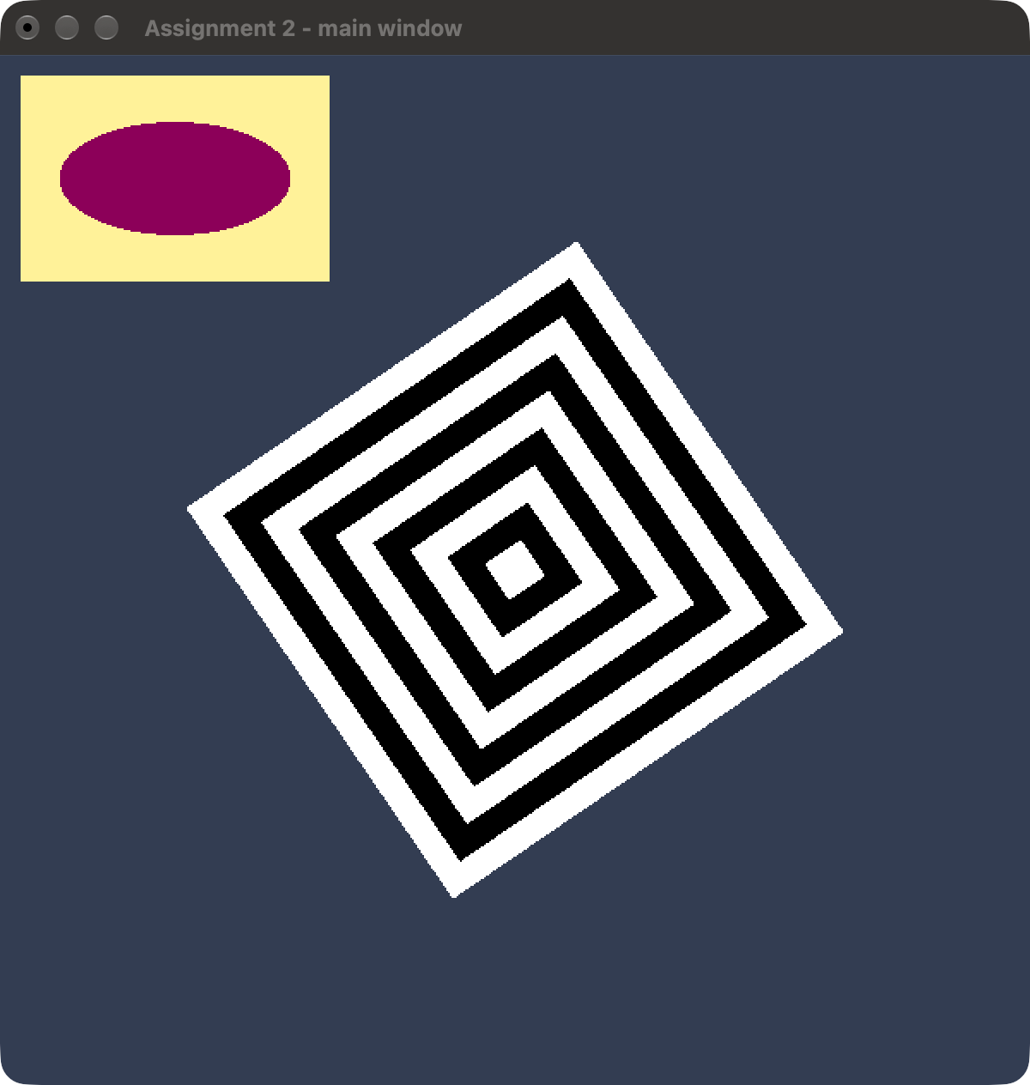
Fig. 1. Main window with the sub-window (live macOS window).
Figure 1 illustrates requirements 2 and 3. The sub-window is created with glutCreateSubWindow(main, 12, 12, 180, 120) and has its own display function, which clears to its own colour before drawing the ellipse (x = 0.75 cos θ, y = 0.55 sin θ).
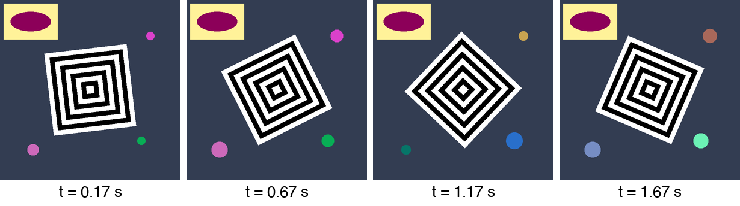
Fig. 2. Main window over time: the squares rotate counter-clockwise.
Figure 2 illustrates the idle animation of the main window. Four frames taken 0.5 s apart show the nested square turning counter-clockwise by 20° per frame interval; the extra-credit circles grow and shrink with their own phases.
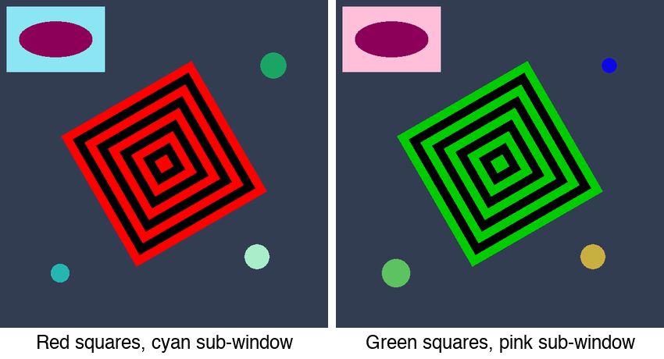
Fig. 3. Result of the menus: Square Colors → Red / Green and new sub-window backgrounds.
Figure 3 illustrates the main-window menu and the sub-window menu. On the left, Square Colors → Red was chosen and the sub-window background was set to Light Cyan; on the right, Square Colors → Green and Pink. The small circles of random colour were added by left clicks (extra credit).
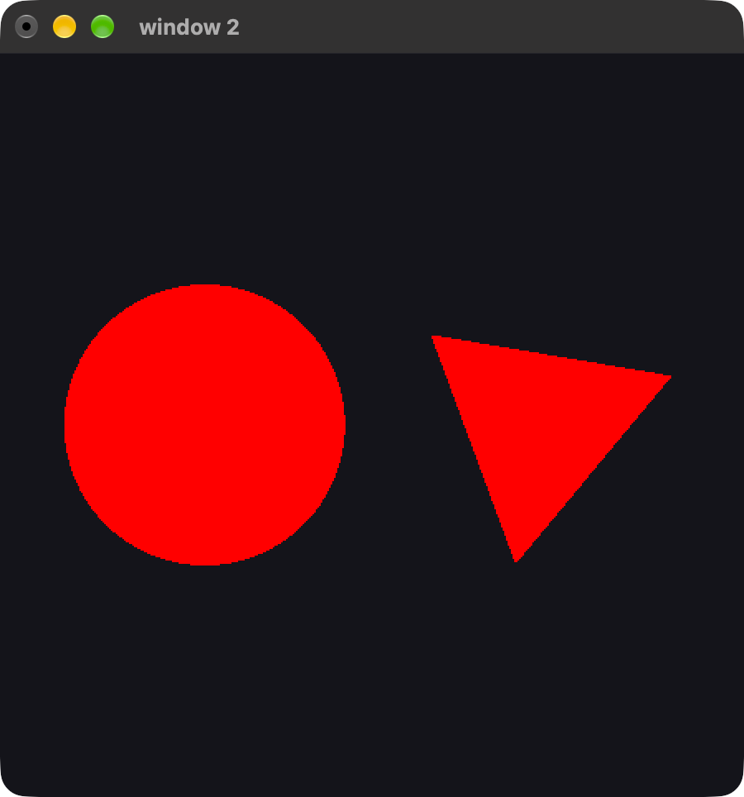
Fig. 4. “window 2” with the circle and the triangle (live macOS window).
Figure 4 illustrates requirement 5: a separate top-level window titled “window 2” that draws a circle and a triangle with one shared colour.
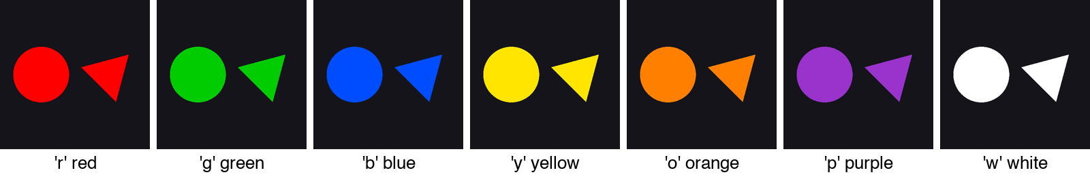
Fig. 5. window 2 after each colour key: r, g, b, y, o, p, w.
Figure 5 illustrates the keyboard callback of window 2. Each key sets the shared colour, so the circle and the triangle always have the same colour.
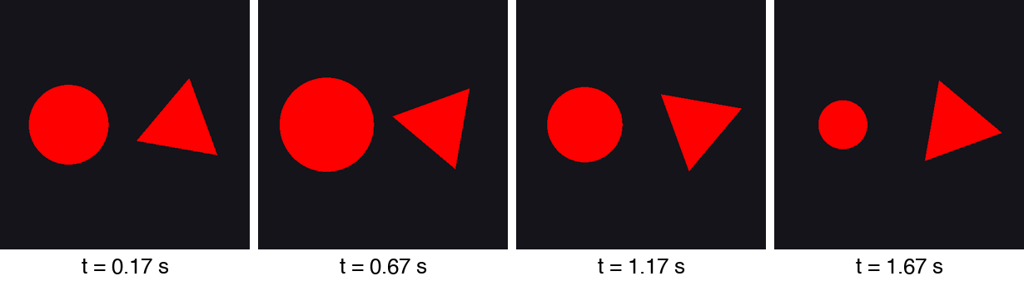
Fig. 6. window 2 over time: the triangle rotates clockwise, the circle “breathes”.
Figure 6 illustrates requirement 6 for window 2. The triangle turns clockwise by 30° between frames, and the circle radius follows 1 + 0.35 sin(phase), so it is larger at t = 0.67 s and smaller at t = 1.67 s.
Part 2 is the first real 3D scene. Figure 7 shows the cube program right after start-up. With the identity transformation the view looks straight along the Z axis, so only one face is visible; the title bar shows the current mode and its delta.
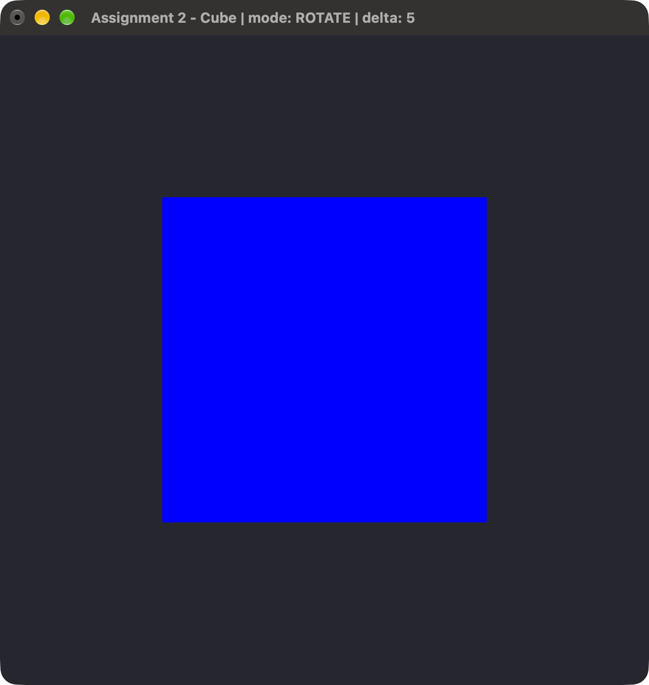
Fig. 7. Cube program at start-up (identity transformation, live macOS window).
Figure 7 illustrates the default orthographic view. In clip space a larger z is farther away, so with the default depth test the face at z = −0.5 (blue) is in front.
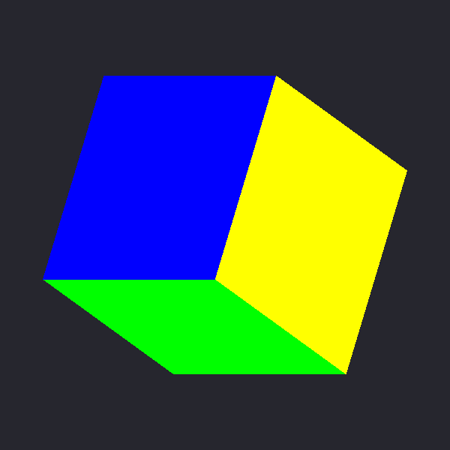
Fig. 8. ROTATE mode: 25° about X and 40° about Y.
Figure 8 illustrates the rotation keys (q pressed five times, w eight times with the default 5° delta). Three faces are visible and the depth test hides the other three correctly.
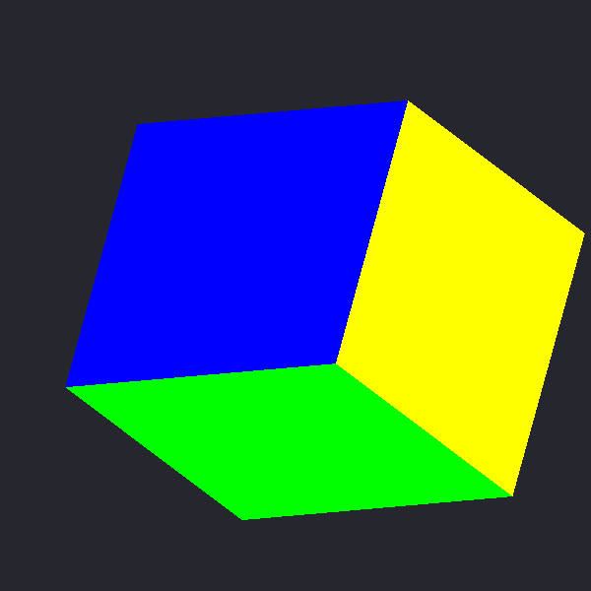
Fig. 9. All three transformations combined: scale, then rotate, then translate.
Figure 9 illustrates the full M = T · R · S pipeline. The cube was scaled, rotated about all three axes and translated to the right and downward; the part that leaves the view volume on the right is clipped, as the brief predicts.
5.2 Lighting and Shading
No illumination model is evaluated. In Part 1 every shape has one solid colour from the uColor uniform. In Part 2 every face has one solid colour from the vColor attribute; the rasteriser still interpolates that attribute [1], but since all six vertices of a face share the colour, faces look flat. The sense of depth comes only from the different face colours and from the depth test [7], [8], which keeps the nearest fragment per pixel. Adding normals and a Phong light would be the next step.
5.3 Texturing and Animation
No textures are used. Animation is the main new topic of Part 1. Motion is time based: the idle callback multiplies speeds by the real elapsed time, so the angular speed does not depend on the frame rate. Double buffering removes flicker, and the NULL idle callback freezes every window at once. The breathing effect is a periodic scale, a simple use of the timing principle described by Lasseter [17]. The cube in Part 2 is deliberately not animated; it changes only on key strokes, as the brief requires.
6. Testing and Evaluation
6.1 Testing Methodology
Testing was visual and build based. The procedure was:
- Run make from a clean tree and confirm that interaction and cube are built without warnings.
- Start ./interaction and check that the main window, its sub-window and window 2 appear, and that the squares turn counter-clockwise, the triangle clockwise and the circle breathes.
- Open the main menu with a right click; check Stop Animation, Start Animation and each Square Colors entry. Open the sub-window menu and check every background colour.
- Press r, g, b, y, o, p and w in window 2 and check that both shapes change colour together.
- Left-click several points in the main window and check that a breathing circle of random colour appears under the cursor.
- Start ./cube, select each mode from the menu, press the six component keys, change the delta with + and −, and reset with r. Check that only the instructions are printed in the terminal.
- Capture the live windows (Figures 1, 4, 7) and use the silent test mode to save fixed animation frames and colour variants (Figures 2, 3, 5, 6, 8, 9).
6.2 Performance Evaluation
The scenes are very small: a few hundred vertices in Part 1 and 36 vertices in Part 2, one draw call per shape, no textures. Part 1 redraws three windows on every idle call and is limited by the display refresh, not by the GPU; Part 2 redraws only after a key press, so it is idle most of the time. This matches the expectations from the GPU architecture literature: a unified GPU is barely used by such scenes [9], [10]. Because motion is scaled by elapsed time, the animation speed is the same on displays with different refresh rates.
6.3 Issues and Debugging
Several practical issues appeared. First, including <GLUT/glut.h> after <OpenGL/gl3.h> pulls in the legacy gl.h and causes conflicts; defining __gl_h_ before glut.h solves this. Second, objects created in the main window were not available in the sub-window, because each GLUT window has its own context; the shader program and VAOs are therefore created per window. Third, a positive angle about Z turns a shape counter-clockwise, so the triangle needs a decreasing angle to turn clockwise. Fourth, after Stop Animation the first idle call measured the whole pause as one time step and the shapes jumped; the stored time is now reset in Start Animation. Fifth, GLUT gives mouse coordinates with y downward, so the y axis had to be flipped for the extra-credit circles. Sixth, in the cube program the face at z = −0.5 appears in front without a projection matrix, because clip-space z grows away from the viewer; this is the expected behaviour of the default view volume and is explained in Figure 7. Finally, menu and status messages are kept out of the terminal in Part 2 (the mode is shown in the title bar) so that the instructions are the only text output.
7. Conclusion and Future Work
The project meets the Assignment 2 specification. Part 1 adds double buffering, a main window, a sub-window with its own menu, a second window controlled from the keyboard, idle-driven animation that can be stopped and started from a menu with a sub-menu, and the extra-credit click-to-add breathing circles. Part 2 displays a depth-tested colour cube and lets the user scale, rotate and translate it from the keyboard, with a menu for the current transformation, per-transformation deltas and a reset key, and with the matrix M = T · R · S applied in the vertex shader. Both programs keep the modern core-profile pipeline from Assignment 1 and build from one Makefile.
Future work suggested by the literature and the course sequence includes: adding view and perspective projection matrices so that Z translation changes the apparent size [4]; replacing axis-angle rotation by quaternions or an arcball for smoother control [5], [6]; adding normals and a Phong light to the cube; and letting the mouse drag the cube directly, in the spirit of direct manipulation [13].
8. References
[1] H. Gouraud, “Continuous shading of curved surfaces,” IEEE Transactions on Computers, vol. C-20, no. 6, pp. 623–629, Jun. 1971, doi: 10.1109/T-C.1971.223313.
[2] W. R. Mark, R. S. Glanville, K. Akeley, and M. J. Kilgard, “Cg: A system for programming graphics hardware in a C-like language,” ACM Transactions on Graphics, vol. 22, no. 3, pp. 896–907, Jul. 2003, doi: 10.1145/882262.882362.
[3] R. F. Riesenfeld, “Homogeneous coordinates and projective planes in computer graphics,” IEEE Computer Graphics and Applications, vol. 1, no. 1, pp. 50–55, Jan. 1981, doi: 10.1109/MCG.1981.1673814.
[4] I. Carlbom and J. Paciorek, “Planar geometric projections and viewing transformations,” ACM Computing Surveys, vol. 10, no. 4, pp. 465–502, Dec. 1978, doi: 10.1145/356744.356750.
[5] K. Shoemake, “Animating rotation with quaternion curves,” ACM SIGGRAPH Computer Graphics, vol. 19, no. 3, pp. 245–254, Jul. 1985, doi: 10.1145/325165.325242.
[6] M. Chen, S. J. Mountford, and A. Sellen, “A study in interactive 3-D rotation using 2-D control devices,” ACM SIGGRAPH Computer Graphics, vol. 22, no. 4, pp. 121–129, Aug. 1988, doi: 10.1145/378456.378497.
[7] I. E. Sutherland, R. F. Sproull, and R. A. Schumacker, “A characterization of ten hidden-surface algorithms,” ACM Computing Surveys, vol. 6, no. 1, pp. 1–55, Mar. 1974, doi: 10.1145/356625.356626.
[8] E. Catmull, “A subdivision algorithm for computer display of curved surfaces,” Ph.D. dissertation, Dept. Computer Science, Univ. of Utah, Salt Lake City, UT, USA, 1974.
[9] J. D. Owens et al., “A survey of general-purpose computation on graphics hardware,” Computer Graphics Forum, vol. 26, no. 1, pp. 80–113, Mar. 2007, doi: 10.1111/j.1467-8659.2007.01012.x.
[10] E. Lindholm, J. Nickolls, S. Oberman, and J. Montrym, “NVIDIA Tesla: A unified graphics and computing architecture,” IEEE Micro, vol. 28, no. 2, pp. 39–55, Mar./Apr. 2008, doi: 10.1109/MM.2008.31.
[11] M. J. Kilgard, The OpenGL Utility Toolkit (GLUT) Programming Interface, API Version 3. Mountain View, CA, USA: Silicon Graphics, Inc., 1996.
[12] I. E. Sutherland, “Sketchpad: A man-machine graphical communication system,” in Proc. AFIPS Spring Joint Computer Conf., Detroit, MI, USA, 1963, pp. 329–346, doi: 10.1145/1461551.1461591.
[13] B. Shneiderman, “Direct manipulation: A step beyond programming languages,” Computer, vol. 16, no. 8, pp. 57–69, Aug. 1983, doi: 10.1109/MC.1983.1654471.
[14] B. A. Myers, “A brief history of human-computer interaction technology,” ACM Interactions, vol. 5, no. 2, pp. 44–54, Mar. 1998, doi: 10.1145/274430.274436.
[15] R. W. Scheifler and J. Gettys, “The X Window System,” ACM Transactions on Graphics, vol. 5, no. 2, pp. 79–109, Apr. 1986, doi: 10.1145/22949.24053.
[16] J. Callahan, D. Hopkins, M. Weiser, and B. Shneiderman, “An empirical comparison of pie vs. linear menus,” in Proc. SIGCHI Conf. Human Factors in Computing Systems (CHI ’88), Washington, DC, USA, 1988, pp. 95–100, doi: 10.1145/57167.57182.
[17] J. Lasseter, “Principles of traditional animation applied to 3D computer animation,” ACM SIGGRAPH Computer Graphics, vol. 21, no. 4, pp. 35–44, Jul. 1987, doi: 10.1145/37402.37407.
[18] M. Segal and K. Akeley, The OpenGL Graphics System: A Specification (Version 4.1 (Core Profile)). Khronos Group, 2010. [Online]. Available: https://registry.khronos.org/OpenGL/specs/gl/glspec41.core.pdf
[19] E. Angel and D. Shreiner, Interactive Computer Graphics: A Top-Down Approach with Shader-Based OpenGL, 6th ed. Boston, MA, USA: Pearson, 2012.
9. Appendix
A. How to build and run
cd "/Users/beknur/code/Computer Graphics/ass2"
make
./interaction
./cube
# Esc quits; programs must be started from the ass2 folder (shaders/)
Tested on macOS, Apple Silicon, Apple GLUT framework, OpenGL 4.1 Core. No extra dependency is required.
B. Vertex shader for the 2D shapes (shaders/vshader2d.glsl)
#version 410 core
in vec4 vPosition;
in vec4 vColor;
uniform mat4 uModel;
uniform vec4 uColor;
uniform int uUseVertexColor;
out vec4 color;
void main() {
gl_Position = uModel * vPosition;
color = (uUseVertexColor != 0) ? vColor : uColor;
}
C. Vertex shader for the cube (shaders/vshader_cube.glsl)
#version 410 core
in vec4 vPosition;
in vec4 vColor;
uniform mat4 uModel; // T * R * S, built in the application
out vec4 color;
void main() {
gl_Position = uModel * vPosition; // no camera / projection
color = vColor;
}
D. Source files
src/common.h, src/common.cpp — shader loading, mesh upload, Mat4 helpers, PPM screenshot. src/interaction.cpp — Part 1 (windows, sub-window, menus, idle animation, extra credit). src/cube.cpp — Part 2 (3D cube and transformations). shaders/*.glsl — GLSL 410 programs. Makefile — default target builds both executables. report_figures/ — images used in this report.
E. Terminal output of the cube program
The cube program prints only the following instructions when it starts:
Assignment 2 - Part 2: 3D colored cube
Right click the window to choose the transformation to modify:
SCALE / ROTATE / TRANSLATE (current mode is shown in the title bar)
Keys (change the current transformation by its delta):
q / a increase / decrease X
w / s increase / decrease Y
e / d increase / decrease Z
+ / - increase / decrease the delta of the current transformation
r reset all transformations and deltas
1 2 3 shortcut for SCALE / ROTATE / TRANSLATE
Esc quit
Note: with the default orthographic view, translating along Z does not
change the cube's size; it is clipped once it leaves the view volume.

