**HOME PAGE**

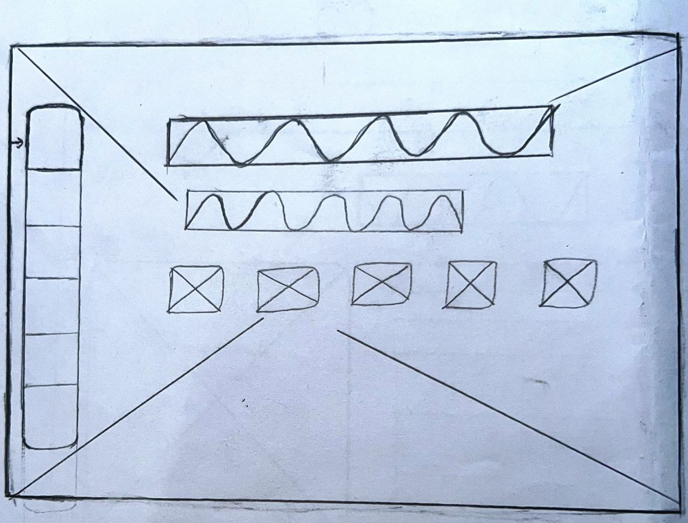

**ABOUT PAGE**

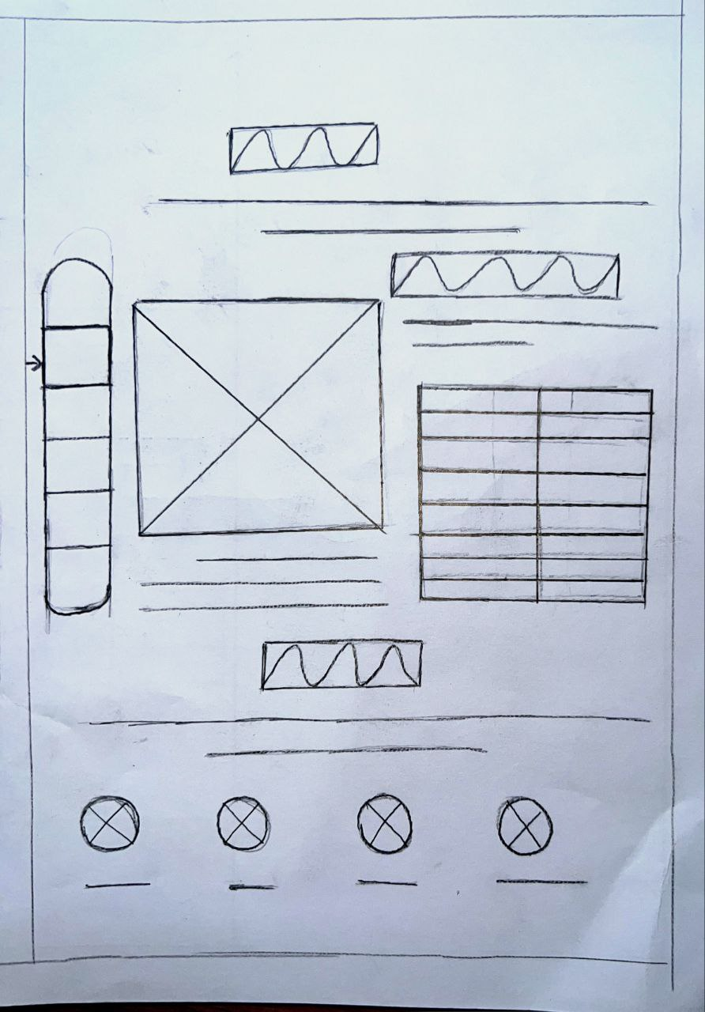

**RESUME PAGE**

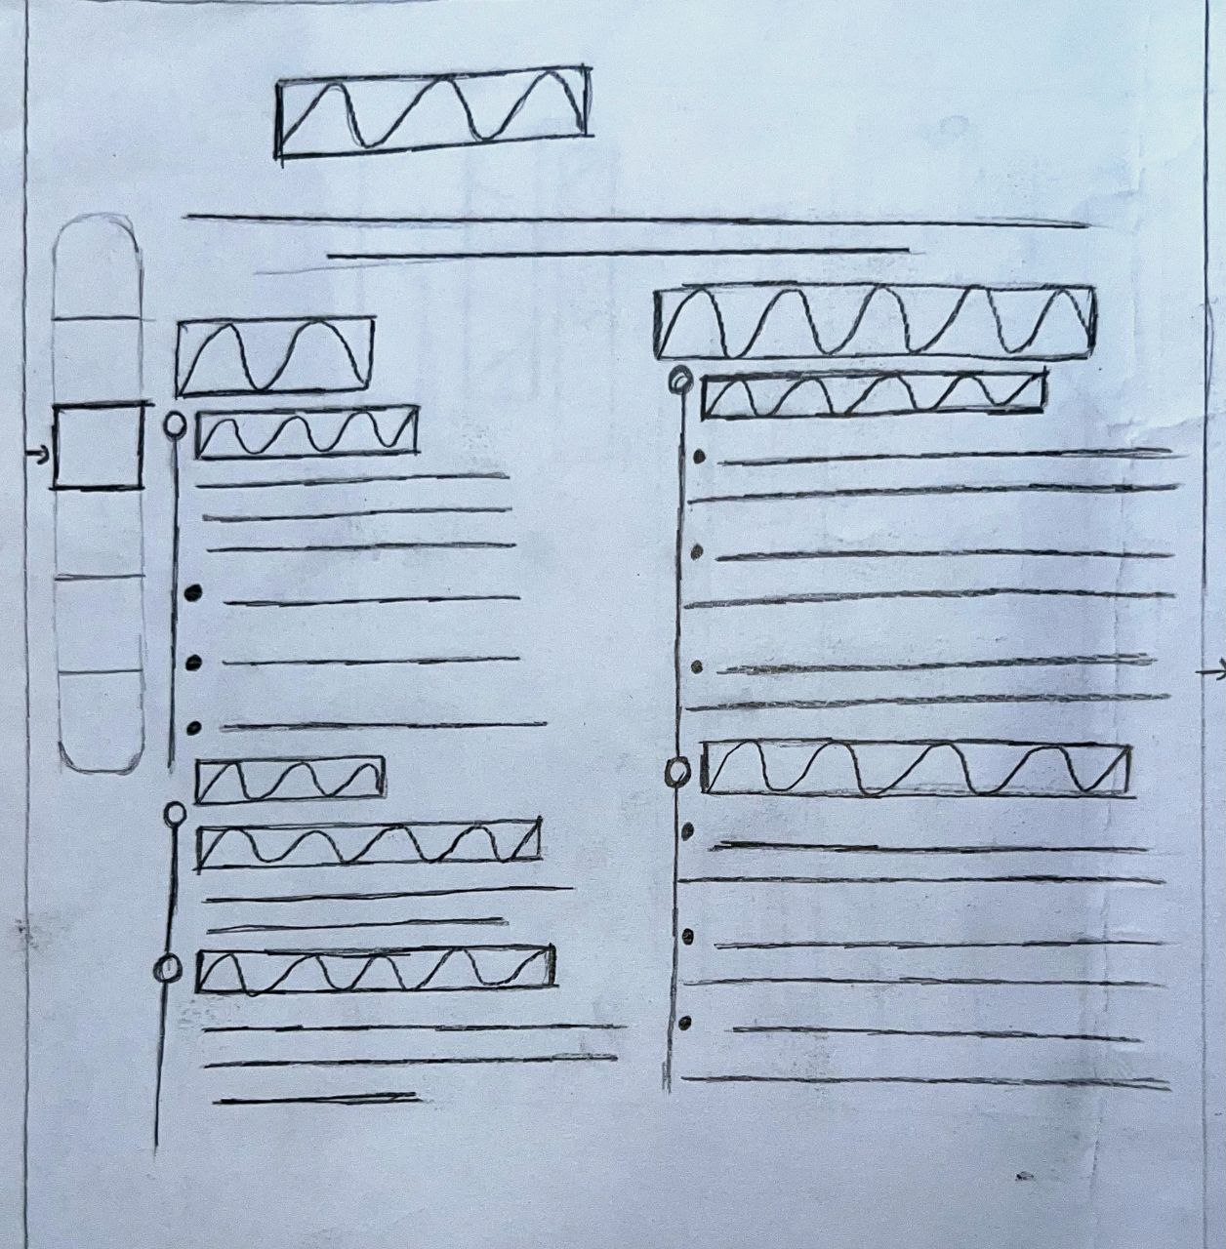

**PORTFOLIO PAGE**

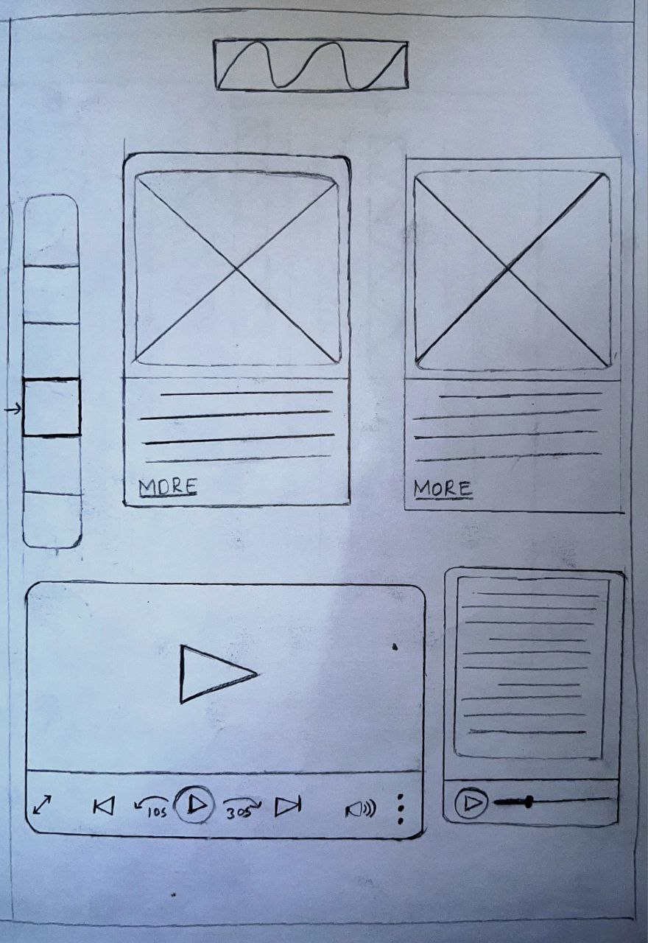

**TESTIMONIALS PAGE**

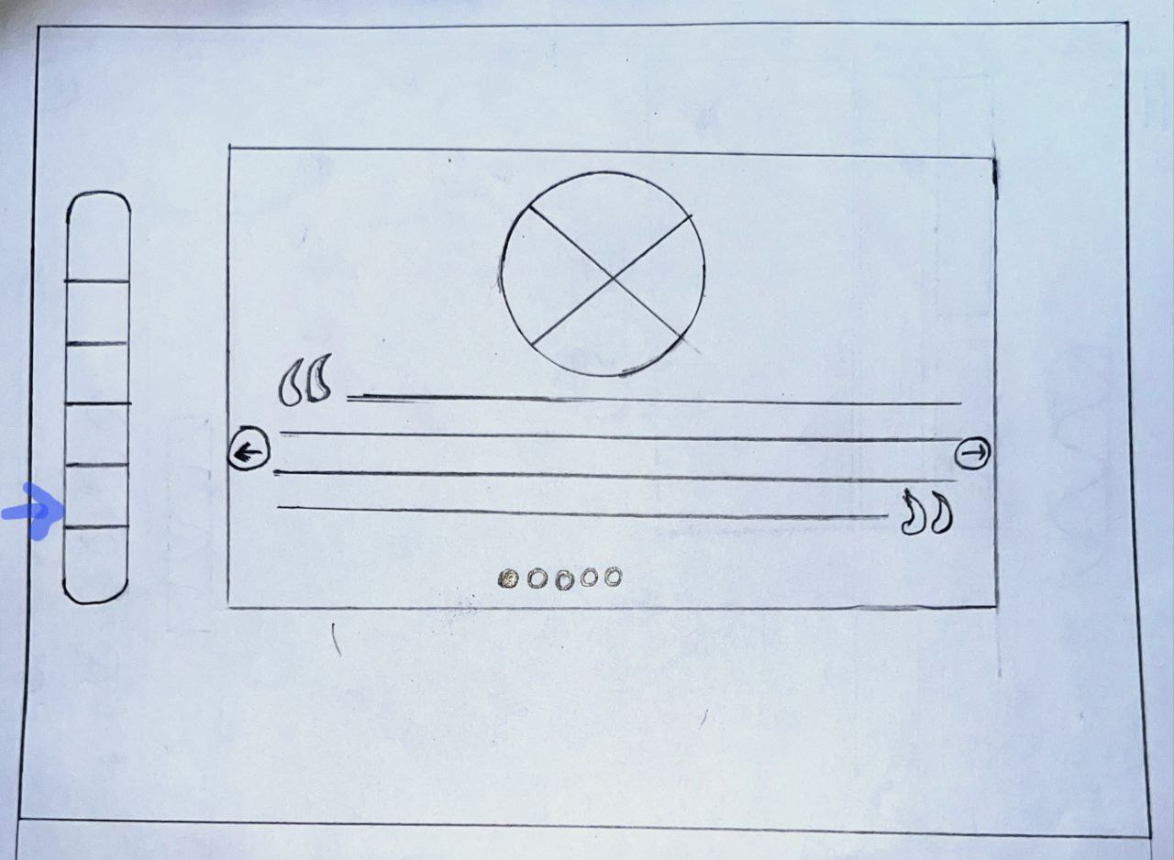

**CONTACT PAGE**

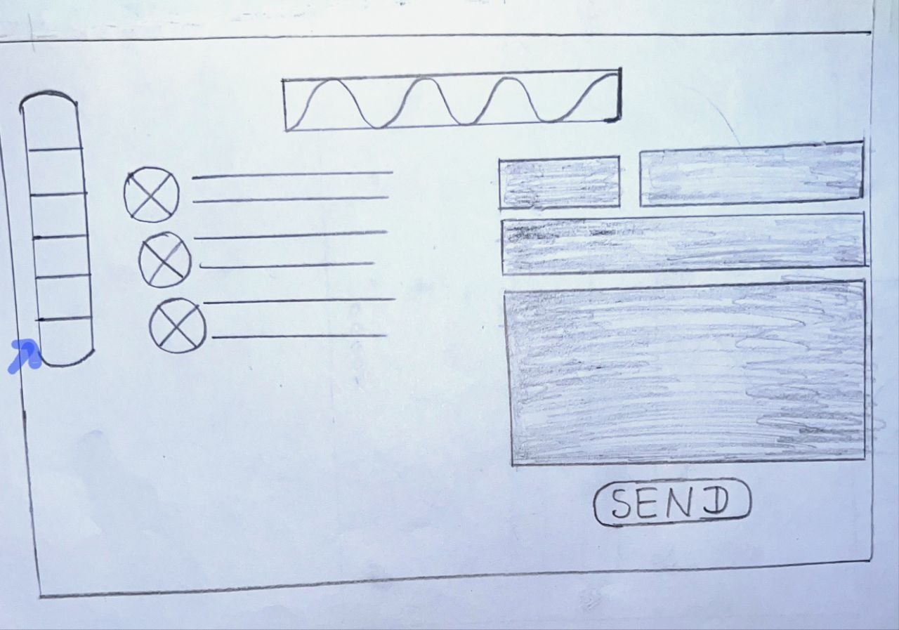

**FOTTER PAGE**

