**NEHEMIAH UNIVERSITY STUDENTS & GRADUATES UNION**

**Excellence Team**

**PRACTICE ENTRANCE EXAM II (PEE)**

1. A diver initially moving horizontally with speed v dives off the edge of a vertical cliff and lands in the water a distance d from the base of the cliff. How far from the base of the cliff would the diver have landed if the diver initially had been moving horizontally with speed 2v? (A) d (B) $\sqrt{2}$ d (C) 2d (D) 4d

Questions 2-3

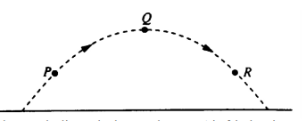 A ball is thrown and follows the parabolic path shown above. Air friction is negligible. Point Q is the highest point on the path. Points P and R are the same height above the ground.

1. How do the speeds of the ball at the three points compare? (A) VP < VQ < VR (B) VR < VQ < VP (C) VQ < VR < VP (D) VQ< VP = VR
2. Which of the following diagrams best shows the direction of the acceleration of the ball at point P? 
3. The position vs. time graph for an object moving in a straight line is shown below. What is the instantaneous velocity at t = 2 s? 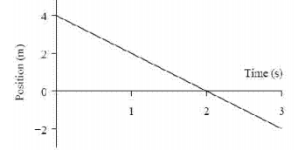 (A) – 2 m/s (B) ½ m/s (C) 0 m/s (D) 2 m/s
4. An object is released from rest and falls a distance h during the first second of time. How far will it fall during the next second of time? (A) h (B) 2h (C) 3h (D) 4h
5. An arrow is aimed horizontally, directly at the center of a target 20 m away. The arrow hits 0.050 m below the center of the target. Neglecting air resistance, what was the initial speed of the arrow? (A) 20 m/s (B) 40 m/s (C) 100 m/s (D) 200 m/s 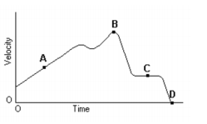
6. Given the graph of the velocity vs. time of a duck flying due south for the winter. At what point did the duck stop its forward motion? (A) A (B) B (C) C (D) D
7. A wooden box is first pulled across a **horizontal steel plate(A)**. The box is then pulled across the same steel plate while the plate is **inclined(B)**. How does the force required to overcome friction in the inclined case **(B)** compare to the horizontal case (**A)?** (A) the frictional force is the same in both cases (B) the inclined case has a greater frictional force (C) the inclined case has less frictional force (D) the frictional force increases with angle until the angle is 90º, then drops to zero

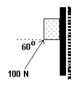

1. A 6.0 kg block initially at rest is pushed against a wall by a 100 N force as shown. The coefficient of kinetic friction is 0.30 while the coefficient of static friction is 0.50. What is

true of the friction acting on the block after a time of 1 second? (A) Static friction acts upward on the block. (B) Kinetic friction acts upward on the block (C) Kinetic friction acts downward on the block. (D) Static friction acts downward on the block.

1. In which of the following situations would an object be accelerated? Select two answers. (A) It moves in a straight line at constant speed. (B) It moves with uniform circular motion. (C) It travels as a projectile in a gravitational field with negligible air resistance. (D) It is at rest.
2. A block on a horizontal frictionless plane is attached to a spring, as shown. The block oscillates along the x-axis with amplitude A. Which of the following statements about energy is correct? (A) The potential energy of the spring is at a minimum at x = 0. (B) The potential energy of the spring is at a minimum at x = A. (C) The kinetic energy of the block is at a minimum at x =0. (D) The kinetic energy of the block is at a maximum at x = A. 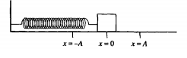
3. A rock is lifted for a certain time by a force F that is greater in magnitude than the rock's weight W. The change in kinetic energy of the rock during this time is equal to the (A) work done by the net force (F - W) (B) work done by F alone (C) work done by W alone (D) difference in the potential energy of the rock

before and after this time.

1. A railroad car of mass m is moving at speed v when it collides with a second railroad car of mass M which is at rest. The two cars lock together instantaneously and move along the track. What is the kinetic energy of the cars immediately after the collision? (A) ½ mv2 (B) ½ (M+m) (mv/M)2 (C) ½ (M+m) (Mv/m)2 (D) ½ (M+m) (mv/(m+M))2

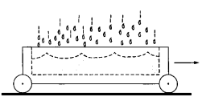

1. An open cart on a level surface is rolling without frictional loss through a vertical downpour of rain, as shown above. As the cart rolls, an appreciable amount of rainwater accumulates in the cart. The speed of the cart will (A) increase because of conservation of mechanical energy (B) decrease because of conservation of momentum (C) decrease because of conservation of mechanical energy (D) remain the same because the raindrops are falling perpendicular to the direction of the cart's motion
2. An object of mass M travels along a horizontal air track at a constant speed v and collides elastically with an object of identical mass that is initially at rest on the track. Which of the following statements is true for the two objects after the impact? (A) The total momentum is Mv and the total kinetic energy is ½ Mv2 (B) The total momentum is Mv and the total kinetic energy is less than ½ Mv (C) The total momentum is less than Mv and the total kinetic energy is ½ Mv2 (D) The momentum of each object is ½ Mv