**SDS Internship – Laravel Auth with JWT – Bekim Frangu**

1. Install jwt via composer



1. Publish vendor



1. Look composer.json file if dependencie is there

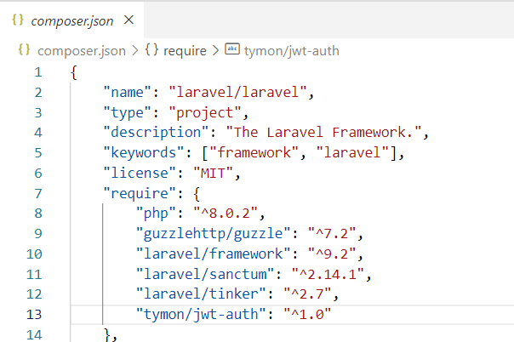

1. Generate jwt secret to the .env file



* 1. Look the key of jwt



1. Update the User model, adding the JWTSubject and methods

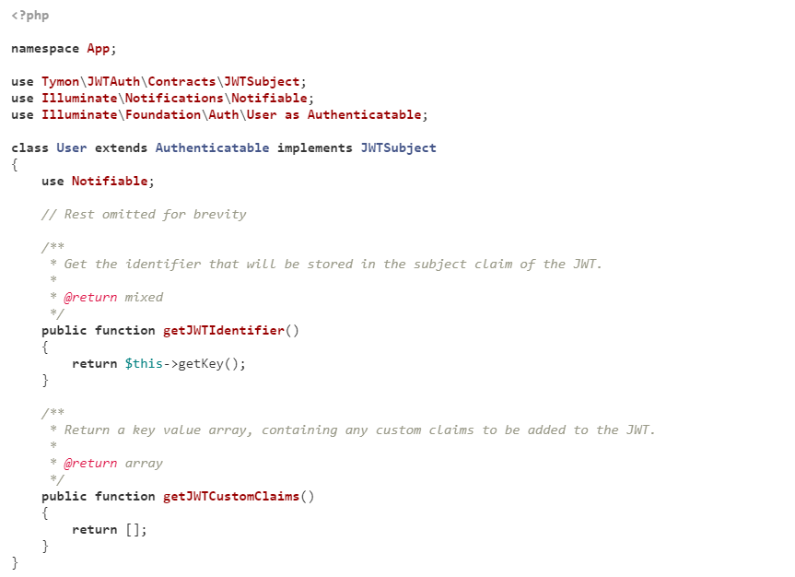

1. Update config/auth file for default guard

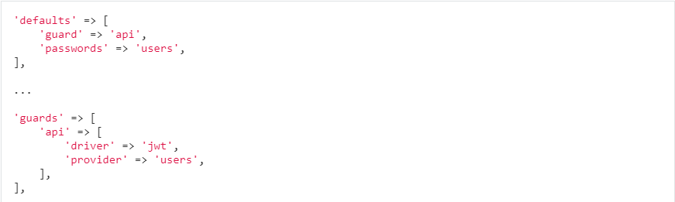

1. Create some auth routes

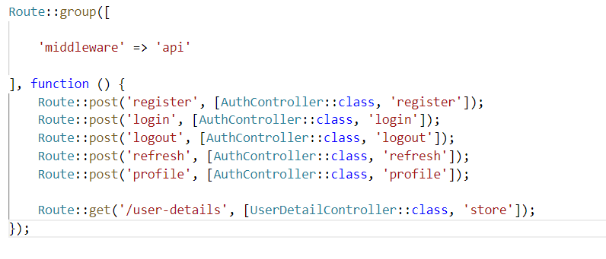

1. Create the AuthController



1. Inside AuthController ceeate methods, constructors for making the routes functional

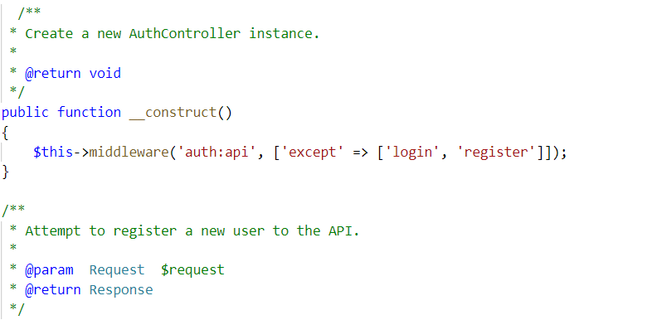

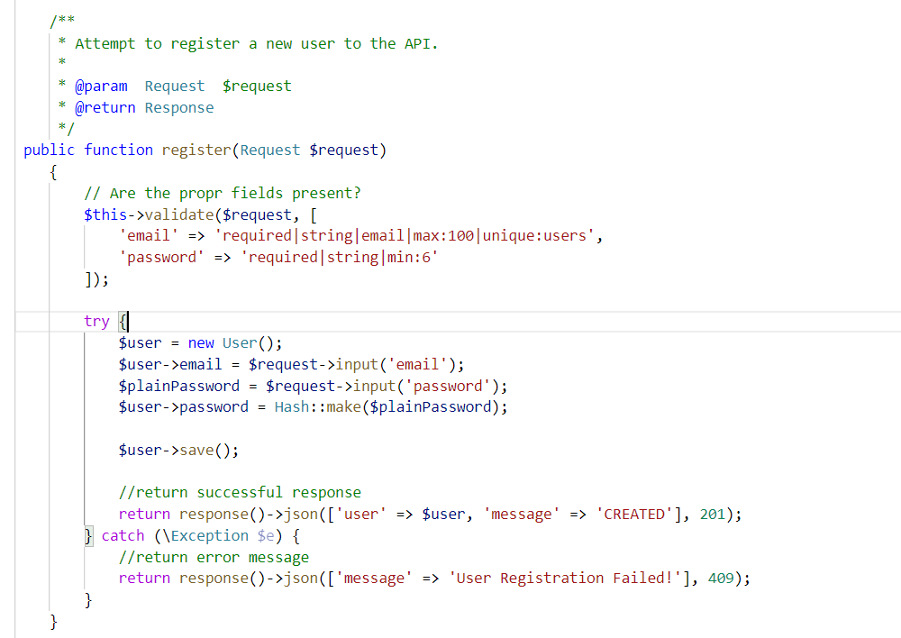

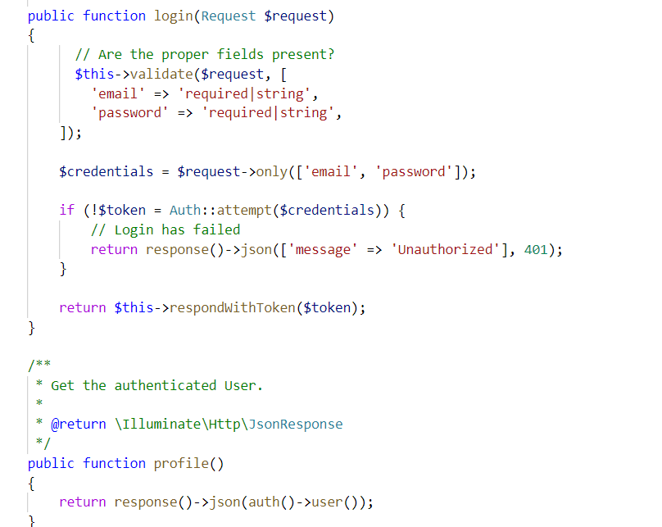

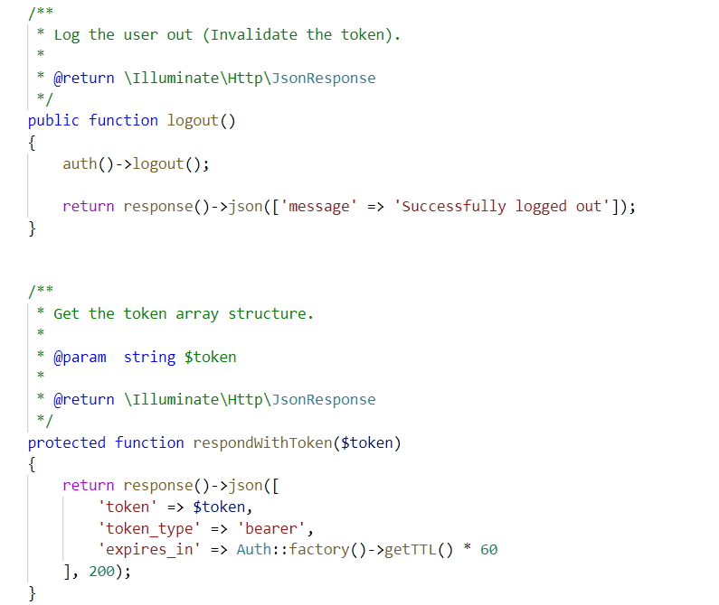

Test functionality using a testing tool like Postman

1. Test register route - POST

Set Header for accepting like an API

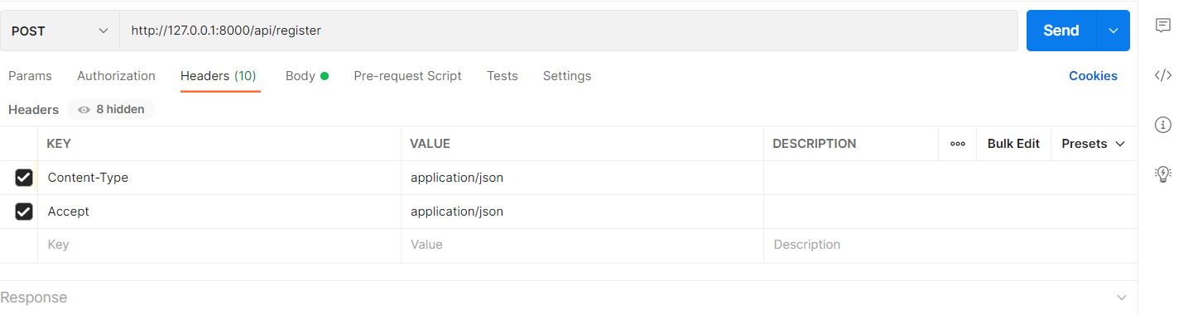

Test using the Body

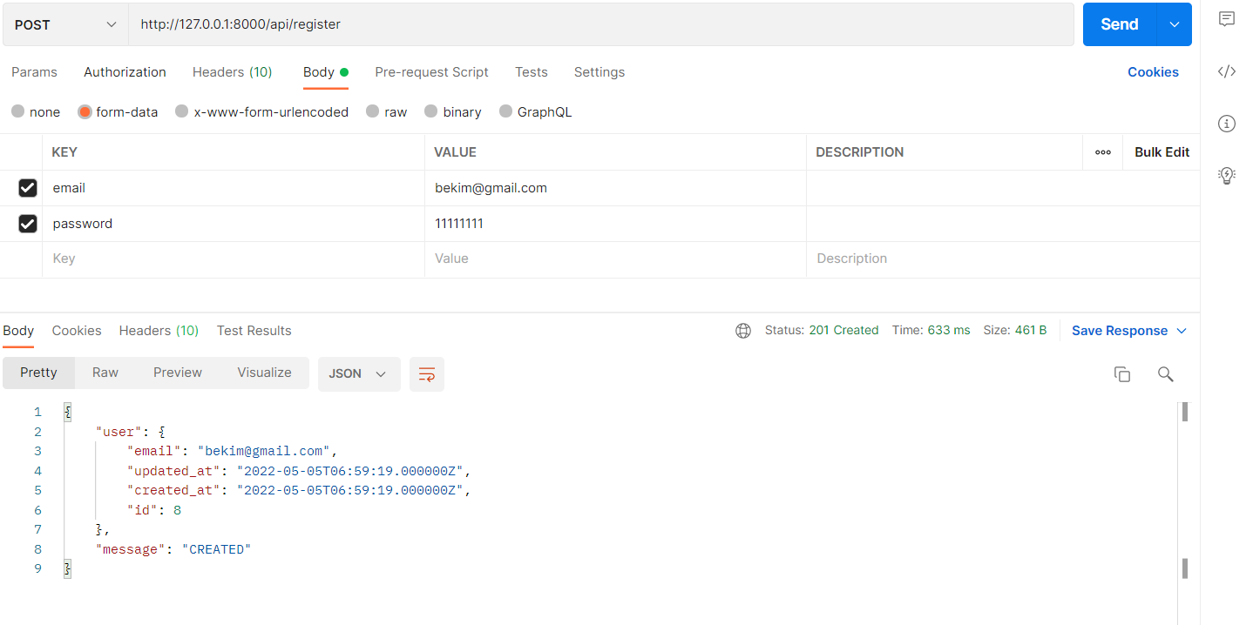

Look into database

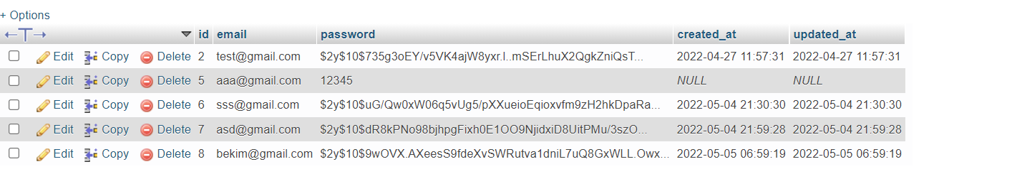

1. Test route login – POST

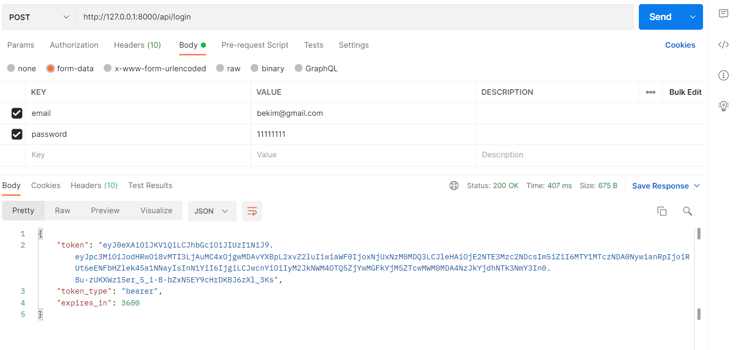

1. Get the login user using authorization of type bearer of route profile, copy the token from login and paste here

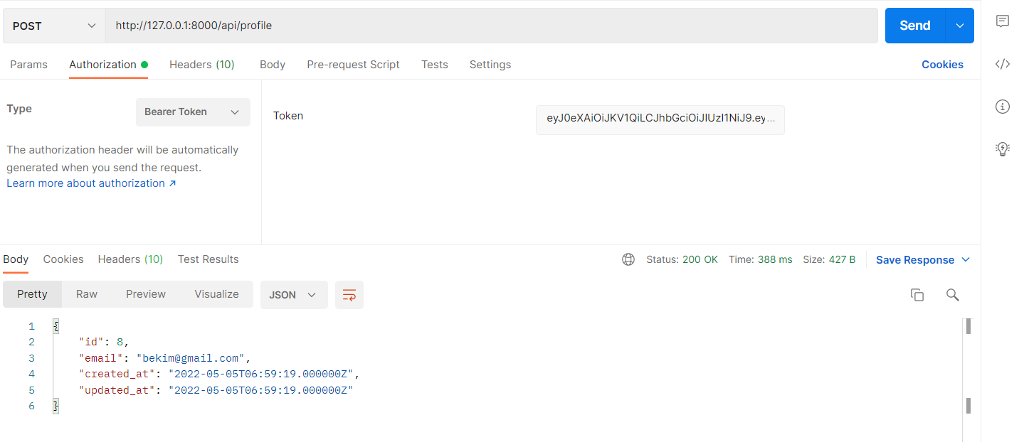

1. Test the logout route using the same method as profile route

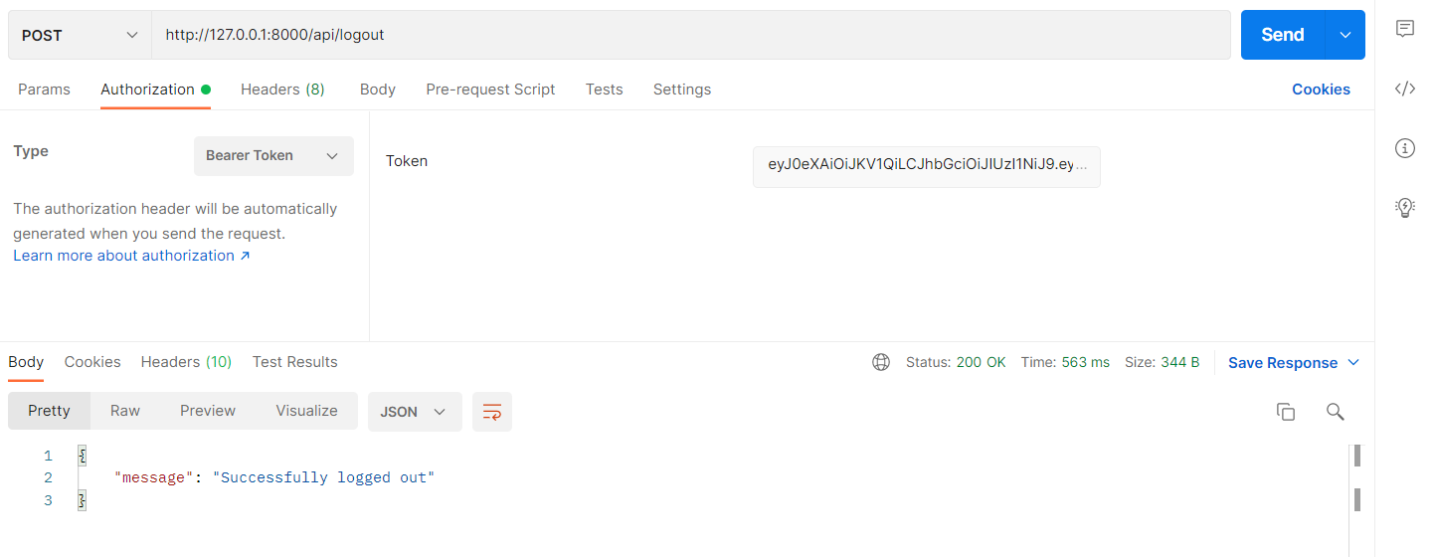

1. Login again and test another route if it’s working the auth or not, if it’s working than at the other route will return Authorized otherwise will return Unauthorized

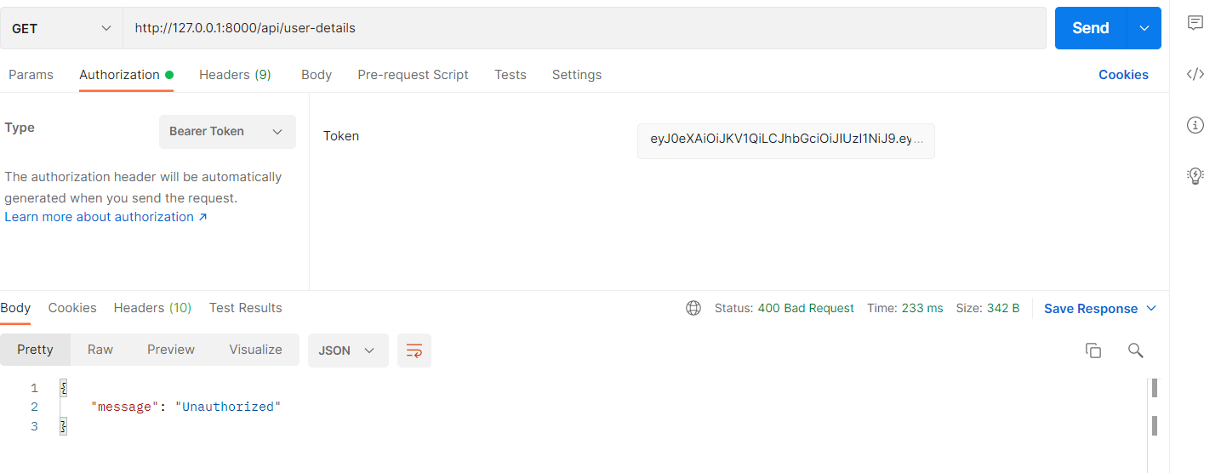

And after login

