Code & Methodology:

Code Design:
The script for this lab was separated into functions and then they were called at the end to quickly test and play around with initial conditions to see the behavior of the Lotka-Volterra competition model, predator-prey population model, and the Lorenz attractor. The functions for each of the three model types were separated into trhee component functions: a time-step/derivative calculator, a integrator/solver for a given time period, and then a plotting function to display the results. The predator-prey model had an additional plotting function to show a phase diagram, as opposed to the other models which plotted a time series.

The time-step calculator functions took in the required information, namely time and current conditions, and returned the rate of change of the applicable variable (either population or position).

The integrator functions were divided between Euler’s method and RK45 solvers. These functions took the initial conditions, timeseries length, and initial timestep size as required inputs. Then called the time-step calculator function to find the behavior over time. Both of them returned a timeseries of applicable variable (populations or positions) over a specified period of time as well as a list of the times.

The plotting functions took initial conditions and a timestep size, not returning anything specifically, but plotting the given model integrated over 100 timeunits. These functions called the integrator functions to get the solution before plotting. Each function had specific titles, axes, etc that matched the integrator and model type.

Since the first question of the homework had set conditions to plot, two functions were made to run a bit of code to plot and show the results of that specific question. The following questions were answered by adjusting the inputs into the plotting functions.

Model Validation
The validation for this lab was primarily graphical. One function, used to calculate the possible two-species survival state, was tested numerically with known solutions. All the others were shown via output. An example for each is shown and described below in Figures 1, 2, 3, and 4. All show generally what is expected. Figure 1 shows the competition model, both the Euler and RK45 functions work as expected, with error growing toward the end of the timeseries (slight blow up). Increasing the tolerance on the RK45 decreased this blowup, but isn’t really necessary as the steady state is reached (the black lines). We’d expect them to stay there. As for the predator-prey models, we see the timeseries (Figure 2) and the phase diagram (Figure 3). The Euler series has growing error, while the RK45 exibits stationarity (both are expected). Then, the phase diagram (using the RK45) looks as one would expect. Finally, Figure 4 shows the lorenz attractor. At this r-value, we see the ‘textbook’ lorenz attractor, which gives confidence in that the model works. The small perterbations affect this trajectory, which we would expect and further validates the model.

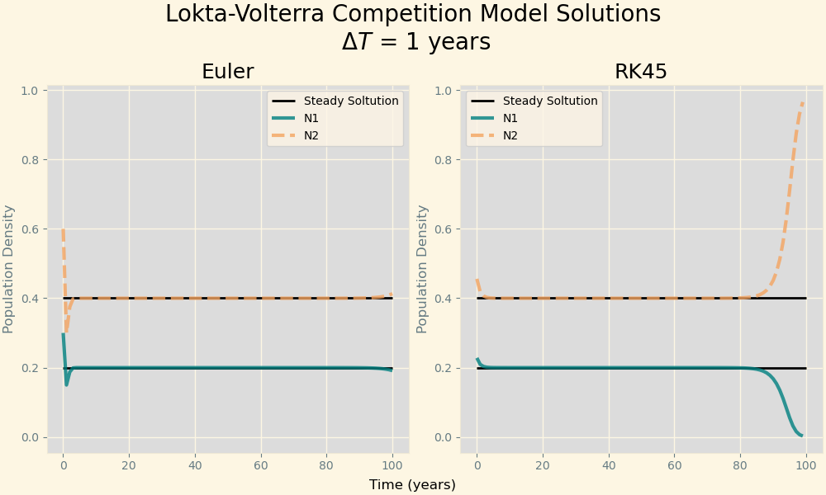

Figure 1. Lokta-Volterra Competition model integrated using the Euler method and a python package, RK45. The stead state solution is plotted in black, species 1 in blue, and species 2 in dotted orange.

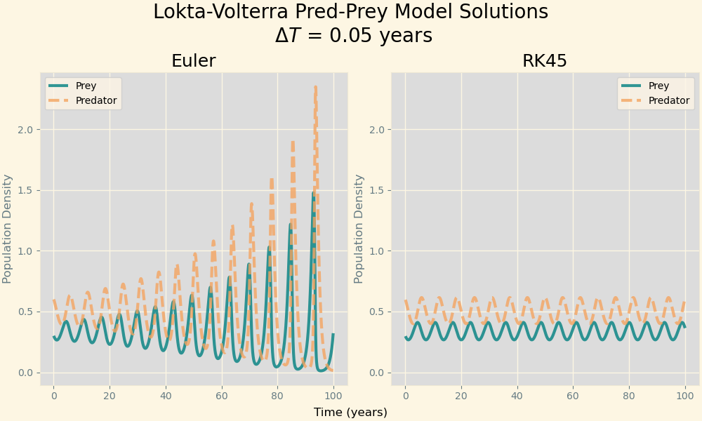

Figure 2. Lokta-Volterra Predator-Prey integrated solution using Euler's Method and the RK45 python integrator. Prey is in blue, and the predator species in in dotted orange.

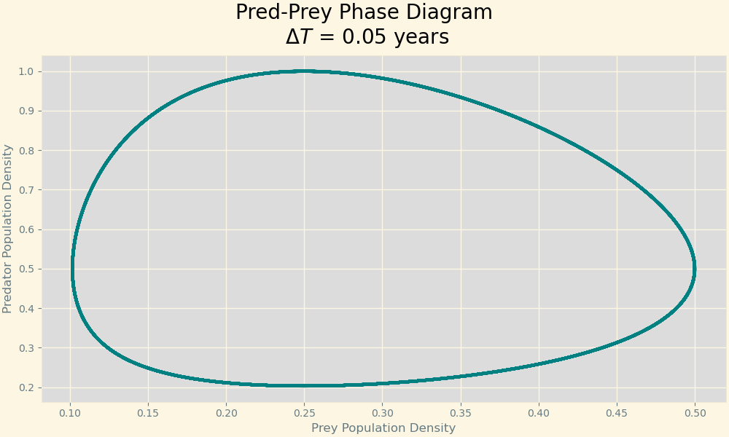

Figure 3. Lokta-Volterra Predator-Prey integrated solution phase diagram.

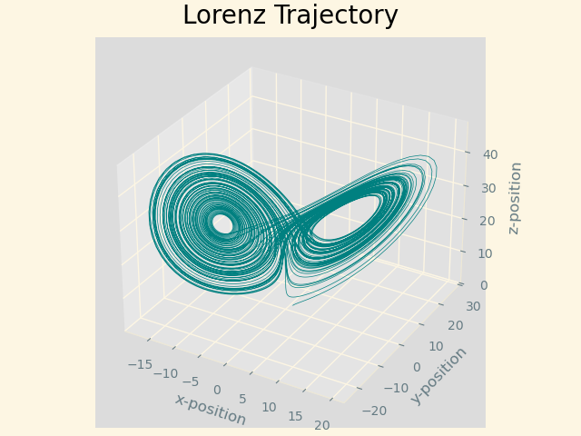
Figure 4. Lorenz Attractor Trajectory. Position in space is shown on the teal curve, initially starting at position (1, 1, 1). The classic lorenz attractor shape is seen (orbiting two points).

Answers to Questions:

Question 1) How does the performance of the Euler method solver compare to the rk45 method for both sets of equations?
Figure 5. Euler and RK45 integration methods for the Lokta-Volterra Competition model.
Figure 6. Euler and RK45 integration methods for the Lokta-Volterra Competition model.
The Euler method performs very similarly to the rk45 method for the competition model, while it performs worse for the predator prey model. Figure 5 shows the competition model results. Both perform well in the middle of the time series, equal to the known solution- the black line on the graph. Toward the end, however, both models begin to deviate, with the rk45 blowing up a bit earlier and stronger than the euler method. This is due to the tolerances set when calling the function (the default value allows for this behavior). As for the predator-prey model in Figure 6, we see that the Euler method’s populations cycle with increasing amplitude, showing it has difficulty landing on stationary cycle for the species’ relationship. The RK45 handles this situation much better.

Question 2) How do the initial conditions and coefficient values affect the final result and general behavior of the two species? (For the competition model)

The initial conditions do affect the final result, determing which of the four solutions the competing species arrive to. The coefficients evaulate to a potential final balanced solution, where both species survive. Otherwise, either one or both of them will die out. Shown below in Figure 7, two identical situations are seen with different initial populations. The graph on the left shows a solution where both species survive, and the right shows a small perterbation that results in one dying out.
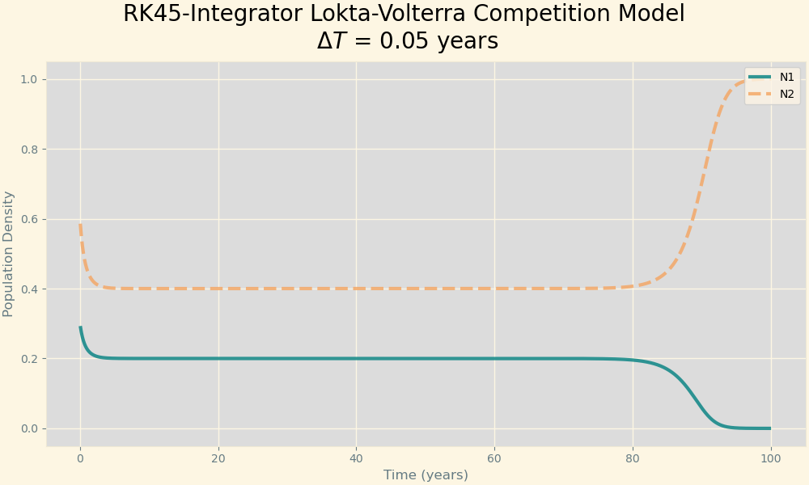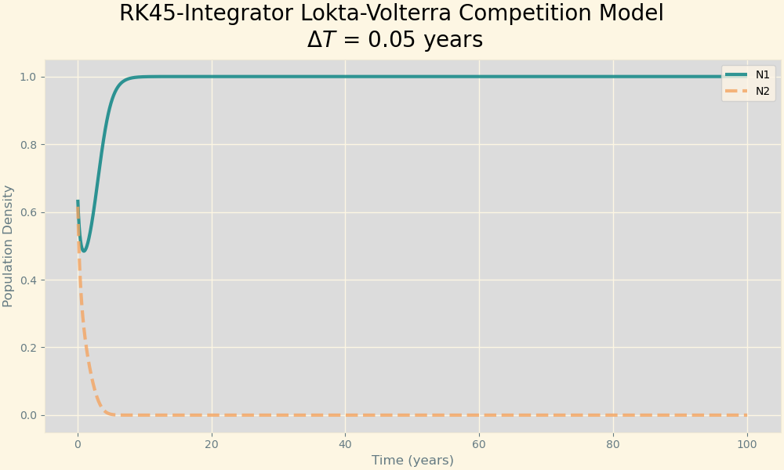
Figure 7. Lokta-Volterra Competition Model for two species. Different starting conditions are shown on the left and right graphs, with the two-species solution (left) and death solution (right). The ending of the left graph is due to a tolerance error.

Question 3) How do the initial conditions and coefficient values affect the final result and general behavior of the two species?
Table 1. Table showing similar conditions with adjusted coefficient values of a Pred-Prey model. Phase diagram and time-series are shown as well.
Initial Conditions | Phase Diagram | Time-Series
[0.5, 0.5]: initial population density  [1, 2, 1, 4]: coefficent values |  | 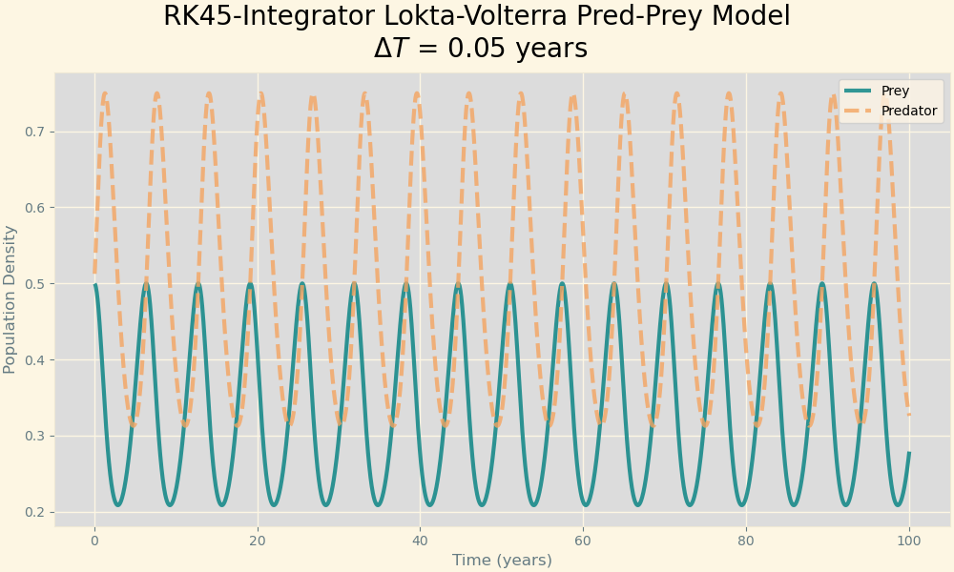
[0.5, 0.5]: initial population density  [2, 2, 1, 4]: coefficent values  (Change a) | 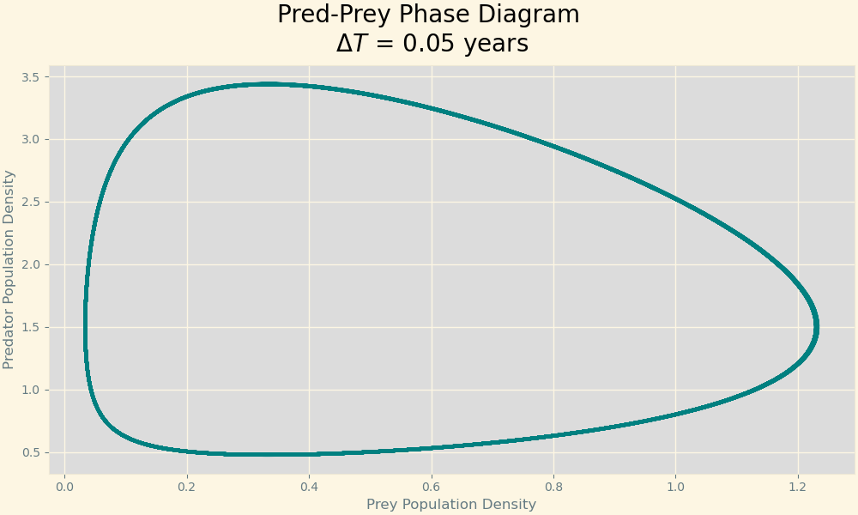 | 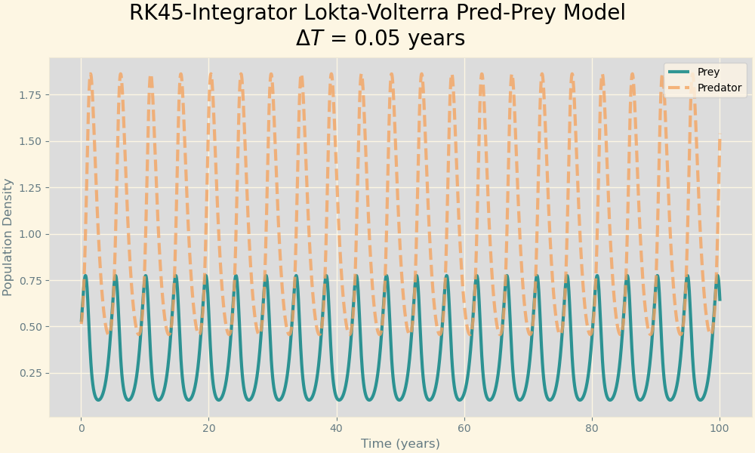
[0.5, 0.5]: initial population density  [1, 3, 1, 4]: coefficent values  (Change b) | 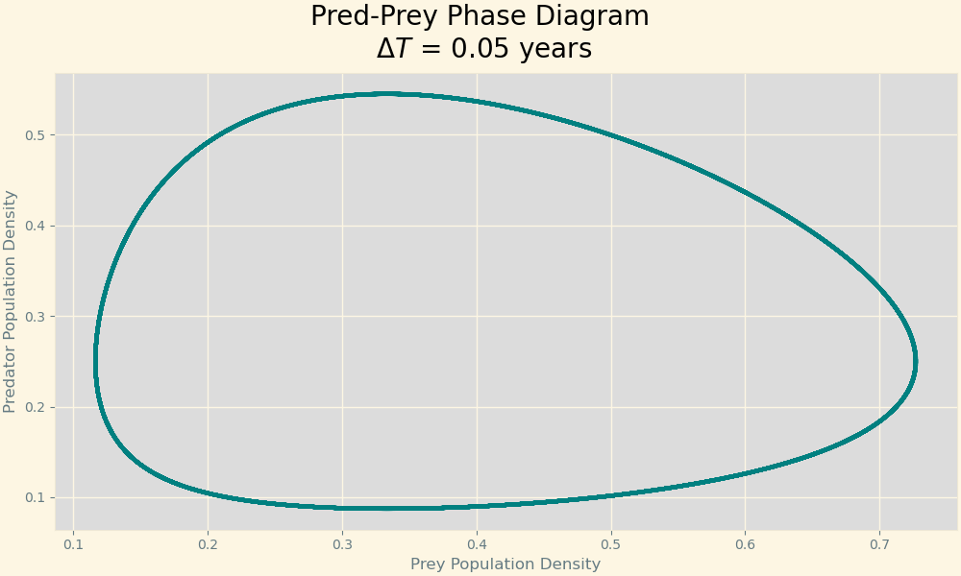 | 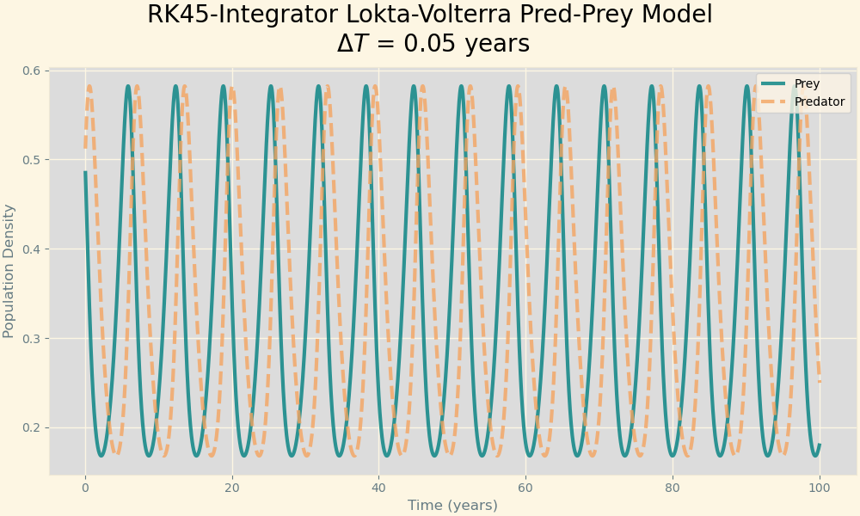
[0.5, 0.5]: initial population density  [1, 2, 2, 4]: coefficent values  (Change c) | 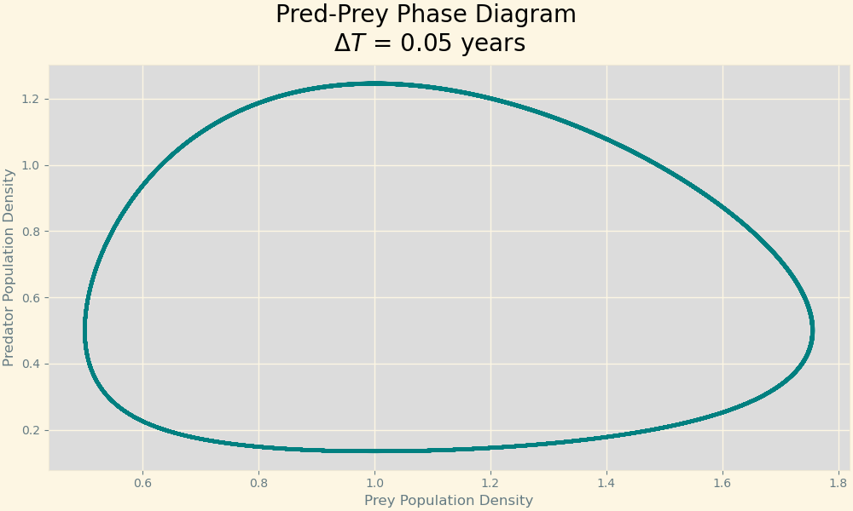 | 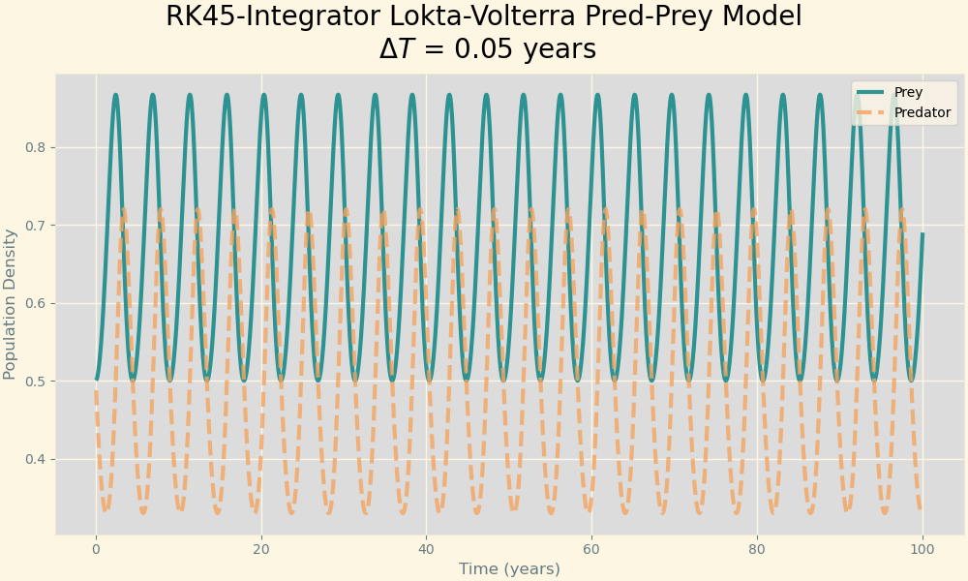
[0.5, 0.5]: Initial population density  [1, 2, 1, 5]: coefficent values  (Change d) | 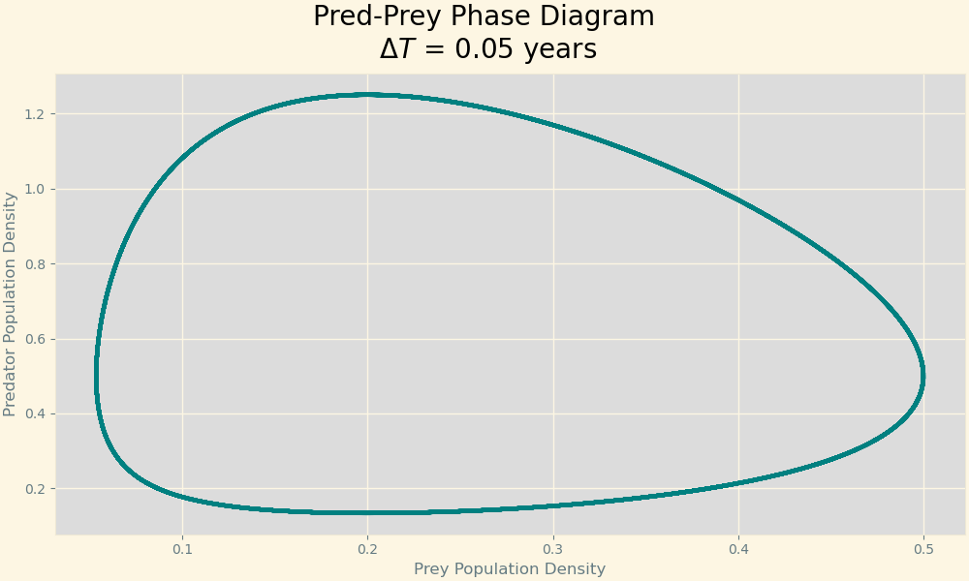 | 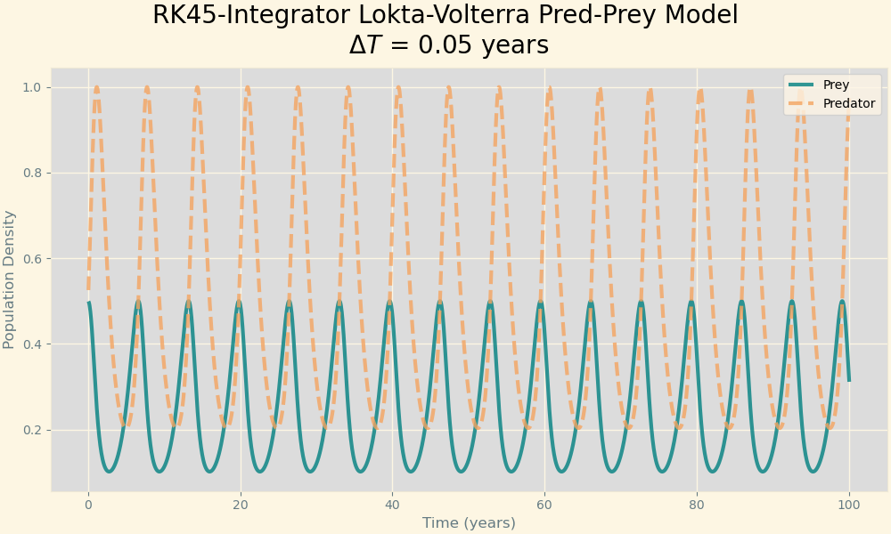

As shown in Table 1, we see the same initial conditions with varied coefficient values for the predator-prey relationship. The phase diagrams give us insight to the stability of the relationship between the species. Higher amplitude/sensitive relationships translate to sharper curves along the bottom and left sides of the phase diagram. It approaches a right triangle (guitar-pick shape) as the relationship is unstable and an ellipse in a stable relationship. Additionally, unlike the competition model, the ultimate relationship depends heavily on the initial conditions as well, shown below in Figure 8. Initial conditions of equal population between prey and predators have different phase diagrams when the population values change, even with the same intial conditions.
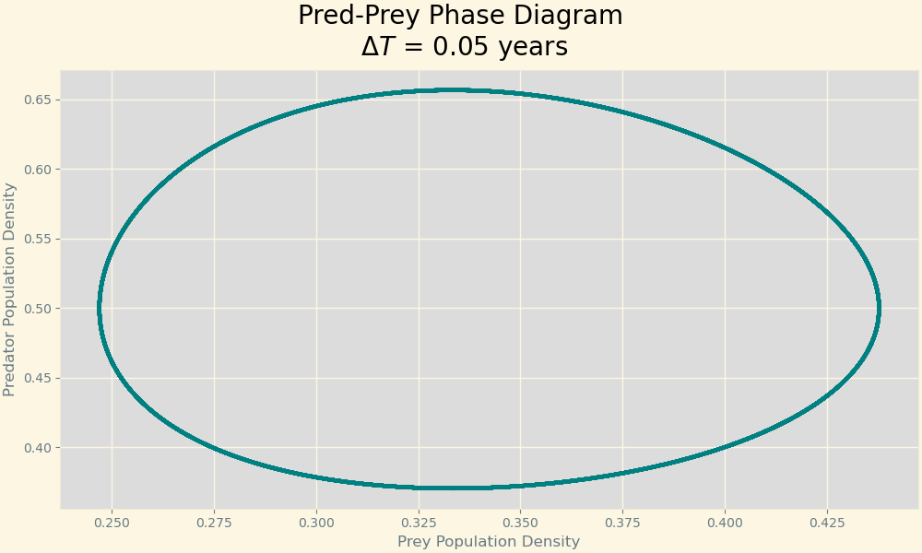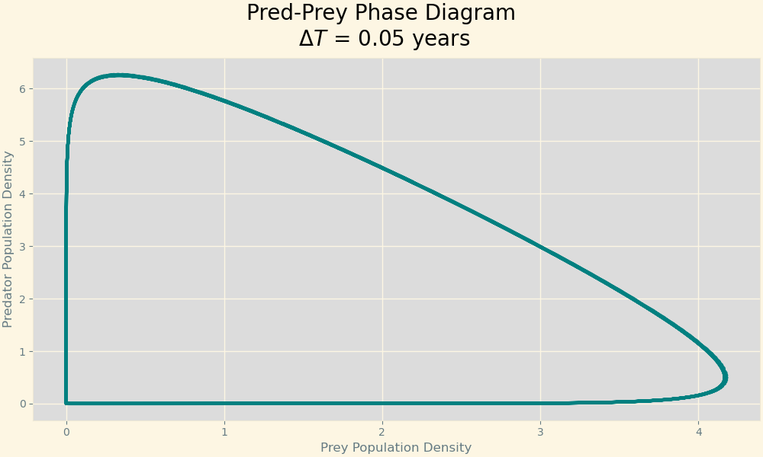
Figure 8. Predator-Prey phase model with varying intial conditions, but identical coefficient values. The left, stable diagram shows initial population densities of 0.5 for both species. The diagram on the right shows initial population densities of 3.

Question 4) What does this tell us about the feasibility of performing long-term weather forecasts or any making long-term predictions about any non-linear system?
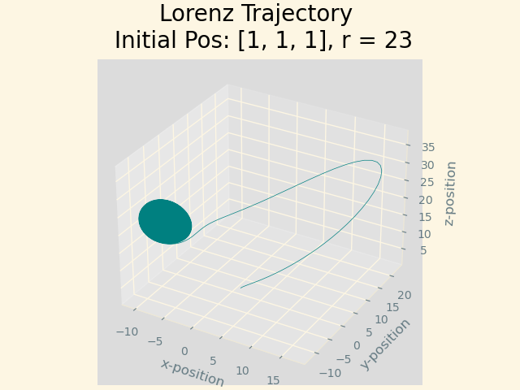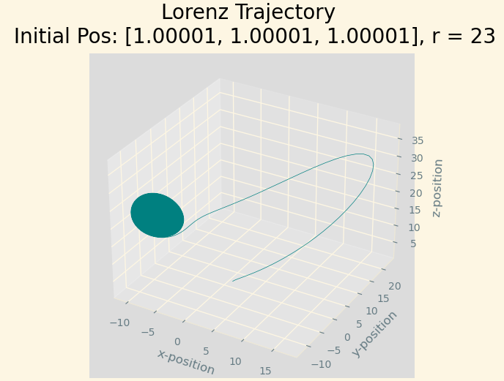
Figure 9. Lorenz Attractor trajectory given an inital position and r-value. Initial vs slightly perturbed trajectories are similar

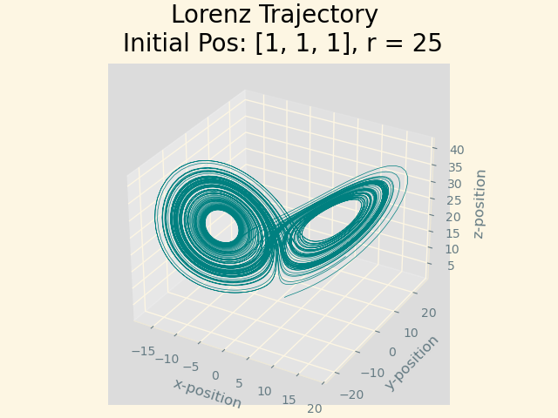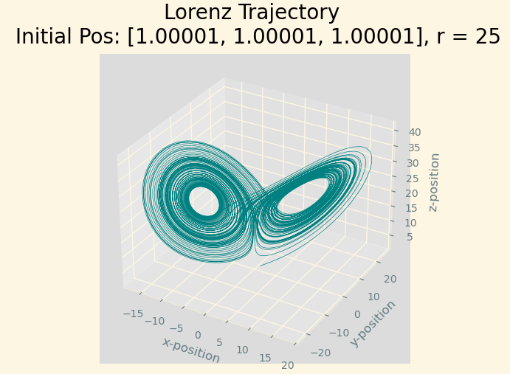
Figure 10. Lorenz attractor trajectory given an initial position and disturbed initial position at an r-value of 25. The two trajectories follow a similar pattern, but the paths themselvs are very different (seen through the 'bands' being different thicknesses.

Overall, it seems that the value of r changes the importance of the precision needed in the intial position measurement. When it is equal to 23, as seen in Figure [#], the intial conditions matter, but small difference don’t seem to affect the overall trajectory. However, as seen in Figure #, a small difference changes the path quite a bit when r = 25. Small changes to the initial conditions produce different trajectories (even if the overall shape/path is the same). This tells us that long-term weather forecasts and long-term prediction in similar systems are extremely difficult, as small errors in the initial conditions change the trajectory down the line greatly. Short-term predicition is less inaccurate.

