Project Report: Agents_Restaurant
Restaurant Using Multi-Agent System
By: Bekkari Abderrahmane & Assassi Salah Eddine
Level: M2 AI
- System Architecture and Design

1.1 Architectural Overview
Agents_Restaurant employs a three-tier distributed architecture that separates agent logic, middleware communication, and user interface presentation:

- Backend Layer (JADE Platform): The core computational layer where all agent logic resides. JADE provides the runtime environment through containers that host agents and facilitate message passing using FIPA-ACL (Agent Communication Language) standards. The system utilizes nine specialized containers organized by functional role: BossContainer, WaiterContainer, ChefContainer, CashierContainer, TableContainer, ClientContainer, EntryContainer, ExitContainer, and EnvContainer for agent transit.

- Middleware Layer (Flask REST API): A Python-based Flask server acts as a bridge between the JADE backend and web frontend. Agents send HTTP POST requests containing their state (position, status, container) to the API every 100 milliseconds, enabling real-time monitoring. The API maintains an in-memory dictionary of agent states and serves them to the dashboard via a /state endpoint.

- Presentation Layer (Web Dashboard): An HTML/JavaScript interface renders a 120×120 grid canvas where agents appear as colored shapes. Control buttons allow users to initialize the system, start/stop simulation, and adjust speed. The dashboard polls the API every 200ms to update agent positions and statuses, providing immediate visual feedback of agent interactions.

1.2 Container Architecture
The container-based design enables both physical separation of agent types and controlled mobility:

- Static Containers: BossContainer, ChefContainer, CashierContainer, and TableContainer host agents that remain in fixed locations, representing permanent restaurant infrastructure.

- Transit Containers: EntryContainer and ExitContainer serve as gateway points for customers entering and leaving the restaurant.

- Movement Space: EnvContainer provides a shared space where mobile agents (ClientAgent, WaiterAgent) physically navigate using A* pathfinding between their origin and destination containers.

This architecture mirrors real-world restaurant topology where certain zones (kitchen, cashier desk) are fixed while customers and staff move between them through common pathways.

2.Agent Classification and Behaviors

2.1 Agent Taxonomy
The system implements ten distinct agent types, each designed according to the Belief-Desire-Intention (BDI) cognitive architecture model:

Agent Class | Category | BDI Type
BossAgent | Managerial | Deliberative
WaiterAgent | Service | Hybrid (Reactive + Deliberative)
ChefAgent | Kitchen | Reactive
CashierAgent | Financial | Reactive
ClientAgent | Customer | Goal-Driven
TableAgent | Resource | Stateful Object
EnterAgent | Gateway | Coordinator
ExitAgent | Gateway | Cleanup
AgentFactoryAgent | Infrastructure | Creator
HelperAgent | Utility | Temporary Messenger

- Deliberative Agents (BossAgent): The restaurant manager maintains beliefs about revenue, costs, and profit margins. Its desires include maximizing profit and ensuring customer satisfaction. Intentions manifest as menu planning at startup and continuous financial monitoring. The boss calculates net profit every five seconds and adjusts mood status (Happy, Cautiously Optimistic, Not Happy) based on whether targets are met.

- Reactive Agents (ChefAgent, CashierAgent): These agents respond immediately to stimuli without complex planning. ChefAgent maintains a FIFO queue of orders and enters a blocking preparation state (simulating cooking time) before notifying the waiter. CashierAgent processes payment requests synchronously, reports profits to the boss, and coordinates table release.

- Hybrid Reactive-Deliberative Agents (WaiterAgent): Waiters exhibit both reactive responses to order requests and deliberative route planning. Upon receiving an ORDER_REQUEST, the waiter acknowledges the client, plans an optimal path to the table using A*, travels to collect the order, forwards it to the chef, waits for preparation completion, and delivers food back to the client—demonstrating goal-oriented behavior with reactive message handling.

- Goal-Driven Agents (ClientAgent): Customer agents follow a predefined goal sequence (eat and leave satisfied) but adapt to environmental constraints. They queue when tables are unavailable, select menu items autonomously, consume food for a timed duration, and navigate to payment and exit autonomously.

- Coordinator Agents (EnterAgent): The maître d' manages the waiting queue using FIFO logic. It periodically queries all TableAgents for availability, assigns the first available table to the next client in queue, and enforces assignment cooldown periods to prevent race conditions.

- Resource Agents (TableAgent): Tables are stateful resources tracking binary availability (occupied/free), current client assignment, and menu information. They respond to availability queries, accept occupancy requests, and reset state upon client departure.

2.2 Agent Communication Protocol
All inter-agent communication adheres to FIPA-ACL message standards with strict performative usage:

- REQUEST: Initiates actions (ORDER_REQUEST, PAYMENT_REQUEST, CHECK_AVAILABILITY)

- INFORM: Provides information or signals completion (ORDER_READY, FOOD_DELIVERED, PAYMENT_COMPLETE)

- CONFIRM: Acknowledges requests (ORDER_RECEIVED, OCCUPIED)

Message content follows a structured format: `ACTION:parameter1:parameter2:...`. For example, `ORDER_REQUEST:Table1:Client1:PIZZA` encapsulates table location, client identity, and menu item in a single parseable string.

3. Core Infrastructure Systems

3.1 Tick-Based Simulation Engine
The TickSystem class implements a global clock synchronized across all agents using the Observer pattern. A daemon thread increments a tick counter every 50 milliseconds (default), notifying all registered TickListener agents. This design ensures:

- Synchronized Movement: Agents advance along pathfinding routes one waypoint per tick, creating smooth animated transitions rather than instantaneous teleportation.

- Timed Actions: Agent behaviors specify durations in ticks (e.g., CLIENT_EATING = 60 ticks = 3 seconds), allowing configurable simulation speed without code changes.

- Speed Control: A speedFactor multiplier adjusts tick interval dynamically, enabling users to accelerate or slow the simulation via web controls (0.5× to 10× speed range).

3.2 Intelligent Navigation System
Movement within the restaurant employs a sophisticated hybrid approach:
Container-Based Mobility: Agents use JADE's doMove() method to physically migrate between containers, triggering afterMove() callbacks for state updates. This models the concept that agents cannot simultaneously exist in multiple locations (e.g., a client cannot be at the table and cashier concurrently).

- A* Pathfinding: For movement within the 120×120 continuous coordinate space, agents invoke the AStarPathfinding class. The algorithm uses Manhattan distance heuristics and 4-directional movement (no diagonals) to generate optimal collision-free paths. The BaseAgent class stores the path as a list of waypoints and advances one coordinate per tick until arrival.

- Callback Mechanism: The onMovementFinished() method allows agents to execute logic upon reaching destinations—for example, ClientAgent transitions from MOVING_TO_TABLE status to AT_TABLE status and initiates menu requests.

3.3 Queue Management
The QueueManager class provides thread-safe FIFO queue operations used by EnterAgent (client waiting list), WaiterAgent (order queue), and ChefAgent (preparation queue). This ensures fair processing order and prevents starvation scenarios where some requests never get serviced.

4. Complete Operational Workflow

4.1 System Initialization Phase
Upon clicking "Initialize" in the web dashboard, the Main class orchestrates system bootstrapping:

- Container Creation: Nine containers are instantiated through messages sent to AgentFactoryAgent using temporary HelperAgent messengers.

- Agent Deployment: Eleven agents are created with specific coordinates: Boss (110, 10), Waiter (20, 20), two Chefs (30, 30) and (35, 30), Cashier (80, 80), four Tables at 15-unit intervals, EnterAgent (0, 0), and ExitAgent (100, 100).

- Menu Initialization: BossAgent randomly selects 3-4 items from the Menu enum (Pizza, Salad, Burger, Pasta, Steak, Dessert) and broadcasts DAILY_MENU messages to all TableAgents.

- TickSystem Activation: The global clock starts in paused state, awaiting the user's "Start" command.

4.2 Customer Journey Lifecycle

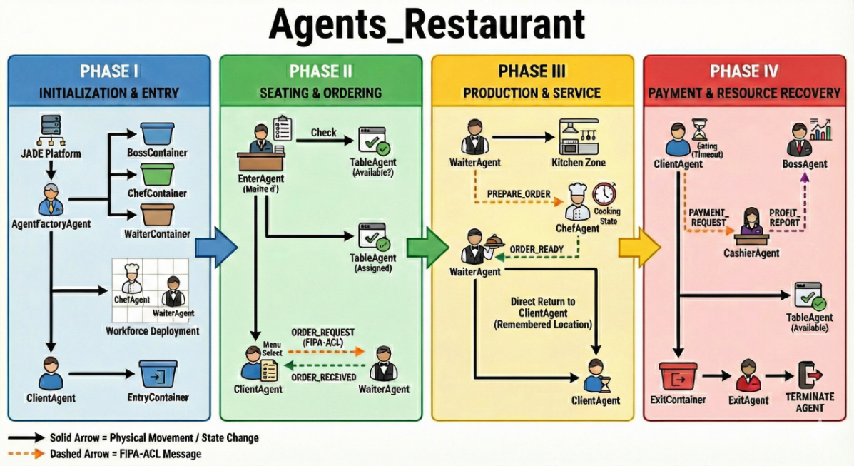

- Entry (Phase I): A ClientAgent spawns in ClientContainer at coordinates (5, 5) with status WAITING_IN_QUEUE. It moves to EntryContainer and sends a JOIN_QUEUE message to EnterAgent, which adds the client to its FIFO waiting list.

- Table Assignment (Phase II): EnterAgent queries all TableAgents with CHECK_AVAILABILITY messages. Upon receiving an AVAILABLE response, it sends OCCUPY:ClientName to reserve the table, then notifies the client with MOVE_TO_TABLE:TableName. The client's status changes to MOVING_TO_TABLE.

- Navigation: The client executes moveToContainer("EnvContainer"), calculates an A* path to the table's coordinates, and moves tick-by-tick until arrival. Upon reaching the destination, it executes moveToContainer("TableContainer") and sets status to AT_TABLE.

- Ordering (Phase II): The client sends GET_MENU to the table, receives the menu response, randomly selects an item (e.g., PIZZA), and sends ORDER_REQUEST:Table1:Client1:PIZZA to WaiterAgent. The waiter responds with ORDER_RECEIVED, setting the client to EATING status.

- Service Coordination (Phase III): WaiterAgent changes status to WAITER_MOVING_TO_TABLE and navigates to TableContainer. After acknowledging the order, it transitions to WAITER_MOVING_TO_CHEF and travels to ChefContainer. It sends PREPARE_ORDER:Table1:Client1:PIZZA to ChefAgent.

- Food Preparation: ChefAgent enters CHEF_PREPARING_ORDER status and blocks for TickDuration.CHEF_PREPARING_ORDER (3 seconds). Upon completion, it sends ORDER_READY back to the waiter.

- Food Delivery: WaiterAgent sets status to WAITER_SERVING_ORDER, navigates back to TableContainer, and sends FOOD_DELIVERED to the client. The client begins EATING for 3 seconds.
- Payment (Phase IV): After eating, the client sets status to MOVING_TO_CASHIER and navigates to CashierContainer. It sends PAYMENT_REQUEST:Table1:Client1:12.50 (price retrieved from menu). CashierAgent processes the payment for 1 second, sends PAYMENT_COMPLETE to the client, and reports PROFIT_REPORT:12.50:5.00 to BossAgent.

- Resource Release: The client sends FREE_TABLE to the table before exiting. TableAgent sets available=true and currentClient=null, allowing EnterAgent to assign it to the next waiting customer.

- Exit (Phase IV): The client moves to ExitContainer with status EXITING. ExitAgent scans every 2 seconds using DFService to find agents in ExitContainer and kills them via doDelete(). The client's takeDown() method sends a removal request to the Flask API.

5. Technical Specifications:
- Platform: JADE 4.x (Java Agent DEvelopment Framework)
- Language: Java 8+ (backend logic), Python 3.x (Flask API)
- Communication: FIPA-ACL messaging over JADE infrastructure
- Visualization: HTML with JavaScript polling (200ms refresh)
- Grid Size: 120×120 continuous coordinate space
- Agents: 10 distinct agent types, 11+ runtime instances
- Containers: 9 specialized JADE containers
- Tick Rate: 50ms base interval (adjustable via speed factor)

